Shengkai Xu
ECGR 4090 – Real time AI
02/12/2021
Homework 0

Problem 1 (Resnet 101)
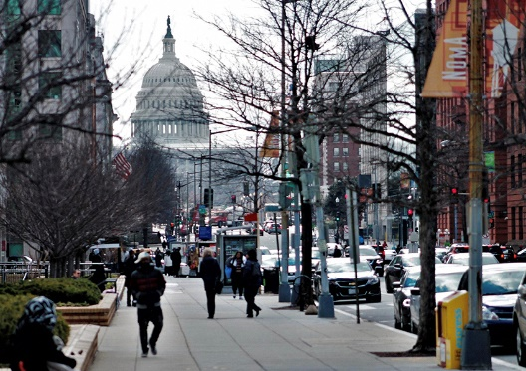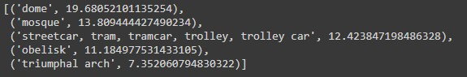
(TOP5) There is multiple objects is showed in the image which result inaccuracy of detection

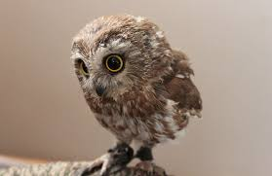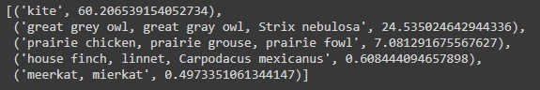
In this case it is a baby owl. The shape of baby owl head to body rational is not regular compare to adult owl, which the model was possibility trained by the images of adult owls.

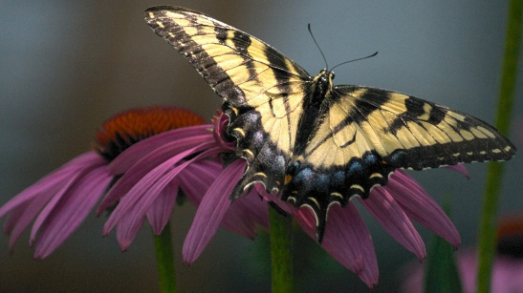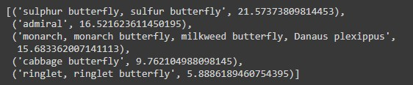
The butterfly pattern is very unique, it is possible there were no enough model trained on the types different between butterflies.

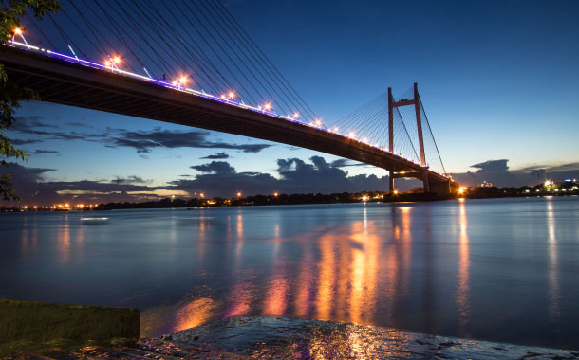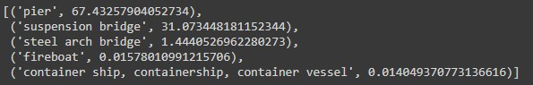
It was identified as pier, where the bridge shares similar feature to pier, and plus the image also showed the image of water which it was more convincing it is a pier more than a bridge.

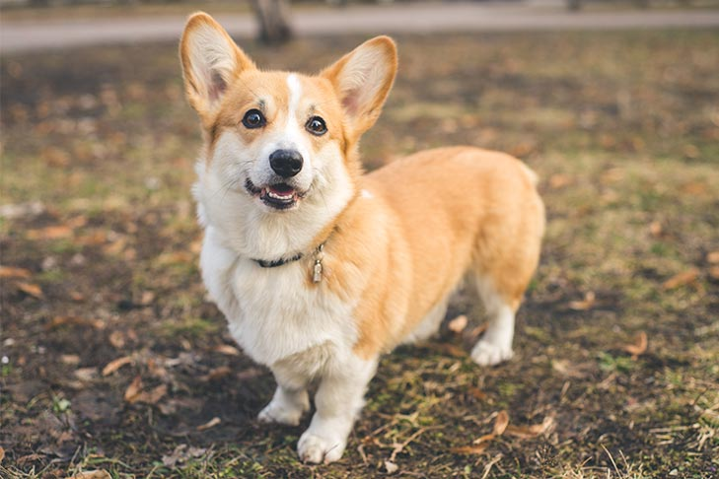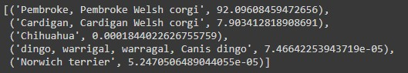
(TOP1) This a very generic image of welsh corgi, which model was possibility train by very similar images.

Problem 2 (ResnetGen – horse2zebra)
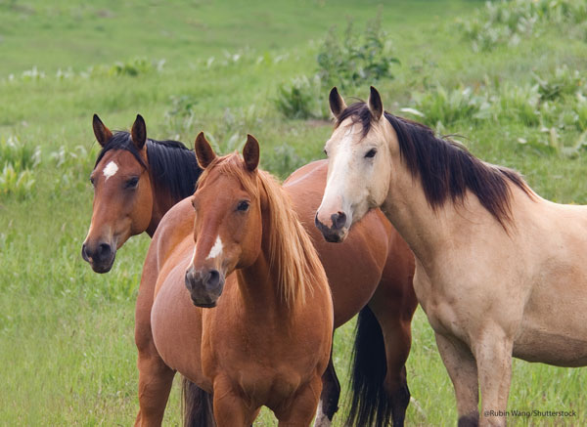 --->> 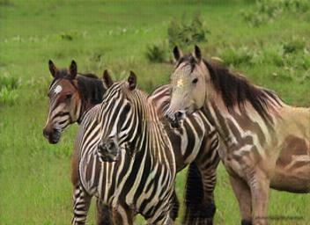
The shade of horse is different in the same image which result inaccuracy transformation of the multiple zebra

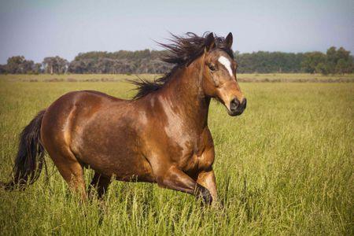 --->> 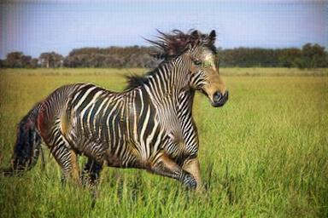
This image is very accurate transformation of the zebra from horse, expect the nose area are hard to transform since the shade different from the rest of body.

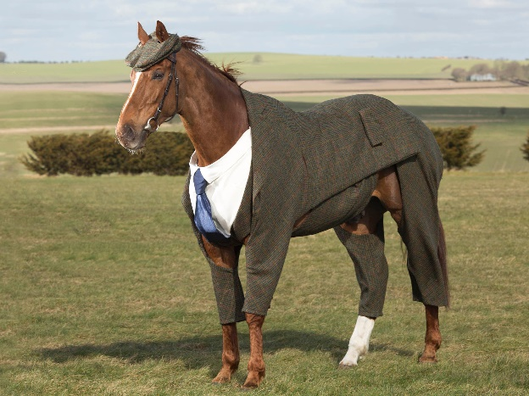 --->> 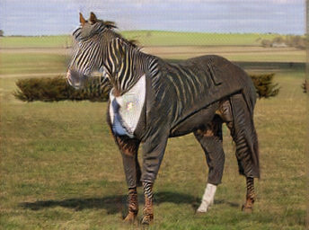
There are some miss leading patch on the cloth of the horse since it is very similar tone of shade to the compare to the cloth and eye color of the horse.

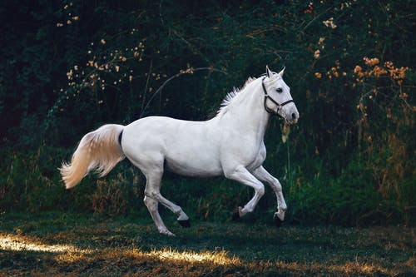 --->> 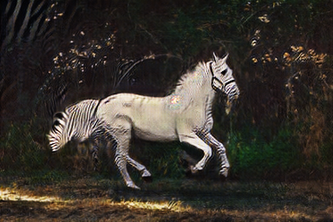
There are significant of color shade changes after the transformation. The eyes of the horse are very similar to the color of the background which lead the miss generations.

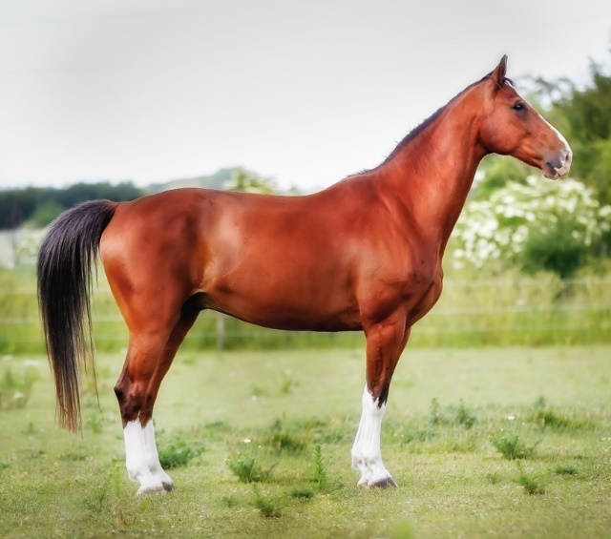 --->> 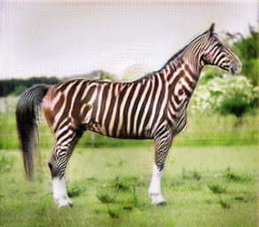
It is very east to generate a zebra from a white or black horse since most of zebra are black and white. In this case when the color of horse is red-ish, it is very hard to generating color from red to complete white strip which leads to very uncomfortable image if “zebra”.

Problem 3 (ptflops)
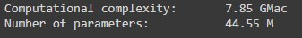 Resnet
ResnetGen
 Mobilenet v2

Problem 4 (Mobilenet v2)
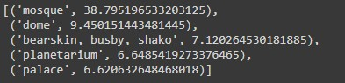
The capital building does have the similar feature as the mosque with pointy roof top.

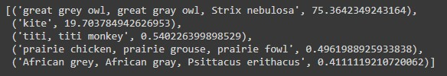
Mobilenet v2 have much more accuracy regarding to the owl type, in this case it was more certain it is a great gray owl.

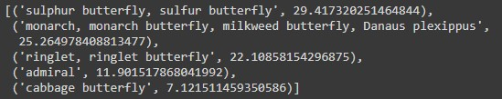

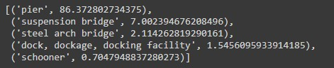
(TOP5) In this case it is more certain it is a pier not a bridge.


(TOP1) Still TOP1, this image is a very good example of commonly image training model.

