Shengkai Xu
ECGR 4090 – Real time AI
03/9/2021
Homework 2
GitHub: https://github.com/ric3b0wl/ECGR4090-RealTimeAI/hw2

Problem 1 “Temp” Tensor from list(range(9))
https://github.com/ric3b0wl/ECGR4090-RealTimeAI/blob/main/hw2/prob1.ipynb
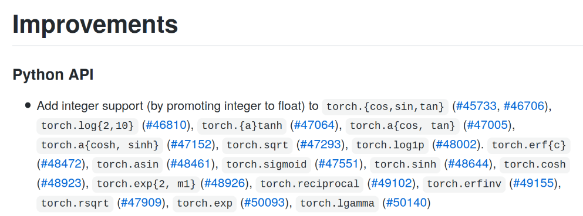
In the new Pytorch update, it improved the support of integer with cos and sqrt function. In the old version I believe the tensor must be a float value to be able to use torch. sqrt() and torch.cos() to get a valid result.
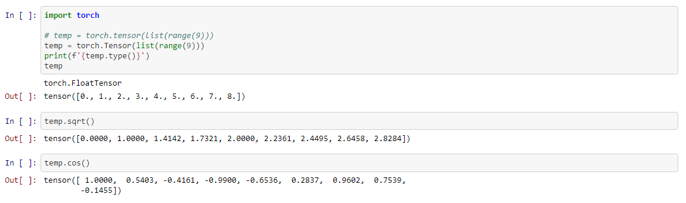

Problem 2 Red, Blue, Green image RGB brightness
https://github.com/ric3b0wl/ECGR4090-RealTimeAI/blob/main/hw2/prob2.ipynb
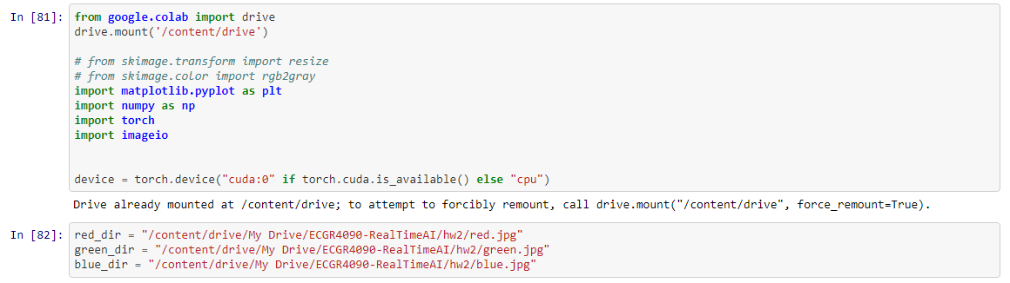
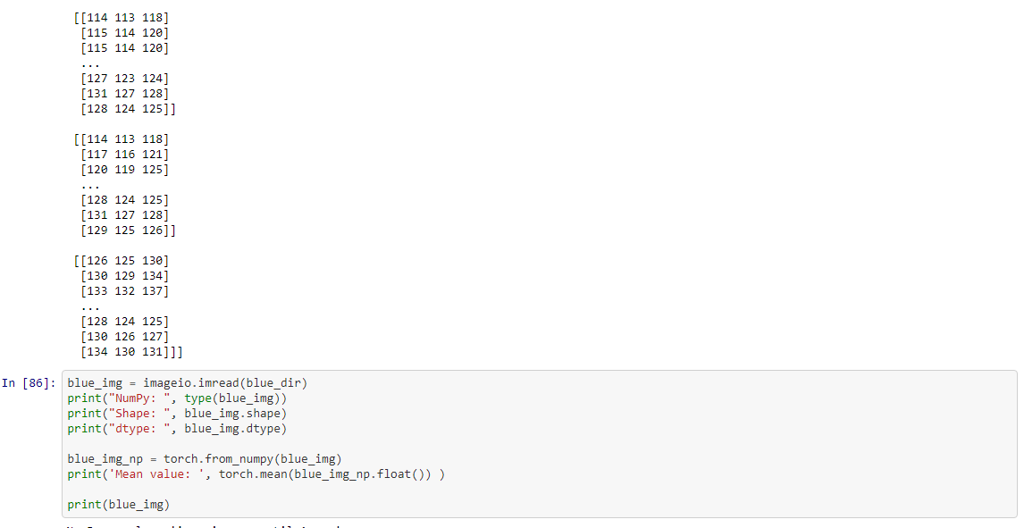
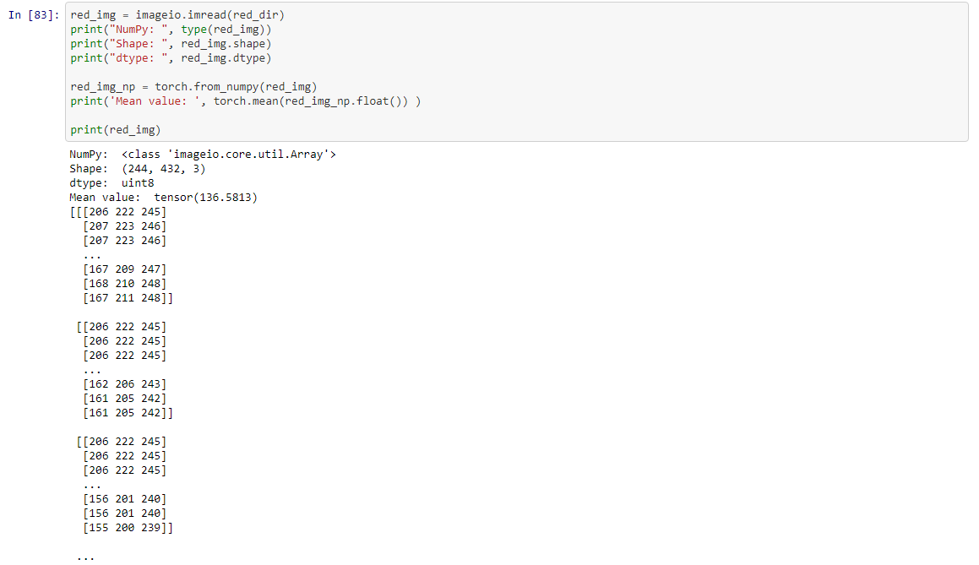

I was able to convert image to tensor and tensor come with three channels represent the RGB color for image. Getting the average value of image tells the brightness of the image. When getting average value of the channel determents the dominating color of the image. An image tensor is size [3,x,y] where [0,:,:] is red pixels, [1,:,:] is blue pixels, and [2,:,:] is green pixels.

