Shengkai Xu
ECGR 4090 – Real time AI
03/9/2021
Homework 1
GitHub: https://github.com/ric3b0wl/ECGR4090-RealTimeAI/hw1

Problem 1 Run Yolo.v5 across all four different model sizes (s, m, l, x)

Yolo v5 small
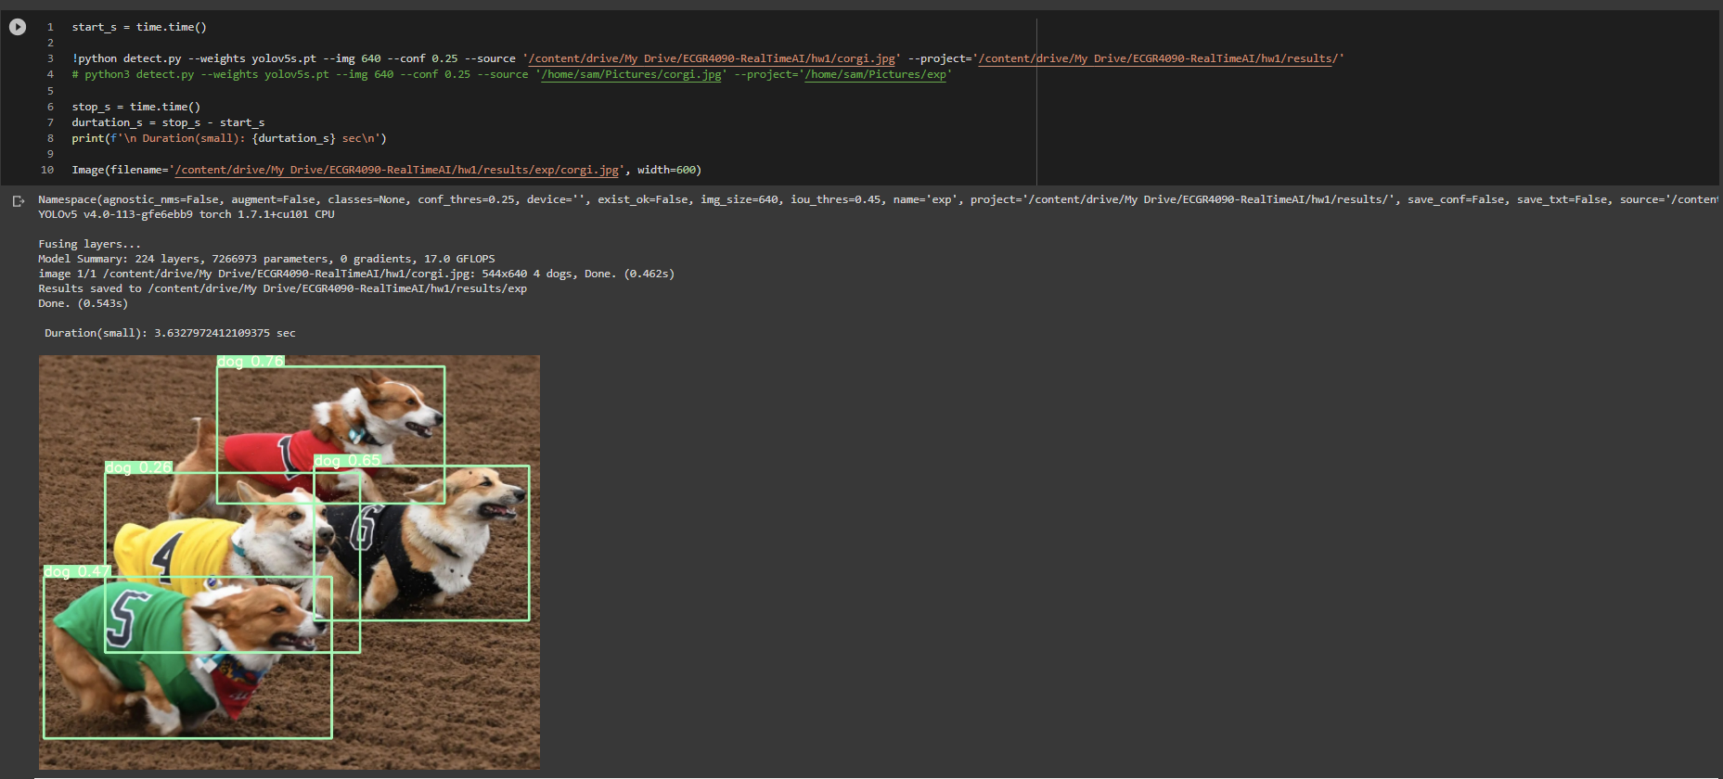

Yolo v5 medium
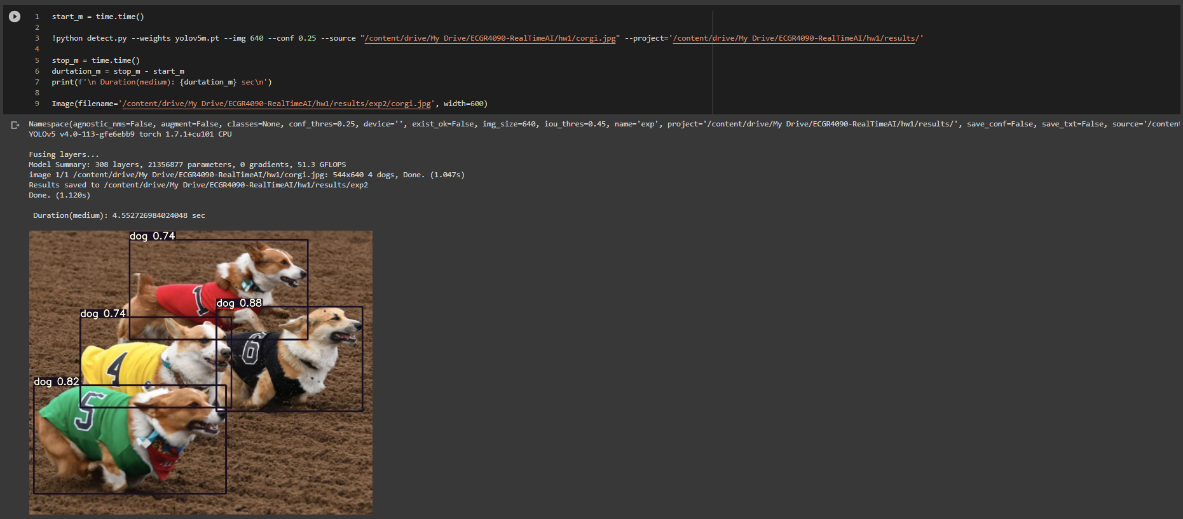

Yolo v5 large
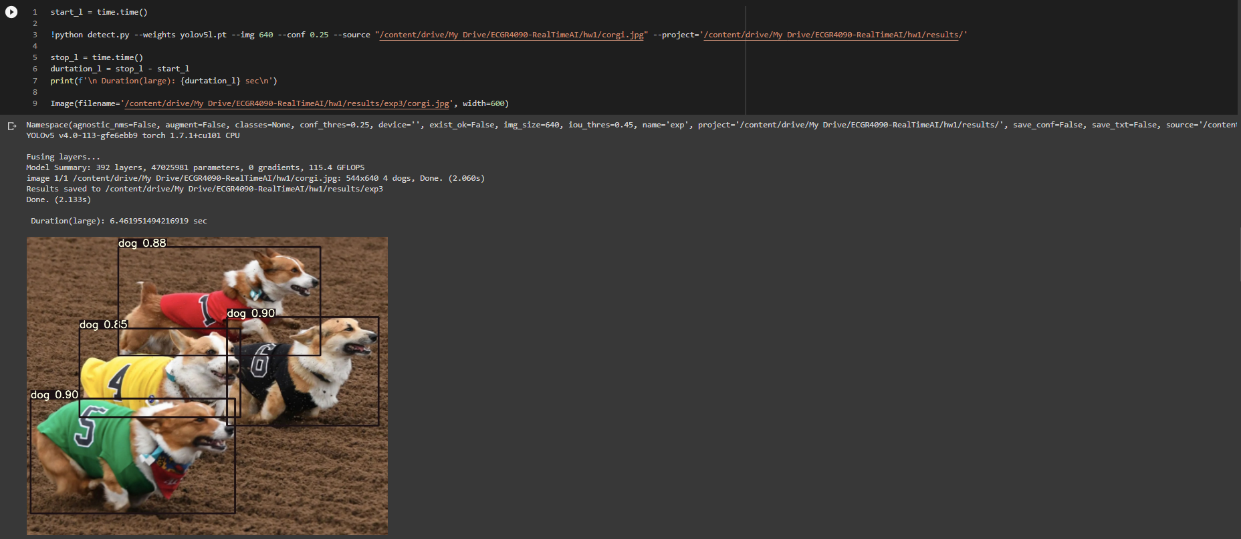

Yolo v5 extra large
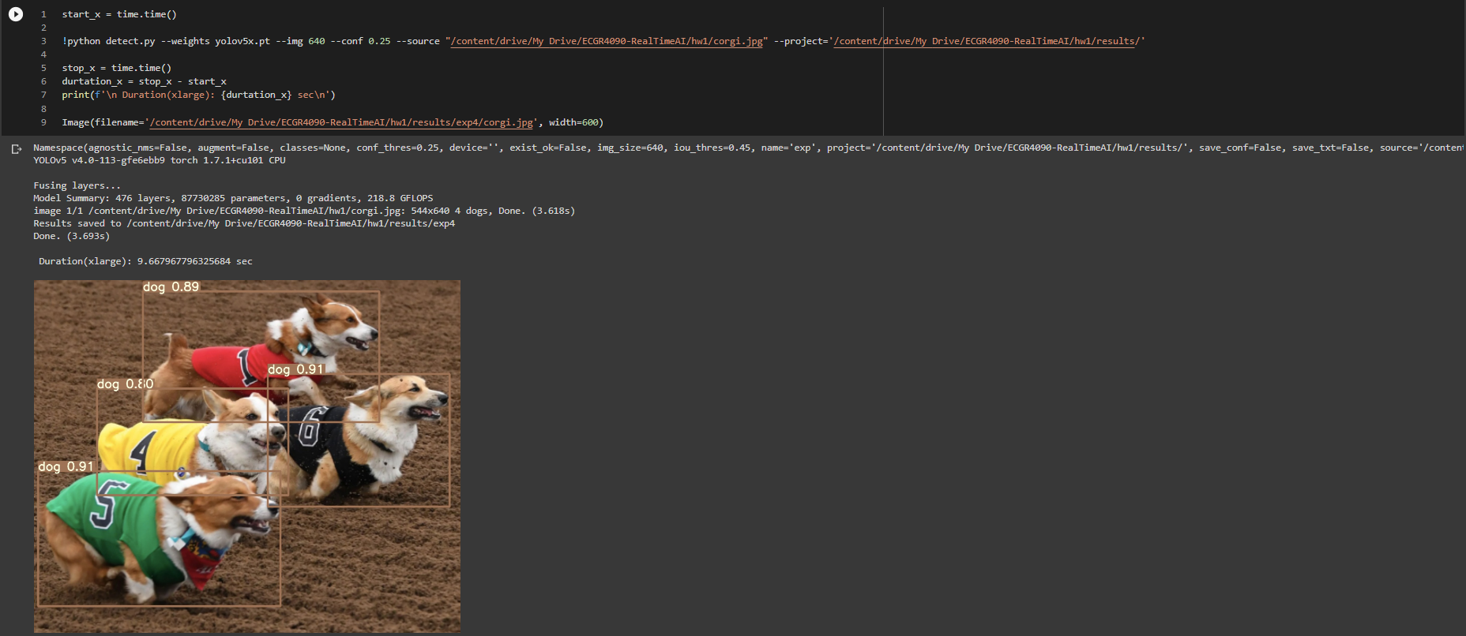

Summary
The predication gets more and more accurate after each size model changes. Example on the red number 1 corgi, from 76% to 89% of confident rate as identify as “dog”. The downside will be because of increase amount of model size, duration time also increased from 3.63 sec to 9.66 sec.

Another example of NYC intersection street view:
Yolo v5 small Yolo v5 medium
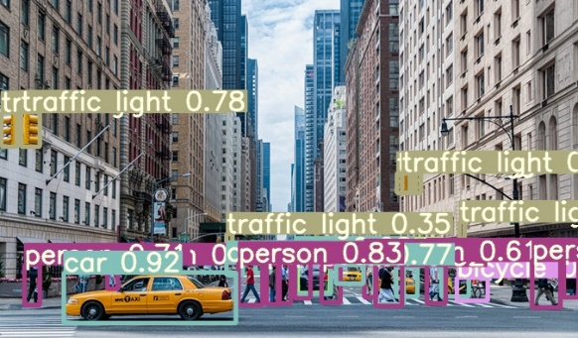
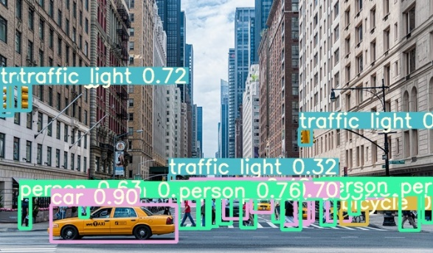

Yolo v5 large Yolo v5 extra large
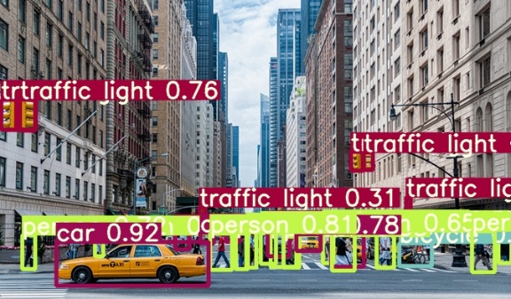
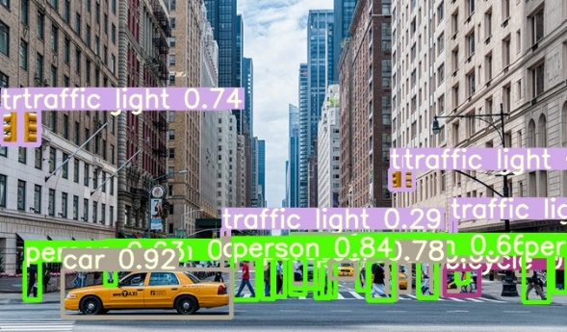

The same result as above corgi pictures, the confidence level increase. Because the example image above has a lot of objects in single image, it took much larger time for program to identify the objects in the images.

Problem 2 Yolo v5 on Jetson Nano 2GB
Using 4 different pretrained size yolo models on Jetson Nano
I was not able to run none of extra larger size model on jetson Nano 2GB, it always killed itself after running out of resource.
There are some examples of result in single batch:
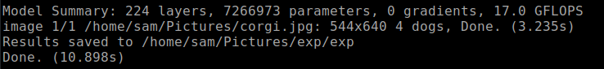
Single batch in small size

Single batch in medium size

Single batch in large size

Tabulated Results:
(all unit in second) | Small | Medium | Large | Extra Large
Single batch | 3.235 | 1.683 | 2.568 | DNF
4 batches | 2.630 | 3.438 | 9.137 | DNF
8 batches | 4.762 | 8.399 | 11.527 | DNF
16 batches | 5.238 | 9.379 | 45.714 | DNF
DNF = Did not finish
As above can show the time different between batches size and model size. When either batch or model size increase, it takes longer time to finish object detections. I also found it is interesting that time different between each image is not determine how many objects in the image, but it depends on the confident level of object in a single image.

Problem 2 Yolo v5 on Jetson Nano 2GB Real time camera detection
Demo video link: https://youtu.be/raz6AccXkZc
GitHub code: https://github.com/ric3b0wl/ECGR4090-RealTimeAI/blob/main/hw1/detect_jetcam.py
import torch
from PIL import Image
from matplotlib import cm
from jetcam.usb_camera import USBCamera
from IPython.display import display
from jetcam.utils import bgr8_to_jpeg

model = torch.hub.load('ultralytics/yolov5', 'yolov5s', pretrained=True)

webcam = USBCamera(width=224, height=224, capture_width=640, capture_height=480, capture_device=0)

image = webcam.read()
# print(webcam.shape)
# print(webcam.value.shape)

webcam.running = True

def update_image(change):
image = change['new']
im = Image.fromarray(image)
im.show()
result = model(image)
result.print()
im.close()

webcam.observe(update_image, names='value')

