We are going to use DynamoDB for our Social Insurance Number database.

Before we begin, double check that you are in the “North Virginia” region. Look in the top right corner of the AWS console:

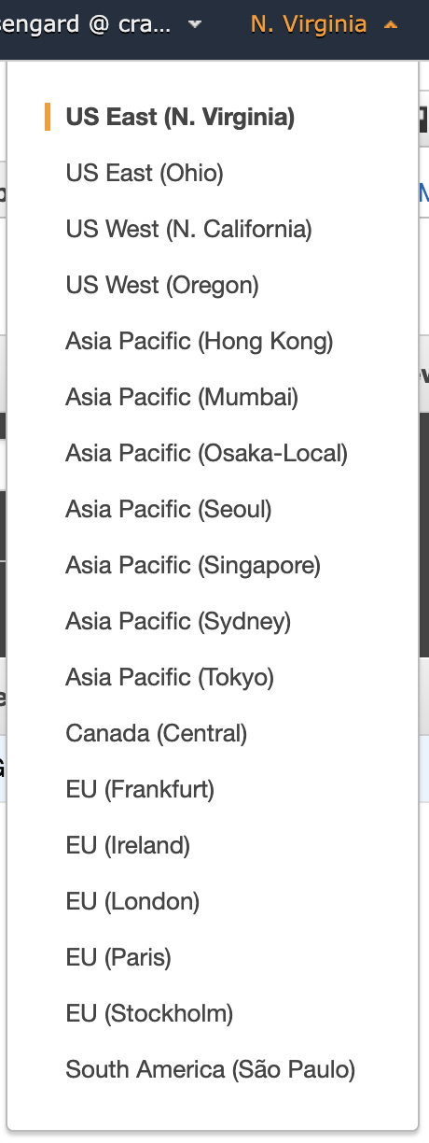

Go to Services, and type DynamoDB

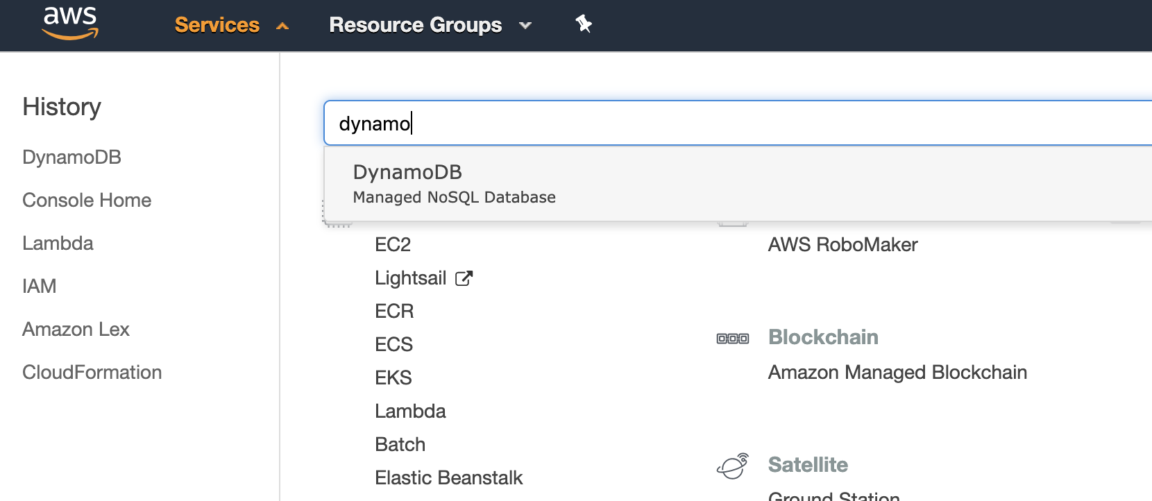

Go to Create Table

Table Name: {Your Initials}-Users [e.g. RP-Users]

Primary Key: sin {number}

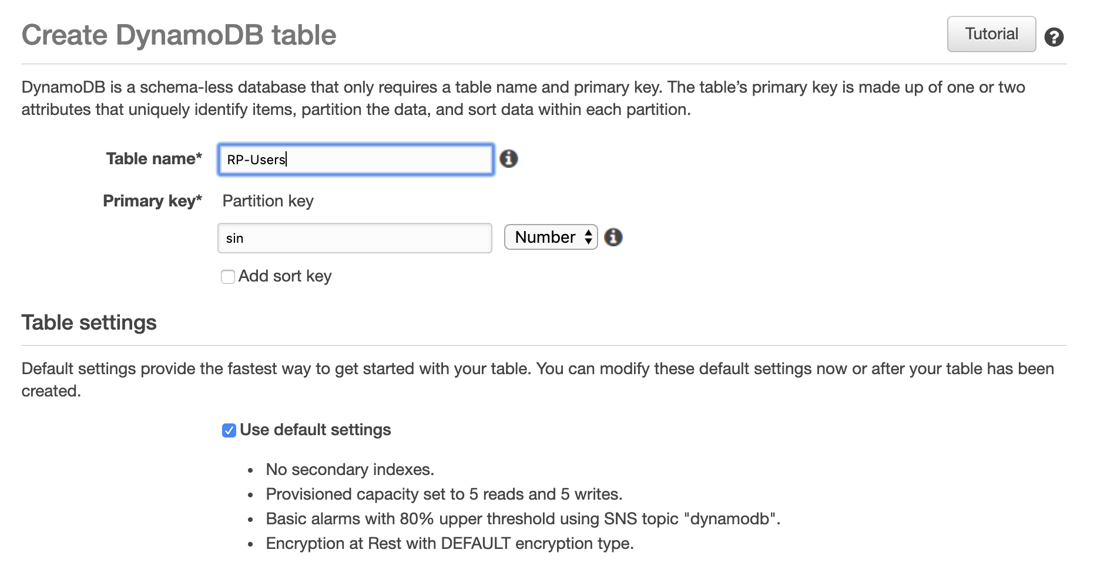

After a minute, your table will be created.

Go to Items

Click Create Item

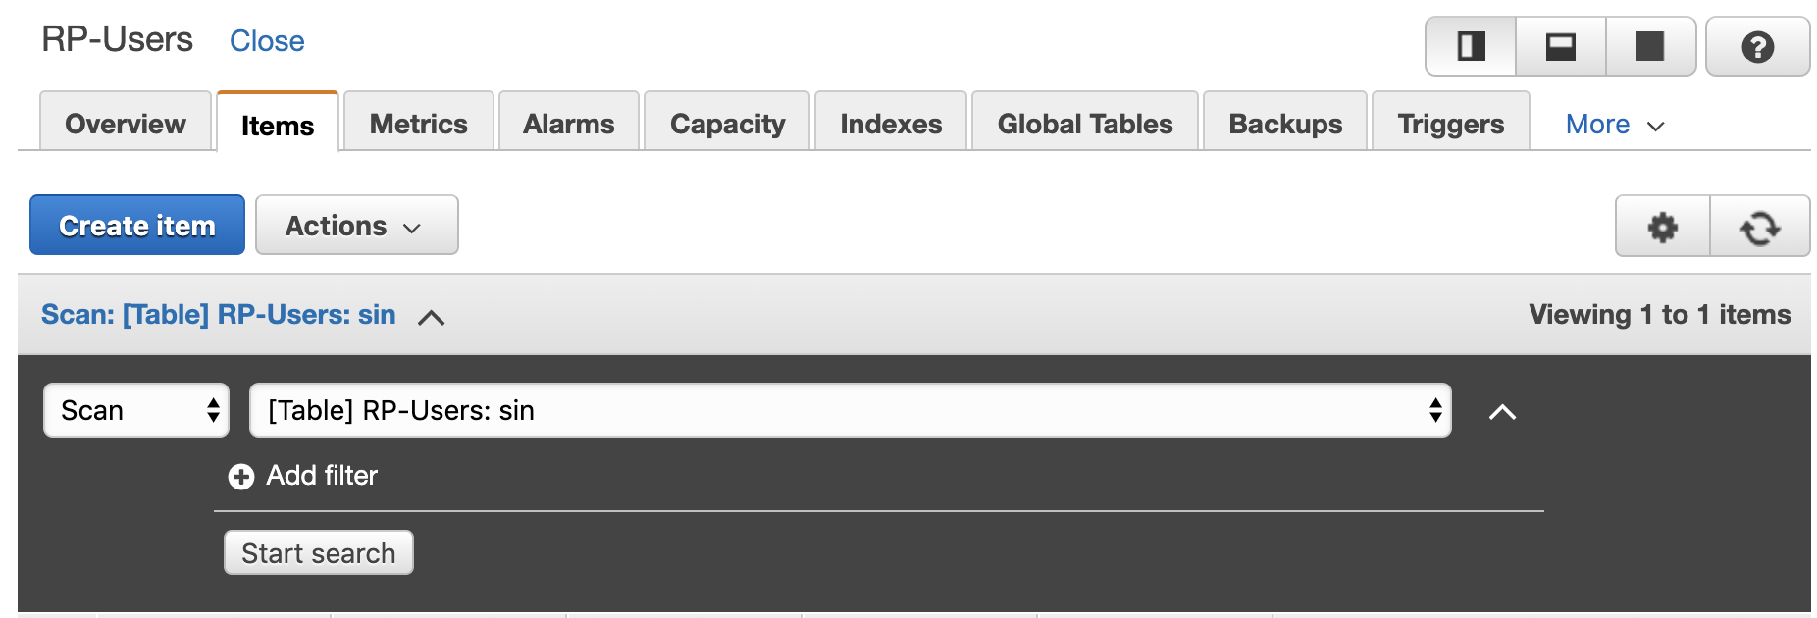

Keep clicking the “+” to add a new row.

Add “address” as a string

Add “city” as a string

Add “postal” as a string

Add “province” as a string

Click Save when done.

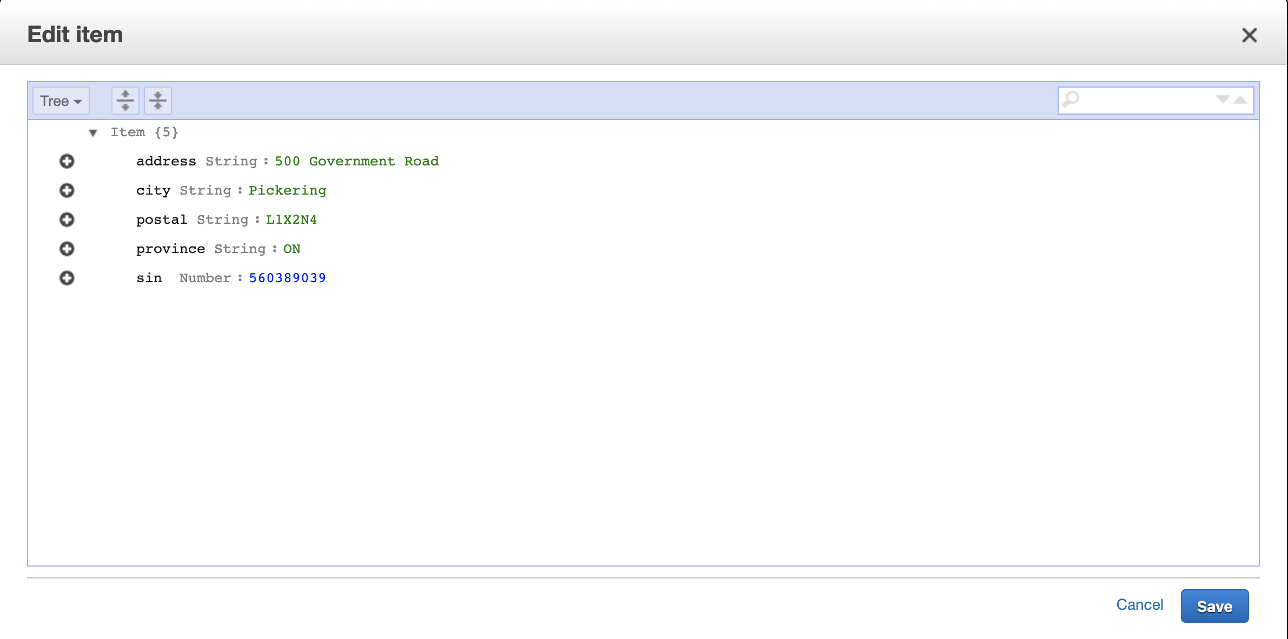

You should now see this:

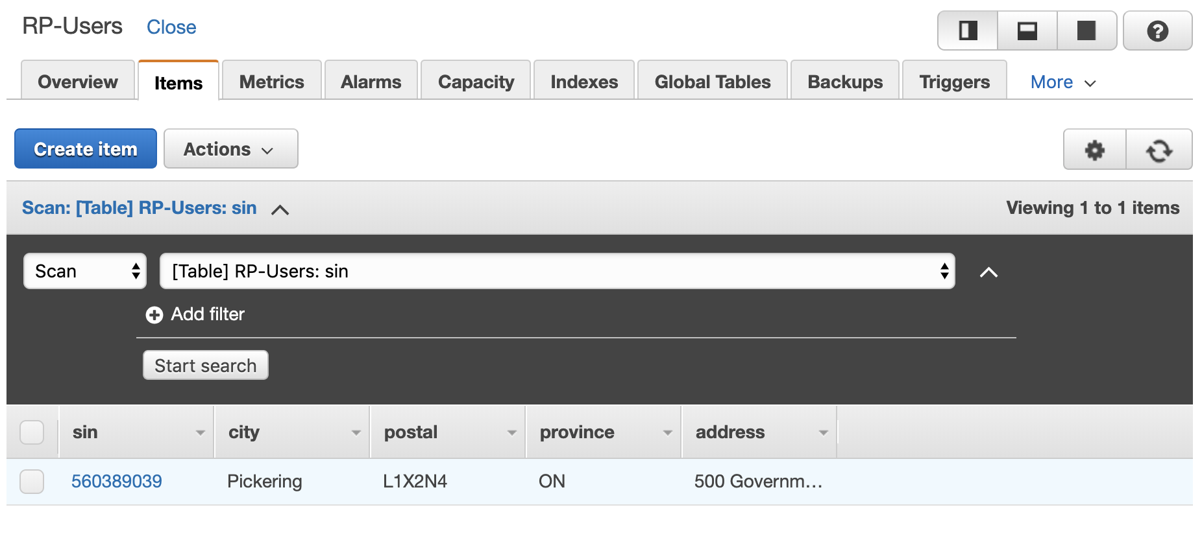

We now have our first Canadian resident stored in DynamoDB!