# Launch Stack

Visit this link:

<https://console.aws.amazon.com/cloudformation/home?region=us-east-1#/stacks/new?stackName=QnABot&templateURL=http://s3.amazonaws.com/aws-bigdata-blog/artifacts/aws-ai-qna-bot/templates/public.json>

It will open a CloudFormation page that looks like this:

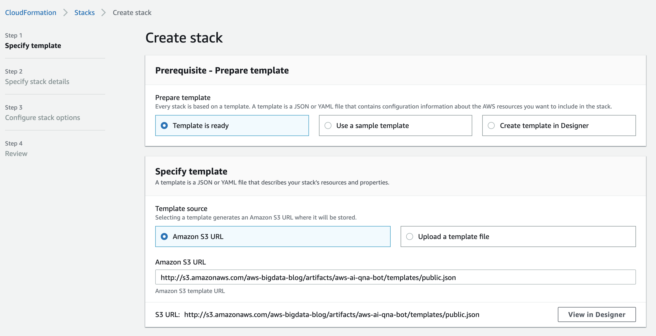

Scroll down and click “Next”

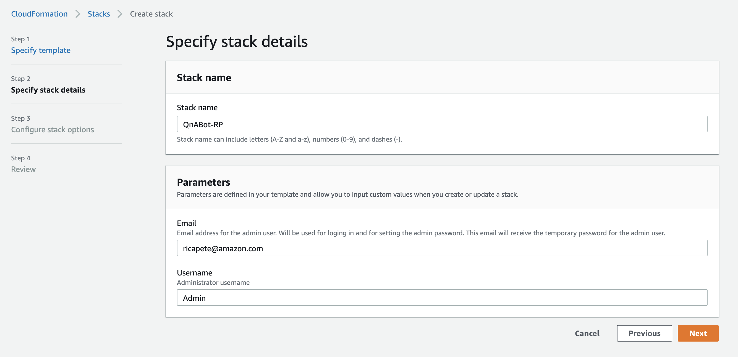

Stack Name: QnABot-{Your Initials}

E.g. QnABot-RP

Email: Enter a real email here! It sends your automatically generated password to this email.

Username: Leave as Admin, or change to anything you wish.

Click “next”.

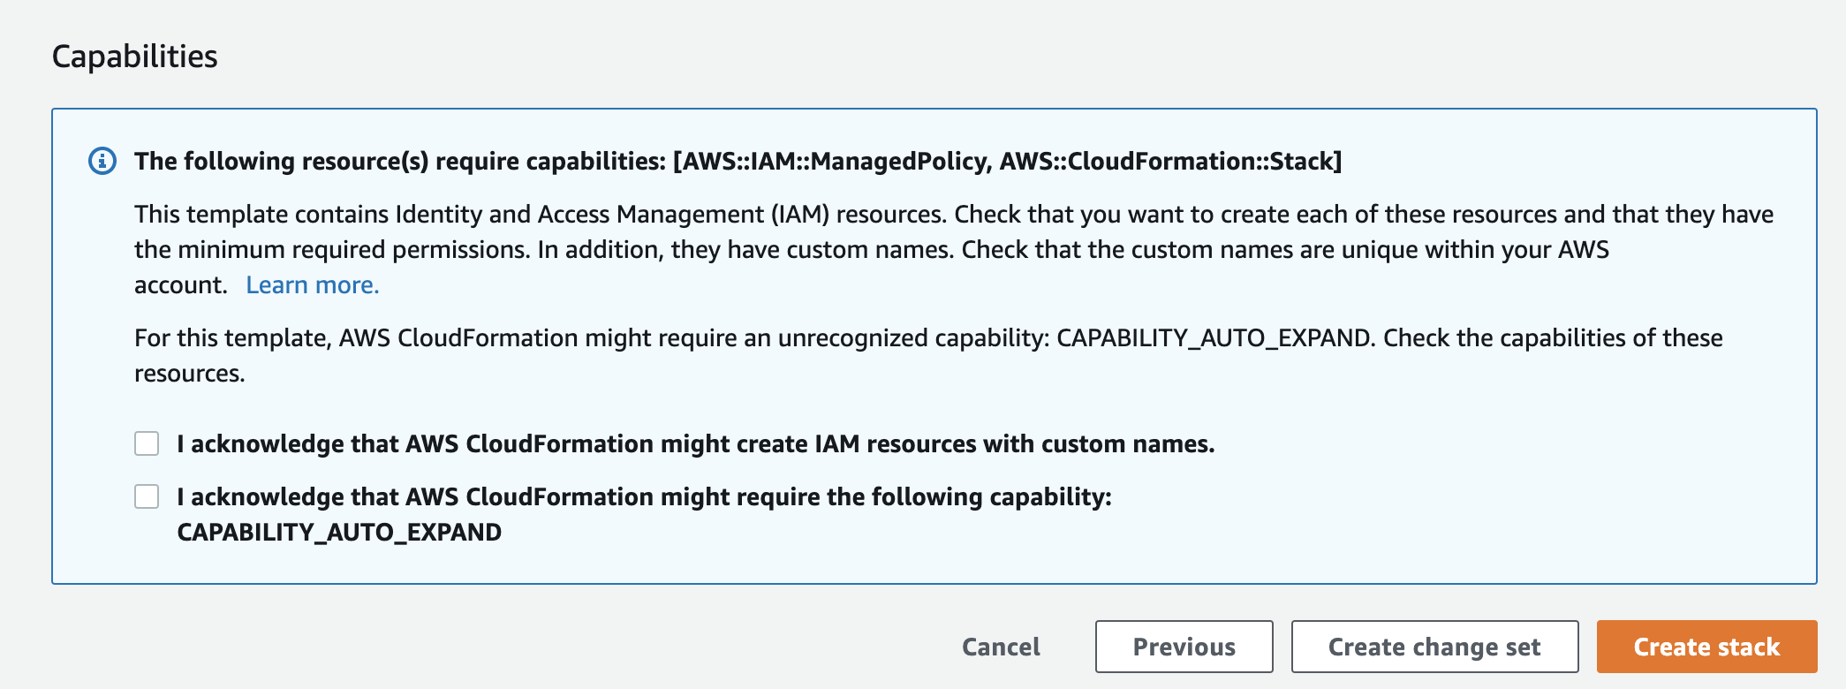

Enable both checkboxes near the bottom of the page. Then click “Create stack”.

This will take roughly ~30 minutes for stack creation to complete!

After ~30 minutes, you will receive an email containing your password and a link to the Dashboard:

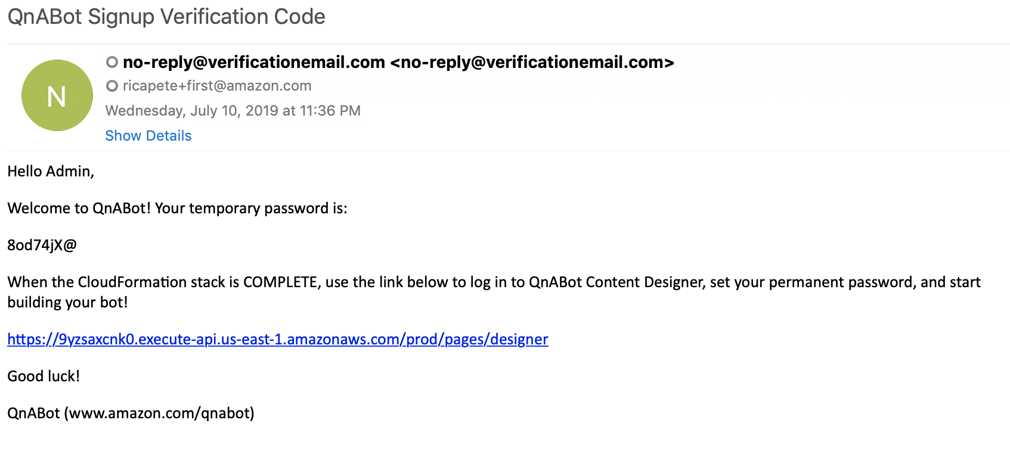

Copy the password, and then click the link in that email.

## Creating initial content in QnABot

You need to load some question and answer data using the Content Designer, before turning QnABot over to your users. Your data is stored in Amazon ES behind the scenes. This way, the data can be searched later when users ask questions using either an Amazon Lex client UI or an Alexa hands-free device. The steps that follow show you how to load sample questions used to illustrate the features of the QnABot. You can easily substitute your own content later.

1. In the CloudFormation console, launch the Content Designer webpage using the **ContentDesignerURL** link from the Outputs tab of the master CloudFormation stack or use the link in your email.  
   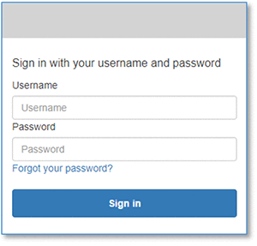
2. Log in with the administrator username you provided when you launched the stack (default: ‘Admin’), and your new password.  
   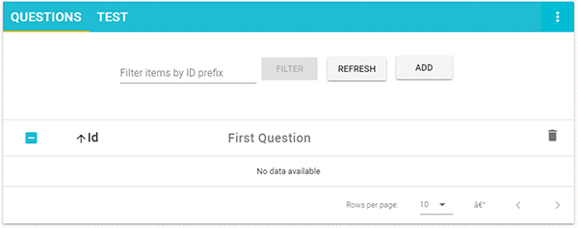
3. Choose **Add**.  
   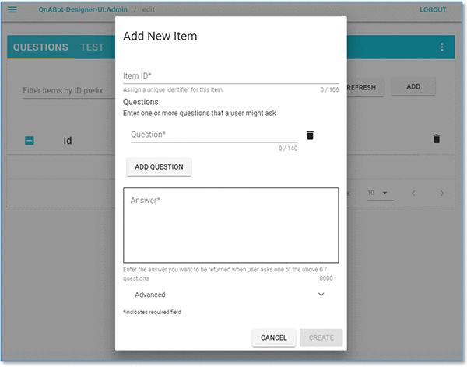
4. Enter the id: CRAGeneral.001  
   **NOTE:**Use a naming convention to identify your items within categories.
5. Enter the question: What is the CRA
6. Enter the answer: The Canada Revenue Agency (CRA) administers tax laws for the Government of Canada and for most provinces and territories, and administers various social and economic benefit and incentive programs delivered through the tax system.
7. Choose the **CREATE** button (bottom right of the card).
8. Repeat steps 3-7, entering the items from the table below.

|  |  |  |
| --- | --- | --- |
| Id | Question | Answer |
| CRAGeneral.002 | What is the role of the Board of Management | The Board of Management consists of 15 members appointed by the Governor in Council. Eleven of these members are nominated by the provinces and territories. The Board has the responsibility of overseeing the organization and management of the CRA, including the development of the Corporate Business Plan, and the management of policies related to resources, services, property and personnel. |
| CRAAbout.001 | What is the mission | To administer tax, benefits, and related programs, and to ensure compliance on behalf of governments across Canada, thereby contributing to the ongoing economic and social well-being of Canadians. |
| CRAAbout.002 | What is the vision | The CRA is the model for trusted tax and benefit administration, providing unparalleled service and value to its clients, and offering its employees outstanding career opportunities. |
| CRAAbout.003 | What is the promise | Contributing to the well-being of Canadians and the efficiency of government by delivering world-class tax and benefit administration that is responsive, effective, and trusted. |
| CRAAbout.004 | What are the values | Integrity is the foundation of our administration. It means treating people fairly and applying the law fairly.  Professionalism is the key to success in achieving our mission. It means being committed to the highest standards of achievement.  Respect is the basis for our dealings with employees, colleagues, and clients. It means being sensitive and responsive to the rights of individuals.  Collaboration is the foundation for meeting the challenges of the future. It means building partnerships and working together toward common goals. |

## Getting answers using a Lex Web Client UI

You can launch QnABot from a Chrome, Firefox, or Microsoft Edge browser on your PC, Mac, Chromebook, or Android tablet.

1. On the [CloudFormation console](https://console.aws.amazon.com/cloudformation/home?region=us-east-1#/stacks?filter=active), select the main QnABot stack, choose **Output**, and then choose the link to the **ClientURL**. Alternatively, launch the client by choosing **QnABot Client** from the Content Designer tools menu ( **☰**).
2. When your browser requests access to the microphone on behalf of the web application, allow it. You’ll see the QnABot chat window:  
   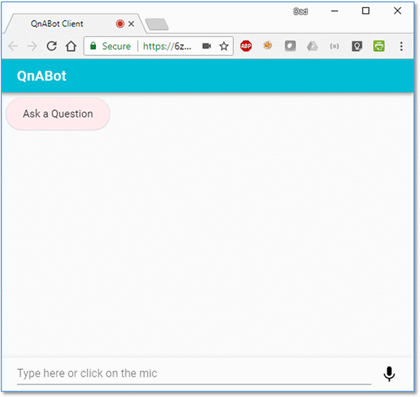  
   You can interact with QnABot using either text chat or voice.
3. Try it! Choose the microphone icon (bottom right) and say, “What is the CRA?”  
   The bot will respond with the answer you previously entered for this question.

**Adding Images to your answers**

You can easily augment your answers with image attachments that can be displayed on a user’s Lex Web Client UI, Amazon Alexa smartphone app, or new Amazon Echo Show device touch screen. Use images to display maps, diagrams, or photographs to depict places and products relevant to the question.

1. Log in to the Content Designer, and choose Add
2. Enter ID: *CRAEmployee.001*
3. Enter question: *Who is the Minister of National Revenue*
4. Enter answer: *The Honourable Diane Lebouthillier. As the former elected warden for the Regional County Municipality of Rocher Percé and owner of La Ferme du Petit Moulin, an outfitting operation, Minister Lebouthillier is profoundly familiar with the reality, strengths, and issues of Gaspésie–Les Îles-de-la-Madeleine.*
5. Enter attachment:
   1. Card Title: *Honourable Diane Lebouthillier*
   2. Card Image Url: <https://www.canada.ca/content/canadasite/en/revenue-agency/corporate/about-canada-revenue-agency-cra/minister-national-revenue/_jcr_content/par/div_0_2/col_2/img_0_1/image.img.jpg/1499886256333.jpg> Choose CREATE to save the new item.
6. Use the Web UI to ask: “*Who is the Minister of National Revenue*?”  
   You’ll see the photograph displayed in the web UI chat.  
   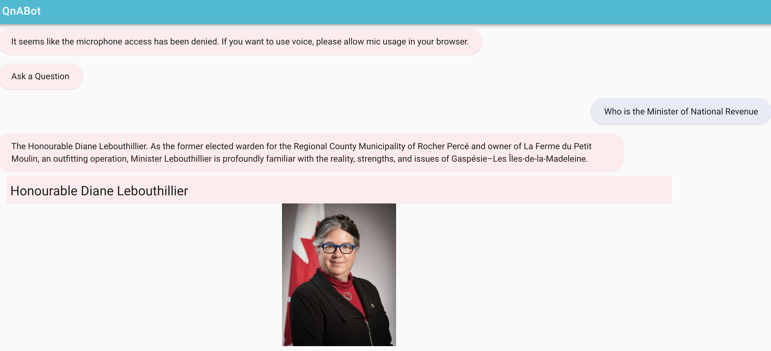

## Displaying rich text answers on the web UI

The latest version of QnABot supports [Markdown](https://daringfireball.net/projects/markdown/syntax), allowing you to create beautiful rich text versions of your answers for displaying on the Web UI client. To use this feature, populate the ‘Alternate Markdown answer’ field in Content Designer.

In Content Designer, edit item CRAAbout.003 (“What is the promise”). Open the **Advanced** section and enter the following text in the Markdown Answer field:  
# Our PromiseContributing to the well-being of Canadians and the efficiency of government by delivering world-class tax and benefit administration that is responsive, effective, and trusted. More information can be found [on the homepage]( <https://www.canada.ca/en/revenue-agency.html>) and [About Page]( https://www.canada.ca/en/revenue-agency/corporate/about-canada-revenue-agency-cra.html) to provide a natural language interface for your FAQ knowledge base.Now your users can just ask a *question* and get a quick and relevant *answer*.

1. Choose **UPDATE** to save the modification:
2. Use the Web UI to ask: “What is the promise?”.  
   You will see that the answer now displays the heading, links, and emphasis specified in your Markdown text.
3. QnABot also supports inline HTML in the Markdown field. This is very powerful, and allows you to do cool things, like including video clips in your answers. Let’s try it – choose **ADD** to create a new item:
   1. Enter ID: CRATax.001
   2. Enter question: Can I file my taxes online?
   3. Enter answer: *Filing your tax return online is fast, easy, and secure. Learn what you should have on hand to get started!*
   4. Enter Markdown answer:
   5. **File your tax online** You can file your taxes online completely free. Here’s how!

<iframe src="https://www.youtube.com/embed/-kNl9nKJDdM"></iframe>

* 1. Choose **CREATE** to save the item
  2. Use the Web UI to ask: “Can I file my taxes online?”.

### Monitoring QnABot Usage and User Feedback

The latest version of QnABot logs what users are saying to your bot. Behind the scenes, we use Amazon Kinesis Data Firehose to store logged utterances to a new index in the Amazon Elasticsearch service.

We have also added the ability to allow your users to provide feedback on QnABot’s answers. To enable the feedback feature:

1. Choose **Import** from the top left tools menu ( ☰ )
2. Open **Examples**/**Demos**, and choose the **LOAD** button for the **feedback** demo.  
   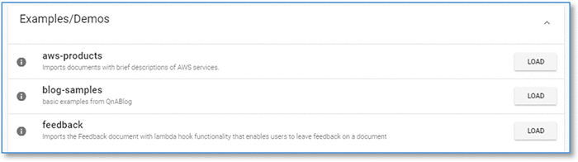
3. Choose **Edit** from the top left tools menu ( ☰ ), and open the new item ‘**Feedback**’. Observe the list of default expressions that the user can input to invoke feedback.

Now that you have enabled the feedback feature, try it:

1. Use the Web UI to ask a question, such as: “What happens if I ask an unanticipated question?”. Since we have not entered a suitable answer for this question, QnABot responds with the best match it can find, which, in this case is not very useful.
2. In the Web UI, say or type “feedback”. QnABot offers response options – enter ‘B’ to indicate that the answer was not useful.  
   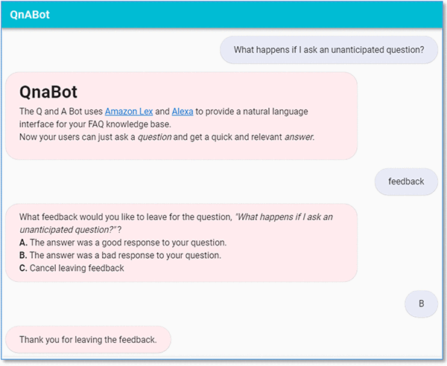

Visualize the usage logs and feedback using the new [Kibana](https://aws.amazon.com/elasticsearch-service/kibana/) dashboard. Note that it can take up to 5 minutes for new utterances and user feedback to become visible in the dashboard.

1. Choose Kibana Dashboard from the top left tools menu ( ☰ ). Kibana opens in a new browser tab, showing usage history (top), dashboard visualizations of the utterance log (middle), and the user feedback (bottom left and right).  
   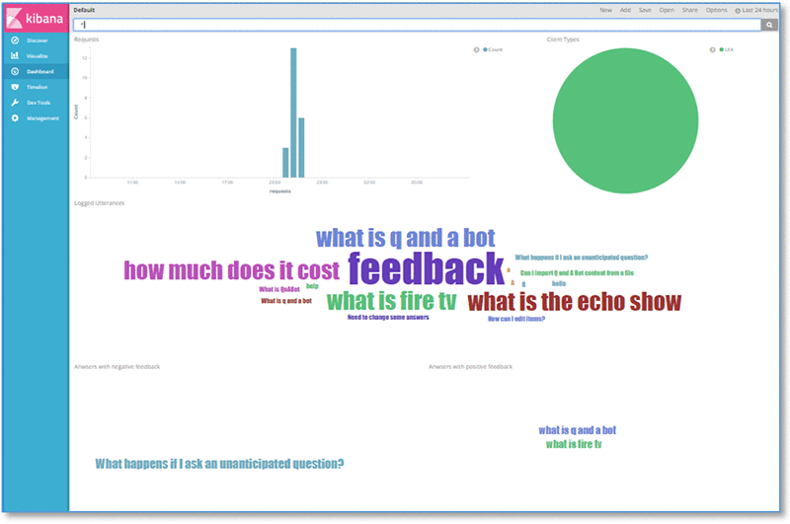
2. Use [Kibana](https://aws.amazon.com/elasticsearch-service/kibana/) to change the time span, customize and build your own visualizations, or to run your own queries.

### Using CloudWatch to monitor and troubleshoot AWS resources

QnABot metrics and logs are available using an Amazon CloudWatch dashboard.

1. Launch the dashboard using the **DashboardUrl** on the Outputs tab of the master CloudFormation stack.  
   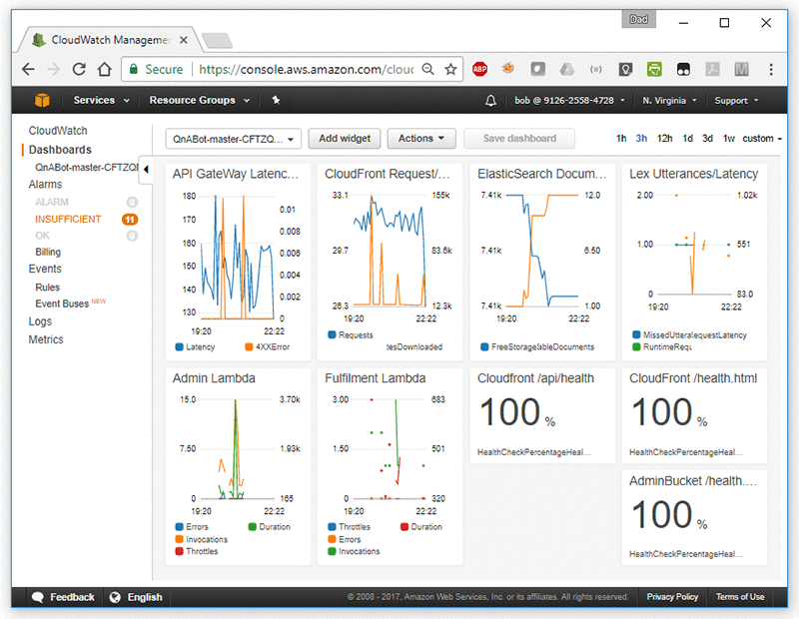
2. When troubleshooting QnABot responses to your questions, trace the request and response using the logs created by the Fulfilment Lambda function.
   1. Choose the **menu** tool in the upper right of the Fulfilment Lambda widget, choose **View logs**, and choose the **AWSLambda function.**  
      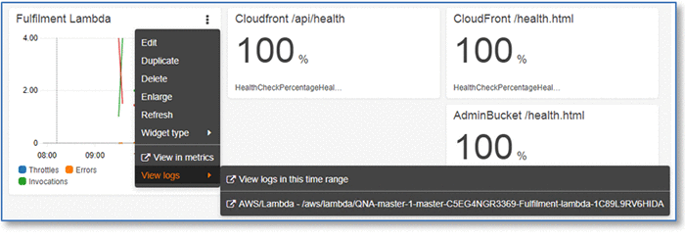
   2. Inspect the log messages. Each interaction with QnABot is delimited by START and END messages. Between these messages you’ll be able to find insights into how QnABot processes the question.  
      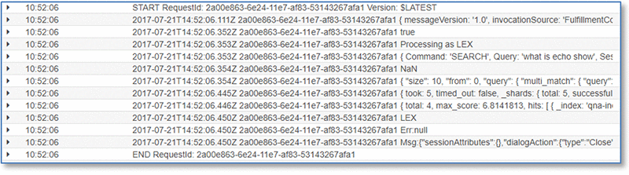

## Looking Under the Hood

Let’s take a quick look at how QnABot works. Here’s a diagram of the main architectural components and how they fit together at a high level.

