**Getting answers using Alexa**

QnABot also works with Alexa, allowing your users to get answers from your content via any Alexa enabled device, including Amazon FireTV, Amazon Dash Wand, and any of the Amazon Echo family of devices.

To enable Alexa, first create an Alexa skill for QnABot using the Amazon Developer Console. QnABot can’t automatically create the Alexa skill at this time, so we’ve provided instructions. Log in to the QnABot Content Designer (as explained earlier), and choose Alexa from the tools menu ( ☰ ):

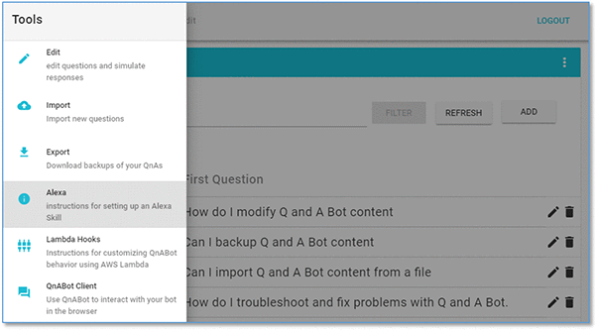

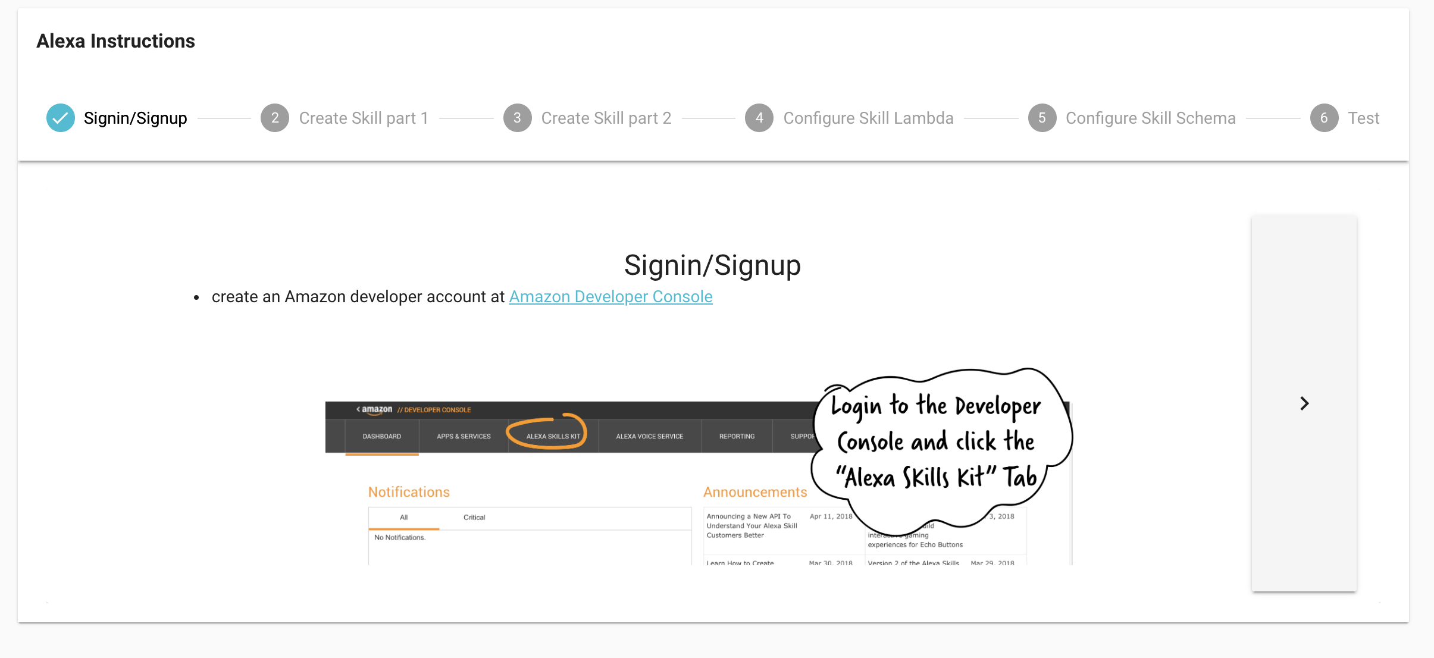

Follow the displayed instructions, step by step, to create an Alexa skill in your Amazon account. It will take you just a few minutes. You can test your new skill in the Amazon Developer Console, even if you don’t have an Alexa enabled device handy.

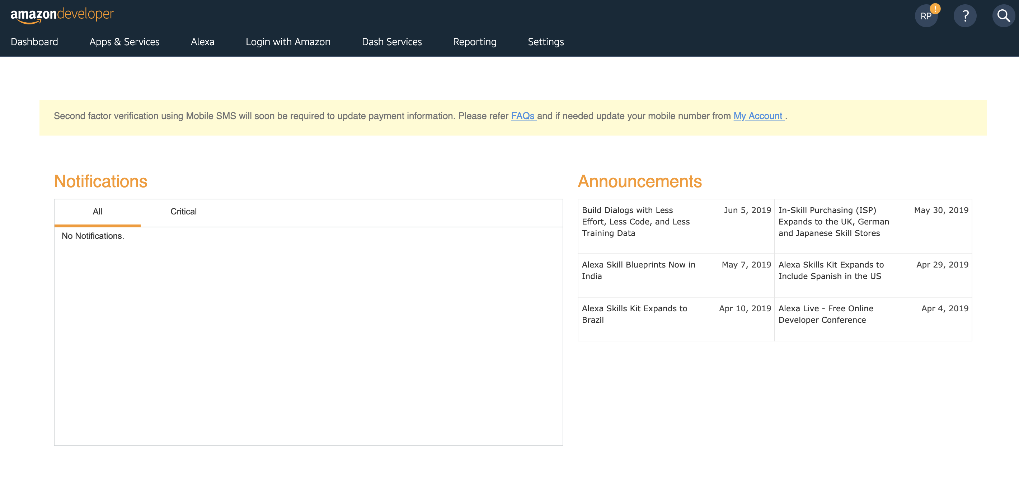

After registering and logging into Amazon Developer, Click “Alexa” at the top. Then select “Alexa Skills Kit”.

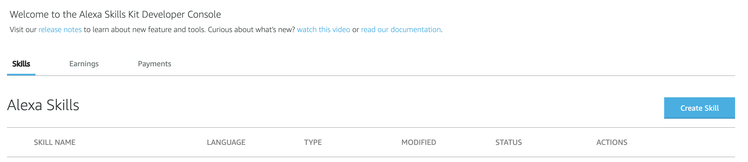

Click “Create Skill”

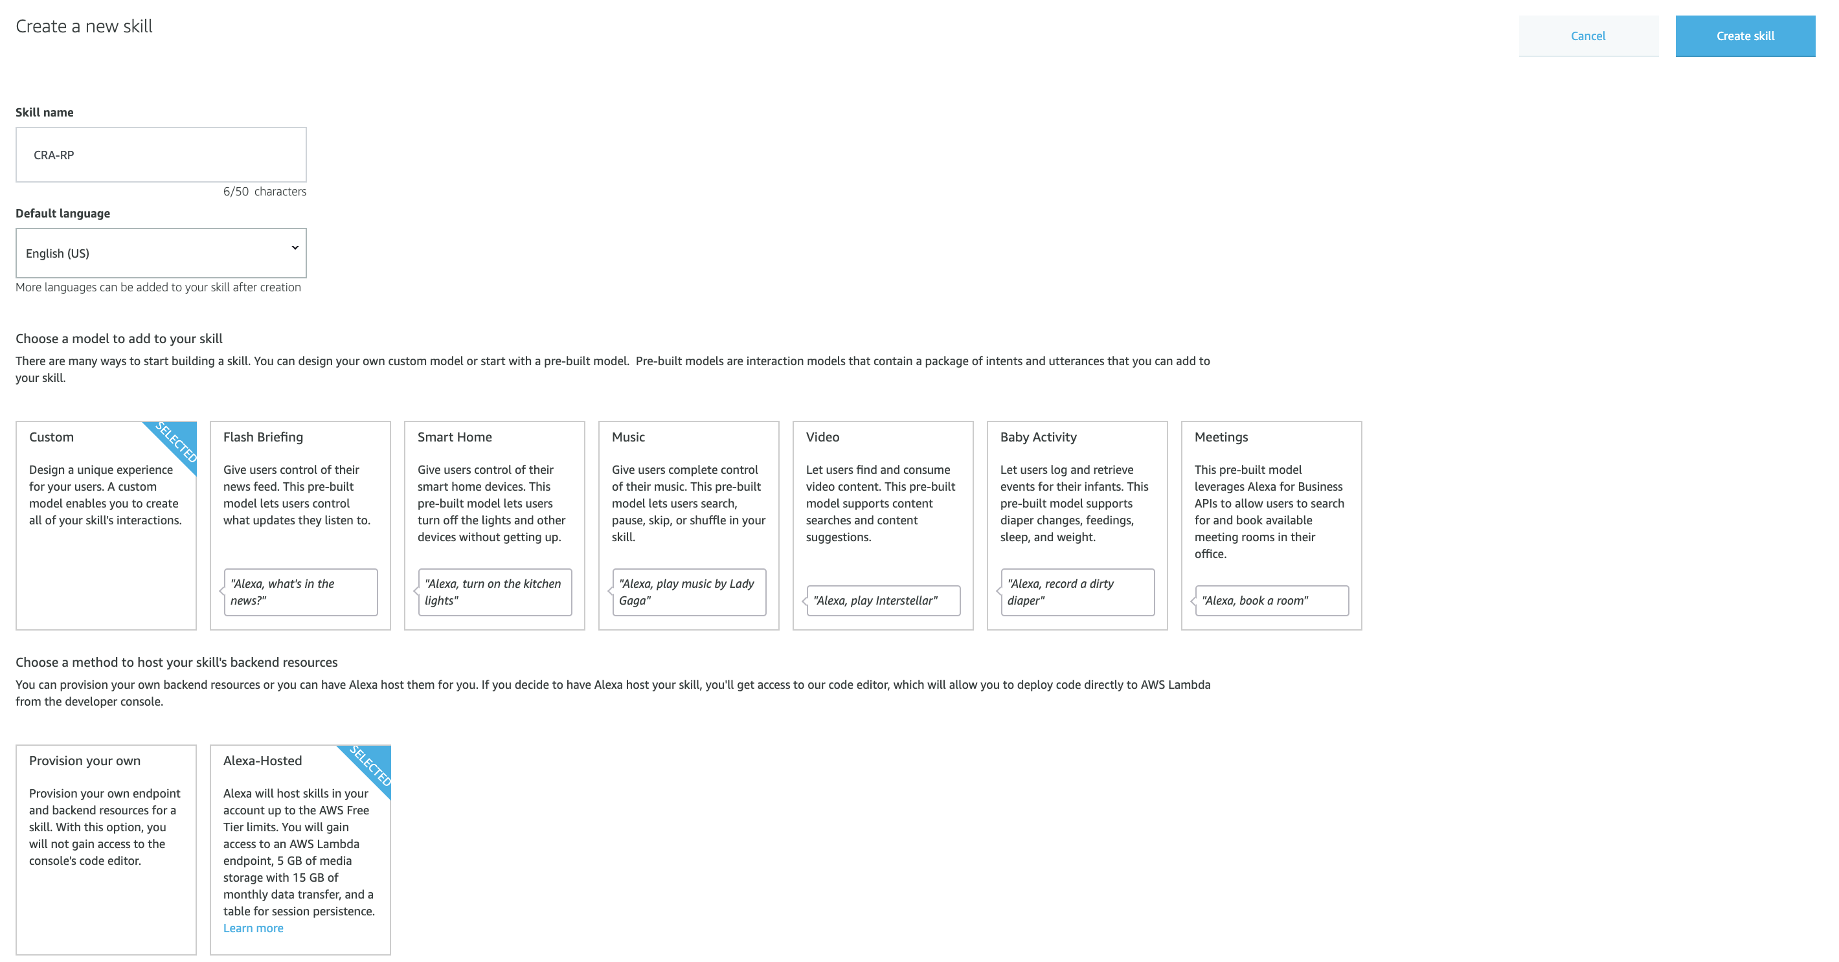

Skill name: CRA-{Your Initials}

E.g. CRA-RP

Choose a model to add to your skill: Custom

Choose a method to host your skill's backend resources: Alexa-Hosted

Then click “Create Skill”

Now go back to the QnA page, go to step 4 “Configure Skill Lambda”. Click the button “Copy Lambda ARN to clipboard”.

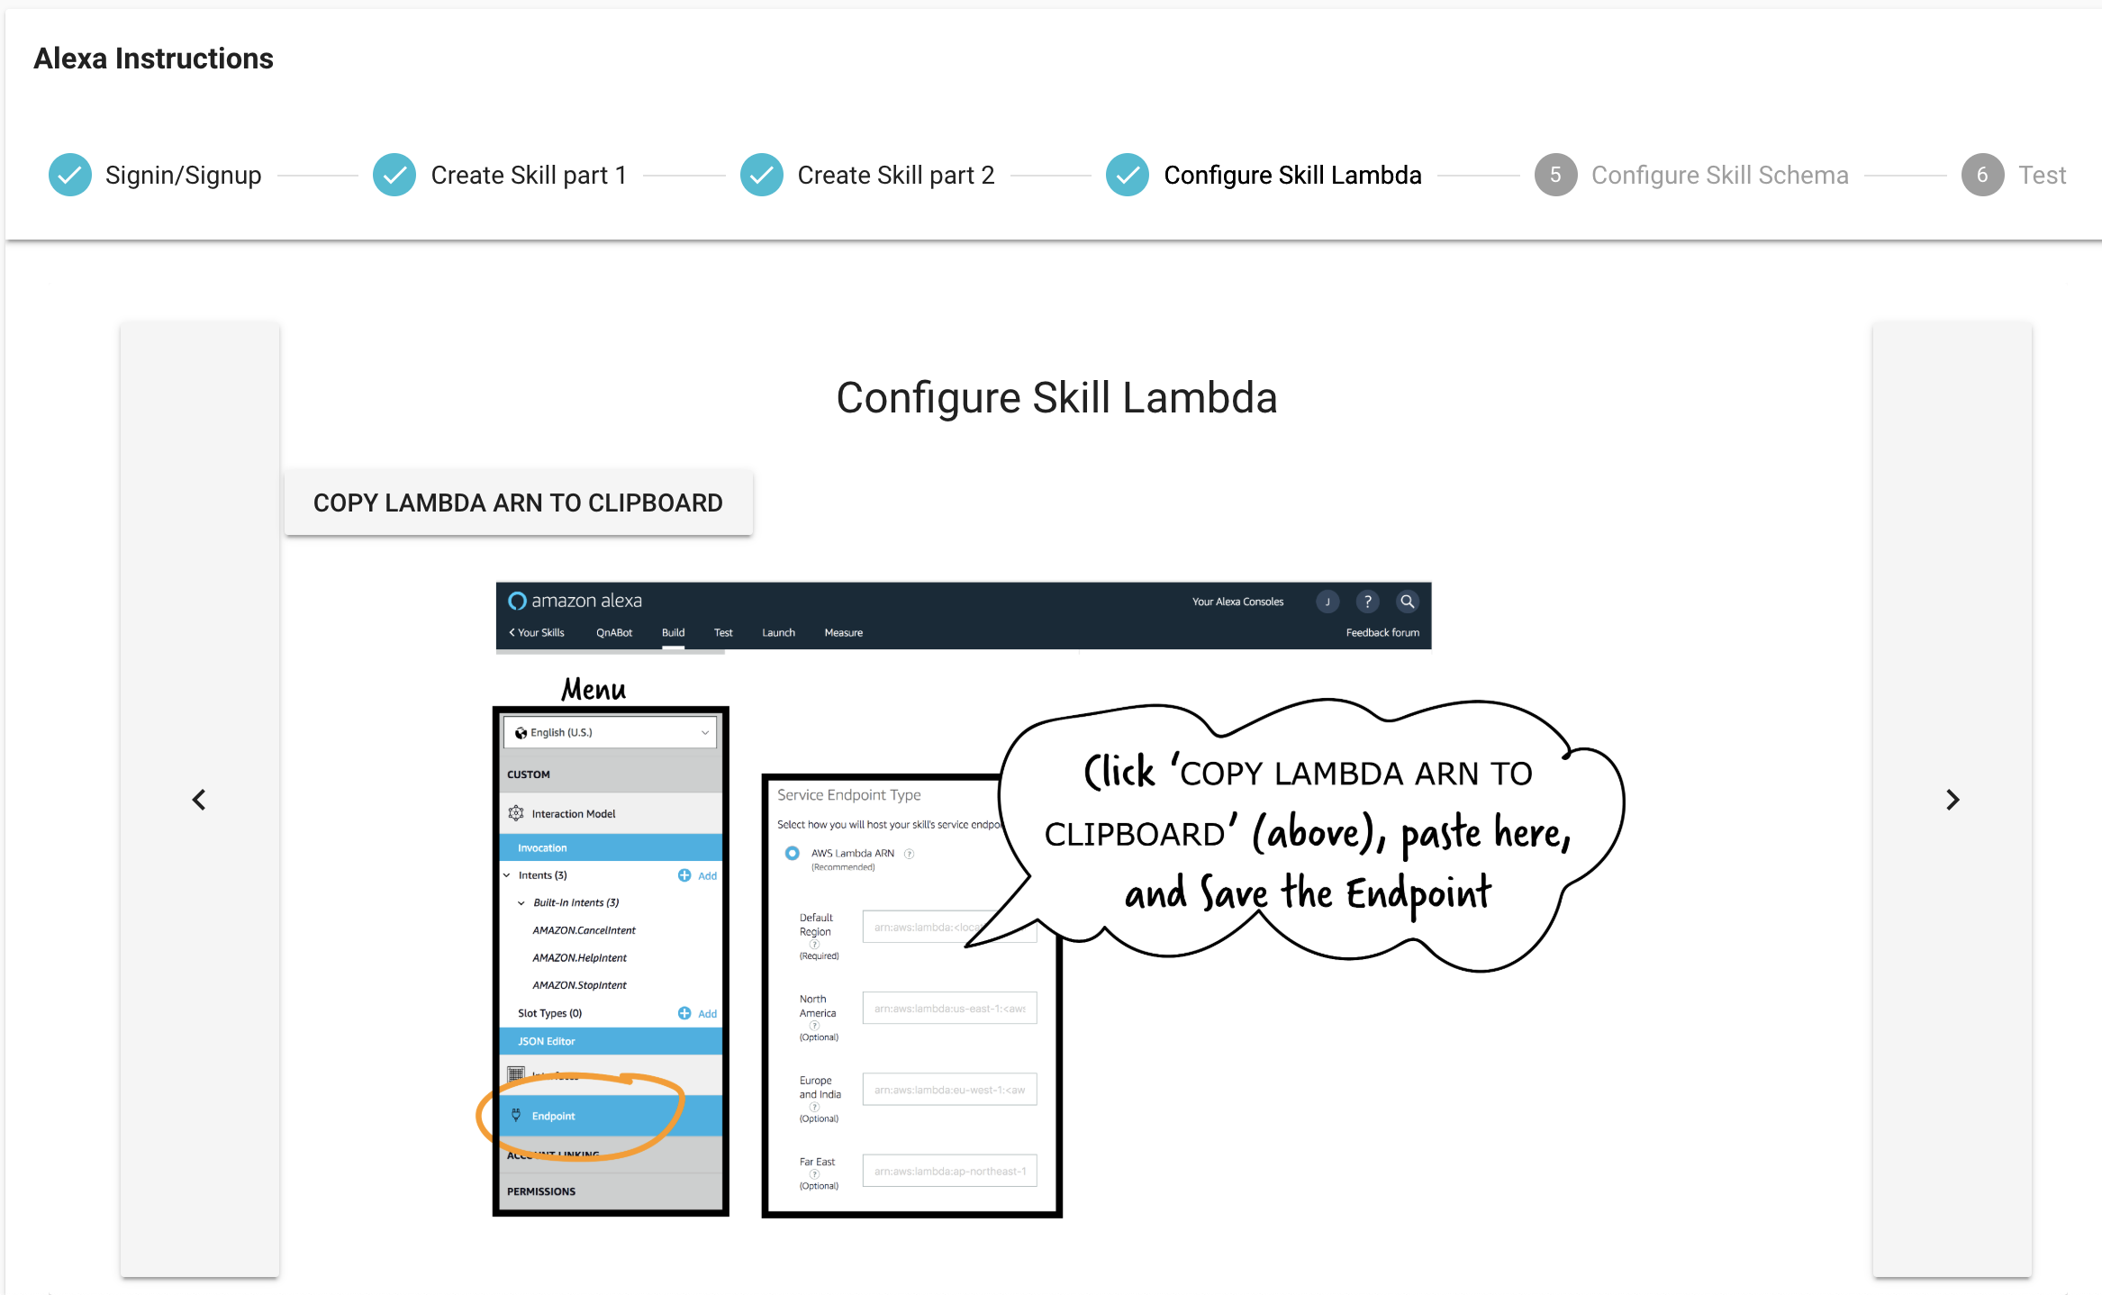

Now Select “Endpoint” on the left.

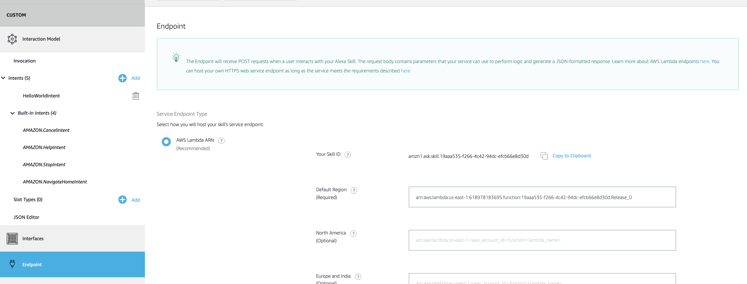

Paste the Lambda ARN in “Default Region”.

Then click “Save Endpoints”.

Now click “JSON Editor”:

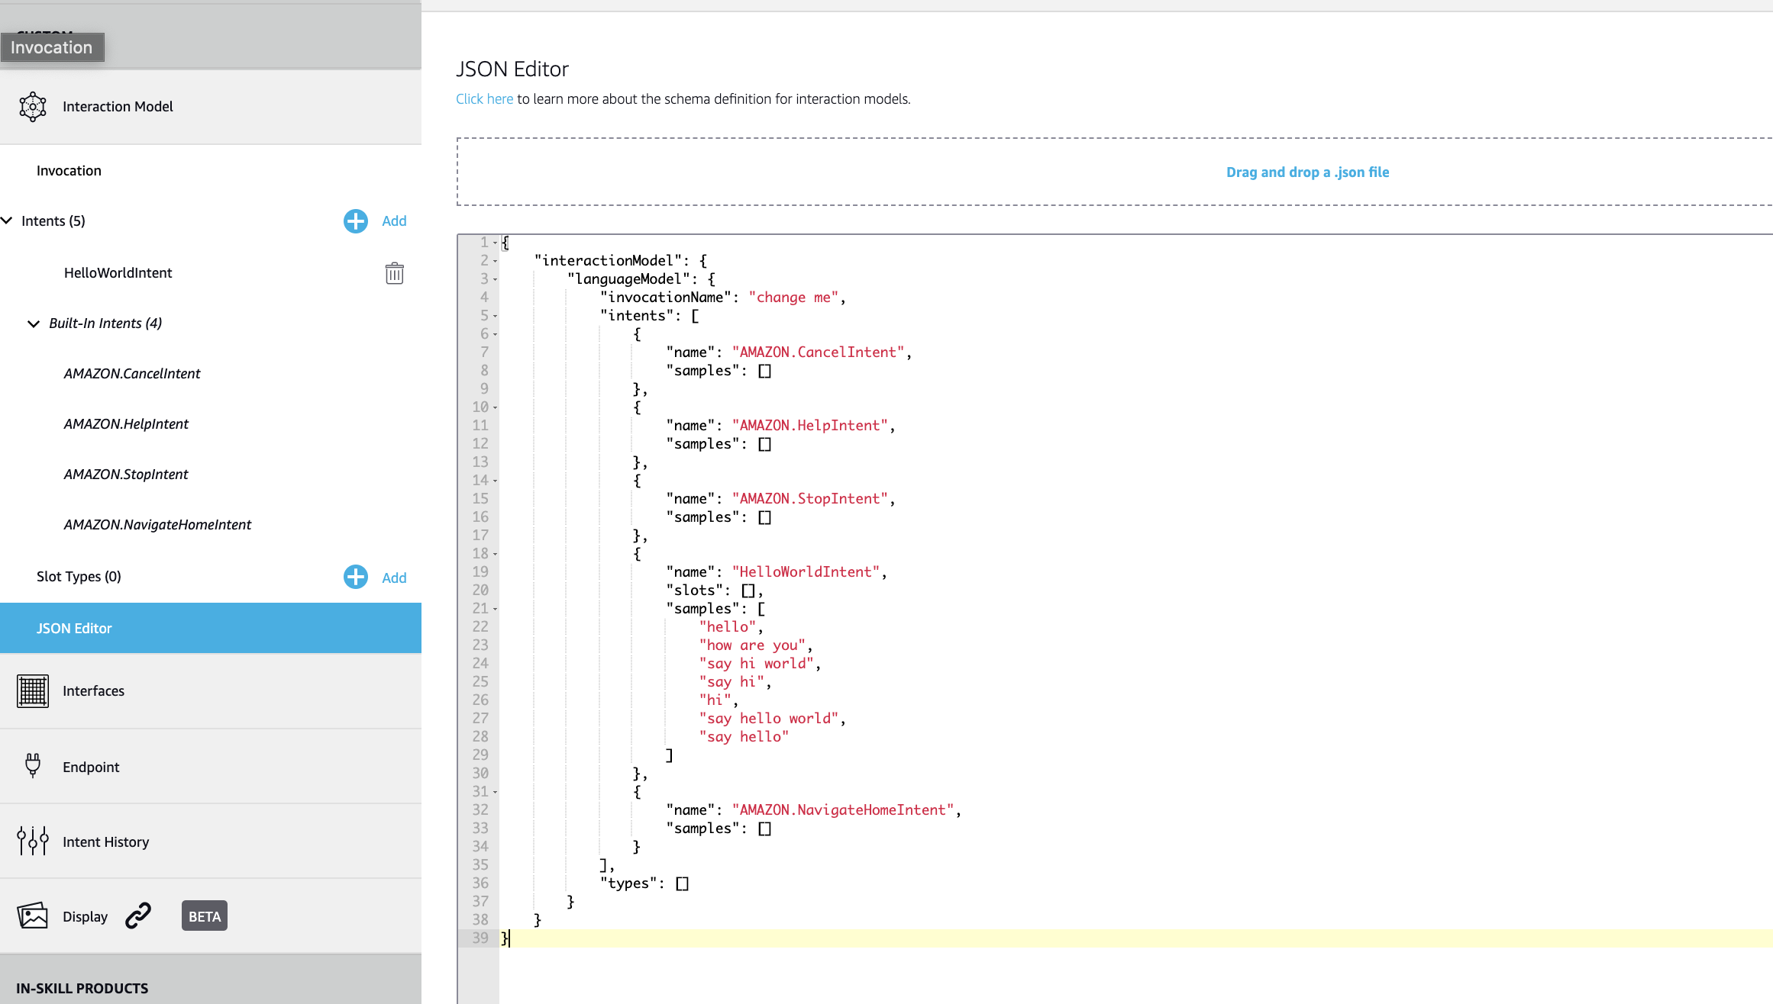

Now go back to QnA page, and go to Step 5: Configure Skill Schema

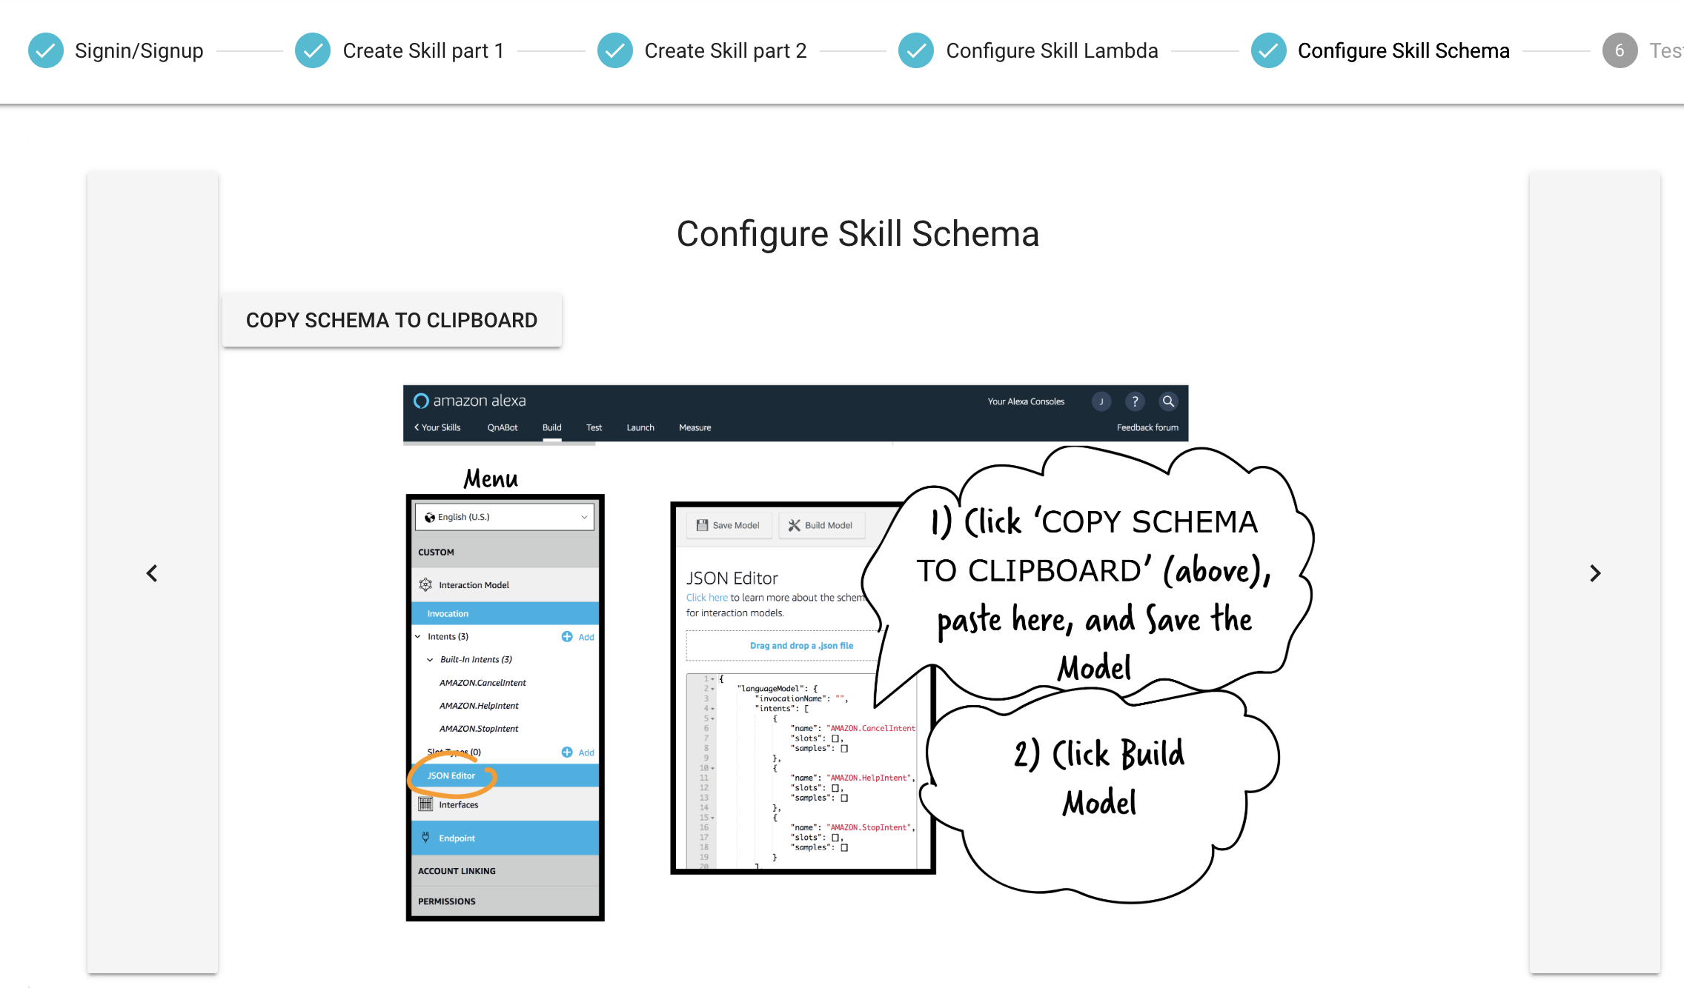

Click the button “Copy Schema to Clipboard”

Now paste it into the JSON Editor page on the Alexa site. Then click Save Model.

Now go to Invocation

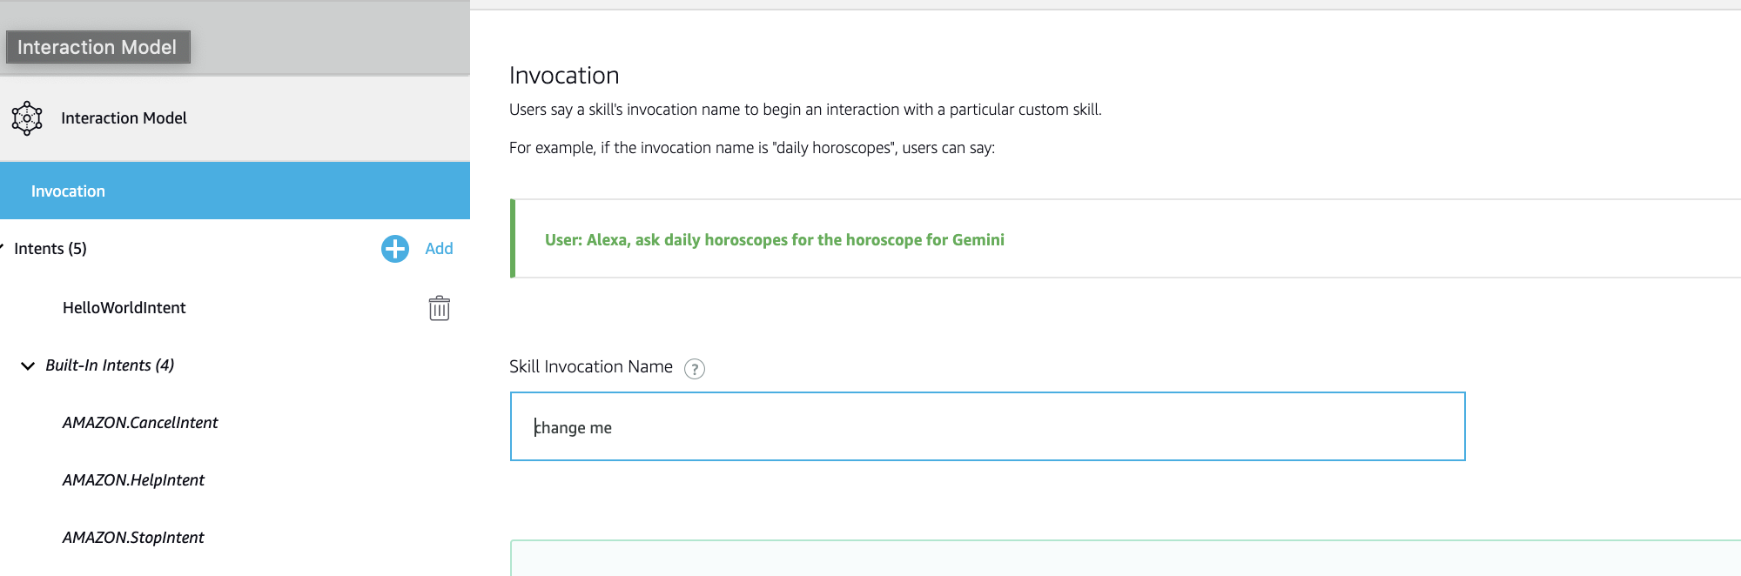

Change your Skill Invocation Name to “CRA”. Then click “Save Model”.

Now click “Test”

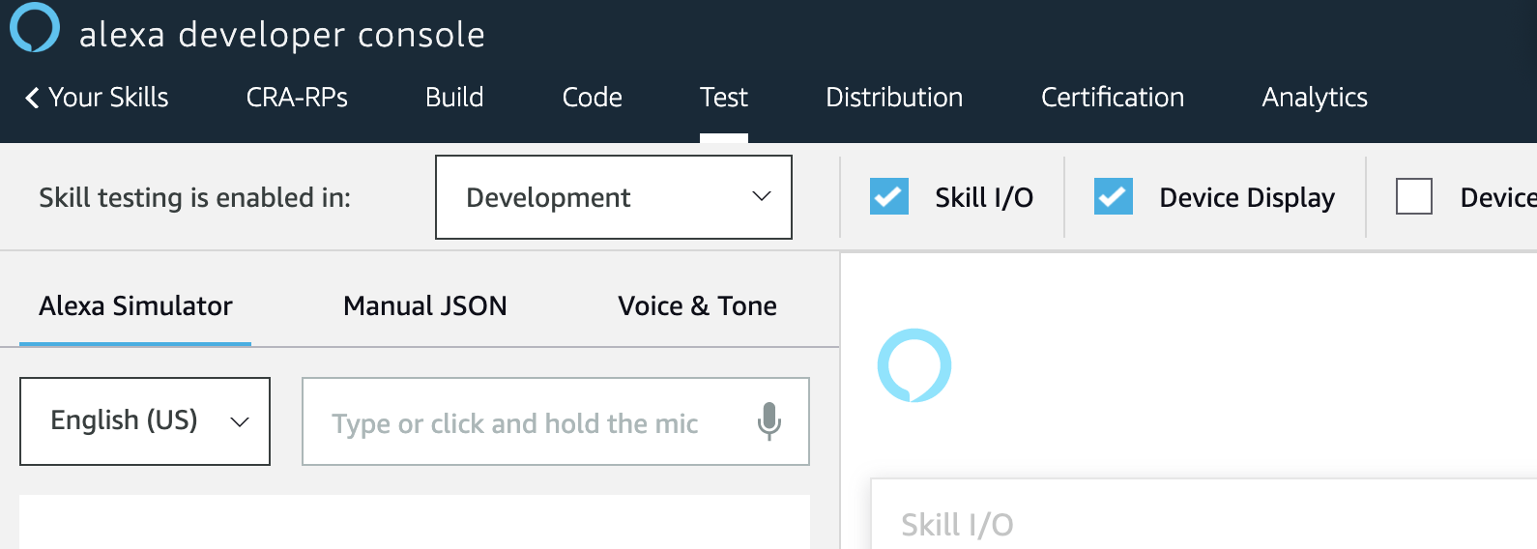

Enable skill testing, and choose “Development”.

Now to begin testing!

Enter: CRA or say “CRA” then press enter.

Now say “What is the cra”

If you want to publish your QnA skill to the Alexa skills store so other users can access it, see [Submitting an Alexa Skill for Certification](https://developer.amazon.com/public/solutions/alexa/alexa-skills-kit/docs/publishing-an-alexa-skill). Unpublished skills are accessible only to Alexa devices registered to your Amazon account, while published skills are available to anyone.