**Create a new Amazon Conect instance**

Go to the [Amazon Connect Console](https://console.aws.amazon.com/connect/home?region=us-east-1) to create a new virtual contact center instance in the us-east-1 (Virgina) region.

1. From the AWS Management Console, choose **Services** then select **Amazon Connect** under Contact Center and then **Get started**
2. In **Step 1: Identity management**, select **Store users within Amazon Connect** and provide a domain name (e.g. {FirstName} to complete the **Access URL** and click **Next step**

The domain name used in your contact center URL needs to be globally unique and cannot be changed. Alternatively, Amazon Connect can use an existing [AWS Directory Services](https://aws.amazon.com/directoryservice) directory.

1. In **Step 2: Administrator**, **Skip this** and continue with **Next step**
2. In **Step 3: Telephony options**, select **I want to handle incoming calls with Amazon Connect** and **I want to make outbound calls with Amazon Connect**
3. In **Step 4: Data storage**, accept the defaults
4. In **Step 5: Review and create**, review your settings and then select **Create Instance**

**Claim a phone number for your Amazon Connect instance**

Once your Amazon Connect instance has been created, click **Get started** to select a phone number.

1. Select **Get started** to open the Amazon Connect Contact Center Manager (CCM) welcome screen
2. Select **Let's go** to claim a phone number
3. Select **United States +1**, **Direct Dial**, and choose a phone number from the numbers provided
4. Dial the phone number you selected in step 3 from another phone (e.g. your mobile phone) and choose **1** from the voice menu to connect with an agent; you can then use the Amazon Connect Contact Control Panel to accept the call

It may take a few minutes before the claimed phone number is active.

1. Choose **Continue** to get to the Amazon Connect Contact Center Manager App (CCM); poke around a bit to see what's available

If you accepted a call, it should show up under the Contact search option.

**Configure contact flow**

With a Connect instance and a phone number, you can now create the Contact Flow that allows callers to interact with our bot in [Module 1](https://github.com/aws-samples/amazon-lex-customerservice-workshop/blob/master/01_LexBotInformational).

1. In the Amazon Connect Console, select your instance, then choose Contact Flows to allow Amazon Connect to interact with the QnABot_{Your Initials} bot

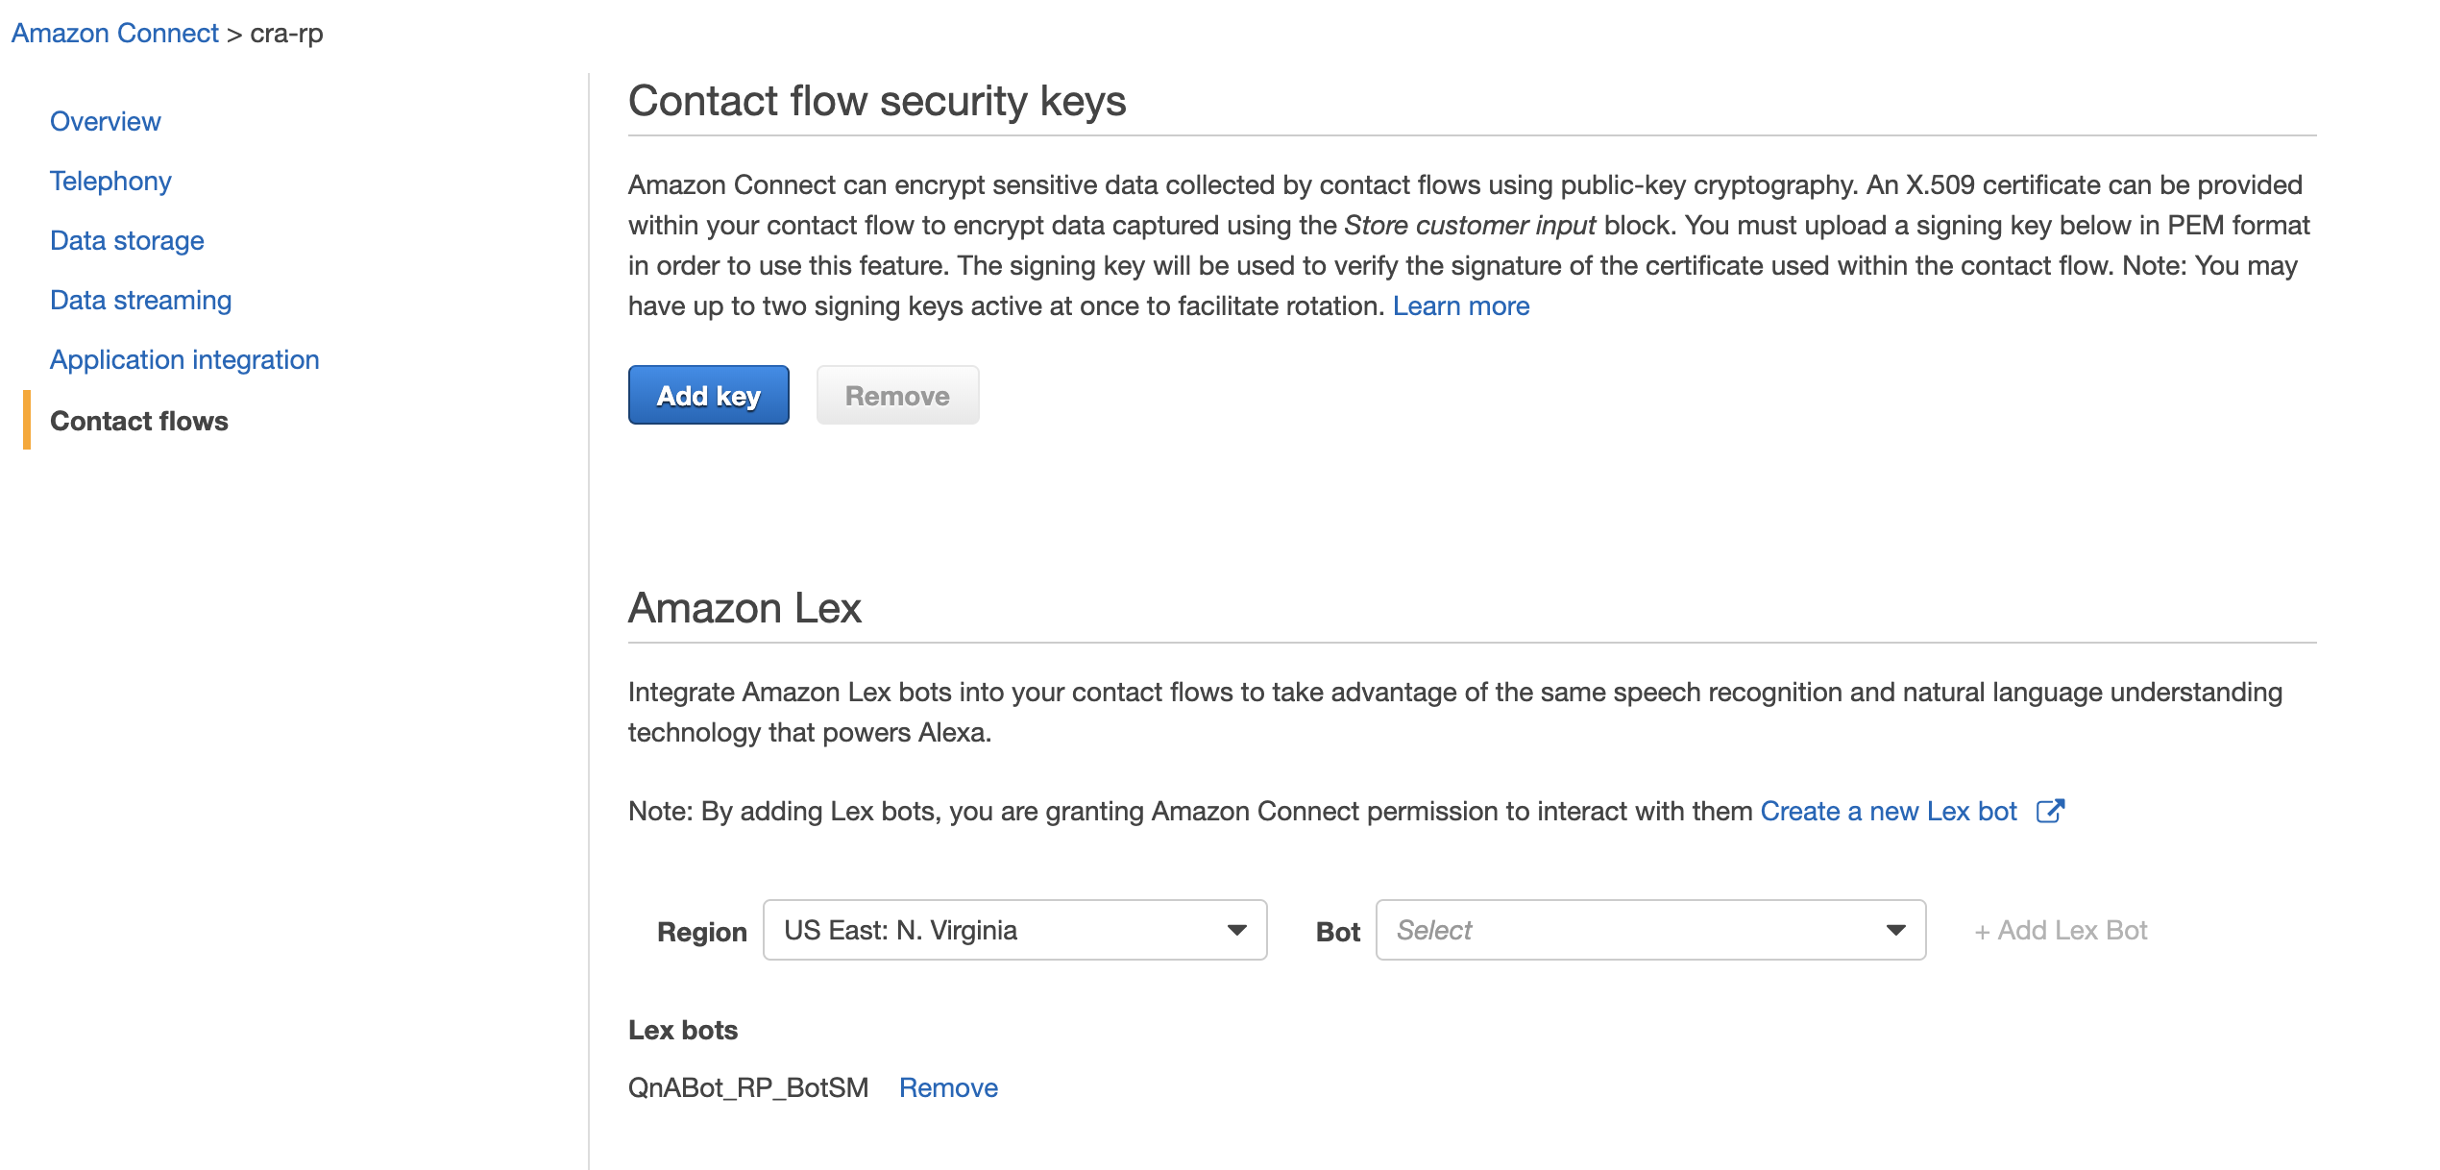

1. In the Amazon Connect Contact Center Manager, use the navigation pane on the left hand side to select **Routing** and then **Contact flows**

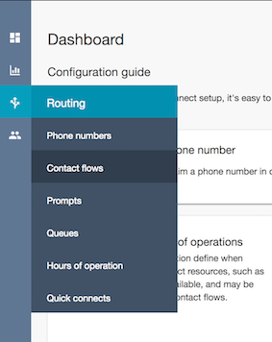

If you closed your browser window you can always re-open the Amazon Connect Contact Center Manager from the [Amazon Connect console](https://console.aws.amazon.com/connect/home?region=us-east-1). Just selct your Amazon connect instance and click on the **Login as administrator**button in the **Overview** section of the console.

1. In the top right corner select **Create contact flow** to open the contact flow editor
2. Name your contact flow CRAChatBot
3. Expand the **Interact** group of blocks and drag and drop the **Get customer input** block onto the grid
4. Expand the **Terminate / Transfer** group of blocks and drag and drop the **Disconnect / Hang up** block onto the grid
5. Wire up the three building blocks as shown in the image below

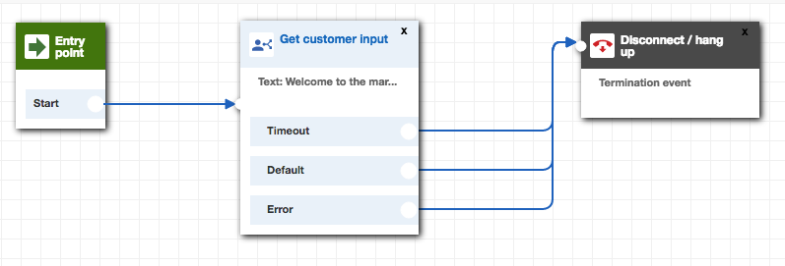

1. Double click on the **Get customer input** block to access its configuration
   1. Select the **Text to speech (Ad hoc)** input type and use this welcome message: Welcome to the CRA. How can we help you today?
   2. Select **Amazon Lex** input type
   3. Enter QnABot_{Your Initials} bot name and leave alias as $LATEST
   4. Click **Save**

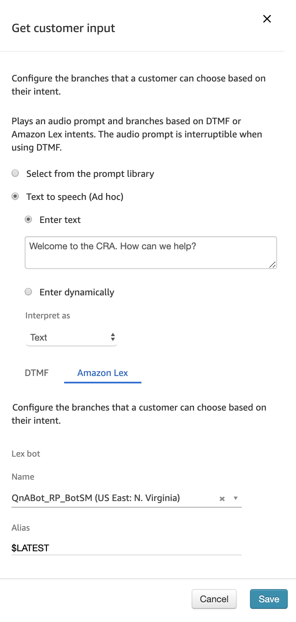

1. Click on the **down arrow** ([DownArrow](https://github.com/aws-samples/amazon-lex-customerservice-workshop/blob/master/03_AmazonConnectIntegration/images/down.png)) next to the Save button at the top right and select **Save & Publish**
2. Wait for the contact flow to be published successfully

### Associate Contact Flow with phone number

Now you need to associate your new contact flow with your phone number

1. Select **Routing** and **Phone Numbers** on the left hand Amazon Connect navigation pane
2. Click on the number to edit the contact flow
3. Search and select the CRAChatbot contact flow in the **Contact flow/IVR** field
4. Select **Save** to confirm the contact flow association

### Test your Amazon Lex enabled Amazon Connect contact flow

Dial your Amazon Connect contact center phone number to confirm functionality of contact flow and Amazon Lex integration. Tell the virtual service agent **"What is the CRA"**;