Suggested Title: Assessing the knowledge-base for commercially exploited marine fisheries with a new database of global stock assessments
Alternative Title 1: A new database of global stock assessments for exploited marine fisheries
Alternative Title 2: Assessing the geographic and taxonomic coverage of marine fisheries using a new database of global stock assessments
Suggested Running Title: A database of global stock assessments
Daniel Ricard et al.

Abstract
Data used to assess the status of individual fish stocks varies from very little information on many of the world’s artisanal fisheries, to commercial landings at various levels of geographic and taxonomic aggregation, research surveys, and sophisticated population dynamics models that integrate many sources of information. Previous evaluations of the state of global fisheries have used catch or landings data, which may be poor proxies for fish stock abundances. A global compilation of stock assessment data in the mid-1990s enabled substantial syntheses of stock status; however the focus of this database was on stock-recruitment relationships and it is now 15 years out of date. To facilitate contemporary syntheses, we have assembled a comprehensive database of the most intensively studied commercially exploited marine fish stocks. The database includes time series of: total biomass, spawner biomass, recruits, fishing mortality, and catch; reference points; and ancillary information on the life history, management, and assessment methods for each stock. Here, we present the first overview of the structure and content of the database. We further evaluate the knowledge-base for assessed marine fishes. Globally, publicly available stock assessments were found for 347 stocks (305 species of fishes representing 46 families and 42 species of invertebrates representing 13 families), from 18 national and international management institutions. Assessments are available for only XX percent of global marine fisheries catches by weight and XX percent by value. There is substantial spatial variation in availability of assessed stocks, with XX percent coming from north temperate regions (North Atlantic, North Pacific). Geographic differences in assessment methods show that Statistical Catch at Age (SCA) models are widely used by the west coast of the U.S. (XX percent of assessments), regional fishery management organizations in the Pacific (XX percent of assessments), and New Zealand (XX percent of assessments); the east coast of the U.S. is transitioning from Virtual Population Analysis (VPA) to SCA (XX percent of assessments conducted since 2000 have used SCA); while VPA is still the dominant assessment technique in western Europe (XX percent of assessments).

Keywords: Marine fisheries, stock assessment, relational database.

1 Introduction
Marine wild capture fisheries provide more than 80 million tons of fisheries products (both food and industrial) per year and employ 43.5 million people (wild capture and aquaculture, FAO (2009)). At the same time, fishing has been recognized as one of the most widespread human impacts in the world’s oceans (Halpern et al., 2008), and the UN Food and Agriculture Organization estimates that two-thirds of fish stocks are fully exploited or overexploited (FAO, 2009). While many fisheries have reduced exploitation rates to levels that should promote recovery, overfishing continues to be a serious global problem (Worm et al., 2009). Fishery managers are asked to address multiple competing objectives including maximizing yields, ensuring profitability, reducing bycatch, and minimizing the risk of overfishing. Given the enormous social and economic costs (Rice et al., 2003) and ecosystems consequences (Frank et al., 2005; Myers et al., 2007) of collapsed fisheries, it is imperative that we are able to quickly learn the lessons of successful and failed fisheries from around the world.
Effective management of exploited fish populations generally requires an understanding of where the current population size and harvest rate lie in relation to the population size and harvest rate which maximize fishery benefits or limit the risk of overfishing. This process of quantitative determination of stock status and estimation of reference points is called stock assessment. Some fisheries in developing countries have apparently provided sustainable yields for long periods of time without formal stock assessment (e.g., many community-managed fisheries in Oceania, Johannes (2002)). This has been achieved by limiting harvest rates, often through gear restrictions or seasonal or area closures. In modern industrialized fisheries where fishing capacity exceeds the productivity of fished stocks, however, stock assessment is an integral component of responsible management (Hilborn and Walters, 1992).
Even in developed countries, however, not all stocks are assessed. For example, in 2007, of the 528 fish and invertebrate stocks recognized by the National Marine Fisheries Service (NMFS), only 179 or slightly over one third were fully assessed (National Marine Fisheries Service, 2008). An assessment by the European Environment Agency (EEA) in 2006 indicated that the percentage of commercial landings obtained from assessed stocks ranged between 66-97 percent in northern European waters and 30-77 percent in the Mediterranean (European Environment Agency, 2009). The New Zealand Ministry of Fisheries reports the status of 117 stocks or sub-stocks out of a total of 628 stocks managed under New Zealand’s Quota Management System (New Zealand Ministry of Fisheries, 2009). In Australia, 98 federally managed stocks have been assessed (Wilson et al., 2009) out of an unknown total. The extent to which stocks are assessed elsewhere in the world is currently unknown.
The global database of fishery landings compiled by Food and Agricultural Organization of the United Nations (FAO, 2009) and synthesized by the Sea Around Us project (Watson et al., 2004) has proven to be a valuable resource for understanding fishery status; however, catch data alone can be misleading when used as a proxy for stock size. Many papers have used these catch databases to examine changes in fishery status (Worm et al., 2006; Costello et al., 2008), including changes in trophic level (Pauly et al., 1998; Essington et al., 2006; Newton et al., 2007). Most of these analyses rely (either explicitly or implicitly) on the assumption that catch or landings is a reliable index of stock size. Critics have pointed out that catch can change for a number of reasons unrelated to stock size, including changes in targeting, fishing restrictions, or market preferences (de Mutsert et al., 2008; Murawski et al., 2007; Hilborn, 2007). Even when catch is standardized by the amount of fishing effort (catch-per-unit-of-effort, CPUE), it can be an unreliable index of relative abundance (Hutchings and Myers, 1994; Harley et al., 2001; Walters, 2003; Polacheck, 2006). Stock assessments consider time series of catch along with other sources of information such as: natural mortality rates, changes in size or age composition, stock-recruitment relationships, and CPUE of different sectors or of fishery-independent surveys. Because they integrate across multiple sources of information, stock assessment models are thought to provide a more accurate picture of changes in abundance than catch data alone (Sibert et al., 2006). Yet, without a current and comprehensive database of stock assessments, scientists wishing to conduct comparative analyses of marine fish population dynamics and fishery status have little choice but to use problematic catch data.
The first global database of stock assessment information, the Myers Stock Recruitment Database, was developed by Ransom Myers and colleagues in the mid-1990s (Myers et al., 1995b). While the database was primarily known for its time series of stock and recruitment, it did contain time series of fishing mortality rates for many stocks but biological reference points were largely absent. The original release version of the Myers database (Myers et al., 1995b) contained spawning stock size and recruitment time series for 274 stocks representing 92 species as well as time series of fishing mortality rates for 144 stocks. It was used to: [1)] 1. decisively answer the question of whether recruitment shows any relationship to spawning stock size (Myers and Barrowman, 1996), 2. investigate potential depensation in stock-recruitment relationships (Myers et al., 1995a; Liermann and Hilborn, 1997), 3. investigate density-dependent juvenile mortality (Myers, 2001; Minto et al., 2008), and 4. develop informative Bayesian priors on steepness (Myers et al., 1999, 2002; Dorn, 2002) , amongst others. The Myers database has also been used for several studies of collapse and recovery of exploited fish populations (Hutchings, 2000, 2001; Hilborn, 1997) and to study depensation dynamics (Garvey et al., 2009).
Although the original Myers database (Myers et al., 1995b) has proven to be a valuable resource, it is now 15 years out of date. For stocks that were depleted in 1995, these additional 15 years include valuable observations at low stock size or of a recovering population, both of which are critical for estimating population dynamics parameters such as the slope of the stock-recruitment relationship near the origin and for evaluating evidence for depensation. In addition, there have been numerous improvements in stock assessment methodologies (including important advances in statistical catch-at-age or catch-at-length models) and assessments have been conducted for the first time for many species.
Previous meta-analyses of fishery status have been hampered by the lack of a global assessment database containing biological reference points (BRPs, e.g., the biomass and fishing mortality rate that produce maximum sustainable yield, 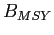 and 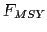). Knowledge of BRPs is important if stocks are to be managed for high yields that can be sustained over time (Mace, 1994). Without information on reference points, previous analyses of stock assessments or catch data have been forced to use non-biological thresholds to define fishery status, such as the greatest 15 year decline (Hutchings and Reynolds, 2004) or 10 percent of maximum catch (Worm et al., 2006). Ad hoc reference points based on some fraction of the maximum of a time series also have undesirable statistical properties and can result in false collapses when applied to inherently variable time series of catch or abundance (Wilberg and Miller, 2007; Branch, 2008). Complicating comparisons of fishery status is the fact that different BRPs are used in different parts of the world and even the same BRP can be used in a different manner, for example, as a target or a limit.
Here we present a new global database of stock assessments for commercially exploited marine fish populations. The database is an update and extension of that developed by Ransom Myers, and is named the RAM Legacy database in honor of his pioneering contribution. This effort is the first global stock assessment database to:
1. Use a formal relational database structure;
2. Use source control software to handle release versions are maintained;
3. Include metadata related to the geographic location of the stock, the type of assessment model used, and the original source document for the assessment data;
4. Include biological reference points and stock-specific life history information.
We use the database to assess the knowledge-base for management of marine fish populations and address the following questions:
1. What fraction of world wild-capture fishery landings come from assessed stocks and how does this proportion vary by region?
2. What is the temporal coverage of stock assessments, i.e. how far back do stock assessments look when reconstructing trends in abundance?
3. What are the taxonomic and geographic biases, if any, in assessed stocks?
4. Which stock assessment approaches are used and how does this vary by region?
5. What biological reference points are reported in assessments and how does this vary by region?
6. How accessible is stock assessment information in different regions?

2 Methods - was “The RAM Legacy database: structure, scope, and method of development”
Publicly available stock assessments were collated by a number of recorders who transferred the available information to a spreadsheet template for inclusion in the relational database management system.

2.1 Database structure and design
The database follows a relational model and is implemented in the Open Source PostgreSQL relational database management system (PostgreSQL Global Development Group, 2009). The database design houses tables for: assessment metadata, timeseries values, timeseries units, biometrics (catch-all term for data, such as life history characteristics or BRPs, that are not part of a timeseries), spatial information, management body, and taxonomy. An entity relationship diagram detailing the data structure is presented in the Supporting Information. The assessment methodology (Virtual Population Analysis, Statistical catch-at-age/length, etc.) and assessor were also recorded.

2.2 Assessment collation
Publically available stock assessment reports available from the interent were the primary data source. These reports were obtained either from the online site of the relevant management agency or directly from stock assessment scientists. Given the range of assessment types, people and agencies involved, it was necessary to design a flexible data entry protocol that captures all pertinent information available about the different stocks.

2.3 Data entry
Data were entered, by an assessment recorder (preferably an assessment author), into a spreadsheet template file, which has three worksheets: (1) meta, (2) biometrics, (3) timeseries. The template was flexible in that stock-specific information could be added depending on the scope of the information contained within the assessment. The ‘meta’ worksheet contained information about the stock (e.g. taxonomic information), the recorder entering the data, and references for the stock assessment document. The ‘biometrics’ worksheet was where point estimates (not time series) were entered. This included life history information, biological reference points, as well as details about the time series data such as the age and sex of spawners, the ages used to compute the fishing mortality etc. The ‘timeseries’ worksheet contained the entered time series data for the stock. Depending on the type of assessment conducted, model results were available for year, SSB (spawner stock biomass), TB (total biomass), R (recruits), TC (total catch), F (fishing mortality).

2.4 Data integrity and quality control flow
The goal of the database quality control was to help ensure that the data entered mirror those present in the assessment document. The process consisted of entering the submitted assessment spreadsheet into a development database from which an automatic summary document was generated. This document contained: summary details of the stock, a selection of biometrics and ratios for comparison (e.g. current biomass relative to the reference point), and time series plots of the biomass, recruitment, and exploitation trajectories. This “Quality Assurance/Quality Controlled (QA/QC)” document was then returned to the assessment recorder and subsequent correspondence was captured in a Plone bug tracking system so that an electronic trail was established. Once the assessment recorder checked the QA/QC document and, if necessary, amended the assessment spreadsheet, the final spreadsheet was entered into the operational database and a quality controlled flag is inserted to signify that the data have passed this check.

2.5 Data products from the database contents
To facilitate analyses, a variety of data products, typically rectangular, matrix-like, summarised contents of information from the database were constructed. This include summarised timeseries for a subset of metrics (e.g. SSB, TB, R, TC and F) as well as timeseries which fulfill certain criteria (e.g. all SR pairs with ≥25 years of data). These products were assembled as database views using the Structured Query Language (SQL). To obtain a comparable set of BRPs, for all stocks s with available total catch (TC) and total biomass (TB) timeseries data (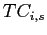, 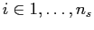 and 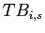, ), a Schaefer surplus production model was used to estimate total biomass and fishing mortality at Maximum Sustainable Yield (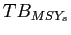 and 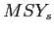, respectively).

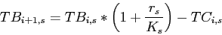 (1)
where,
is the intrinsic growth rate of stock s
is the carrying capacity of stock s
is the catch of stock s in year i
and can then be calculated as:

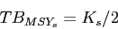 (2)

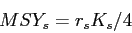 (3)

2.6 Database access
The database was designed to accomodate multiple users and collaborators and to maintain its usefulness as its contents grow. Users familiar with Structured Query Language (SQL) can query the database directly from their analytical software of choice via appropriate connection settings (e.g. Open Database Connectivity (ODBC) connection and other examples can be found in the Supporting Information). Database views assist this level of entry by formatting data to be returned in column format such as those typically held in spreadsheets. This entry approach minimizes the risk posed by the alternative static copy, whereby changes enter and are inherited in the process of dissemination (Barbrook et al., 1998, for a literary example).

2.7 Links to related databases
To facilitate integration of the RAM Legacy database with related databases, such as Fishbase (Froese and Pauly, 2009) and the Sea Around Us Project’s (SAUP) global landings database (Watson et al., 2004), each species present in the RAM Legacy database was assigned a matching FishBase species name and species code as well as the SAUP taxon code. Additonally, each stock was assigned to a primary, secondary, and tertiary Large Marine Ecosystem (NOAA, 1998). Open ocean species that do not fit the LME classification (e.g. highly migratory species such as tuna) were assigned to new categories “Atlantic High Seas”, “Pacific High Seas”, “Indian High Seas”, and “Aubantarctic High Seas”. These steps ensure that researchers using data from the database can easily find matching data from other data sources without unnecessary linking difficulties.

2.8 Knowledge-base analyses
The holdings of assessments are summarised by their geographic coverage, their management regime, the type of assessment used. We also identify assessments where other life-history parameters are identified in the reference assessment document. The available timeseries for different stocks are examined in terms of their duration in years and first and last years of assessment time window.
Taxonomic coverage in the database was compared to the diversity of marine fishes in global fisheries landings (as represented by the SAUP database) and all marine fishes (as represented by FishBase). We compare the taxonomic information of the three different data sources to determine the taxonomic bias of [1)] 1. the global catch data compared to the accepted taxonomic coverage; 2. the assessments data compared to the global catch data .

3 Results

3.1 Geographic coverage
In total, 347 recent stock assessments for 305 marine fish and 42 invertebrate populations are included in the RAM Legacy database (Version 1.0, 2010). These include all stocks assessed by fisheries agencies in European Countries (International Council for the Exploration of the Sea (ICES), n=64), the United States (National Marine Fisheries Service (NMFS), n=150), Canada (Department of Fisheries and Oceans (DFO), n=32), New Zealand (Ministry of Fisheries, n=29), Australia (Australian Fisheries Management Authority (AFMA) n=16), South Africa (Department of Environment and Tourism, Marine and Coastal Management (DETMCM), n=14) and Argentina (Consejo Federal Pesquero, n=6). Also included are assessments conducted by Regional Fisheries Management Organizations (RFMOs) in the Northwest Atlantic (Northwest Atlantic Fisheries Organization (NAFO), n= 10), Atlantic (International Commission for the Conservation of Atlantic Tunas (ICCAT), n=10), Pacific (Western and Central Pacific Fisheries Commission, n=4 and South Pacific Regional Fisheries Management Organization, n=1 and Inter-American Tropical Tuna Commission, n=2 and International Pacific Halibut Commission, n=1) and Indian Ocean (Indian Ocean Tuna Commission, n=1).
The three Large Marine Ecosystems (LMEs) with the most number of assessed populations entered are the: Northeast U.S. Continental Shelf (n=74), California Current (n=36) and New Zealand Shelf (n=29) (Figure 6.2).

3.2 Taxonomic coverage
The taxonomic coverage of the database includes 168 species from 59 families. This comprises a relatively small proportion of caught taxa and a smaller proportion of marine fish biodiversity (Figure ).
Three taxonomic orders (Gadiformes, Pleuronectiformes Perciformes and Scorpaeniformes) account for 67% of available stock assessments.

3.3 Temporal coverage
The number and median lengths of timeseries stored in the RAM Legacy database are catch/landings: n=321, length=38 years, SSB: n=275, length=34 years, and recruitment: n=270, length=33 years (Figure ).

3.4 Assessment methodology
Of the 347 assessments in the database, 321 use a proper population dynamics model while the remaining 26 are based on scientific survey information. The most common assessment methods were Statistical catch-at-age/length models (n=162), Virtual Population Analyses (n=89) and Biomass dynamics model (n=44).

3.5 Reference points and life history information
The total number and percentage of assessments that reported biomass- or exploitation- based reference points was 261 (75%) and 223 (64%), respectively. While the total number and percentage of assessments that reported any life-history information (growth, maturity, fecundity) was REF:SQL:NUMASSESSLIFE.

4 Discussion
The compilation of available stock assessments for the world’s marine fisheries, although non-exhaustive, provides a basis to evaluate the existing knowledge-base of populations under exploitation. The stocks comprising the database are predominantly from developed nations with properly identified fisheries management bodies and tendq to cover a recent time period. Few assessments extend back beyond 30 years from present. The taxonomic makeup of available assessments is a very limited subset of the accepted taxonomic coverage of marine species worldwide.

4.1 Biases

4.1.1 Geographic bias
Large Marine Ecosystems were defined by NOAA (NOAA, 1998). They encompass the continental shelves of the world’s oceans and represent the most productive areas of the oceans. However, they do not include a classification category for large migratory species such as tuna that also inhabit the open ocean and is not associated with given LMEs. Each species of highly migratory species is also observed in a number of LMEs. While the global coverage of LMEs is beneficial to classify assessments from around the world, it is debatable whether once can use each LME as an independent unit of comparison.
There are important geographic biases in the amount of assessments entered per LME (Figure 6.2). A large proportion of assessments come from North America, Europe, Australia, New Zealand and the High Seas. Few assessments are entered from regions such as Southeast Asia, South America, and the Indian Ocean (outside Australian waters). The question of geographic bias relates to whether: [1)] 1. an assessment is conducted on a stock; 2. it is possible to access the assessment; and 3. the non-exhaustive collation we undertook may have overlooked the assessment . Whether an assessment is conducted for a given stock depends upon a multitude of factors, including the economic value of the stock and availability of fiscal resources to collect the data required for an assessment. How accessible assessments are for entry depends upon the transparency and access policies of the relevant management agencies, which varies geographically. Similarly, the legal context where fisheries are prosecuted will strongly influence the requirement for conducting stock assessments. In the United States, the Magnuson-Stevens Act defines what stocks are to be monitored and managed, hence a large number of the assessments in the RAM Legacy database are under the jurisdiction of the US National Marine Fisheries Services.
Our incomplete search for assessments could also give rise to geographic biases, as concerted collation efforts have only been conducted in those assessment-rich regions of Figure 6.2. It is hoped that readers of this article can assist in correcting these biases by participating in future updates of the RAM Legacy database.

4.1.2 Taxonomic bias
The accepted taxonomic coverage of fish and elasmobranch species from FishBase includes 12339 species from 54 different orders. In comparsion, the SAUP data is from XX species and XX orders. Taxonomic biases in those species that are assessed include ...
Global fish catches represent XX% of the accepted taxonomic coverage for fish species.
The assessed stocks present in the RAM Legacy database represent XX% of the global catch for fish species.

4.2 Caveats and limitations
Assessment outputs e.g. biomass timeseries, are estimates, not raw data. The uncertainty associated with these estimates should be carried forth in subsequent analyses. The RAM Legacy database structure allows for estimates of uncertainty (standard errors, 95% credible/confidence intervals), however these estimates are only occassionally provided because they aren’t produced by the assessment model (e.g. non-bootstrapped VPA assessments) or the focus of the assessment document was on central tendency (e.g. mean biomass), not the associated uncertainty. Note that this view is changing with the advent of MCMC aproaches to Bayesian inference for assessments, bootstrap methods, statistical catch-at-age models and a focus on uncertainty (Walters and Maguire, 1996). As with any analysis, clearer inference on the strength of a signal is available when all uncertainty in the data is carried forth. This represents a difficulty for large-scale analyses of fisheries data in that in an ideal world one would access the raw data per sub-unit (e.g. stock) and carry forth the uncertainty at all levels of the analysis. In the case of assessments, the raw data is typically catch-at-age matrices and potentially survey indices. To understand the fleet characteristics and survey stratification schema for each stock in a potentially global meta-analysis would be extremely time consuming and error-prone. So, the expert opinion of those researchers most familiar with the data, stock assessment authors, is used but without accompanying uncertainty estimates the strength of conclusions drawn may be weakened.
The original database developed by Dr. Myers was used to address a variety of ecological question derived from stock-recruit relationships. This was possible because of the timeseries of stock and recruitment generated in assessment using VPA-type models. With the increasing use of statistical catch-at-age/length models, an underlying stock-recruit relationship is assumed to exist. Estimating the parameters of a stock-recruit relationship using timeseries from such models does not constitute a valid statistical procedure.
Point data are stored in the database with an associated unit, value and year. We expect to also include age-varying and length-varying data such as maturity ogive and age-disaggregated natural mortality in subsequent releases of the RAM Legacy database. In addition to the initial aim of providing reliable access to timeseries information about stocks, we hope to also stimulate research in the relationships of life-history characteristics and their relation to exploitation.

4.3 Using a Relational Database Management System
Housing assessments in a Relational Database Management System (RDBMS) allows mutliple users to concurrently access and extract subsets of persistent data in an efficient and reproducible manner. With the development of Application Programming Interfaces (APIs) that allow analytical softwares to directly communicate and extract data from the database, a common data environment is established, independent of ones choice of analytical software e.g. (SAS:SAS ACCESS, Matlab: Matlab/Database, R:RDBI/RODBC, Perl:DBI, etc.). In all these applications the same SQL query will extract the same data. A data product tailored to a specific project can be generated and stored as a dynamic (continually updated) “view” within the database. These are typically spreadsheet-like results of an expansive query of the relevant tables that can be readily read into all commonly-used analytical softwares. In contrast, manipulating flat text files or spreadsheets for importing into a specific analytical software runs the risk of losing data integrity and becomes impractical with large, non-rectangular, datasets. Full benefits of the database can be realized through the development of tailored queries to suit one’s analyses. Such queries require an understanding of the structure of the various data within assessments. RDBMSs form the server back-end to a great many applications of interest to ecologists, including web-clients and GIS softwares.

4.4 Continuity
It is anticipated that the RAM Legacy database will continue to grow with hitherto unentered and updated assessments. The ultimate goal is to provide a data standard for researchers to use results from multiple regions to assist in their own applied and fundamental research in population ecology. The development of a standard for assessment reporting would assist in realizing this goal. For example, ICES assessments have a very regular standard, including agreed-upon reference points and regular estimate reporting. This makes the process of data collation much more routine than unstandardized documents where the recorder trawls through a report for information. Certainly different stocks and regions require different formats but the basic output tables, consisting of total and spawning biomass, recruitment, catch/landings, estimated fishing mortality over vulnerable age groups, associated measures of uncertainty, and commonly-used reference points would streamline the process immensely. A process whereby the assessment spreadsheets are filled out at each assessment meeting would be the least error prone method. In return, the assessment scientists can access results for a global collation of assessments to further their own research initiatives in population assessment and management. Other products include management-agency-level reports containing summaries of all stocks within their remit. Future versions to the database will also include timelines of management actions per stock. The RAM Legacy database contains the corresponding species codes to the Sea Around Us Project and FishBase, thus facilitating researchers’s use of a global fisheries data “toolkit” to address questions on the relationships between life history attributes and resulting population dynamics in an exploited setting.

Availability of the database
Contributions or corrections to the existing database, as well as requests to use the database (subject to standard “Fair Use” policies), should be directed to the corresponding author.

Acknowledgments
Funders: NCEAS, NSERC, CFI, Smith Fellowship, CoML/FMAP, assessment scientists Help: Rainer Froese, Dirk Zeller, Boris Worm, Ray Hilborn, Mike Fogarty, Ana Parma, Jeff Hutchings, Trevor Branch All recorders:

References

Barbrook, A., Howe, C., Blake, N. & Robinson, P. ( 1998).
The phylogeny of the Canterbury Tales.
Nature (London) 394(6696), 839.
Branch, T. (2008).
Not all fisheries will be collapsed in 2048.
Marine Policy 32, 38-39.
Costello, C., Gaines, S.D. & Lynham, J. ( 2008).
Can catch shares prevent fisheries collapse?
Science (Washington) 321(5896), 1678-1681.
de Mutsert, K., Cowan, Jr., J.H., Essington, T.E. & Hilborn, R. (2008).
Reanalyses of Gulf of Mexico fisheries data: Landings can be misleading in assessments of fisheries and fisheries ecosystems.
Proceedings of the National Academy of Sciences 105(7), 2740-2744.
Dorn, M. (2002).
Advice on West Coast rockfish harvest rates from Bayesian meta-analysis of stock-recruit relationships.
North American Journal of Fisheries Management 22, 280-300.
Essington, T.E., Beaudreau, A.H. & Wiedenmann, J. ( 2006).
Fishing through marine food webs.
Proceedings of the National Academy of Science 103(9), 3171-3175.
European Environment Agency (2009).

FAO (2009).
FISHSTAT-PC: Data retrieval, graphical and analytical software for microcomputers.
Frank, K., Petrie, B., Choi, J. & Leggett, W. ( 2005).
Trophic cascades in a formerly cod-dominated ecosystem.
Science (Washington) 308(5728), 1621-1623.
Froese, R. & Pauly, D. (2009).
FishBase www.fishbase.org, version (10/2009).
World Wide Web electronic publication.
Garvey, J., Wright, R. & Marschall, E. ( 2009).
Searching for threshold shifts in spawner-recruit data.
Canadian Journal of Fisheries and Aquatic Sciences 66, 312-320.
Halpern, B., Walbridge, S., Selkoe, K. et al. ( 2008).
A global map of human impact on marine ecosystems.
Science (Washington) 319(5865), 948-952.
Harley, S., Myers, R. & Dunn, A. ( 2001).
Is catch-per-unit-effort proportional to abundance?
Canadian Journal of Fisheries and Aquatic Sciences 58, 1705-1772.
Hilborn, R., ed. (1997).
The frequency and severity of fish stock declines and increases.
Developing and sustaining world fisheries resources. Proceedings of the 2nd World Fisheries Congress. CSIRO Publishing, Victoria, Australia.
Hilborn, R. & Walters, C.J. ( 1992).
Quantitative Fisheries Stock Assessment: Choice, Dynamics and Uncertainty.
Kluwer Academic Publishers.
Hilborn, R. (2007).
Biodiversity loss in the ocean: how bad is it?
Science (Washington) 316(5829), 1281.
Hutchings, J. (2000).
Collapse and recovery of marine fishes.
Nature (London) 406, 882-885.
Hutchings, J. (2001).
Influence of population decline, fishing, and spawner variability on the recovery of marine fishes.
Journal of Fish Biology Suppl. A, 306-322.
Hutchings, J. & Myers, R. (1994).
What can be learned from the collapse of a renewable resource? Atlantic cod, Gadus morhua, of Newfoundland and Labrador.
Canadian Journal of Fisheries and Aquatic Sciences 51, 2126-2146.
Hutchings, J. & Reynolds, J. ( 2004).
Marine fish population collapses: Consequences for recovery and extinction risk.
BioScience 54, 297-309.
Johannes, R. (2002).
The renaissance of community-based marine resource management in Oceania.
Annual Review of Ecology, Evolution, and Systematics 33, 317-340.
Liermann, M. & Hilborn, R. ( 1997).
Depensation in fish stocks: a hierarchic Bayesian meta-analysis.
Canadian Journal of Fisheries and Aquatic Sciences 54, 1976-1984.
Mace, P.M. (1994).
Relationships between Common Biological Reference Points Used as Thresholds and Targets of Fisheries Management Strategies.
Canadian Journal of Fisheries and Aquatic Sciences 51(1), 110-122.
Minto, C., Myers, R.A. & Blanchard, W. ( 2008).
Survival variability and population density in fish populations.
Nature (London) 452, 344-347.
Murawski, S., Methot, R. & Tromble, G. ( 2007).
Letter to the editors of Science.
Science (Washington) 316, 1281.
Myers, R.A. (2001).
Stock and recruitment: Generalizations about maximum reproductive rate, density dependence and variability using meta-analytic approaches.
ICES Journal of Marine Science 58, 937-951.
Myers, R. & Barrowman, N. (1996).
Is fish recruitment related to spawner abundance?
Fishery Bulletin 94, 707-724.
Myers, R., Barrowman, N., Hilborn, R. & Kehler, D. ( 2002).
Inferring bayesian priors with limited direct data: applications to risk analysis.
North American Journal of Fisheries Management 22, 351-364.
Myers, R., Barrowman, N., Hutchings, J. & Rosenberg, A. (1995a).
Population dynamics of exploited fish stocks at low population levels.
Science (Washington) 269, 1106-1108.
Myers, R., Baum, J., Shepherd, T., Powers, S. & Peterson, C. (2007).
Cascading Effects of the Loss of Apex Predatory Sharks from a Coastal Ocean.
Science 315(5820), 1846-1850.
Myers, R., Bowen, K. & Barrowman, N. ( 1999).
Maximum reproductive rate of fish at low population sizes.
Canadian Journal of Fisheries and Aquatic Sciences 56, 2404-2419.
Myers, R.A., Bridson, J. & N.J., B. ( 1995b).
Summary of Worldwide Spawner and Recruitment Data.
Canadian Technical Report of Fisheries and Aquatic Sciences, No. 2020 p. 327.
National Marine Fisheries Service (2008).
Status of US Fisheries 2007.
Tech. rep., NMFS.
Http://www.nmfs.noaa.gov/sfa/statusoffisheries/SOSmain.htm.
New Zealand Ministry of Fisheries (2009).
Stock Status http://fs.fish.govt.nz/Page.aspx?pk=16.
Newton, K., Côté, I., Pilling, G., Jennings, S. & Dulvy, N. (2007).
Current and Future Sustainability of Island Coral Reef Fisheries.
Current Biology 17(7), 655-658.
NOAA (1998).
Large Marine Ecosystems.
Tech. rep., National Oceanic and Atmospheric Administration.
Pauly, D., Christensen, V., Dalsgaard, J., Froese, R. & Torres, Jr., F. (1998).
Fishing Down Marine Food Webs.
Science (Washington) 279(5352), 860-863.
Polacheck, T. (2006).
Tuna longline catch rates in the Indian Ocean: Did industrial fishing result in a 90% rapid decline in the abundance of large predatory species.
Marine Policy 30, 470-482.
PostgreSQL Global Development Group (2009).
PostgreSQL, version 8.3.8. http://www.postgresql.org.
Rice, J., Shelton, P., Rivard, D., Chouinard, G. & Fréchet, A. (2003).
Recovering Canadian Atlantic cod stocks: the shape of things to come.
ICES CM 2003/U 06, 23pp.
Sibert, J., Hampton, J., Kleiber, P. & Maunder, M. ( 2006).
Biomass, Size, and Trophic Status of Top Predators in the Pacific Ocean.
Science (Washington) 314(5806), 1773-1776.
Walters, C. & Maguire, J. (1996).
Lessons for stock assessment from the northern cod collapse.
Reviews in Fish Biology and Fisheries 6(2), 125-137.
Walters, C. (2003).
Folly and fantasy in the analysis of spatial catch rate data.
Canadian Journal of Fisheries and Aquatic Sciences 60(12), 1433-1436.
Watson, R., Kitchingman, A., Gelchu, A. & Pauly, D. (2004).
Mapping global fisheries: sharpening our focus.
Fish and Fisheries 5, 168-177.
Wilberg, M. & Miller, T. (2007).
Comment on "Impacts of biodiversity loss on ocean ecosystem services".
Science (Washington) 316, 1285b.
Wilson, D., Curtotti, R., Begg, G. & Phillips, K., eds. (2009).
Fishery status reports 2008: status of fish stocks and fisheries managed by the Australian Government.
Bureau of Rural Sciences and Australian Bureau of Agricultural and Resource Economics, Canberra.
Worm, B., Barbier, E., Beaumont, N. et al. ( 2006).
Impacts of Biodiversity Loss on Ocean Ecosystem Services.
Science (Washington) 314, 787-790.
Worm, B., Hilborn, R., Baum, J.K. et al. ( 2009).
Rebuilding global fisheries.
Science (Washington) 325, 578-585.

6 Figures

6.1 Figure legends
Figure 1. Global map of Large Marine Ecosystems (LMEs) showing the number of stock assessments present in the database for each LME.

Figure 2. Temporal coverage of (A) catch/landings, (B) spawning stock biomass and (C) recruitment. The temporal coverage for individual assessments is represented by thin alternating black and grey horizontal lines in the main panels. Thick horizontal lines at the base of each main panel represent the time periods which are present in 90% (black) and 50% (grey) of all series for that data type. Subfigure histograms contain the frequency of occurrence of the various timespans without reference to time period. Solid and long-dash vertical lines within the subfigures represent the median, 2.5% and 97.5% quantiles, respectively.

Figure 3. Taxonomic coverage of assessed marine species present in the Myers II database. The circle located near the middle of the circular dendrogram represents kingdom Animalia and each subsequent branching represents a different taxonomic group (Kingdom to Phylum to Class to Order to Family to Genus to Species). The width of each line is proportional to the square root of the number of assessments in the database. The outermost lines represent species and the number of lines is the number of assessments for each species. The names of multi-assessment species are not repeated on the outermost portion of the dendrogram but continue counter-clockwise from the first entry. Note that branch lengths are chosen for graphical purposes and do not convey phylogenetic distance.

6.2 Figures

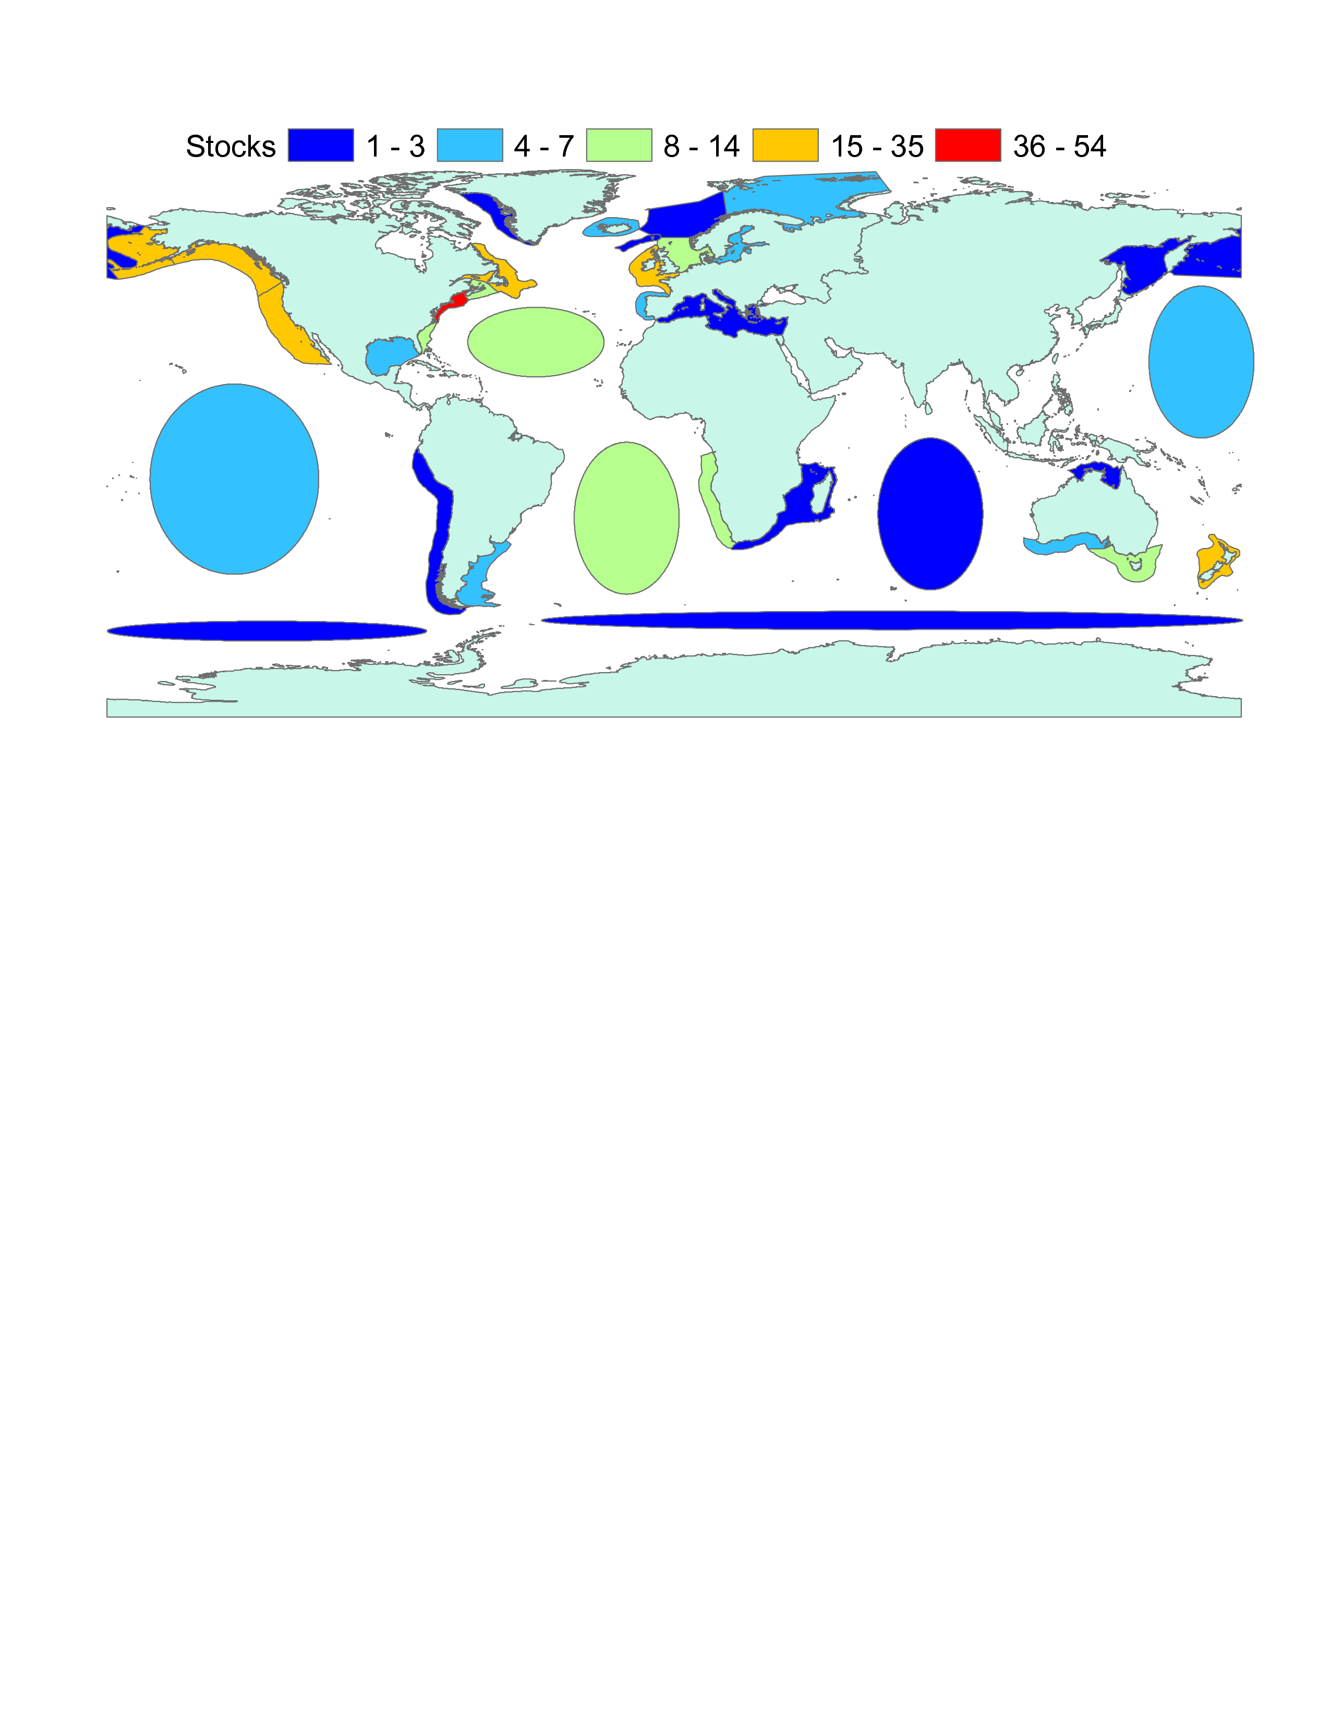
Figure 1:

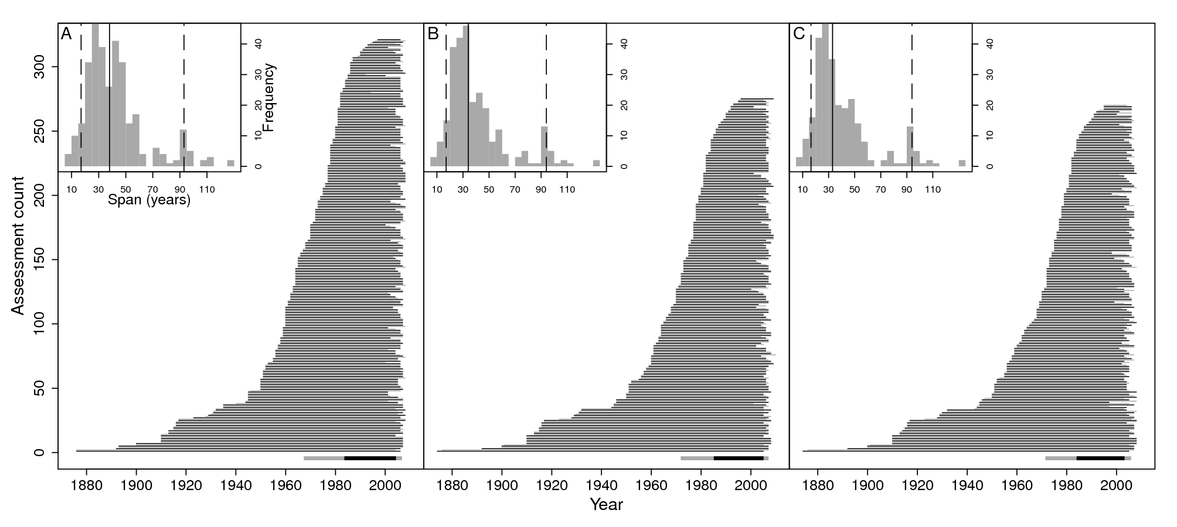
Figure 2:

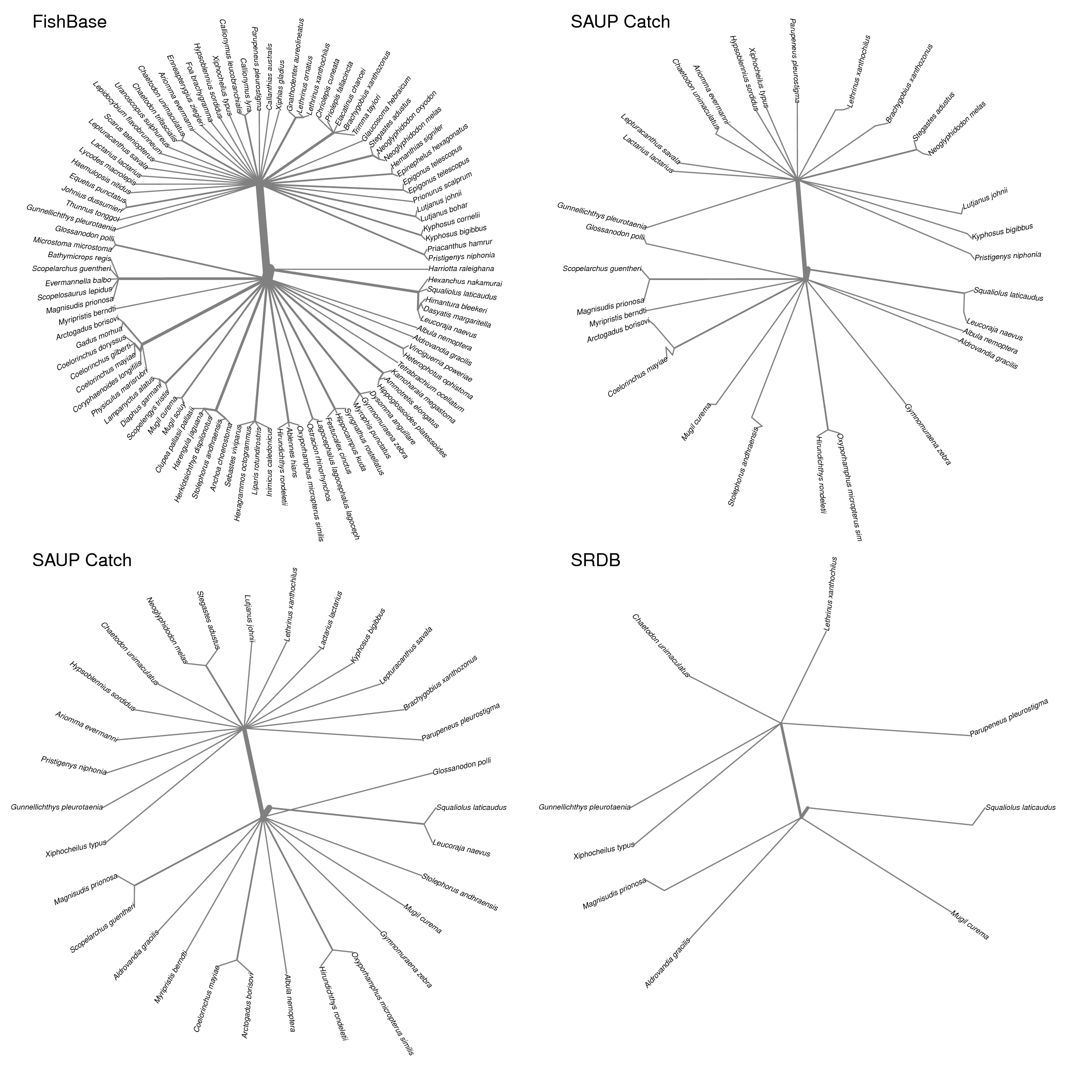
Figure 3:

7 Supporting Information

7.1 Entity relationship diagram

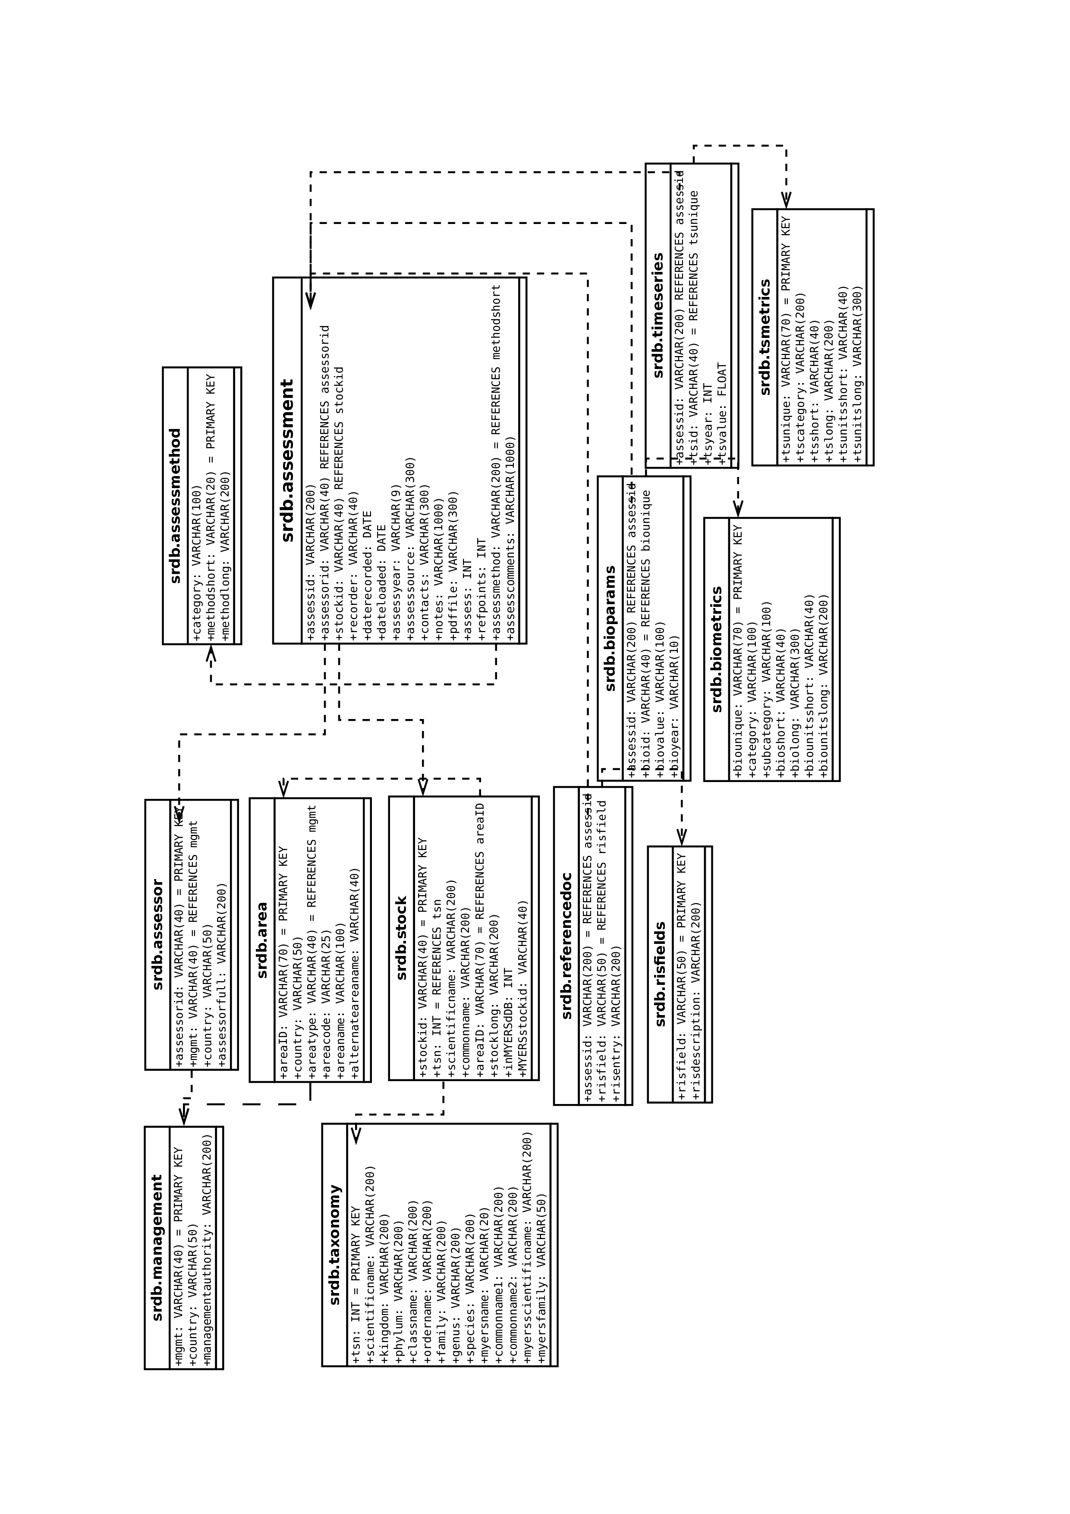
Figure 4: Entity relationship diagram of the RAM legacy database.

