Assessing the knowledge-base for commercially exploited marine fishes and invertebrates with a new global database of stock assessments
Alternative Title 1: A new global stock assessment database for exploited marine species
Alternative Title 2: Understanding marine fish population dynamics using a new global database
Daniel Ricard^{1*}, Cóilín Minto¹, Julia K. Baum^{2,‡}, Olaf P. Jensen³
1 Department of Biology, Dalhousie University, Halifax, NS B3H 4J1, Canada
2 Scripps Institution of Oceanography, UCSD, 9500 Gilman Drive, La Jolla, CA 92093-0202, USA
3 School of Aquatic and Fishery Sciences, University of Washington, Seattle, WA 98195-5020, USA

*Corresponding Author: Tel: 902-494-2146, Fax: 902-494-3736,
Email: ricardd@mathstat.dal.ca
‡Current Address: National Center for Ecological Analysis and Synthesis, UCSB, 735 State St. Suite 300, Santa Barbara, CA 93101, USA

Suggested Running Title: A new global stock assessment database

Abstract
Data used to assess the status of individual fish stocks varies from very little information on many of the world’s artisanal fisheries, to commercial landings at various levels of geographic and taxonomic aggregation, research surveys, and sophisticated population dynamics models that integrate many sources of information. Previous evaluations of the state of global fisheries have used catch or landings data, which may be poor proxies for fish stock abundances. A global compilation of stock assessment data in the mid-1990s enabled substantial syntheses of stock status; however the focus of this database was on stock-recruitment relationships and it is now 15 years out of date. To facilitate contemporary syntheses, we have assembled a comprehensive database of the most intensively studied commercially exploited marine fish stocks. The database includes time series of: total biomass, spawner biomass, recruits, fishing mortality, and catch; reference points; and ancillary information on the life history, management, and assessment methods for each stock. Here, we present the first overview of the structure and content of the database. We further evaluate the knowledge-base for assessed marine fishes. Globally, publicly available stock assessments were collated for 347 stocks (305 species of fishes representing 46 families and 42 species of invertebrates representing 13 families), from 18 national and international management institutions. Assessments are available for only XX percent of global marine fisheries catches by weight and XX percent by value. There is substantial spatial variation in availability of assessed stocks, with XX percent coming from north temperate regions (North Atlantic, North Pacific). Geographic differences in assessment methods show that, as of 2008, Statistical Catch at Age (SCA) models are widely used by the west coast of the U.S. (XX percent of assessments), regional fishery management organizations in the Pacific (XX percent of assessments), and New Zealand (XX percent of assessments); the east coast of the U.S. is transitioning from Virtual Population Analysis (VPA) to SCA (XX percent of assessments conducted since 2000 have used SCA); while VPA is still the dominant assessment technique in western Europe (XX percent of assessments).

Keywords: marine fisheries, meta-analysis, population dynamics models, relational database, stock assessment, synthesis.

Introduction
Marine wild capture fisheries provide more than 80 million tons of fisheries products (both food and industrial) per year and employ 43.5 million people (wild capture and aquaculture, FAO (2009)). At the same time, fishing has been recognized as one of the most widespread human impacts in the world’s oceans (Halpern et al., 2008), and the UN Food and Agriculture Organization estimates that two-thirds of fish stocks are fully exploited or overexploited (FAO, 2009). While many fisheries have reduced exploitation rates to levels that should promote recovery, overfishing continues to be a serious global problem (Worm et al., 2009). Fishery managers are asked to address multiple competing objectives including maximizing yields, ensuring profitability, reducing bycatch, and minimizing the risk of overfishing. Given the enormous social and economic costs (Rice et al., 2003) and ecosystems consequences (Frank et al., 2005; Myers et al., 2007) of collapsed fisheries, it is imperative that we are able to quickly learn the lessons of successful and failed fisheries from around the world.
Effective management of exploited fish populations generally requires an understanding of where the current population size and harvest rate lie in relation to the population size and harvest rate which maximize fishery benefits or limit the risk of overfishing. This process of quantitative determination of stock status and estimation of reference points is called stock assessment. Some fisheries in developing countries have apparently provided sustainable yields for long periods of time without formal stock assessment (e.g., many community-managed fisheries in Oceania, Johannes (2002)). This has been achieved by limiting harvest rates, often through gear restrictions or seasonal or area closures. In modern industrialized fisheries where fishing capacity exceeds the productivity of fished stocks, however, stock assessment is an integral component of responsible management (Hilborn and Walters, 1992).
Even in developed countries, however, not all fished stocks are assessed. For example, in 2007, of the 528 fish and invertebrate stocks recognized by the National Marine Fisheries Service (NMFS), only 179 or slightly over one third were fully assessed (National Marine Fisheries Service, 2008). An assessment by the European Environment Agency (EEA) in 2006 indicated that the percentage of commercial landings obtained from assessed stocks ranged between 66-97 percent in northern European waters and 30-77 percent in the Mediterranean (European Environment Agency, 2009). The New Zealand Ministry of Fisheries reports the status of 117 stocks or sub-stocks out of a total of 628 stocks managed under New Zealand’s Quota Management System (New Zealand Ministry of Fisheries, 2009). In Australia, 98 federally managed stocks have been assessed (Wilson et al., 2009) out of an unknown total. The extent to which stocks are assessed elsewhere in the world is currently unknown.
The global database of fishery landings compiled by Food and Agricultural Organization of the United Nations (FAO, 2009) and synthesized by the Sea Around Us project (Watson et al., 2004) has proven to be a valuable resource for understanding fishery status; however, catch data alone can be misleading when used as a proxy for stock size. Many papers have used these catch databases to examine changes in fishery status (Worm et al., 2006; Costello et al., 2008), including changes in trophic level (Pauly et al., 1998; Essington et al., 2006; Newton et al., 2007). Most of these analyses rely (either explicitly or implicitly) on the assumption that catch or landings is a reliable index of stock size. Critics have pointed out that catch can change for a number of reasons unrelated to stock size, including changes in targeting, fishing restrictions, or market preferences (de Mutsert et al., 2008; Murawski et al., 2007; Hilborn, 2007). Even when catch is standardized by the amount of fishing effort (catch-per-unit-of-effort, CPUE), it can be an unreliable index of relative abundance (Hutchings and Myers, 1994; Harley et al., 2001; Walters, 2003; Polacheck, 2006). Stock assessments consider time series of catch along with other sources of information such as: natural mortality rates, changes in size or age composition, stock-recruitment relationships, and CPUE of different sectors or of fishery-independent surveys. Because they integrate across multiple sources of information, stock assessment models are thought to provide a more accurate picture of changes in abundance than catch data alone (Sibert et al., 2006). Yet, without a current and comprehensive database of stock assessments, scientists wishing to conduct comparative analyses of marine fish population dynamics and fishery status have little choice but to use problematic catch data.
The first global database of stock assessment information, the Myers Stock Recruitment Database, was developed by Ransom Myers and colleagues in the mid-1990s (Myers et al., 1995b). While the database was primarily known for its time series of stock and recruitment, it did contain time series of fishing mortality rates for many stocks but biological reference points were largely absent. The original release version of the Myers database (Myers et al., 1995b) contained spawning stock size and recruitment time series for 274 stocks representing 92 species as well as time series of fishing mortality rates for 144 stocks. It was used to: 1. decisively answer the question of whether recruitment shows any relationship to spawning stock size (Myers and Barrowman, 1996), 2. investigate potential depensation in stock-recruitment relationships (Myers et al., 1995a; Liermann and Hilborn, 1997; Garvey et al., 2009), 3. investigate density-dependent juvenile mortality (Myers, 2001; Minto et al., 2008), and 4. develop informative Bayesian priors on steepness (Myers et al., 1999, 2002; Dorn, 2002) , amongst others. The Myers database has also been used for several studies of collapse and recovery of exploited fish populations (Hutchings, 2000, 2001; Hilborn, 1997).
Although the original Myers database (Myers et al., 1995b) has proven to be a valuable resource, it is now 15 years out of date. For stocks that were depleted in 1995, these additional 15 years include valuable observations at low stock size or of a recovering population, both of which are critical for estimating population dynamics parameters such as the behaviour of the stock-recruitment relationship near the origin. In addition, there have been numerous improvements in stock assessment methodologies (including important advances in statistical catch-at-age or catch-at-length models) and assessments have been conducted for the first time for many species.
Previous meta-analyses of fishery status have been hampered by the lack of a global assessment database containing biological reference points (BRPs, e.g., the biomass and fishing mortality rate that produce maximum sustainable yield, 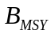and 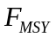, respectively). Knowledge of BRPs is important if stocks are to be managed for high yields that can be sustained over time (Mace, 1994). Without information on reference points, previous analyses of stock assessments or catch data have been forced to use non-biological thresholds to define fishery status, such as the greatest 15 year decline (Hutchings and Reynolds, 2004) or 10 percent of maximum catch (Worm et al., 2006). Ad hoc reference points based on some fraction of the maximum of a time series also have undesirable statistical properties and can result in false collapses when applied to inherently variable time series of catch or abundance (Wilberg and Miller, 2007; Branch, 2008). Complicating comparisons of fishery status is the fact that different BRPs are used in different parts of the world and even the same BRP can be used in a different manner, for example, as a target or a limit.
Here we present a new global database of stock assessments for commercially exploited marine fish populations. The database is an update and extension of that developed by Ransom Myers, and is named the RAM Legacy database in honor of his pioneering contribution. This effort is the first global stock assessment database to:
1. Use a formal relational database structure;
2. Use source control software to organize release versions;
3. Include metadata related to the geographic location of the stock, the type of assessment model used, and the original source document for the assessment data;
4. Include biological reference points and stock-specific life history information.
We use the database to assess the knowledge-base for management of marine fish populations and address the following questions:
1. What fraction of world wild-capture fishery landings come from assessed stocks and how does this proportion vary by region?
2. What is the temporal coverage of stock assessments, i.e. how far back do stock assessments look when reconstructing trends in abundance?
3. What are the taxonomic and geographic biases, if any, in assessed stocks?
4. Which stock assessment approaches and biological reference points are used and how does this vary by region?
5. How does stock status (biomass and fishing mortality rates relative to reference points) differ among regions?
5.
6.

Methods

The RAM Legacy Database

The RAM Legacy database is a relational database designed and developed to store data from all current and accessible population dynamics model-based fisheries stock assessments for marine fish and invertebrate populations globally. Time series of spawning stock biomass (SSB), total biomass (TB), recruits (R), total catch (TC) or landings (TL), and fishing mortality (F) from individual stock assessments form the core of the database. Apart from catch/landings, these time series are not raw data, but rather the output of population dynamics models; depending on the type of model conducted not all of these time series were available for every stock. The database also contains details about the time series data, including the age and sex of spawners, age of recruits, and the ages used to compute the fishing mortality, as well as BRPs and some life history information (e.g. growth parameters, age and length at 50% maturity, natural mortality). Meta-data for each stock assessment consists of taxonomic information about the stock (retrieved from the Integrated Taxonomic Information System (ITIS) (http://www.itis.gov)), the geographic location of the stock (primary, and in some cases, secondary and tertiary Large Marine Ecosystem, LME), the management body that conducted the assessment, the assessment model type, the reference for the stock assessment document, the name of the recorder entering the assessment data, and the date the assessment was entered. Many assessments, particularly those for invertebrates, were based only on CPUE time series rather than population dynamics models, and we did not include these in the database.

We employed a variety of search methods in an attempt to obtain all recent fisheries stock assessments. Publically available stock assessment reports available from the internet were the primary data source. These reports were obtained either from the website of the relevant management agency or directly from stock assessment scientists. Assessments also were obtained from the primary literature and through personal contacts at fisheries management agencies. Significant contributions also were made by other members of the NCEAS working group ‘Finding common ground in marine conservation and management’. Relevant assessment data were first transferred into a standardized spreadsheet template by a number of recorders, including ourselves, assessment authors, our NCEAS collaborators, and associated graduate students and postdoctoral researchers, and then uploaded into the relational database management system by the first author.

Database structure and advantages
The database is implemented in the Open Source PostgreSQL relational database management system (RDBMS) (PostgreSQL Global Development Group, 2009), and includes tables for the assessment metadata, timeseries values, timeseries units, and biometrics (a catch-all term for data, such as life history characteristics or BRPs, that are not part of a timeseries). The relationship between the thirteen database tables is shown in the entity relationship diagram (Fig. S1).

RDBMSs form the server back-end to a great many applications of interest to ecologists, including web-clients and GIS softwares, and have a number of advantages over spreadsheet or flat text file data compilations. First, housing stock assessments in an RDBMS allows multiple users to concurrently access and extract subsets of persistent data in an efficient and reproducible manner. Second, with the development of Application Programming Interfaces (APIs) that allow analytical softwares to directly communicate and extract data from the PostgreSQL database, a common data environment is established, independent of one’s choice of analytical software (e.g., SAS:SAS ACCESS, Matlab: Matlab/Database, R:RDBI/RODBC, Perl:DBI, etc.). Users familiar with Structured Query Language (SQL) can therefore query the database directly from their analytical software of choice and the same SQL query will extract the same data through each of these applications. Third, data products tailored to specific projects can be generated and stored as dynamic (continually updated) “views” within the database. These are typically rectangular, spreadsheet-like results of an expansive query of the relevant tables that can be readily read into all commonly-used analytical softwares. The use of views is, however, greatly advantageous over manipulating spreadsheets or flat text files for importing into a specific analytic software, which runs the risk of losing data integrity (e.g. multiple copies) and becomes impractical with large, non-rectangular, datasets and multiple users.

Data integrity and quality control
We have employed several mechanisms to ensure that the database is of high quality. During the data recording process, assessment authors often were contacted to clarify aspects of the assessment or to obtain more detailed data. Time series data presented in figures were, for example, only entered into the database if the exact numbers could be obtained from the asssessment or its authors. In cases where multiple models were presented in an assessment without a preferred or ‘best’ model being denoted, we attempted to ascertain which model was preferred by the stock assessment scientist, but included all model results whenever this was not possible. Once uploaded into the database all stock assessments underwent an additional ‘Quality Assurance/Quality Control’ (QA/QC) step, to ensure that the entered data replicated that of the original assessment document exactly. This process consisted of creating a ‘QA/QC’ summary document for each assessment, containing summary details of the stock, a selection of biometrics and ratios for comparison (e.g. current biomass relative to the reference point), and time series plots of the biomass, recruitment, and exploitation trajectories. QA/QC documents were then returned to assessment recorders and an electronic trail of subsequent correspondence was captured in a Plone bug tracking system. Recorders were responsible for checking, and where necessary correcting, their QA/QC documents, after which all corrections were transmitted back to the operational database and a quality controlled flag was inserted to signify the assessment had passed the check. Only assessments that have passed this QA/QC step are available for subsequent analyses.

Links to related databases
To facilitate integration of the RAM Legacy database with related databases, such as Fishbase (Froese and Pauly, 2009) and the Sea Around Us Project’s (SAUP) global landings database (Watson et al., 2004), each species present in the RAM Legacy database was assigned a matching FishBase species name and species code as well as the SAUP taxon code. Additionally, each stock was assigned to a primary, secondary, and tertiary Large Marine Ecosystem (LME) (NOAA, 1998). LMEs encompass the continental shelves of the world’s oceans and represent the most productive areas of the oceans.
Open ocean areas beyond the continental shelves are, however, not included. Large, highly migratory oceanic species such as tuna were therefore assigned to new categories “Atlantic High Seas”, “Pacific High Seas”, “Indian High Seas”, and “Subantarctic High Seas”.

Database analyses: Assessing the knowledge-base for commercially exploited stocks
We first assess the scope of the stock assessments held in the current version of the RAM Legacy database (Version 1.0, 2010) in terms of institutional contributions, geography, taxonomy, global fisheries, timespan, and ecology. To evaluate the taxonomic scope of the database, we compare the taxonomy of assessed stocks with the diversity of i) all marine fishes (as represented by FishBase), and ii) marine fishes in global fisheries catches (as represented by the SAUP database), and discuss taxonomic biases in species included in catch data and in populations assessed using stock assessments. To determine what fraction of world wild-capture fisheries landings come from assessed stocks, we used the SAUP’s average global fisheries catches from the most recent ten years of available data (1995-2004); we also discuss limitations to obtaining assessments for some of the world’s major fisheries.

Next, we briefly overview the types of asssessment models and BRPs contained within the stock assessments, and the frequencies of different assessment methods and BRPs overall and by management body..

We then evaluate the status of assessed stocks overall and by management body, using standard reference points so that all stocks are referenced to a comparable benchmark. Following Froese and ProelB (2010) and Worm et al. (2009), we compare the current abundance and fishing mortality rate of stocks relative to their MSY reference points, B_{msy} and F_{msy}, respectively. For those assessments that did not contain MSY reference points, but did include total catch (TC_{i,s} i ∈ 1,...,n_{s}) and total biomass (TB_{i,s} i ∈ 1,...,n_{s}) timeseries data,
we used a Schaefer surplus production model.to estimate total biomass and fishing mortality at Maximum Sustainable Yield (TB_{MSYs} and MSY_{s}, respectively) for the stock (s) as follows:
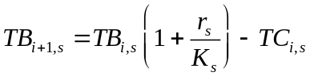 (1)
where, and 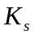 are the intrinsic growth rate and carrying capacity of stock s, respectively. BRPs are obtained from:
TB_{MSYs} = K_{s} / 2 (2)
MSY_{s} = r_{s} K_{s} / 4 (3)
U_{MSYs} = MSY_{s}/ TB_{MSY,s} (4)
(Quinn & DeRiso 1999).

Finally, we discuss potential applications of the database, point out its limitations and caveats about its use, and outline directions for future development.

Results

Scope of the RAM Legacy Database

In total, 347 recent stock assessments for 305 marine fish and 42 invertebrate populations are included in the RAM Legacy database (Version 1.0, 2010).

Management bodies and geography
The database includes stocks assessed by fisheries management bodies in Europe, the United States, Canada, New Zealand, Australia, Russia, South Africa and Argentina (Table 1). Also included are assessments conducted by eight Regional Fisheries Management Organizations (RFMOs), in the Northwest Atlantic, Atlantic, Pacific and Indian Ocean (Table 1). Assessments from the United States comprise by far the most stocks of any country or region (n=150); assessments from the European Union’s management body ICES comprise the the second greatest number of stocks (n=64). Whereas nations are responsible for managing all populations within their EEZs, RFMOs typically focus on a certain type of species (e.g. halibut, tunas) or fisheries (e.g. pelagic high seas) within a given area and hence assess a smaller number of stocks.

Most assessments come from North America, Europe, Australia, New Zealand and the High Seas, while few are entered from regions such as Southeast Asia, South America, and the Indian Ocean (outside Australian waters) (Figure 1). LMEs with the greatest number of assessed stocks are the Northeast U.S. Continental Shelf (n=88), the California Current (n=35, the East Bering Sea (n=32), the New Zealand Shelf (n=29), the Gulf of Alaska (n=28), the Celtic-Biscay Shelf (n=24) and the Newfoundland-Labrador Shelf (n=21) (Figure 1).

Taxonomy
One hundred and sixty-eight species from fifty-nine families and XX orders are included in the database (Figure 2). .Five taxonomic orders (Clupeiformes, Gadiformes, Pleuronectiformes, Perciformes and Scorpaeniformes) account for 67(?)% of available stock assessments. Of these, Perciformes, the most speciose Order of marine fishes are in fact underrepresented in the database (46.04% of all marine fish species, Figure 3a vs. XX% of all marine fish assessments), while it is the other four orders that are taxonomically overrepresented: Clupeiformes (2.1% of marine fishes vs. XX% in the database), Gadiformes (3.3% of marine fishes vs. XX% in the database), Pleuronectiformes (4.5% of marine fishes vs. XX% in the database), Scorpaeniformes (8.5% of marine fishes vs. XX% in the database).

Assessed marine fish stocks in the RAM Legacy database comprise a relatively small proportion of harvested taxa (XX% of fish species from the SAUP database) and an even smaller proportion of marine fish biodiversity (XX% of fish species in FishBase; Figure 3). In turn, catches from the SAUP database, which come from XX species and XX orders (Figure 3b), represent onlg XX% of the 12339 species and XX% of the 54 different orders in FishBase that (FigureX3a,b).

The paucity of marine invertebrate stock assessments means these species are more poorly taxonomically represented in the database than fishes (Figure 4XX). Only XX% .....
Any reference on number of marine invertebrate species? In total, and how many are listed in SAUP?

Global Fisheries

-Need ‘In Database’ column of Table 2 filled in to write this part

Timespan
Of the 347 stock assessments, time series data of catch/landings were available for 321 stocks (X%), of SSB for 275 stocks, and of recruitment for 270 stocks (X%). The median lengths of catch/landings, SSB, and recruitment timeseries were 38, 34, and 33 years, respectively (Figure 5). The time period covered by 90% of assessments is: catch/landings (XX-XX), SSB (XX-XX), recruitment (XX-XX), whiledthat covered by 50% of assessments is: catch/landings (XX-XX), SSB (XX-XX), recruitment (XX-XX) (Figure 5).

Ecology
Assessed species in the dataspan span a range of ecological traits..... [need trophic level plot here; Figure 6). -assessemnts by trophic level – can we make a barplot showing number of stocks by trophic level for a) overexploited, and b) not overexploited species (i.e. could be on same plot but different hatching for the a vs. b. While the total number and percentage of assessments that reported any life-history information (growth, maturity, fecundity) was REF:SQL:NUMASSESSLIFE.

Stock assessment methodologies and BRPs
Of the 347 assessments in the database, 321 use a population dynamics model while the remaining 26 are based on indices of relative abundance from scientific surveys. The most common assessment methods were Statistical catch-at-age/length models (n=162), Virtual Population Analyses (n=89) and Biomass dynamics model (n=44). .....Need to add a sentence here about the regional differences.... .

The total number and percentage of assessments that reported biomass- or exploitation- based reference points was 261 (75%) and 223 (64%), respectively.

Status of Assessed Stocks
Need to know:
% of stocks with biomass below Bmsy
% of stocks with
overall and by management body.

4 Discussion
The RAM Legacy Database of available stock assessments for the world’s marine fisheries, although non-exhaustive, provides a basis to evaluate the existing knowledge-base of exploited marine populations. The stocks comprising the database are predominantly from developed nations with properly identified fisheries management bodies and tend to cover a recent time period. Few assessments extend back beyond 30 years from present. The taxonomic makeup of available assessments is a very limited subset of the accepted taxonomic coverage of marine species worldwide.

Biases

Geographic bias
There are important geographic biases in the amount of assessments entered per LME

The question of geographic bias relates to whether: [1)] 1. an assessment is conducted on a stock; 2. it is possible to access the assessment; and 3. the non-exhaustive collation we undertook may have overlooked the assessment . Whether an assessment is conducted for a given stock depends upon a multitude of factors, including the economic value of the stock and availability of fiscal resources to collect the data required for an assessment. How accessible assessments are for entry depends upon the transparency and access policies of the relevant management agencies, which varies geographically. Similarly, the legal context where fisheries are prosecuted will strongly influence the requirement for conducting stock assessments. In the United States, the Magnuson-Stevens Act defines what stocks are to be monitored and managed, hence a large number of the assessments in the RAM Legacy database are under the jurisdiction of the US National Marine Fisheries Services.
Our incomplete search for assessments could also give rise to geographic biases, as concerted collation efforts have only been conducted in those assessment-rich regions of
It is hoped that readers of this article can assist in correcting these biases by participating in future updates of the RAM Legacy database.

Note Also: from Figure 4 SOFIA 2008 (FAO 2009) the top – The top 10 wild-caught marine fisheries producer countries are China, Peru, U.S.A., Indonesia, Japan, Chile, India, Russia, Thailand, Philippines. We only have assessments for U.S.A. and Russia (and only 2 for Russia!). Most major fish producing countires do not do assessments or do not make them accessible!you ecide i

Taxonomic bias
Taxonomic biases in those species that are assessed include ...

Caveats and limitations
Assessment outputs e.g. biomass timeseries, are model estimates, not raw data. The uncertainty associated with these estimates should be carried forth in subsequent analyses. The RAM Legacy database structure allows for estimates of uncertainty (standard errors, 95% credible/confidence intervals), however these estimates are often missing from assessments either because they aren’t produced by the assessment model (e.g. non-bootstrapped VPA assessments) or the focus of the assessment document was on central tendency (e.g. mean biomass), not the associated uncertainty. Note that this view is changing with the advent of MCMC aproaches to Bayesian inference for assessments, bootstrap methods, statistical catch-at-age models, delta method approximations (ADMB Project, 2009) and a general focus on uncertainty (Walters and Maguire, 1996). As with any analysis, clearer inference on the strength of a signal is available when all uncertainty in the data is carried forth. This represents a difficulty for large-scale analyses of fisheries data in that in an ideal world one would access the raw data per sub-unit (e.g. stock) and carry forth the uncertainty at all levels of the analysis. In the case of assessments, the raw data is typically catch-at-age matrices and potentially survey indices. To understand the fleet characteristics and survey stratification schema for each stock in a potentially global meta-analysis would be extremely time consuming and error-prone. So, the expert opinion of those researchers most familiar with the data, stock assessment authors, is used but without accompanying uncertainty estimates the strength of conclusions drawn may be weakened.
The original database developed by Dr. Myers was used to address a variety of ecological question derived from stock-recruit relationships. This was possible because of the timeseries of stock and recruitment generated in assessment using VPA-type models. With the increasing use of statistical catch-at-age/length models, an underlying stock-recruit relationship is assumed to exist. Estimating the parameters of a stock-recruit relationship using timeseries from such models does not constitute a valid statistical procedure. More generally, the increasing use of Bayesian methods that incorporate prior information poses a challenge for meta-analysis of such model outputs.
Point data are stored in the database with an associated unit, value and year. We expect to also include age-varying and length-varying data such as maturity ogive and age-disaggregated natural mortality in subsequent releases of the RAM Legacy database. In addition to the initial aim of providing reliable access to timeseries information about stocks, we hope to also stimulate research in the relationships of life-history characteristics and their relation to exploitation.

Future Development
It is anticipated that the RAM Legacy database will continue to grow with hitherto unentered stocks and updated assessments for already included stocks. The ultimate goal is to provide a data standard for researchers to use results from multiple regions to assist in their own applied and fundamental research in population ecology, fisheries science, and conservation biology. The development of a standard for assessment reporting would assist in realizing this goal. For example, ICES assessments have a very regular standard, including agreed-upon reference points and regular estimate reporting. This makes the process of data collation much more routine than unstandardized documents where the recorder trawls through a report for information. Certainly different stocks and regions require different formats but the basic output tables, consisting of total and spawning biomass, recruitment, catch/landings, estimated fishing mortality over vulnerable age groups, associated measures of uncertainty, and commonly-used reference points would streamline the process immensely. A process whereby the assessment spreadsheets are filled out at each assessment meeting would be the least error prone method. In return, the assessment scientists can access results for a global collation of assessments to further their own research initiatives in population assessment and management. Other products include management-agency-level reports containing summaries of all stocks within their remit. Future versions to the database will also include timelines of management actions per stock. The RAM Legacy database contains the corresponding species codes to the Sea Around Us Project and FishBase, thus facilitating researchers’s use of a global fisheries data “toolkit” to address questions on the relationships between life history attributes and resulting population dynamics in an exploited setting.

Availability of the database
Contributions or corrections to the existing database, as well as requests to use the database (subject to standard “Fair Use” policies), should be directed to the corresponding author.

Acknowledgments
We sincerely thank all of the fisheries scientists around the world for conducting the stock assessments that form the basis of this new global database. We are also grateful for the database contributions, advice, and support of Trevor Branch, Jeremy Collie, Laurence Fauconnet, Mike Fogarty, Rainer Froese, Ray Hilborn, Jeff Hutchings, Simon Jennings, Heike Lotze, Pamela Mace, Michael Melnychuk, Ana Parma, Renee Prefontaine, Boris Worm, Dirk Zeller, and the financial support of the National Science Foundation through an NCEAS Working Group, the Natural Sciences and Engineering Research Council (NSERC) of Canada, the Canadian Foundation for Innovation, the David H. Smith Conservation Research Fellowship, the Schmidt Research Vessel Institute, and the Census of Marine Life (CoML/FMAP).
References
ADMB Project (2009). AD Model Builder: automatic differentiation model builder. Developed by David Fournier and freely available from admb-project.org.

Barbrook, A., Howe, C., Blake, N. & Robinson, P. ( 1998).
The phylogeny of the Canterbury Tales.
Nature (London) 394(6696), 839.
Branch, T. (2008).
Not all fisheries will be collapsed in 2048.
Marine Policy 32, 38-39.
Costello, C., Gaines, S.D. & Lynham, J. ( 2008).
Can catch shares prevent fisheries collapse?
Science (Washington) 321(5896), 1678-1681.
de Mutsert, K., Cowan, Jr., J.H., Essington, T.E. & Hilborn, R. (2008).
Reanalyses of Gulf of Mexico fisheries data: Landings can be misleading in assessments of fisheries and fisheries ecosystems.
Proceedings of the National Academy of Sciences 105(7), 2740-2744.
Dorn, M. (2002).
Advice on West Coast rockfish harvest rates from Bayesian meta-analysis of stock-recruit relationships.
North American Journal of Fisheries Management 22, 280-300.
Essington, T.E., Beaudreau, A.H. & Wiedenmann, J. ( 2006).
Fishing through marine food webs.
Proceedings of the National Academy of Science 103(9), 3171-3175.
European Environment Agency (2009).

FAO (2009).
FISHSTAT-PC: Data retrieval, graphical and analytical software for microcomputers.
Frank, K., Petrie, B., Choi, J. & Leggett, W. ( 2005).
Trophic cascades in a formerly cod-dominated ecosystem.
Science (Washington) 308(5728), 1621-1623.
Froese, R. & Pauly, D. (2009).
FishBase www.fishbase.org, version (10/2009).
World Wide Web electronic publication.
Garvey, J., Wright, R. & Marschall, E. ( 2009).
Searching for threshold shifts in spawner-recruit data.
Canadian Journal of Fisheries and Aquatic Sciences 66, 312-320.
Halpern, B., Walbridge, S., Selkoe, K. et al. ( 2008).
A global map of human impact on marine ecosystems.
Science (Washington) 319(5865), 948-952.
Harley, S., Myers, R. & Dunn, A. ( 2001).
Is catch-per-unit-effort proportional to abundance?
Canadian Journal of Fisheries and Aquatic Sciences 58, 1705-1772.
Hilborn, R., ed. (1997).
The frequency and severity of fish stock declines and increases.
Developing and sustaining world fisheries resources. Proceedings of the 2nd World Fisheries Congress. CSIRO Publishing, Victoria, Australia.
Hilborn, R. & Walters, C.J. ( 1992).
Quantitative Fisheries Stock Assessment: Choice, Dynamics and Uncertainty.
Kluwer Academic Publishers.
Hilborn, R. (2007).
Biodiversity loss in the ocean: how bad is it?
Science (Washington) 316(5829), 1281.
Hutchings, J. (2000).
Collapse and recovery of marine fishes.
Nature (London) 406, 882-885.
Hutchings, J. (2001).
Influence of population decline, fishing, and spawner variability on the recovery of marine fishes.
Journal of Fish Biology Suppl. A, 306-322.
Hutchings, J. & Myers, R. (1994).
What can be learned from the collapse of a renewable resource? Atlantic cod, Gadus morhua, of Newfoundland and Labrador.
Canadian Journal of Fisheries and Aquatic Sciences 51, 2126-2146.
Hutchings, J. & Reynolds, J. ( 2004).
Marine fish population collapses: Consequences for recovery and extinction risk.
BioScience 54, 297-309.
Johannes, R. (2002).
The renaissance of community-based marine resource management in Oceania.
Annual Review of Ecology, Evolution, and Systematics 33, 317-340.
Liermann, M. & Hilborn, R. ( 1997).
Depensation in fish stocks: a hierarchic Bayesian meta-analysis.
Canadian Journal of Fisheries and Aquatic Sciences 54, 1976-1984.
Mace, P.M. (1994).
Relationships between Common Biological Reference Points Used as Thresholds and Targets of Fisheries Management Strategies.
Canadian Journal of Fisheries and Aquatic Sciences 51(1), 110-122.
Minto, C., Myers, R.A. & Blanchard, W. ( 2008).
Survival variability and population density in fish populations.
Nature (London) 452, 344-347.
Murawski, S., Methot, R. & Tromble, G. ( 2007).
Letter to the editors of Science.
Science (Washington) 316, 1281.
Myers, R.A. (2001).
Stock and recruitment: Generalizations about maximum reproductive rate, density dependence and variability using meta-analytic approaches.
ICES Journal of Marine Science 58, 937-951.
Myers, R. & Barrowman, N. (1996).
Is fish recruitment related to spawner abundance?
Fishery Bulletin 94, 707-724.
Myers, R., Barrowman, N., Hilborn, R. & Kehler, D. ( 2002).
Inferring bayesian priors with limited direct data: applications to risk analysis.
North American Journal of Fisheries Management 22, 351-364.
Myers, R., Barrowman, N., Hutchings, J. & Rosenberg, A. (1995a).
Population dynamics of exploited fish stocks at low population levels.
Science (Washington) 269, 1106-1108.
Myers, R., Baum, J., Shepherd, T., Powers, S. & Peterson, C. (2007).
Cascading Effects of the Loss of Apex Predatory Sharks from a Coastal Ocean.
Science 315(5820), 1846-1850.
Myers, R., Bowen, K. & Barrowman, N. ( 1999).
Maximum reproductive rate of fish at low population sizes.
Canadian Journal of Fisheries and Aquatic Sciences 56, 2404-2419.
Myers, R.A., Bridson, J. & N.J., B. ( 1995b).
Summary of Worldwide Spawner and Recruitment Data.
Canadian Technical Report of Fisheries and Aquatic Sciences, No. 2020 p. 327.
National Marine Fisheries Service (2008).
Status of US Fisheries 2007.
Tech. rep., NMFS.
Http://www.nmfs.noaa.gov/sfa/statusoffisheries/SOSmain.htm.
New Zealand Ministry of Fisheries (2009).
Stock Status http://fs.fish.govt.nz/Page.aspx?pk=16.
Newton, K., Côté, I., Pilling, G., Jennings, S. & Dulvy, N. (2007).
Current and Future Sustainability of Island Coral Reef Fisheries.
Current Biology 17(7), 655-658.
NOAA (1998).
Large Marine Ecosystems.
Tech. rep., National Oceanic and Atmospheric Administration.
Pauly, D., Christensen, V., Dalsgaard, J., Froese, R. & Torres, Jr., F. (1998).
Fishing Down Marine Food Webs.
Science (Washington) 279(5352), 860-863.
Polacheck, T. (2006).
Tuna longline catch rates in the Indian Ocean: Did industrial fishing result in a 90% rapid decline in the abundance of large predatory species.
Marine Policy 30, 470-482.
PostgreSQL Global Development Group (2009).
PostgreSQL, version 8.3.8. http://www.postgresql.org.
Rice, J., Shelton, P., Rivard, D., Chouinard, G. & Fréchet, A. (2003).
Recovering Canadian Atlantic cod stocks: the shape of things to come.
ICES CM 2003/U 06, 23pp.
Sibert, J., Hampton, J., Kleiber, P. & Maunder, M. ( 2006).
Biomass, Size, and Trophic Status of Top Predators in the Pacific Ocean.
Science (Washington) 314(5806), 1773-1776.
Walters, C. & Maguire, J. (1996).
Lessons for stock assessment from the northern cod collapse.
Reviews in Fish Biology and Fisheries 6(2), 125-137.
Walters, C. (2003).
Folly and fantasy in the analysis of spatial catch rate data.
Canadian Journal of Fisheries and Aquatic Sciences 60(12), 1433-1436.
Watson, R., Kitchingman, A., Gelchu, A. & Pauly, D. (2004).
Mapping global fisheries: sharpening our focus.
Fish and Fisheries 5, 168-177.
Wilberg, M. & Miller, T. (2007).
Comment on "Impacts of biodiversity loss on ocean ecosystem services".
Science (Washington) 316, 1285b.
Wilson, D., Curtotti, R., Begg, G. & Phillips, K., eds. (2009).
Fishery status reports 2008: status of fish stocks and fisheries managed by the Australian Government.
Bureau of Rural Sciences and Australian Bureau of Agricultural and Resource Economics, Canberra.
Worm, B., Barbier, E., Beaumont, N. et al. ( 2006).
Impacts of Biodiversity Loss on Ocean Ecosystem Services.
Science (Washington) 314, 787-790.
Worm, B., Hilborn, R., Baum, J.K. et al. ( 2009).
Rebuilding global fisheries.
Science (Washington) 325, 578-585.

Table 1. Number of assessments included in the RAM Legacy database by country and ocean basin with associated national management bodies and regional fisheries management organizations (RFMOs) respectively.

Country/Ocean | Management Body | Acronym | No. stocks
Argentina | Consejo Federal Pesquero | CFP | 6
Australia | Australian Fisheries Management Authority | AFMA | 16
Canada | Department of Fisheries and Oceans | DFO | 22
Europe | International Council for the Exploration of the Sea | ICES | 63
New Zealand | Ministry of Fisheries | MFish | 29
Russia | Russian Federal Fisheries Agency | RFFA | 2
South Africa | Department of Environment and Tourism, Marine and Coastal Management | DETMCM | 14
USA | National Marine Fisheries Service | NMFS | 137
 | US state-level management | US State | 3
Atlantic Ocean | International Commission for the Conservation of Atlantic Tunas | ICCAT | 10
 | Northwest Atlantic Fisheries Organization | NAFO | 8
Indian Ocean | Indian Ocean Tuna Commission | IOTC | 1
Pacific Ocean | Inter-American Tropical Tuna Commission | IATTC | 2
 | International Pacific Halibut Commission | IPHC | 1
 | South Pacific Regional Fisheries Management Organization | SPRFMO | 1
 | Western and Central Pacific Fisheries Commission | WCPFC | 4
Antarctic | Commission for the Conservation of Antarctic Marine Living Resources | CCAMLR | 1

Table 2. The world’s forty largest wild-caught fisheries (comprising >41% of total global catches, based on average catches 1995-2004 in SAUP database), and the thirty largest fisheries of individual stocks (i.e. fisheries identified to the species level; comprising >32% of total global catches), including their LME, whether or not stock assessments for them are included in the RAM Legacy database, and the reason if not included (e.g. 1= no known assessment, 2=assessment is not based on a population dynamics model, 3=assessment inaccessible).

Stock Rank | Species (Common name, Latin name) or higher taxonomic unit | LME | In Database? | Reason if not included
1 | Peruvian anchoveta, Engraulis ringens | Humboldt Current
 | Marine fishes not identified | South China Sea | -
 | Marine fishes not identified | Bay of Bengal | -
2 | Alaska pollock, Theragra chalcogramma | Okhotsk Sea
3 | Ammodytes | North Sea | ✓
4 | Atlantic herring, Clupea harengus | Norwegian Sea | ✓
5 | Alaska pollock, Theragra chalcogramma | East Bering Sea | ✓
6 | Capelin, Mallotus villosus | Iceland Shelf/Sea | ✓
7 | European pilchard, Sardina pilchardus | Canary Current | ✓
8 | Japanese anchovy, Engraulis japonicus | East China Sea
9 | Inca scad, Trachurus murphyi | Humboldt Current | ✓
 | Marine fishes not identified | East China Sea | -
10 | Gulf menhaden, Brevoortia patronus | Gulf of Mexico | ✓
 | Marine fishes not identified | Yellow Sea | -
 | Marine fishes not identified | Indonesian Sea | -
11 | Alaska pollock, Theragra chalcogramma | Gulf ofAlaska
12 | Argentinean short-finned squid, Illex argentinus | Patagonian Shself
13 | Argentine hake, Merluccius hubbsi | Patagonian Shelf
14 | Japanese anchovy, Engraulis japonicus | South China Sea
15 | Araucanian herring, Strangomera bentincki | Humboldt Current
16 | Atlantic cod, Gadus morhua | Barents Sea | ✓
17 | European sprat, Sprattus sprattus | Baltic Sea
18 | Atlantic herring, Clupea harengus | North Sea | ✓
19 | Alaska pollock, Theragra chalcogramma | Arctic Ocean
 | Marine fishes not identified | Gulf of Thailand | -
20 | Atlantic herring, Clupea harengus | Baltic Sea | ✓
21 | Cape horse mackerel, Trachurus capensis | Benguela Current
22 | Largehead hairtail, Trichiurus lepturus | East China Sea
23 | Japanese anchovy, Engraulis japonicus | Yellow Sea
24 | European anchovy, Engraulis encrasicolus | Black Sea
25 | Chub mackerel, Scomber japonicus | East China Sea
26 | Indian oil sardine, Sardinella longiceps | Arabian Sea
 | Decapterus | South China Sea | -
 | Sciaenidae | Arabian Sea | -
27 | Atlantic mackerel, Scomber scombrus | North Sea
28 | Largehead hairtail, Trichiurus lepturus | Yellow Sea
 | Merluccius | Benguela Current | -
 | Marine fishes not identified | Kuroshio Current | -
29 | Alaska pollock, Theragra chalcogramma | Sea of Japan
30 | Round sardinella, Sardinella aurita | Canary Current

Figures
Figure 1. Global map of the # coastal Large Marine Ecosystems (LMEs) and different high seas areas (ovals) showing the number of stock assessments present in the RAM Legacy database for each area. Note: multiple polygons are used to depict the Pacific, Atlantic, and Subantarctic High Seas Areas but the number of assessments is summarized for each High Seas Area as a whole.

Figure 2. Taxonomic coverage of assessed marine species present in the RAM Legacy database. The circle located near the middle of the circular dendrogram represents kingdom Animalia and each subsequent branching represents a different taxonomic group (Kingdom to Phylum to Class to Order to Family to Genus to Species). The width of each line is proportional to the square root of the number of assessments in the database. The outermost lines represent species and the number of lines is the number of assessments for each species. The names of multi-assessment species are not repeated on the outermost portion of the dendrogram but continue counter-clockwise from the first entry. Note that branch lengths are chosen for graphical purposes and do not convey phylogenetic distance.

Figure 3. Comparison of the taxonomic diversity of marine species A) in FishBase (top-left panel) with that of the Sea Around Us Project (SAUP) catch database (top-right panel). The branching pattern of the FishBase spoked dendrogram is maintained to generate the SAUP dendrogram in the top-right panel; and B) in the SAUP database compared to the RAM Legacy database. The SAUP data is used to create another full spoked dendrogram (bottom-left panel) whose branching pattern is maintained to generate the RAM Legacy dendrogram (bottom-right panel.

Figure 4. Invertebrate dendrogram

Figure 5. Temporal coverage of (A) catch/landings, (B) spawning stock biomass and (C) recruitment time series data in the RAM Legacy database. The temporal coverage for individual assessments is represented by thin alternating black and grey horizontal lines in the main panels. Thick horizontal lines at the base of each main panel represent the time periods which are present in 90% (black) and 50% (grey) of all time series for that data type. Subfigure histograms contain the frequency of occurrence of the various timespans without reference to time period. Solid and long-dash vertical lines within the subfigures represent the median, 2.5% and 97.5% quantiles, respectively.

Figure 6. Trophic level of stocks compared to their status (overfished vs. not overfished). [NEW FIGURE- Is it possible to make a barplot like this using species specific trophic levels from FishBase?]

Figure 7. Current exploitation rate versus biomass for 226 individual stocks. Exploitation is scaled relative to that which should allow maximum sustainable yield (u_{MSY}); biomass is scaled relative to B_{MSY}. Colors indicate probability of occurrence as revealed by a kernel density smooth function. Gray circles indicate B_{MSY} and u_{MSY} were obtained directly from assessments; open circles indicate that they were estimated from surplus production models.

Figure 8. Current exploitation rate versus biomass for individual stocks grouped by management unit. Plot details as in Figure 7.

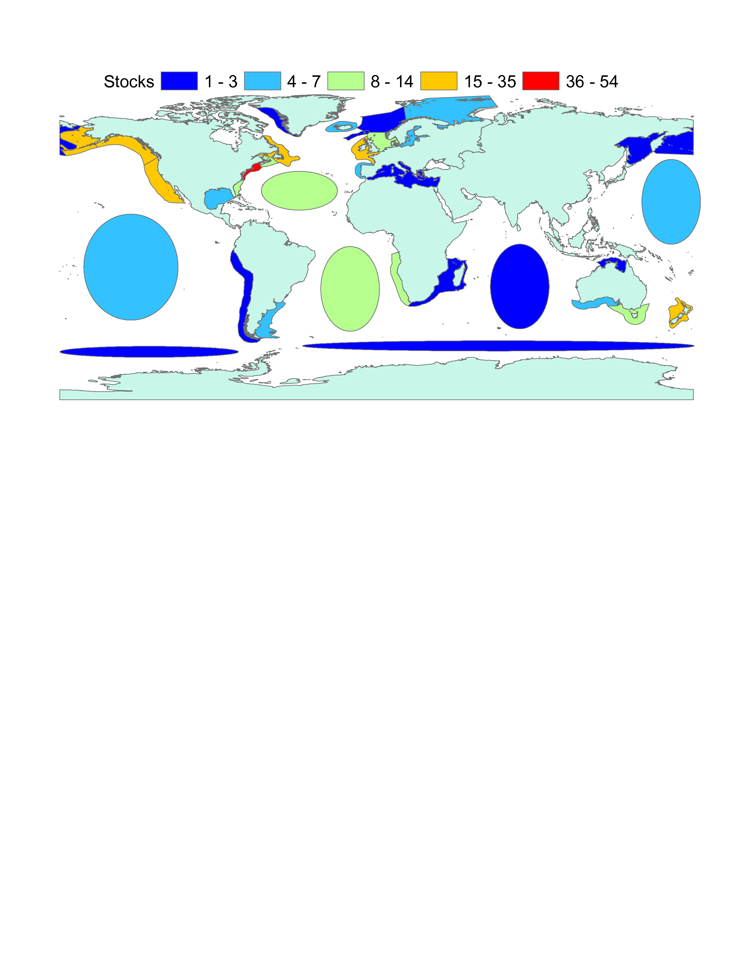
Figure 1:

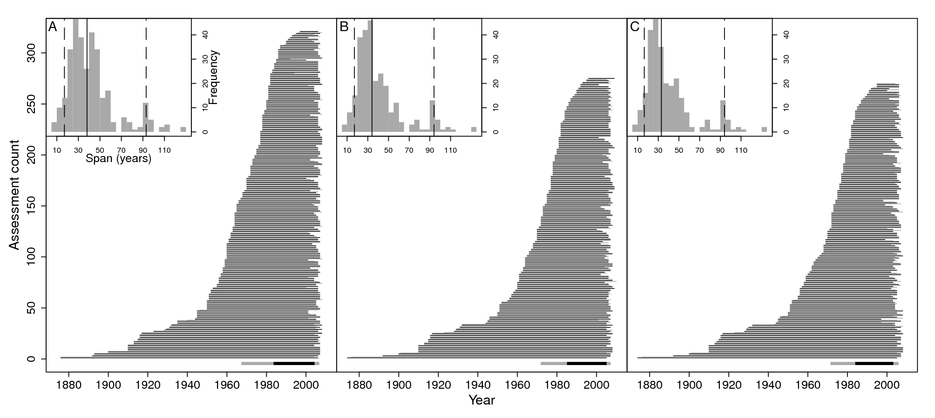
Figure 5:

Supporting Information
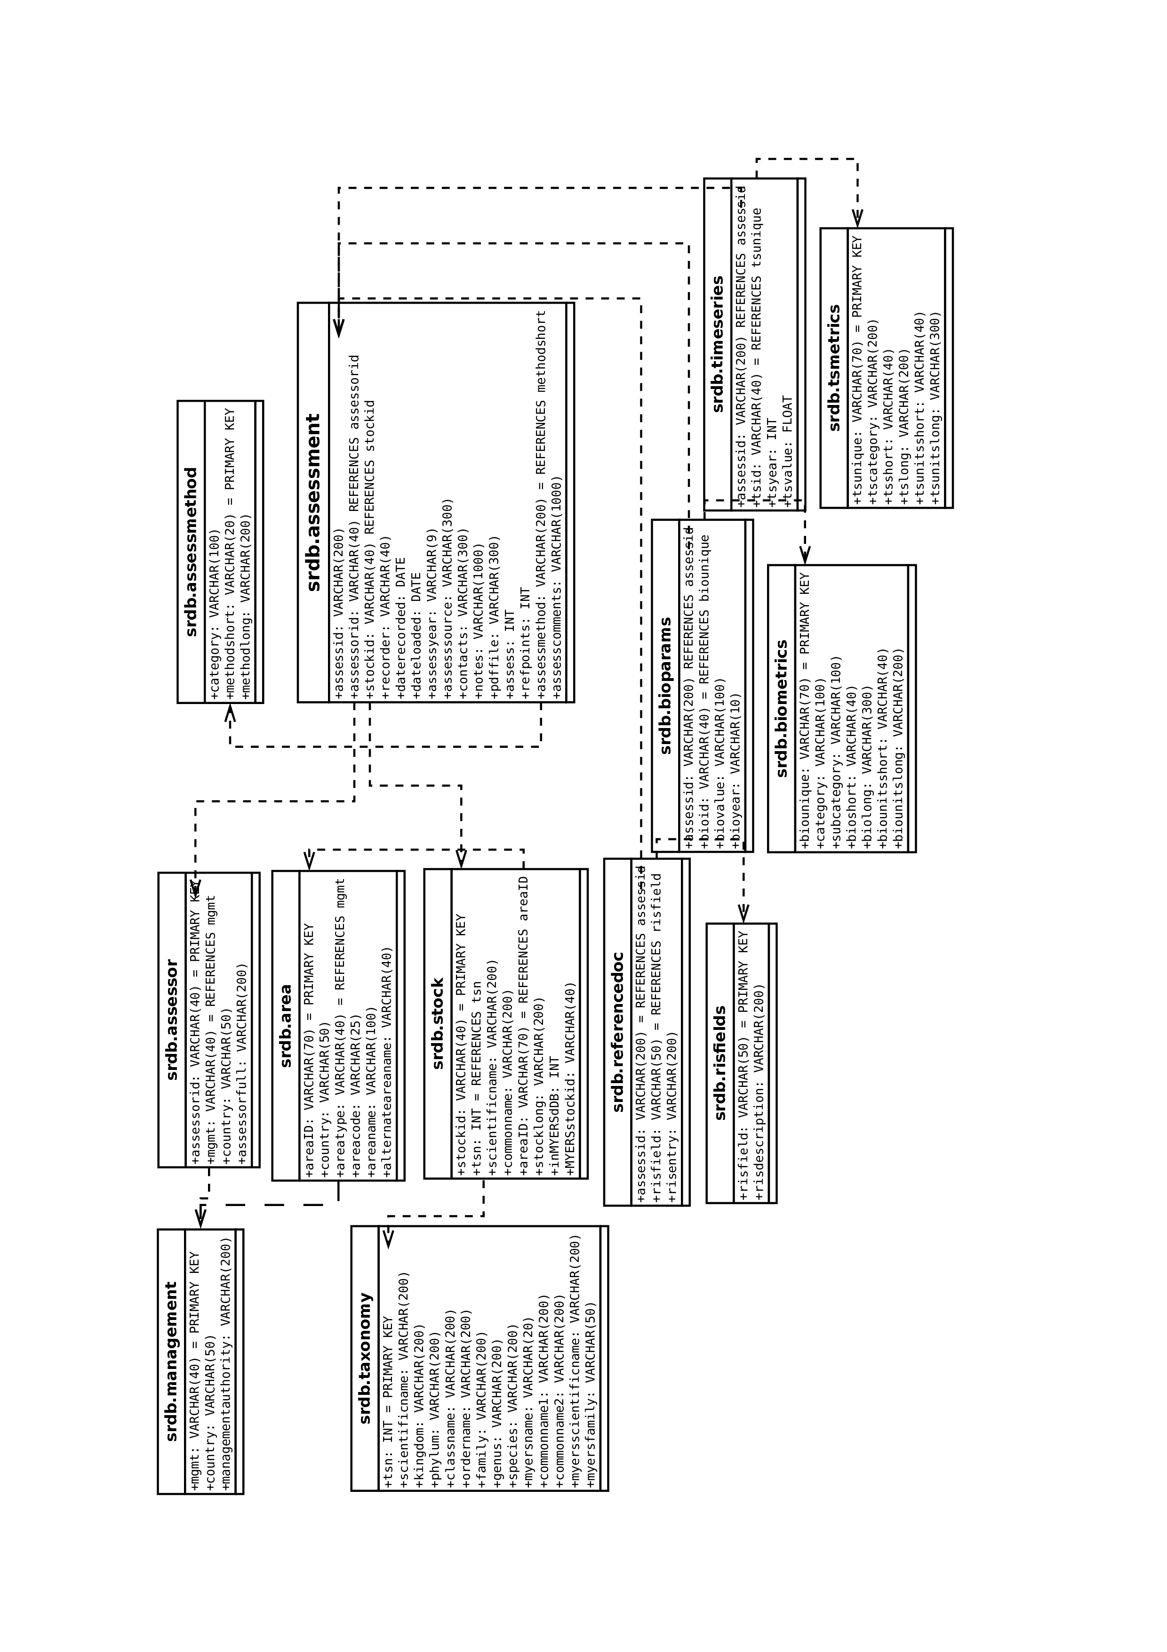
Figure S1. Entity relationship diagram of the RAM legacy database.

