Case of Study Personal. Crud JSF3 of Products, migration the JSF3 To PrimeFaces based in JSF3.

Description:
Creation the an application CRUD of Products in JSF3, after it was migrate to Primefaces based in JSF3. All building the aplication with technology Jakarta 9.

Role:

- Analytic of system legacy.
- It is develope arquitecture MVC with enphasys in a layer of Classes service how the applications modern in present.
- Use of Classes with a representation repositories, use internationalization in the components not in data.
- Integration with Front-end JSF3 + PrimeFaces.

Technologies:
Jakarta 9, , JSF3, PrimeFaces, PostgreSQL, Git, GitHub.

Result:

- Application revamp of JS3 towards PrimeFaces improve maintainability in to 40%.
- The increment the scalability given result in the reduction in expenses of maintenance.

Appearance of application (screen shots)

List of Products.

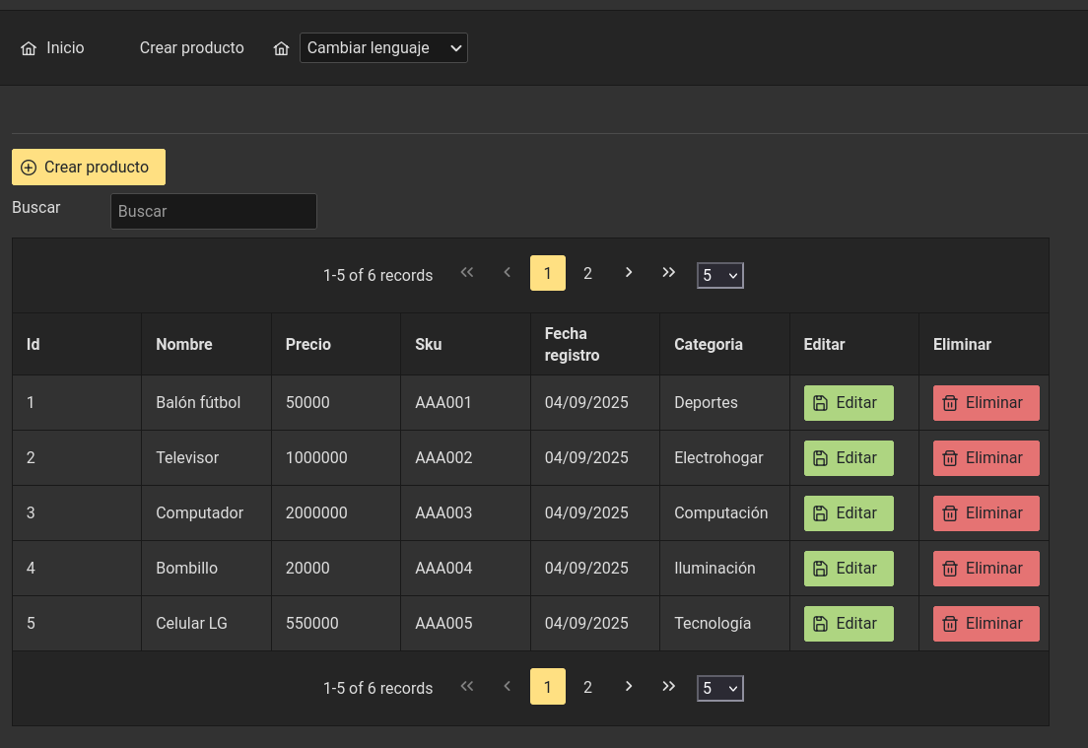
Internationalization of components

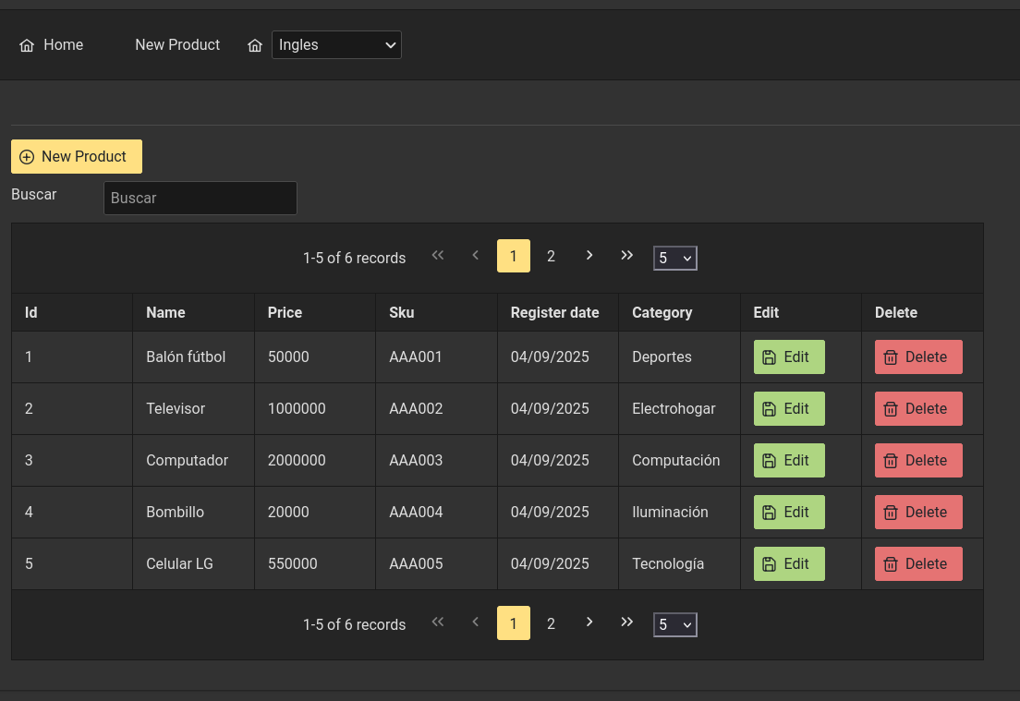

Create Products

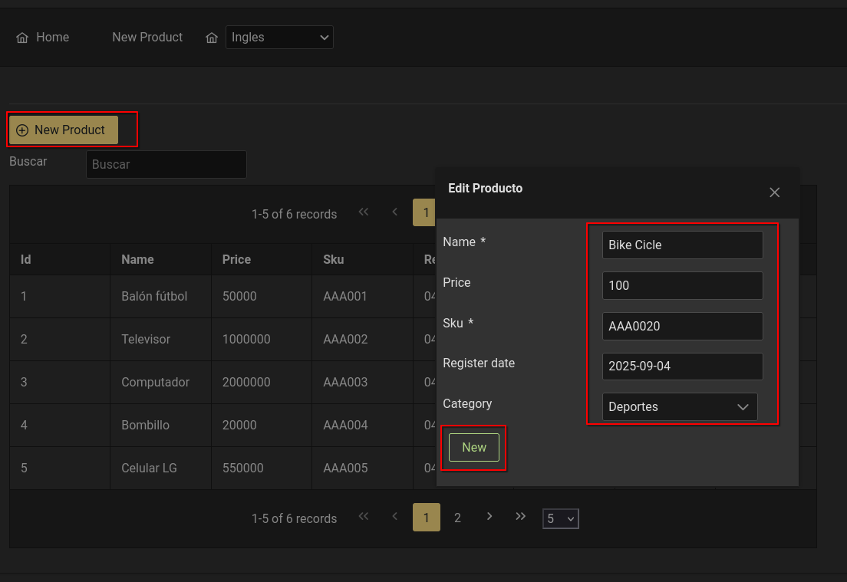
New product listed.

