ROUTE 25 – December

Ricardo Abreu

General Information
Template Info
Template Name | Version | Tongue | Date
T-TDW(TemplateDocumentoWord)-PT | 11.0 | EN | 2025/12/05

General
Context | R&D – Route 25
Document Name | ROUTE 25 – DECEMBER

Distribution List
Name | Function | Organization
Ricardo Miguel Ferreira Abreu | Junior Consultant | R&D - Capgemini
Table 1: Distribution list

Change History
Date | Version | Author | Description | Approved
2025/12/05 | N | Ricardo Abreu | Initial Document | -
Table 2: Change history

Reference Documents
Document | Author | Date | Version | Observations
ROUTE 25 – DECEMBER | Capgemini Engineering | 05/12/2025 | 1.0 | Internal project document outlining goals, architecture and system built
Table 3: Reference Documents

Index
1 Introduction 5
2 Development 6
2.1.1 Define internal mock actions 6
2.1.2 Key Features 6
2.1.3 Testing the object 8
2.1.4 UI development 8
3 Conclusion 11

List of figures
Figure 1: Logging and attributes 7
Figure 2: Car methods 7
Figure 3: Object testing 8
Figure 4: UI part 1 9
Figure 5: UI part 2 9
Figure 6: UI settings 10
Figure 7: UI settings 2 10

Executive Summary
This document outlines the development process and key features of a prototype object designed to simulate vehicle functionalities for testing and UI integration purposes. The project focuses on creating a Python-based class, “Car,” equipped with realistic attributes and methods to mimic physical car actions. Logging capabilities were implemented to track events, and a user interface was developed using Streamlit to demonstrate these functionalities interactively. The work establishes a foundation for future enhancements, including expanded testing scenarios and improved UI design.

Introduction
The purpose of this project is to create a digital prototype that replicates essential characteristics and behaviors of a physical vehicle. This approach enables early-stage testing and validation before deploying actual hardware. The development process began with defining internal mock actions and constructing a Python class to represent a car, complete with attributes such as brand, model, speed, and lighting systems. Methods simulating real-world actions like acceleration and braking were implemented, alongside event logging for traceability. The project also includes a user interface to showcase these capabilities, ensuring usability and transparency for end-users.

Development

Define internal mock actions
This is the first step of this project. The idea is to develop an object that would have capabilities similar to a vehicle in order to assist in future testing with an actual physical prototype of the same nature.
So in order to complete this step, it was constructed an initial python script where it was built a class object with name “Car” with some attributes and mock methods that represent actions that physical cars actually have. In this same script it was included a functionality for tracking events so that every action has a timestamp and a small description of what occurred. For this last purpose, it was included in the script the library “logging” to keep track of these events.

Key Features
For the class “Car” it was selected the following attributes:
- Brand – brand of the car
- Model – model of the car
- Year – year of the car
- Speed – speed of the car
- Lights – interior lights of the car
- Clutch – clutch of the car
- Radio – radio of the car
- Blinkers – lights that signal change in direction
- Reverse light – light that signals reverse direction
- Hazard lights – lights that signal emergencies
- Wipers – brushes of the car
The following picture shows the logging feature and the attributes described.

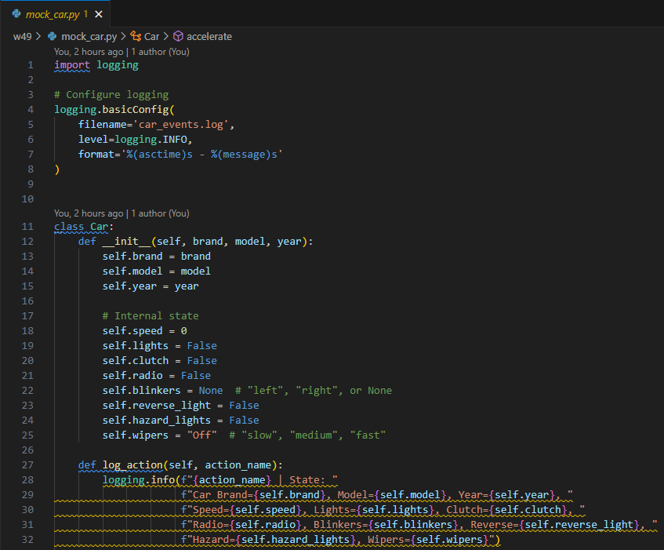
Figure 1: Logging and attributes

Then some methods were built into this class object to represent actions that physical vehicles can do, for example the act of accelerating to increase speed or braking to reduce the speed of the car. These and more methods were developed. The following picture shows part of the methods that were built.
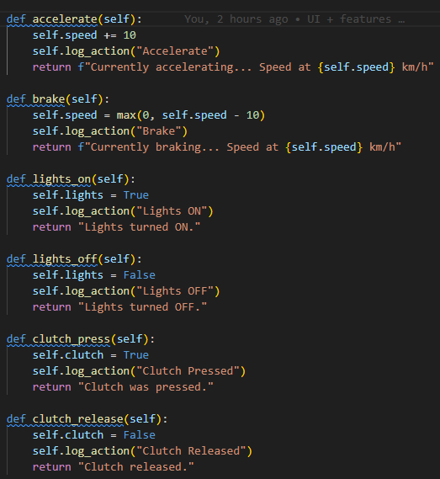
Figure 2: Car methods

Testing the object
In order to validate that the methods worked, a second python script was built to verify that all the methods and characteristics worked correctly. Even thought the test is simple, it shows that the current object is fully functional and in the future the object and the testing can be further developed to introduce different scenarios. The following picture shows the test script.
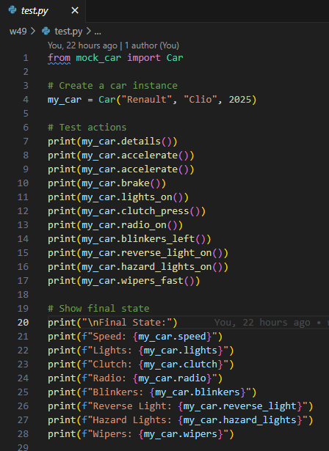
Figure 3: Object testing

As mentioned previously, in the future this can and will be expanded upon.

UI development
A third python script was built to accommodate for the UI page, as per the requirements detailed in the project task details. The following pictures show some of the code used to build the UI page to show final users the object capabilities and different actions that the car object is able to do. These actions were already discussed but, in the UI, final users can see in action these methods and actions. It’s worth noting that there are different ways to accomplish this part of the project, although in this particular instance, the UI was built using the library “streamlit”.

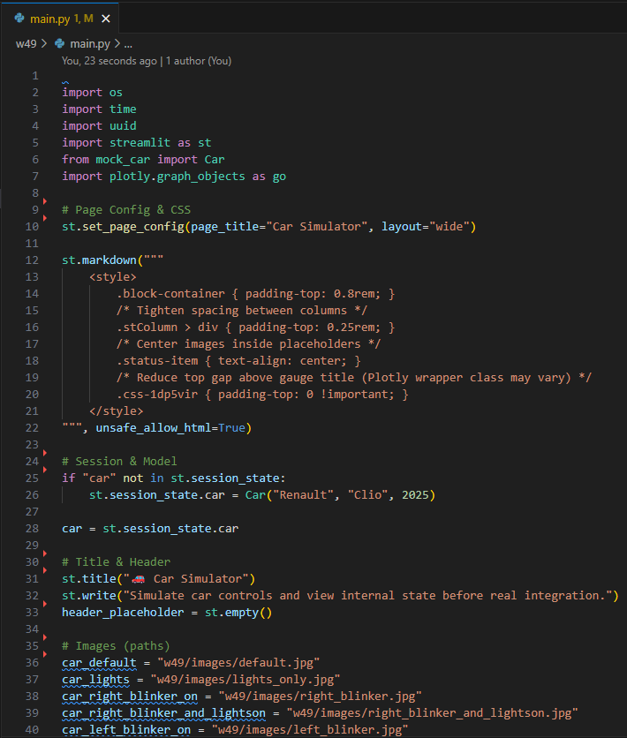
Figure 4: UI part 1

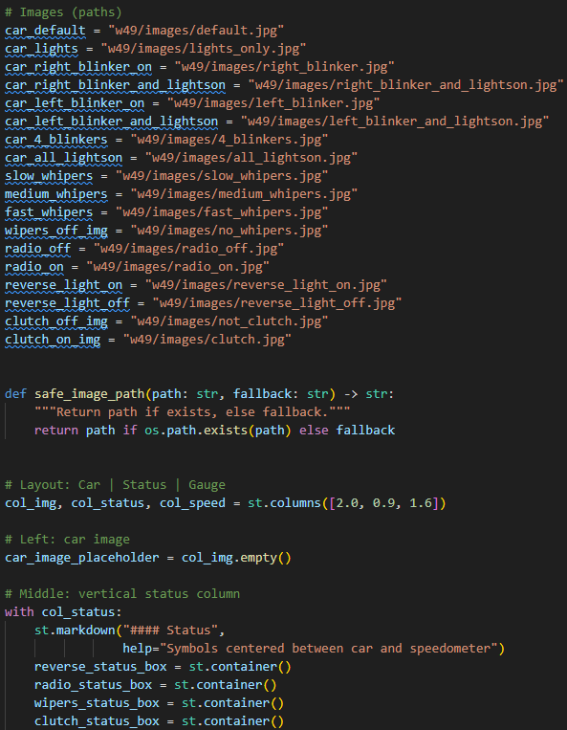
Figure 5: UI part 2

In the future the UI will be further developed to improve the overall appearance of the page and add more functionality to page itself. The following 2 pictures show the front page and the logging section of the object.
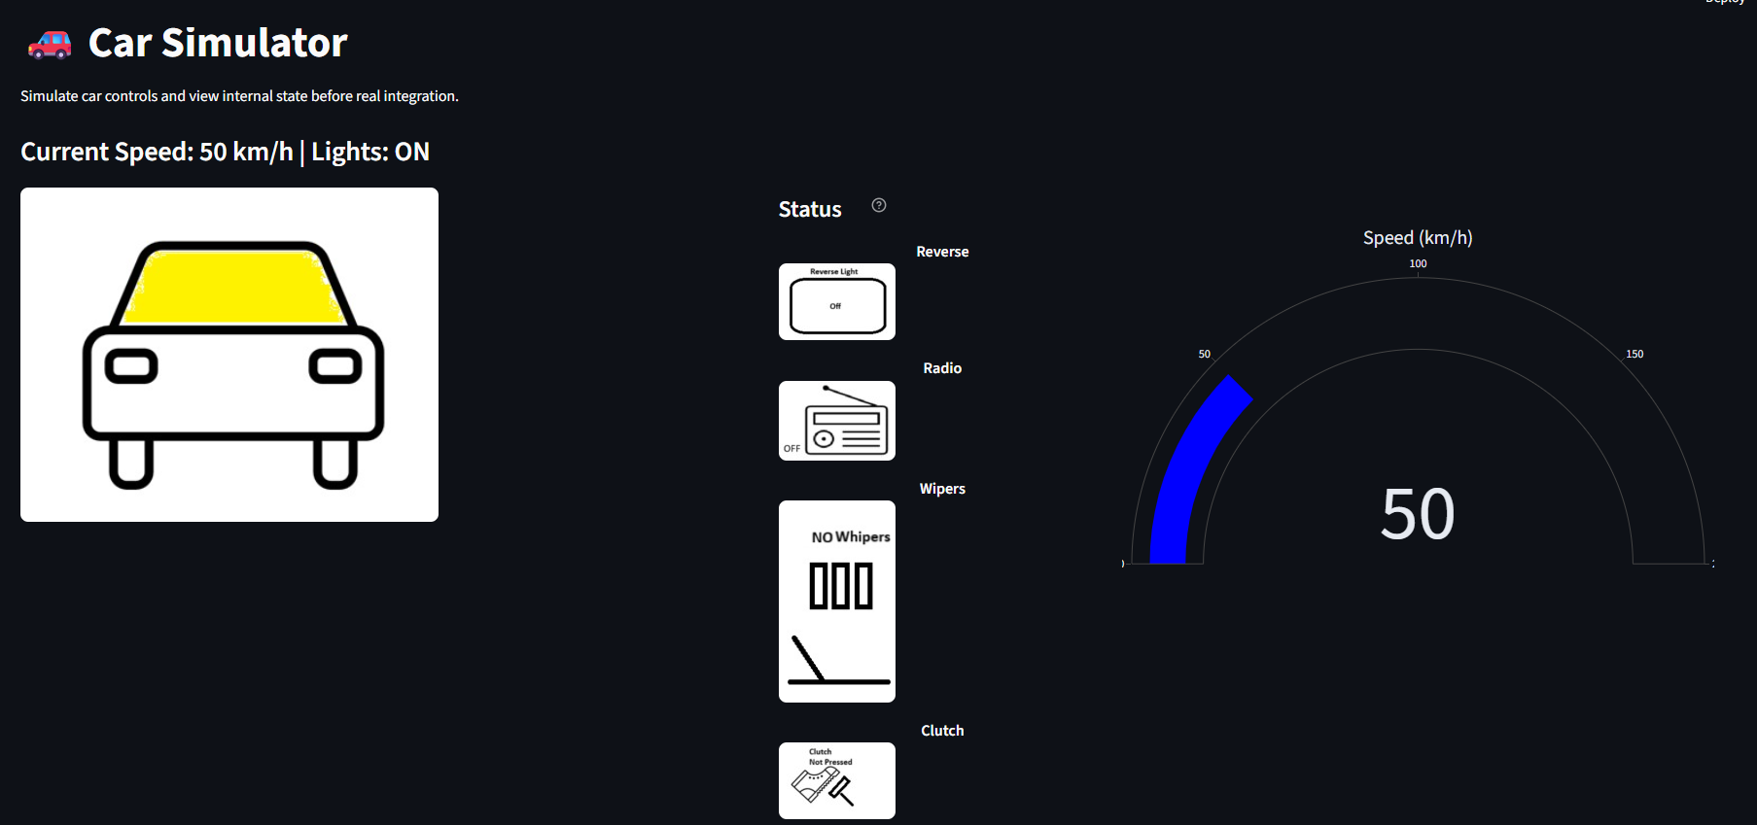
Figure 6: UI settings
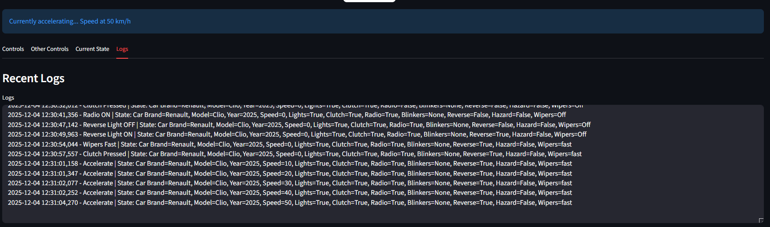
Figure 7: UI settings 2

Conclusion
The project successfully delivered a functional object model and an interactive UI, demonstrating the feasibility of simulating vehicle operations digitally. While the current implementation meets initial requirements, future work will focus on expanding test scenarios, refining the UI for better user experience, and integrating additional features to enhance realism. This iterative approach ensures continuous improvement and alignment with evolving project goals.

About Capgemini
Capgemini is a global leader in partnering with companies to transform and manage their businesses by harnessing the power of technology. The Group is guided daily by the goal of unleashing human energy through technology for an inclusive and sustainable future. It is a responsible and diverse organization with more than 270,000 professionals in nearly 50 countries. With a strong heritage of 50 years and deep industry experience, Capgemini is trusted by its clients to address the full breadth of their business needs, from strategy and design to operations, fueled by the innovative and rapidly evolving world of cloud, data, AI, connectivity, software, digital engineering and platforms. The Group reported in 2020 a global revenue of €16 billion.
Get the Future You Want | www.capgemini.com







This document contains information that may be privileged or
confidential and is owned by the Capgemini Group.
Choose an item. Copyright © 2021 Capgemini. All rights reserved.

