CLI Screenshot

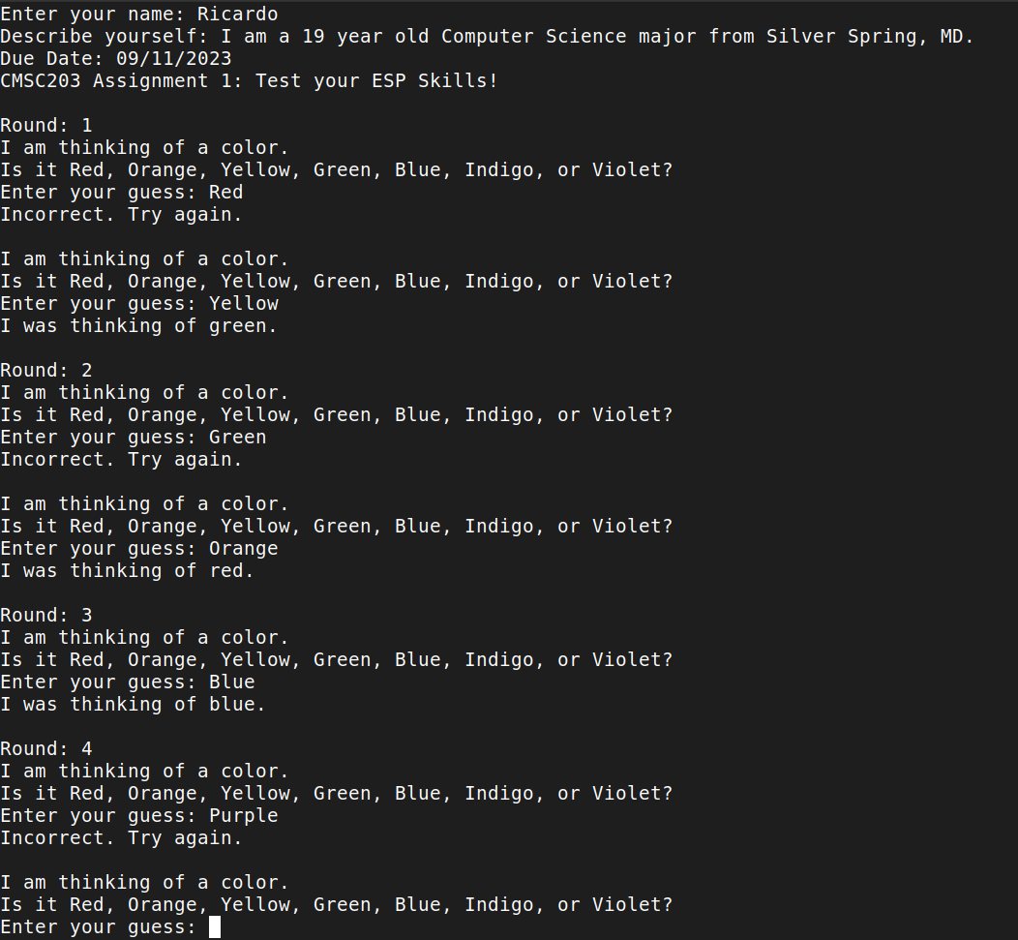

IDE Screenshot

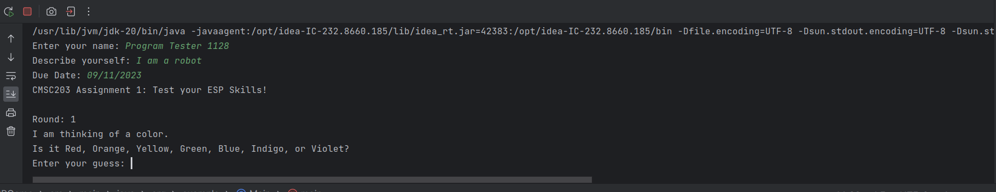

GitHub Screenshot

Lessons Learned:

* I learned how to step out of my comfort zone and use programs different than what I’m used to using in order to ensure that my code would compile on a Windows machine running Eclipse IDE.
* I struggled with getting my program to compile in Eclipse. I think my compiler structures code slightly differently, so finding where the code was so I could execute it was a bit difficult.
* On my next project I will probably rely more on GitHub to sync files between my Linux and Windows installs
* I was successful with getting my program to run on both Eclipse and IntelliJ Idea.
* I did not use any additional resources/links/videos