**CMSC203 Assignment 2 Design**

Class: CMSC203 CRN 30339

 Program: Assignment #2

Instructor: Grigoriy Grinberg

 Summary of Description: This program collects information about a patient and procedures that they’ve had done and lists the information in an easily readable format.

 Due Date: 02/26/2024

 Integrity Pledge: I pledge that I have completed the programming assignment independently.

 I have not copied the code from a student or any source. Ricardo Hernandez

**Part1: UML Diagram – including all three classes:**

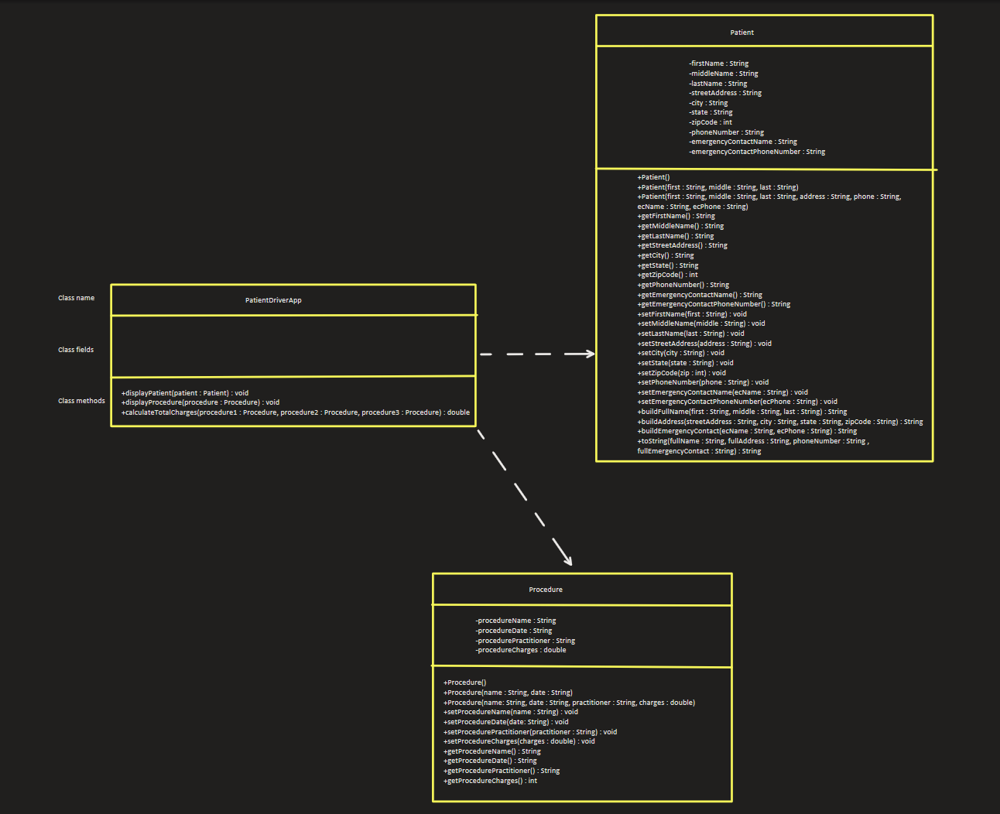

**Scroll down for close ups of each class**

