

206: Dynamic Custom Controls in Xcode 6  
Part 3: Lab Instructions

Copyright © 2014 Razeware LLC.

All rights reserved. No part of this book or corresponding materials (such as text, images, or source code) may be reproduced or distributed by any means without prior written per- mission of the copyright owner.

This book and all corresponding materials (such as source code) are provided on an "as is" basis, without warranty of any kind, express or implied, including but not limited to the warranties of merchantability, fitness for a particular purpose, and noninfringement. In no event shall the authors or copyright holders be liable for any claim, damages or other liability, whether in action of contract, tort or otherwise, arising from, out of or in connec- tion with the software or the use or other dealings in the software.

All trademarks and registered trademarks appearing in this book are the property of their respective owners.

# It’s Going To Be Legen…

At this point, you have a solid Suit View that you can customize to display the four French suits and a Joker image.

But what about the **card** itself? Where will these suits be displayed on?

Furthermore, the distinctive feature of any deck of cards is the visual design of the **back**.

You’ve already begun to *suit up*, so let’s use this lab time to make this deck *…dary!*

## Part 1: Card View

Open up **CardView.swift** and you won’t see anything but an empty UIView subclass… so let’s start here!

First of all, make this a designable class by adding the following class attribute just above the line class CardView: UIView:

@IBDesignable

Add the following code inside the class declaration:

// MARK: Inspectables

@IBInspectable var cornerRadius: CGFloat = 20.0 {

didSet {

layer.cornerRadius = cornerRadius

}

}

@IBInspectable var borderColor: UIColor = UIColor.blackColor() {

didSet {

layer.borderColor = borderColor.CGColor

}

}

@IBInspectable var borderWidth: CGFloat = 4.0 {

didSet {

layer.borderWidth = borderWidth

}

}

Instead of using drawRect(rect:) like before, you will simply be using *property observers* to update your drawing code. The didSet observer on all your inspectable variables will be called immediately after their new value is set in Interface Builder.

Open up **Main.storyboard** and click on the light gray *View* inside the *View Controller*. Change its class to CardView in the *Identity Inspector* and let Interface Builder update itself. Switch to the *Attributes Inspector* tab but don’t touch anything yet! You’ll notice how your inspectable variables are there, but none of their default values are being rendered. Hmm…

To fix this, switch back to **CardView.swift** and add the following code at the bottom of the class declaration:

// MARK: IB code

override func prepareForInterfaceBuilder() {

layer.cornerRadius = cornerRadius

layer.borderColor = borderColor.CGColor

layer.borderWidth = borderWidth

}

prepareForInterfaceBuilder() is an awesome new method where you can place code that will only run in Interface Builder at design time. This way, you can create a light setup for your custom view, which in this case is simply setting your default layer values.

Check back on **Main.storyboard** to see the automatic update, then feel free to change the values as you please :]

Open up **CardView.swift** and add the following code just above the // MARK: IB Code comment:

@IBInspectable var skeumorphic: Bool = false {

didSet {

if(skeumorphic) {

layer.shadowColor = UIColor.blackColor().CGColor

layer.shadowOpacity = 0.33

layer.shadowRadius = 3.0

layer.shadowOffset = CGSizeMake(6.0, 6.0)

}

}

}

In case you miss the pre-iOS 7 days of skeumorphism, you can add a sweet drop shadow to your playing card. Switch to **Main.storyboard** and turn the Skeumorphic control On. Uh-oh.



That didn’t render so well, so build and run the app to see the actual effect.



Live rendering in Xcode 6 is pretty powerful, but some advanced effects are simply too much to compute at design time. Shadows are one such case (and so are UIVisualEffectView instances), so use this example as a reminder that even the best previews in Interface Builder aren’t a substitute for real device renderings :]

Also, notice how the prepareForInterfaceBuilder() code wasn’t called in your actual app :O

With that said, you now have all the tools to build a custom back view in Interface Builder, so let’s move on!

## Part 2: Back View

Open up **BackView.swift** and you will once again be greeted by a whole lot of empty… a perfect opportunity to start your visual design from scratch.

Drag a UIView from the *Object Library* onto the main *View*. Resize it to fit the entire container, if needed. Change its class to CardView in the *Identity Inspector* and wait for the visual update, then customize it as you wish. The sample project keeps the default values and changes the background color to r=12, g=93, b=42.

Next, drag a UIImageView onto the *Card View*. Resize it to 280x280, center it in its parent view, and set its image to *Logo* with an *Aspect Fit Mode*.

Finally, you’ll be adding two UILabel components to check out Xcode 6’s “one last thing”. Add the first UILabel above the logo and resize it to 280x50, with the text reading “Legen…” then left-align it with the left edge of the UIImageView. Add the second UILabel below the logo and resize it to 280x50 too, with the text reading “… dary!” then right-align the text with the right edge of the UIImageView.

Now, here comes the magic :]

Try setting a custom font on the UILabel components. For the sample project, I used the Bitter family for both at size 32 with a Regular style for the top label, and an Italic style for the bottom one. Hopefully you are thrilled by this new feature of Xcode 6!

There is plenty of room for artistic freedom in this part of the lab, but for reference purposes, make sure the back of your card looks something like this:

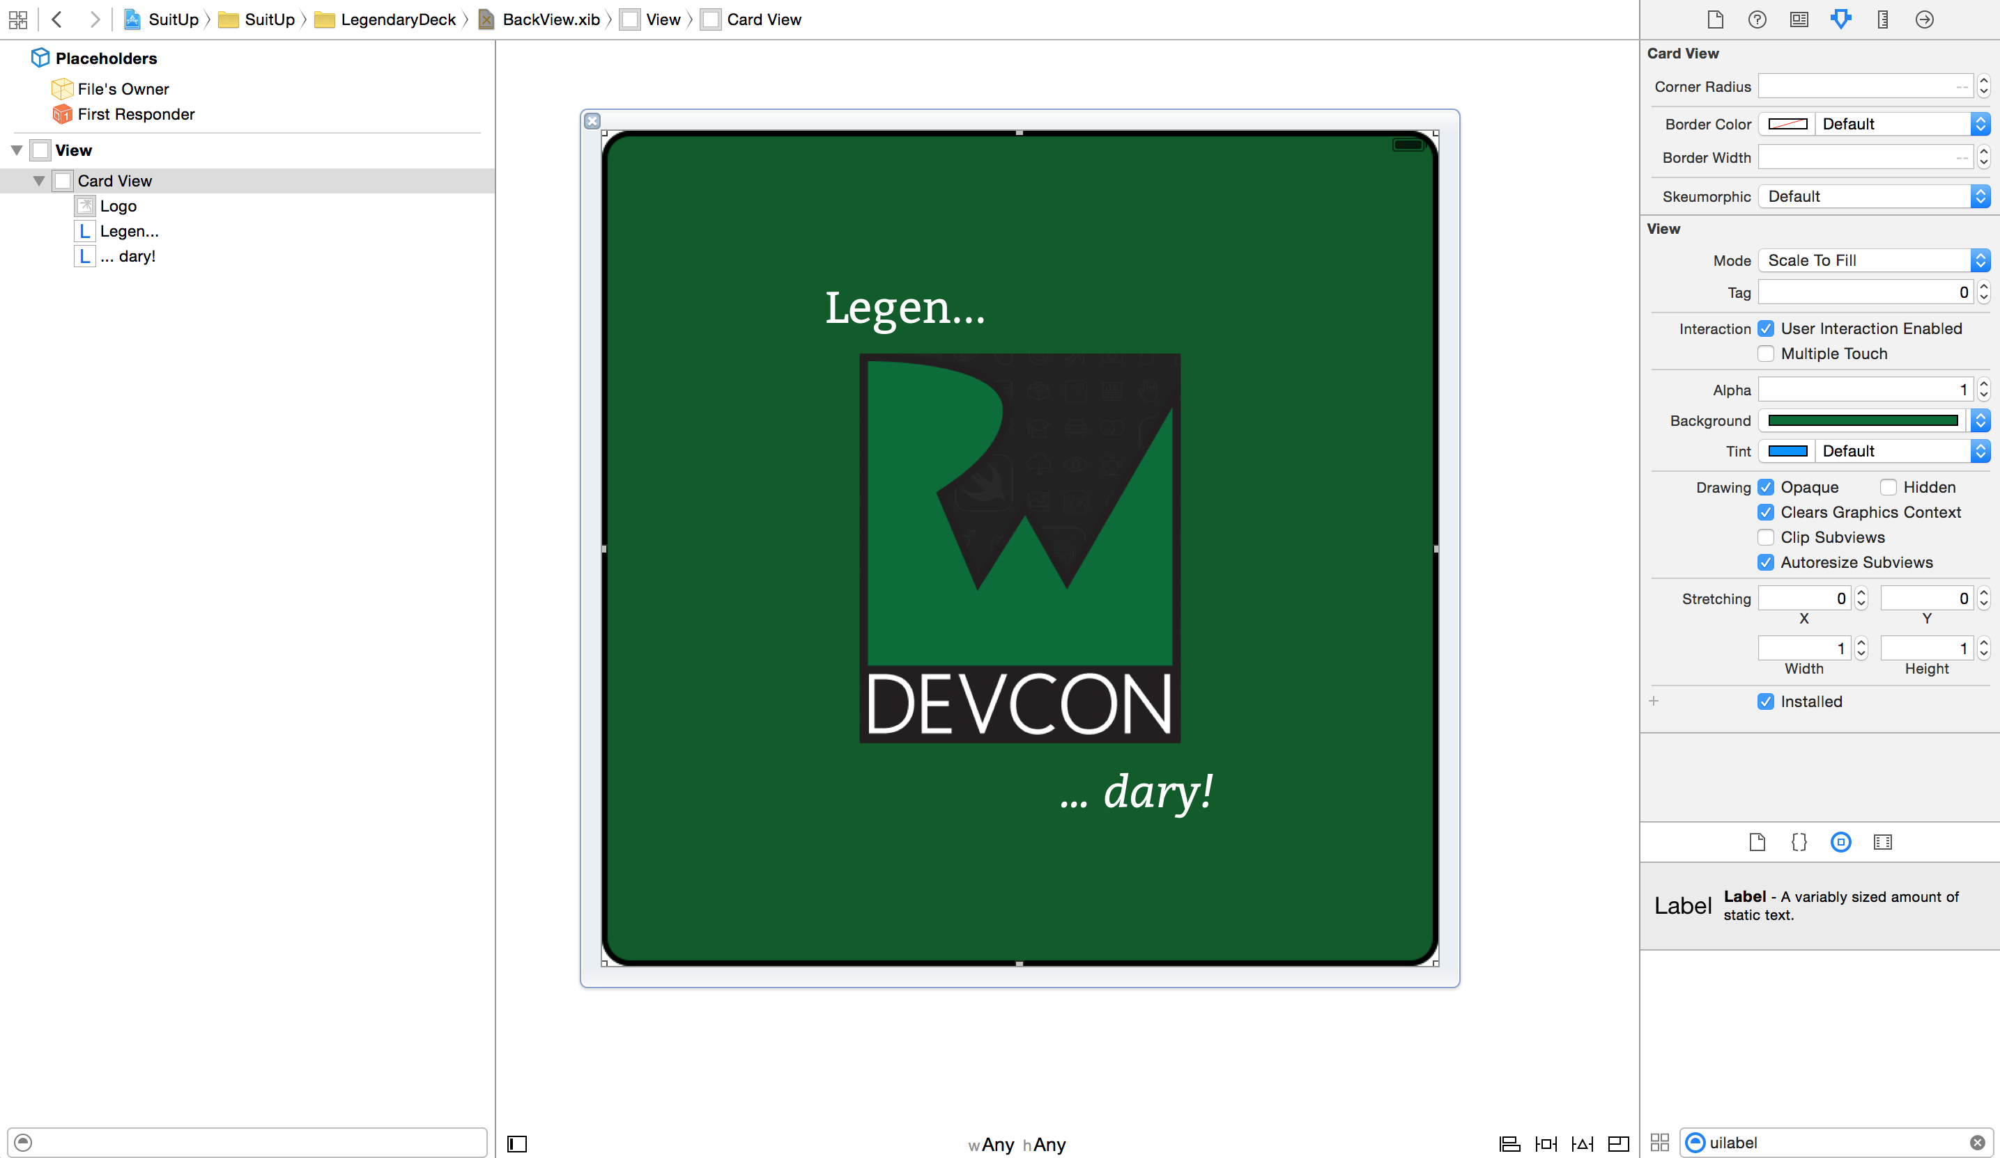

If you have some extra time and are feeling brave, try setting some auto layout constraints and verify them using the assistant editor preview :]

Congratulations, you’ve now uncovered a few more tricks in Xcode 6 and have a solid grasp of how to live-render a dynamic custom control in different situations. You’re ready to continue on to the challenge, where you’ll design a more complex front view to finalize your deck with style!