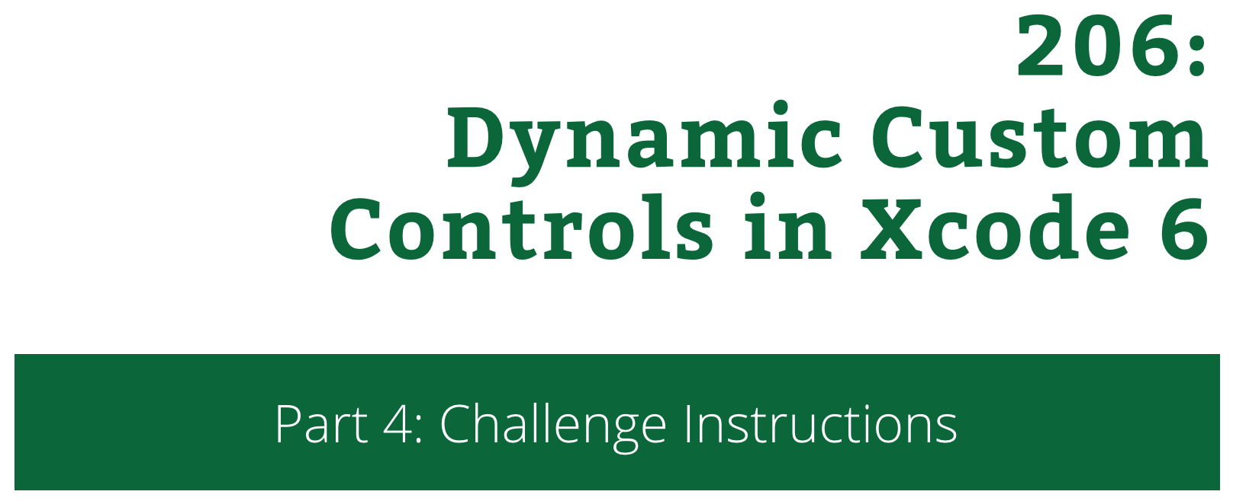

206: Dynamic Custom Controls in Xcode 6  
Part 4: Challenge Instructions

Copyright © 2014 Razeware LLC.

All rights reserved. No part of this book or corresponding materials (such as text, images, or source code) may be reproduced or distributed by any means without prior written per- mission of the copyright owner.

This book and all corresponding materials (such as source code) are provided on an "as is" basis, without warranty of any kind, express or implied, including but not limited to the warranties of merchantability, fitness for a particular purpose, and noninfringement. In no event shall the authors or copyright holders be liable for any claim, damages or other liability, whether in action of contract, tort or otherwise, arising from, out of or in connec- tion with the software or the use or other dealings in the software.

All trademarks and registered trademarks appearing in this book are the property of their respective owners.

# The Front (Porch)*

* Hopefully, HIMYM fans will recognize the episode title :]

Your challenge for this one will be delivered with screenshots, and your task will be to write the code to produce them. All code should be written in **FrontView.swift** and verified in **FrontView.xib**, with a single FrontView and no additional UI components. The end goal is to allow a designer to be able to select a primary color, secondary color, rank, and suit to test the look of all 52 cards in a deck. Once completed, you should have a wonderful front view for your deck of cards!



## Part 1: IBInspectables

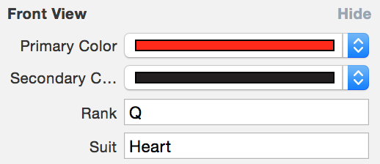

## Part 2: Prepare for IB

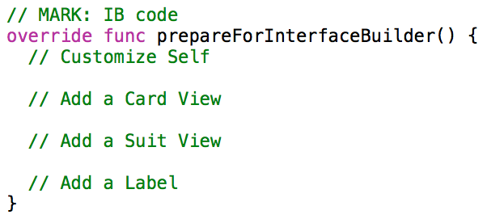

If you get this part rendering, then congratulations! This was a tough one, but not unlike working with rough mockups from a design team. You now have plenty of experience with Dynamic Custom Controls in Xcode 6 :]