Simulación de Inteligencia en juegos de arcade
Ricardo J. Garcia Izasiga, Dambert Muñoz Santillana,
Students of UPC faculty of software engineering
Abstract—En la presente se expondrán algunas de las metodologías y técnicas más usadas en inteligencia artificial. Así mismo, se propondrá una problemática basada en un juego de arcade al cual se le dará solución usando las metodologías expuestas.

INTRODUCTION
U
no de los acontecimientos más importantes que impulso con gran fuerza el desarrollo de la inteligencia artificial fue la victoria del computador Deep-Blue sobre el campeón de ajedrez Gary Kasparow, ya que ello marcó la idea de que una máquina puede llegar a tener una inteligencia superior a la humana. La inteligencia artificial es una combinación de la investigación de psicología cognitiva y lógica matemática. La idea de construir una máquina que pueda realizar tareas que tengan como requerimiento la inteligencia humana es atrayente. Las tareas que han sido estudiadas desde este punto de vista se incluyen en juegos, traducción de idiomas, comprensión de idiomas, diagnóstico de fallas, robótica, entre otros. En la actualidad, la popularidad de los videojuegos no deja de crecer, y con ello la necesidad de aplicar cada vez más los conceptos de IA en los juegos para así dar una mayor sensación de realismo a los usuarios finales. Por ello, como principal objetivo del presente documento es lograr la autonomía del jugador CPU en el juego de peleas robóticas Bot-Fighter el cual se explicará a continuación.

Descripción del problema
El Proyecto propuesto a resolver es un juego el cual consta de dos jugadores, el usuario final y el CPU (con IA). Estos jugadores tendrán una serie de Skills (habilidades) tanto ofensivas como defensivas. Dichas habilidades tendrán una serie de parámetros en específico tales como coste de energía para usarlo (MP), distancia máxima de alcance (rango de ataque), daño efectivo y velocidad de ataque. Así mismo, los jugadores contarán con características específicas distintas tales como vida máxima, energía máxima, Resistencia a ataques energéticos, resistencia a ataques físicos, velocidad de movimiento.
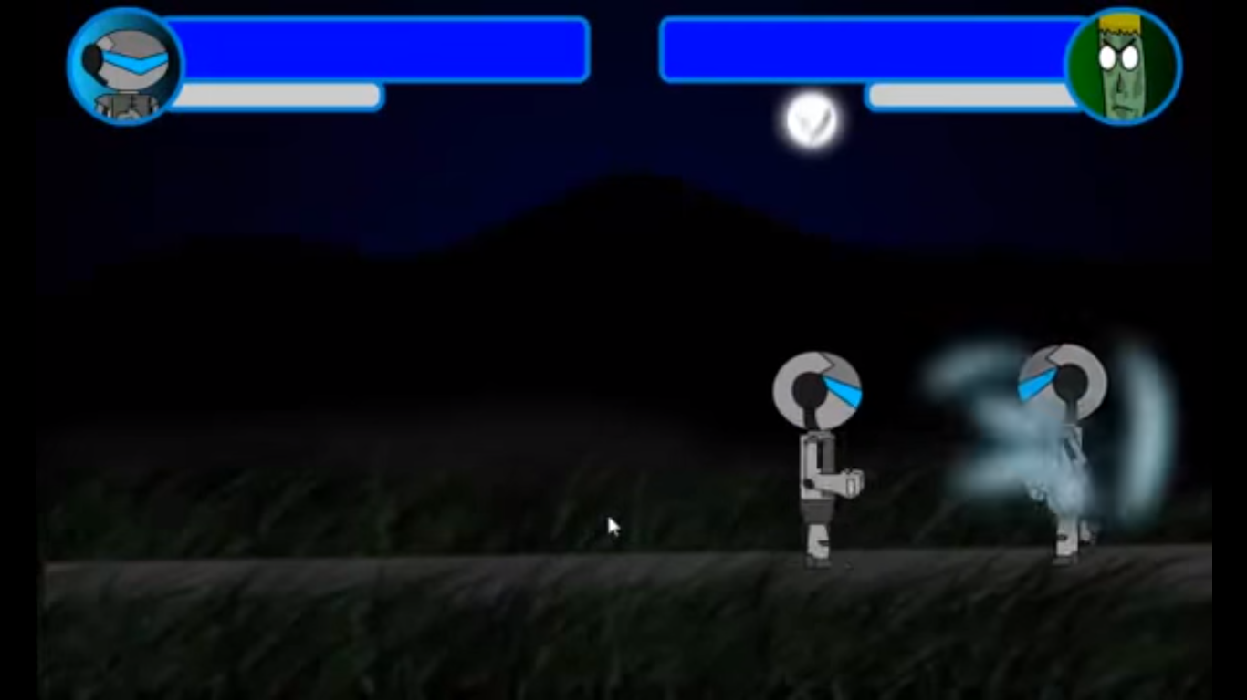
(Imagen de ataque energético)

Como problemática del juego se escogió la autonomía del jugador CPU, el cual debe escoger la mejor opción de ataque según su energía disponible la distancia en la que esta y el daño que causaría al enemigo. Además, debe calcular si el ataque alcanzará a su contrincante de acuerdo a la distancia que esta. Cabe mencionar como regla del juego que mientras más cerca se este del adversario los ataques físicos tendrán mayor daño.

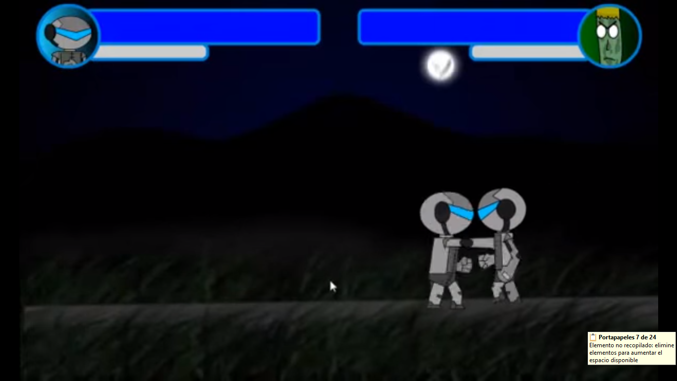
(Imagen de ataque físico).

References
Basic format for books:
- J. K. Author, “Title of chapter in the book,” in Title of His Published Book, xth ed. City of Publisher, Country if not
- USA: Abbrev. of Publisher, year, ch. x, sec. x, pp. xxx–xxx.
Examples:
- G. O. Young, “Synthetic structure of industrial plastics,” in Plastics, 2nd ed., vol. 3, J. Peters, Ed. New York: McGraw-Hill, 1964, pp. 15–64.
- W.-K. Chen, Linear Networks and Systems. Belmont, CA: Wadsworth, 1993, pp. 123–135.

Basic format for periodicals:
- J. K. Author, “Name of paper,” Abbrev. Title of Periodical, vol. x, no. x, pp. xxx-xxx, Abbrev. Month, year.
Examples:
- J. U. Duncombe, “Infrared navigation—Part I: An assessment
of feasibility,” IEEE Trans. Electron Devices, vol. ED-11, no. 1, pp. 34–39, Jan. 1959.
- E. P. Wigner, “Theory of traveling-wave optical laser,” Phys. Rev.,
vol. 134, pp. A635–A646, Dec. 1965.
- E. H. Miller, “A note on reflector arrays,” IEEE Trans. Antennas Propagat., to be published.

Basic format for reports:
- J. K. Author, “Title of report,” Abbrev. Name of Co., City of Co., Abbrev. State, Rep. xxx, year.
Examples:
- E. E. Reber, R. L. Michell, and C. J. Carter, “Oxygen absorption in the earth’s atmosphere,” Aerospace Corp., Los Angeles, CA, Tech. Rep. TR-0200 (4230-46)-3, Nov. 1988.
- J. H. Davis and J. R. Cogdell, “Calibration program for the 16-foot antenna,” Elect. Eng. Res. Lab., Univ. Texas, Austin, Tech. Memo. NGL-006-69-3, Nov. 15, 1987.

Basic format for handbooks:
- Name of Manual/Handbook, x ed., Abbrev. Name of Co., City of Co., Abbrev. State, year, pp. xxx-xxx.
Examples:
- Transmission Systems for Communications, 3rd ed., Western Electric Co., Winston-Salem, NC, 1985, pp. 44–60.
- Motorola Semiconductor Data Manual, Motorola Semiconductor Products Inc., Phoenix, AZ, 1989.

Basic format for books (when available online):
- Author. (year, month day). Title. (edition) [Type of medium]. volume (issue). Available: site/path/file
Example:
- J. Jones. (1991, May 10). Networks. (2nd ed.) [Online]. Available: http://www.atm.com

Basic format for journals (when available online):
- Author. (year, month). Title. Journal. [Type of medium]. volume (issue), pages. Available: site/path/file
Example:
- R. J. Vidmar. (1992, Aug.). On the use of atmospheric plasmas as electromagnetic reflectors. IEEE Trans. Plasma Sci. [Online]. 21(3), pp. 876–880. Available: http://www.halcyon.com/pub/journals/21ps03-vidmar

Basic format for papers presented at conferences (when available online):
- Author. (year, month). Title. Presented at Conference title. [Type of Medium]. Available: site/path/file
Example:
- PROCESS Corp., MA. Intranets: Internet technologies deployed behind the firewall for corporate productivity. Presented at
INET96 Annual Meeting. [Online]. Available: http://home.process.com/Intranets/wp2.htp

Basic format for reports and handbooks (when available online):
- Author. (year, month). Title. Comp an y . C ity, State or Country. [Type of Medium]. Available: site/path/file
Example:
- S. L. Tall een. (1996 , Apr . ). The In t r an et Archi -tecture: M a nagi ng i n f o rm at i on i n t h e ne w paradigm. Amdahl Corp., CA. [Online]. Available: http://www.amdahl.com/doc/products/bsg/intra/infra/html

Basic format for computer programs and electronic documents (when available online): ISO recommends that capitalization follow the accepted practice for the language or script in which the information is given.
Example:
- A. Harriman. (1993, June). Compendium of genealogical software. Humanist. [Online]. Available e-mail: HUMANIST@NYVM.ORG Message: get GENEALOGY REPORT

Basic format for patents (when available online):
- Name of the invention, by inventor’s name. (year, month day). Patent Number [Type of medium]. Available: site/path/file
Example:
- Musical toothbrush with adjustable neck and mirror, by L.M.R. Brooks. (1992, May 19). Patent D 326 189
[Online]. Available: NEXIS Library: LEXPAT File: DESIGN

Basic format for conference proceedings (published):
- J. K. Author, “Title of paper,” in Abbreviated Name of Conf., City of Conf., Abbrev. State (if given), year, pp. xxxxxx.
Example:
- D. B. Payne and J. R. Stern, “Wavelength-switched pas- sively coupled single-mode optical network,” in Proc. IOOC-ECOC, 1985,
pp. 585–590.
Example for papers presented at conferences (unpublished):
- D. Ebehard and E. Voges, “Digital single sideband detection for interferometric sensors,” presented at the 2nd Int. Conf. Optical Fiber Sensors, Stuttgart, Germany, Jan. 2-5, 1984.

Basic format for patents:
- J. K. Author, “Title of patent,” U.S. Patent x xxx xxx, Abbrev. Month, day, year.
Example:
- G. Brandli and M. Dick, “Alternating current fed power supply,”
U.S. Patent 4 084 217, Nov. 4, 1978.
Basic format for theses (M.S.) and dissertations (Ph.D.):
- J. K. Author, “Title of thesis,” M.S. thesis, Abbrev. Dept., Abbrev. Univ., City of Univ., Abbrev. State, year.
- J. K. Author, “Title of dissertation,” Ph.D. dissertation, Abbrev. Dept., Abbrev. Univ., City of Univ., Abbrev. State, year.
Examples:
- J. O. Williams, “Narrow-band analyzer,” Ph.D. dissertation, Dept. Elect. Eng., Harvard Univ., Cambridge, MA, 1993.
- N. Kawasaki, “Parametric study of thermal and chemical nonequilibrium nozzle flow,” M.S. thesis, Dept. Electron. Eng., Osaka Univ., Osaka, Japan, 1993.
Basic format for the most common types of unpublished references:
- J. K. Author, private communication, Abbrev. Month, year.
- J. K. Author, “Title of paper,” unpublished.
- J. K. Author, “Title of paper,” to be published.
Examples:
- A. Harrison, private communication, May 1995.
- B. Smith, “An approach to graphs of linear forms,” unpublished.
- A. Brahms, “Representation error for real numbers in binary computer arithmetic,” IEEE Computer Group Repository, Paper R-67-85.

Basic format for standards:
- Title of Standard, Standard number, date.
Examples:
- IEEE Criteria for Class IE Electric Systems, IEEE Standard 308, 1969.
- Letter Symbols for Quantities, ANSI Standard Y10.5-1968.

First A. Author (M’76–SM’81–F’87) and the other authors may include biographies at the end of regular papers. Biographies are often not included in conference-related papers. This author became a Member (M) of IEEE in 1976, a Senior Member (SM) in 1981, and a Fellow (F) in 1987. The first paragraph may contain a place and/or date of birth (list place, then date). Next, the author’s educational background is listed. The degrees should be listed with type of degree in what field, which institution, city, state, and country, and year the degree was earned. The author’s major field of study should be lower-cased.
The second paragraph uses the pronoun of the person (he or she) and not the author’s last name. It lists military and work experience, including summer and fellowship jobs. Job titles are capitalized. The current job must have a location; previous positions may be listed without one. Information concerning previous publications may be included. Try not to list more than three books or published articles. The format for listing publishers of a book within the biography is: title of book (city, state: publisher name, year) similar to a reference. Current and previous research interests end the paragraph.
The third paragraph begins with the author’s title and last name (e.g., Dr. Smith, Prof. Jones, Mr. Kajor, Ms. Hunter). List any memberships in professional societies other than the IEEE. Finally, list any awards and work for IEEE committees and publications. If a photograph is provided, the biography will be indented around it. The photograph is placed at the top left of the biography, and should be of good quality, professional-looking, and black and white (see above example). Personal hobbies will be deleted from the biography. Following are two examples of an author’s biography.

Second B. Author was born in Greenwich Village, New York City, in 1977. He received the B.S. and M.S. degrees in aerospace engineering from the University of Virginia, Charlottesville, in 2001 and the Ph.D. degree in mechanical engineering from Drexel University, Philadelphia, PA, in 2008.
From 2001 to 2004, he was a Research Assistant with the Princeton Plasma Physics Laboratory. Since 2009, he has been an Assistant Professor with the Mechanical Engineering Department, Texas A&M University, College Station. He is the author of three books, more than 150 articles, and more than 70 inventions. His research interests include high-pressure and high-density nonthermal plasma discharge processes and applications, microscale plasma discharges, discharges in liquids, spectroscopic diagnostics, plasma propulsion, and innovation plasma applications. He is an Associate Editor of the journal Earth, Moon, Planets, and holds two patents.
Mr. Author was a recipient of the International Association of Geomagnetism and Aeronomy Young Scientist Award for Excellence in 2008, the IEEE Electromagnetic Compatibility Society Best Symposium Paper Award in 2011, and the American Geophysical Union Outstanding Student Paper Award in Fall 2005.

Third C. Author, Jr. (M’87) received the B.S. degree in mechanical engineering from National Chung Cheng University, Chiayi, Taiwan, in 2004 and the M.S. degree in mechanical engineering from National Tsing Hua University, Hsinchu, Taiwan, in 2006. He is currently pursuing the Ph.D. degree in mechanical engineering at Texas A&M University, College Station.
From 2008 to 2009, he was a Research Assistant with the Institute of Physics, Academia Sinica, Tapei, Taiwan. His research interest includes the development of surface processing and biological/medical treatment techniques using nonthermal atmospheric pressure plasmas, fundamental study of plasma sources, and fabrication of micro- or nanostructured surfaces.
Mr. Author’s awards and honors include the Frew Fellowship (Australian Academy of Science), the I. I. Rabi Prize (APS), the European Frequency and Time Forum Award, the Carl Zeiss Research Award, the William F. Meggers Award and the Adolph Lomb Medal (OSA).

