**P-value:** The p-value is about the strength of a hypothesis. We build hypotheses based on some statistical model and compare the model's validity using p-value. One way to get the p-value is by using T-test.

**Example:** The average weight of the citizens of a city is 72kg with a standard deviation of 4. A sample of 36 people has been picked with a mean value of 74kg. Define the null hypothesis and prove if at a 95% confidence interval there is enough evidence to support it or not.

**Solution:**

The null and alternate hypotheses can be defined as

H0 = Average weight of the citizens of the city is 72 kgs.

## H1 = Average weight of the citizens of the city is not equal to 72 kgs.

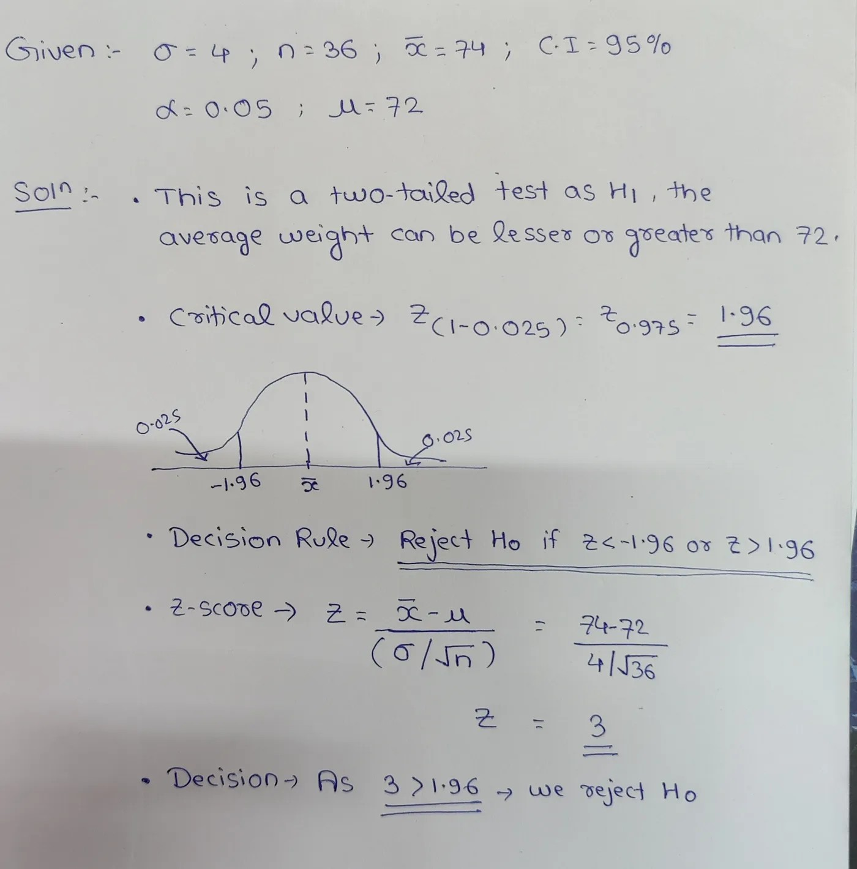

We can reject the null hypothesis as the calculated z score value is greater than the critical value which means that the average weight of the citizens of the city is not equal to 72 kgs.

## We can also arrive at the same conclusion with the help of the p-value. The area under the curve is found from the z table using the z score.

The final decision is made by comparing the p-value with the significance value and ***reject H0 if p<= α*** and we ***fail to reject H0 if p > α***

