Resultados Aoki Velloso e Decourt Quaresma

# Dados de Entrada

Lista Nspt:  
   
 [1, 3, 5, 8, 8, 10, 15]  
   
 Tipo de Estaca: Hélice Contínua  
  
 Diâmetro da Estaca: 30.0 cm  
  
 Carga Admissível Esperada: 200.0 kN  
  
 Nível d'água: 2.0 m

# Resultados Aoki Velloso

Figura 1: Gráfico dos resultados pelo método de Aoki Velloso.

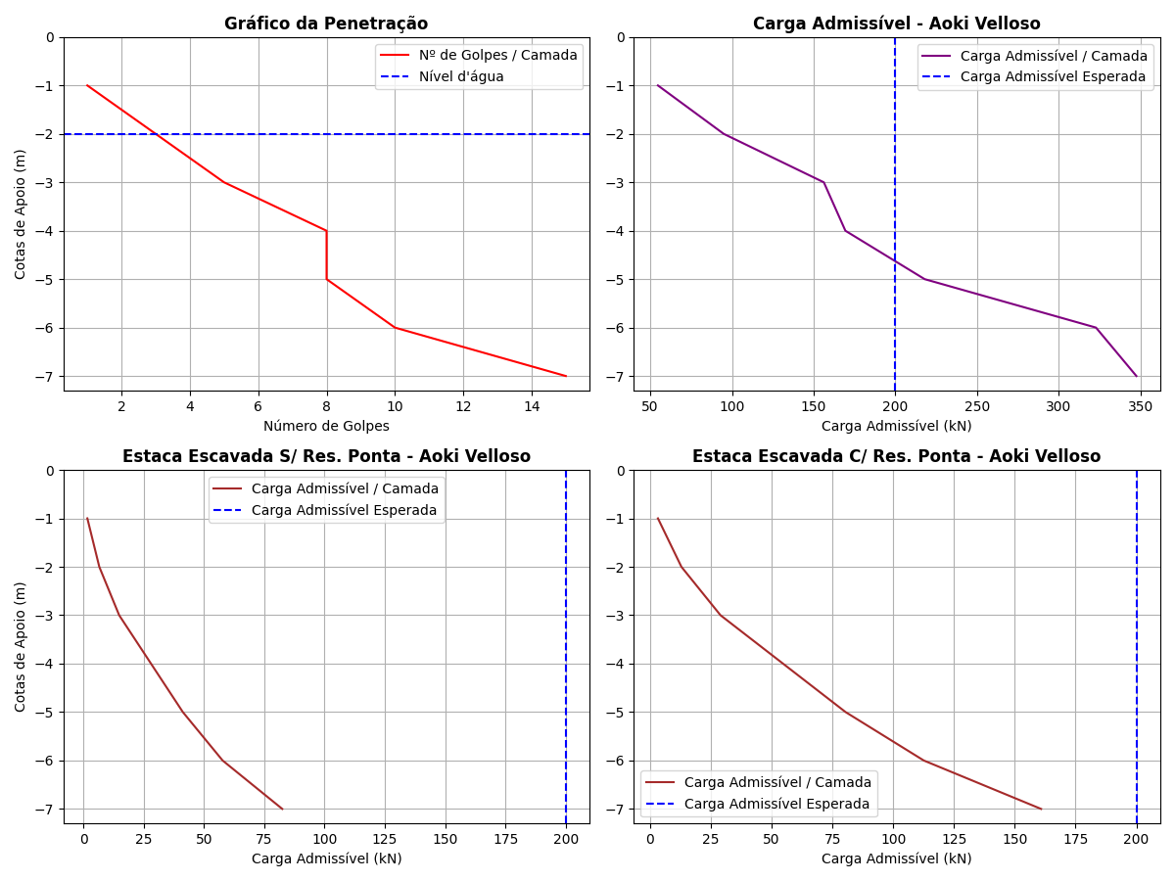

Tabela 1: Resultados pelo método de Aoki Velloso.

|  |  |  |  |  |  |  |  |  |  |  |  |
| --- | --- | --- | --- | --- | --- | --- | --- | --- | --- | --- | --- |
| Cotas | K (kPa) | α (%) | rp (kPa) | Rp (kN) | rl (kPa) | Rl (kN) | Rl Acum. (kN) | Rt (kN) | Padm (kN) | Padm Escavada S/Res. Ponta (kN) | Padm Escavada C/Res. Ponta (kN) |
| -1 | 1000 | 1.4 | 1500.0 | 106.03 | 3.5 | 3.3 | 3.3 | 109.33 | 54.66 | 1.65 | 3.22 |
| -2 | 1000 | 1.4 | 2500.0 | 176.71 | 10.5 | 9.9 | 13.2 | 189.91 | 94.96 | 6.6 | 12.87 |
| -3 | 1000 | 1.4 | 4000.0 | 282.74 | 17.5 | 16.49 | 29.69 | 312.43 | 156.22 | 14.84 | 28.95 |
| -4 | 1000 | 1.4 | 4000.0 | 282.74 | 28.0 | 26.39 | 56.08 | 338.82 | 169.41 | 28.04 | 54.68 |
| -5 | 1000 | 1.4 | 5000.0 | 353.43 | 28.0 | 26.39 | 82.47 | 435.9 | 217.95 | 41.24 | 80.41 |
| -6 | 1000 | 1.4 | 7500.0 | 530.14 | 35.0 | 32.99 | 115.46 | 645.6 | 322.8 | 57.73 | 112.57 |
| -7 | 1000 | 1.4 | 7500.0 | 530.14 | 52.5 | 49.48 | 164.94 | 695.08 | 347.54 | 82.47 | 160.82 |

# Resultados Decourt Quaresma

Figura 2: Gráfico dos resultados pelo método de Decourt Quaresma.

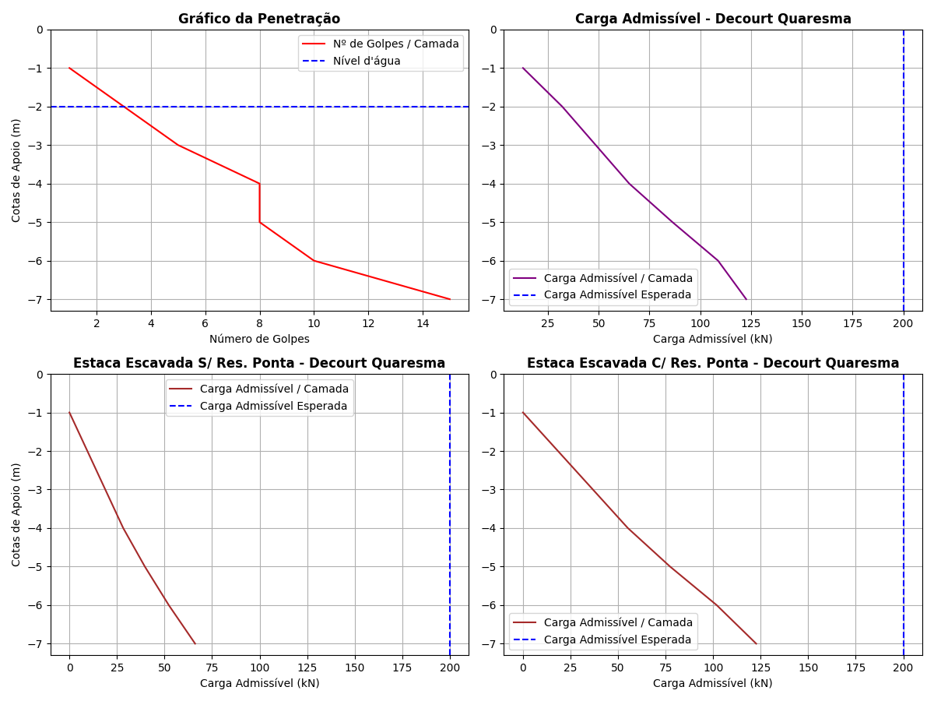

Tabela 2: Resultados pelo método de Decourt Quaresma.

|  |  |  |  |  |  |  |  |  |  |  |  |  |  |  |
| --- | --- | --- | --- | --- | --- | --- | --- | --- | --- | --- | --- | --- | --- | --- |
| Cotas | Nsptl | Nsptp | C (kPa) | α | β | rp (kPa) | Rp (kN) | rl (kPa) | Rl (kN) | Rl Acum. (kN) | Rt (kN) | Padm (kN) | Padm Escavada S/Res. Ponta (kN) | Padm Escavada C/Res. Ponta (kN) |
| -1 | 3.0 | 3.0 | 400 | 0.3 | 1 | 1200.0 | 25.45 | 0.0 | 0.0 | 0.0 | 25.45 | 12.72 | 0.0 | 0.0 |
| -2 | 3.0 | 5.33 | 400 | 0.3 | 1 | 2132.0 | 45.21 | 20.0 | 18.85 | 18.85 | 64.06 | 32.03 | 9.43 | 18.38 |
| -3 | 3.0 | 7.0 | 400 | 0.3 | 1 | 2800.0 | 59.38 | 20.0 | 18.85 | 37.7 | 97.08 | 48.54 | 18.85 | 36.76 |
| -4 | 3.0 | 8.67 | 400 | 0.3 | 1 | 3468.0 | 73.54 | 20.0 | 18.85 | 56.55 | 130.09 | 65.04 | 28.28 | 55.14 |
| -5 | 4.25 | 11.0 | 400 | 0.3 | 1 | 4400.0 | 93.31 | 24.17 | 22.78 | 79.33 | 172.64 | 86.32 | 39.66 | 77.35 |
| -6 | 5.0 | 13.33 | 400 | 0.3 | 1 | 5332.0 | 113.07 | 26.67 | 25.14 | 104.47 | 217.54 | 108.77 | 52.24 | 101.86 |
| -7 | 5.83 | 13.33 | 400 | 0.3 | 1 | 5332.0 | 113.07 | 29.43 | 27.74 | 132.21 | 245.28 | 122.64 | 66.1 | 122.64 |

# Comparativo entre Aoki Velloso e Decourt Quaresma

Figura 3: Comparativo entre Aoki Velloso e Decourt Quaresma.

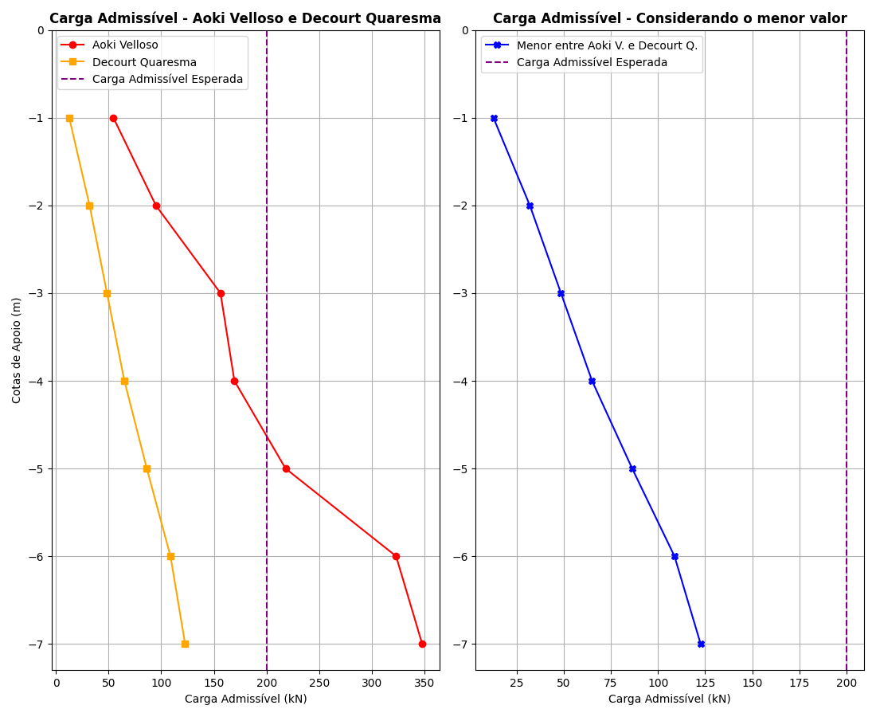

Tabela 3: Comparativo entre Aoki Velloso e Decourt Quaresma.

|  |  |  |  |
| --- | --- | --- | --- |
| Cotas | Padm - Aoki Velloso (kN) | Padm - Decourt Quaresma (kN) | Menor valor entre os métodos (kN) |
| -1 | 54.66 | 12.72 | 12.72 |
| -2 | 94.96 | 32.03 | 32.03 |
| -3 | 156.22 | 48.54 | 48.54 |
| -4 | 169.41 | 65.04 | 65.04 |
| -5 | 217.95 | 86.32 | 86.32 |
| -6 | 322.8 | 108.77 | 108.77 |
| -7 | 347.54 | 122.64 | 122.64 |