Resultados Aoki Velloso e Decourt Quaresma

# Dados de Entrada

Lista Nspt:  
   
 [1, 3, 5, 8, 8, 10, 15]  
   
 Tipo de Estaca: Hélice Contínua  
  
 Diâmetro da Estaca: 40.0 cm  
  
 Carga Admissível Esperada: 300.0 kN  
  
 Nível d'água: 3.0 m

# Resultados Aoki Velloso

Figura 1: Gráfico dos resultados pelo método de Aoki Velloso.

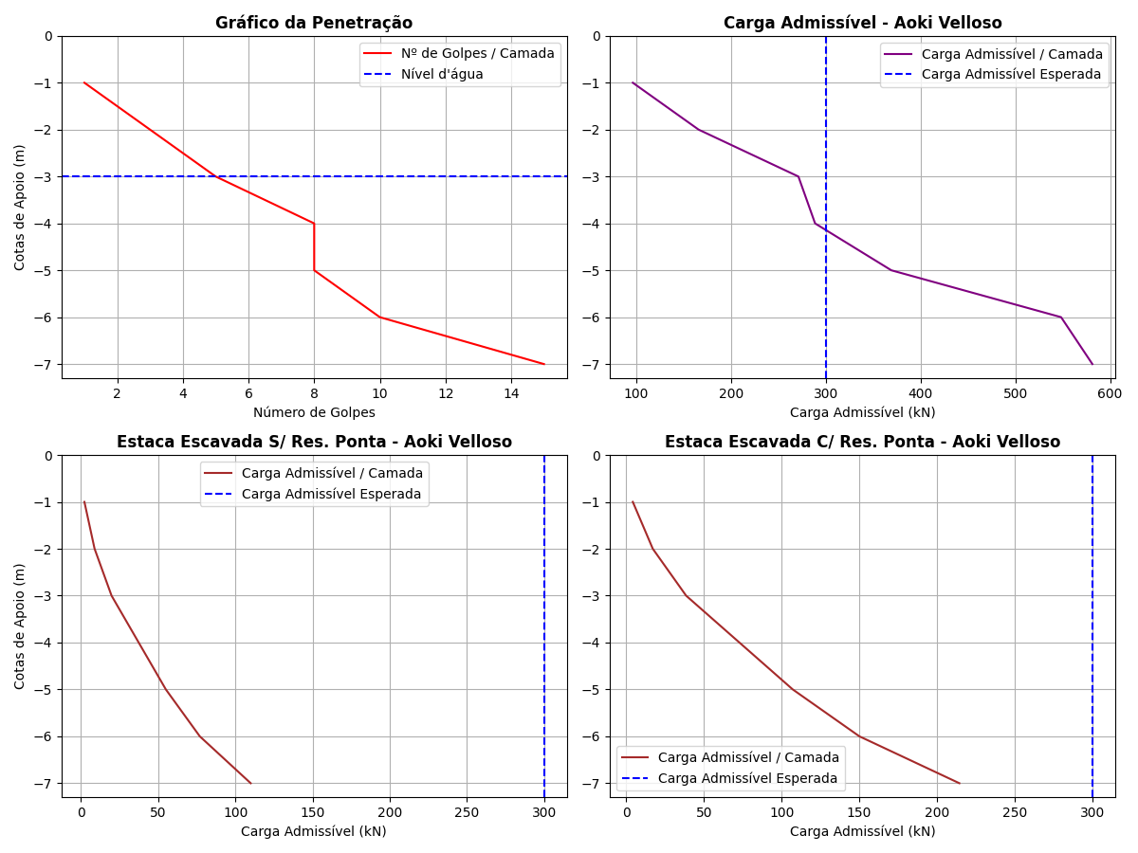

Tabela 1: Resultados pelo método de Aoki Velloso.

|  |  |  |  |  |  |  |  |  |  |  |  |
| --- | --- | --- | --- | --- | --- | --- | --- | --- | --- | --- | --- |
| Cotas | K (kPa) | α (%) | rp (kPa) | Rp (kN) | rl (kPa) | Rl (kN) | Rl Acum. (kN) | Rt (kN) | Padm (kN) | Padm Escavada S/Res. Ponta (kN) | Padm Escavada C/Res. Ponta (kN) |
| -1 | 1000 | 1.4 | 1500.0 | 188.5 | 3.5 | 4.4 | 4.4 | 192.9 | 96.45 | 2.2 | 4.29 |
| -2 | 1000 | 1.4 | 2500.0 | 314.16 | 10.5 | 13.19 | 17.59 | 331.75 | 165.88 | 8.8 | 17.15 |
| -3 | 1000 | 1.4 | 4000.0 | 502.65 | 17.5 | 21.99 | 39.58 | 542.23 | 271.12 | 19.79 | 38.59 |
| -4 | 1000 | 1.4 | 4000.0 | 502.65 | 28.0 | 35.19 | 74.77 | 577.42 | 288.71 | 37.38 | 72.9 |
| -5 | 1000 | 1.4 | 5000.0 | 628.32 | 28.0 | 35.19 | 109.96 | 738.28 | 369.14 | 54.98 | 107.21 |
| -6 | 1000 | 1.4 | 7500.0 | 942.48 | 35.0 | 43.98 | 153.94 | 1096.42 | 548.21 | 76.97 | 150.09 |
| -7 | 1000 | 1.4 | 7500.0 | 942.48 | 52.5 | 65.97 | 219.91 | 1162.39 | 581.2 | 109.96 | 214.41 |

# Resultados Decourt Quaresma

Figura 2: Gráfico dos resultados pelo método de Decourt Quaresma.

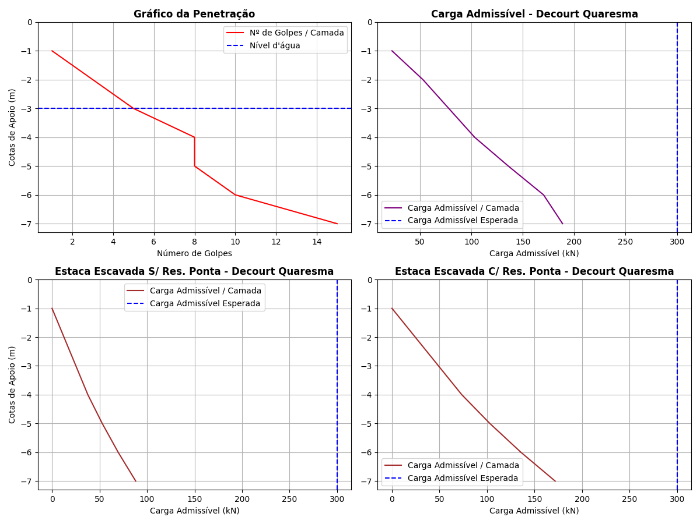

Tabela 2: Resultados pelo método de Decourt Quaresma.

|  |  |  |  |  |  |  |  |  |  |  |  |  |  |  |
| --- | --- | --- | --- | --- | --- | --- | --- | --- | --- | --- | --- | --- | --- | --- |
| Cotas | Nsptl | Nsptp | C (kPa) | α | β | rp (kPa) | Rp (kN) | rl (kPa) | Rl (kN) | Rl Acum. (kN) | Rt (kN) | Padm (kN) | Padm Escavada S/Res. Ponta (kN) | Padm Escavada C/Res. Ponta (kN) |
| -1 | 3.0 | 3.0 | 400 | 0.3 | 1 | 1200.0 | 45.24 | 0.0 | 0.0 | 0.0 | 45.24 | 22.62 | 0.0 | 0.0 |
| -2 | 3.0 | 5.33 | 400 | 0.3 | 1 | 2132.0 | 80.37 | 20.0 | 25.13 | 25.13 | 105.5 | 52.75 | 12.56 | 24.5 |
| -3 | 3.0 | 7.0 | 400 | 0.3 | 1 | 2800.0 | 105.56 | 20.0 | 25.13 | 50.26 | 155.82 | 77.91 | 25.13 | 49.0 |
| -4 | 3.0 | 8.67 | 400 | 0.3 | 1 | 3468.0 | 130.74 | 20.0 | 25.13 | 75.39 | 206.13 | 103.06 | 37.7 | 73.51 |
| -5 | 4.25 | 11.0 | 400 | 0.3 | 1 | 4400.0 | 165.88 | 24.17 | 30.37 | 105.76 | 271.64 | 135.82 | 52.88 | 103.12 |
| -6 | 5.0 | 13.33 | 400 | 0.3 | 1 | 5332.0 | 201.01 | 26.67 | 33.51 | 139.27 | 340.28 | 170.14 | 69.64 | 135.79 |
| -7 | 5.83 | 13.33 | 400 | 0.3 | 1 | 5332.0 | 201.01 | 29.43 | 36.98 | 176.25 | 377.26 | 188.63 | 88.12 | 171.84 |

# Comparativo entre Aoki Velloso e Decourt Quaresma

Figura 3: Comparativo entre Aoki Velloso e Decourt Quaresma.

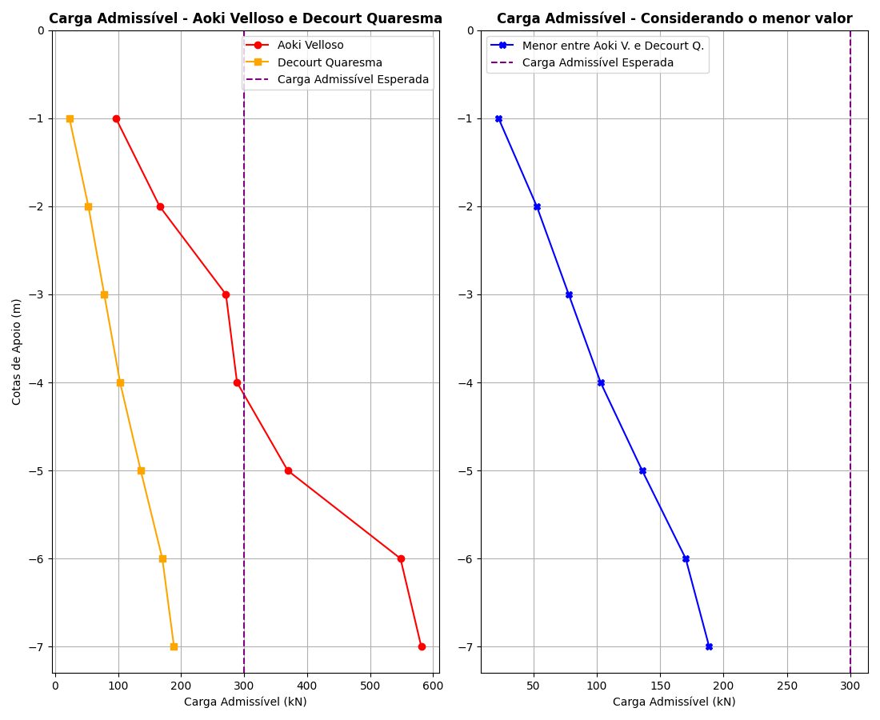

Tabela 3: Comparativo entre Aoki Velloso e Decourt Quaresma.

|  |  |  |  |
| --- | --- | --- | --- |
| Cotas | Padm - Aoki Velloso (kN) | Padm - Decourt Quaresma (kN) | Menor valor entre os métodos (kN) |
| -1 | 96.45 | 22.62 | 22.62 |
| -2 | 165.88 | 52.75 | 52.75 |
| -3 | 271.12 | 77.91 | 77.91 |
| -4 | 288.71 | 103.06 | 103.06 |
| -5 | 369.14 | 135.82 | 135.82 |
| -6 | 548.21 | 170.14 | 170.14 |
| -7 | 581.2 | 188.63 | 188.63 |