European Union-wide Risk Assessment Methodology

R. Fernández-Blancoa,*, J.-F. Vuillaumea, R. Schilla, S. Giaccariaa, A. Costescua, N. Rodrígueza, R. Bolado-Lavína

aJoint Research Centre (JRC), European Commission, Westerduinweg 3, NL-1755 LE Petten, Netherlands

# Introduction

This document contains additional input data about the description of the European natural gas system model used for the journal paper entitled “European Union-wide Risk Assessment Methodology”.

# European natural gas system

The contents of the tables related to the input data are described as follows:

* Table 1 shows the interconnection capacities between each pair of model regions and its availability. Those connections with an X in their availability are the ones affected by the interruption in the disruption scenarios.
* Table 2 provides technical parameters for the LNG terminals in EU countries plus UK such as the storage capacity, regasification capacity, and injection rate into the LNG tanks.
* Table 3 and Table 4 provide technical parameters for the aggregated UGS in the EU plus UK such as the storage capacity, injection/withdrawal maximum capacities, and the parameters required to define two-block injection/withdrawal capacity curves.

In addition, Figures 1 and 2 provide the average and standard deviation of the gas curtailment for all scenarios and countries.

Table 1. Cross-border capacity in interconnection points and availability.

|  |  |  |  |  |  |  |  |
| --- | --- | --- | --- | --- | --- | --- | --- |
| From node | To node | Capacity (GWh/d) | Availability | From node | To node | Capacity (GWh/d) | Availability |
| AT | DE | 340 | 1 | RO | BG | 44 | 1 |
| AT | HU | 153 | 1 | RO | HU | 73 | 1 |
| AT | IT | 1176 | 1 | SI | HR | 54 | 1 |
| AT | SI | 113 | 1 | SI | IT | 26 | 1 |
| AT | SK | 247 | 1 | SK | AT | 1570 | 1 |
| BE | DE | 542 | 1 | SK | CZ | 395 | 1 |
| BE | FR | 530 | 1 | SK | HU | 129 | 1 |
| BE | LU | 49 | 1 | SK | PL | 174 | 1 |
| BE | NL | 428 | 1 | SK | UA | 437 | 1 |
| BE | GB | 803 | 1 | I_TBP_RO | BG | 185 | 1 |
| BG | I_BGT_BG | 21 | 1 | GB | BE | 652 | 1 |
| BG | RO | 27 | 1 | GB | IE | 387 | 1 |
| I_BGT_BG | BG | 322 | 1 | GB | NL | 168 | 1 |
| I_BGT_BG | GR | 120 | 1 | EE | FI | 71 | 1 |
| I_BGT_BG | MK | 33 | 1 | FI | EE | 78 | 1 |
| I_BGT_BG | TR | 584 | 0 | LV | EE | 179 | 1 |
| BG | I_TAP_GR | 106 | 1 | I_BY_RU | LT | 325 | 0 |
| CH | DE | 240 | 1 | I_BY_RU | PL | 176 | 0 |
| CH | FR | 100 | 1 | I_BY_RU | I_YAM_PL | 1027 | 0 |
| CH | IT | 640 | 1 | RU | I_BY_RU | 1529 | 0 |
| CZ | DE | 961 | 1 | DZ | ES | 337 | X |
| CZ | SK | 1399 | 1 | I_YAM_PL | DE | 932 | 0 |
| DE | AT | 370 | 1 | I_YAM_PL | PL | 278 | 1 |
| DE | BE | 356 | 1 | RU | DE | 1742 | 0 |
| DE | CH | 363 | 1 | RU | EE | 36 | 0 |
| DE | CZ | 1628 | 1 | RU | FI | 220 | 0 |
| DE | DK | 124 | 1 | RU | LV | 105 | 0 |
| DE | FR | 614 | 1 | I_TAP_GR | GR | 53 | 1 |
| DE | LU | 24 | 1 | I_TAP_GR | IT | 494 | 1 |
| DE | NL | 384 | 1 | I_TBP_BG | I_BGT_BG | 591 | 0 |
| DE | PL | 49 | 1 | TR | I_BGT_BG | 118 | 1 |
| DE | I_YAM_PL | 278 | 1 | TR | GR | 49 | 0 |
| DK | DE | 16 | 1 | I_TRA_UA | HU | 518 | 0 |
| DK | SE | 88 | 1 | I_TRA_UA | PL | 136 | 0 |
| DK | PL | 322 | 1 | I_TRA_UA | RO | 202 | 0 |
| ES | FR | 224 | 1 | I_TRA_UA | SK | 2278 | X |
| ES | PT | 144 | 1 | RU | I_TBP_UA | 584 | 0 |
| FR | BE | 270 | 1 | I_TBP_UA | I_TBP_RO | 591 | 0 |
| FR | CH | 259 | 1 | I_TBP_RO | I_TBP_BG | 591 | 0 |
| FR | ES | 165 | 1 | RU | I_TRA_UA | 3501 | X |
| GR | I_BGT_BG | 67 | 1 | I_TBP_RO | RO | 185 | 1 |
| HR | HU | 51 | 1 | DZ | I_TRA_IT | 1155 | X |
| HR | SI | 8 | 1 | LY | I_TRA_IT | 494 | X |
| HU | HR | 77 | 1 | NO | I_TRA_DK | 1231 | X |
| HU | RO | 78 | 1 | NO | I_TRA_DE | 356 | X |
| HU | SK | 51 | 1 | RU | I_BGT_BG | 584 | X |
| IT | AT | 194 | 1 | AZ | I_TAP_GR | 390 | X |
| IT | CH | 388 | 1 | BG | RS | 53 | 1 |
| IT | SI | 39 | 1 | BG | I_TBP_RO | 185 | 1 |
| LT | I_KAL_LT | 114 | 1 | CZ | PL | 28 | 1 |
| LT | LV | 90 | 1 | EE | LV | 179 | 1 |
| LV | LT | 82 | 1 | FR | DE | 100 | 1 |
| LT | PL | 58 | 1 | I_BGT_BG | RS | 407 | 1 |
| NL | BE | 1388 | 1 | I_TAP_GR | BG | 106 | 1 |
| NL | DE | 422 | 1 | I_TRA_DE | DE | 1231 | 1 |
| NL | GB | 494 | 1 | I_TRA_DE | NL | 964 | 1 |
| NO | BE | 488 | X | I_TRA_DK | DK | 322 | 1 |
| NO | FR | 575 | X | I_TRA_DK | I_TRA_DE | 1231 | 1 |
| NO | GB | 1499 | X | I_TRA_IT | IT | 1385 | 1 |
| PL | DE | 0 | 1 | IT | I_TAP_GR | 158 | 1 |
| PL | DK | 91 | 1 | RS | BG | 51 | 1 |
| PL | SK | 144 | 1 | RS | I_BGT_BG | 342 | 1 |
| PL | LT | 74 | 1 | RS | HU | 246 | 1 |
| PT | ES | 80 | 1 |  |  |  |  |

Table 2. Technical parameters related to LNG terminals in EU Member States and UK.

|  |  |  |  |
| --- | --- | --- | --- |
| Node | Storage capacity (TWh) | Regasification capacity (GWh/d) | Injection capacity (TWh/d) |
| BE | 3.7 | 668.9 | 3.5 |
| DE | 4.2 | 693.2 | 4.2 |
| ES | 21.7 | 1910.4 | 13.3 |
| FI | 1.0 | 140.0 | 1.0 |
| FR | 9.7 | 1481.0 | 7.4 |
| GR | 1.5 | 224.6 | 1.7 |
| HR | 0.9 | 85.5 | 1.7 |
| IT | 4.0 | 720.6 | 4.5 |
| LT | 1.1 | 122.4 | 1.0 |
| NL | 4.7 | 860.3 | 6.4 |
| PL | 2.1 | 220.0 | 1.4 |
| PT | 2.6 | 200.0 | 1.4 |
| UK | 11.7 | 1617.8 | 4.8 |

Table 3. Injection and withdrawal capacity and storage capacity for underground gas storages by model region.

|  |  |  |  |
| --- | --- | --- | --- |
| Country | Injection capacity (GWh/d) | Withdrawal capacity (GWh/d) | Storage capacity (TWh) |
| AT | 852.3 | 1070.8 | 97.6 |
| BE | 88.1 | 169.7 | 9.1 |
| BG | 41.2 | 40.9 | 5.9 |
| CZ | 511.8 | 705.1 | 44.9 |
| DE | 4025.7 | 6879.3 | 254.8 |
| DK | 90.7 | 180.0 | 10.1 |
| ES | 166.6 | 241.4 | 35.3 |
| FR | 1215.2 | 2487.6 | 134.4 |
| HR | 45.4 | 60.6 | 4.8 |
| HU | 488.1 | 839.7 | 70.1 |
| IT | 1699.2 | 2916.1 | 197.0 |
| LV | 179.0 | 280.0 | 24.1 |
| NL | 1446.2 | 2831.4 | 142.5 |
| PL | 345.0 | 595.9 | 37.5 |
| PT | 24.0 | 85.7 | 4.0 |
| RO | 266.5 | 340.1 | 33.0 |
| SK | 411.0 | 491.6 | 38.8 |
| UK | 496.0 | 487.3 | 9.9 |

Table 4. Parameters defining the injection and deliverability capacity curves of underground gas storages by country in per unit.

|  |  |  |  |  |
| --- | --- | --- | --- | --- |
| Country | $$W_{empty}$$ | $$S_{wd}$$ | $$I_{full}$$ | $$S_{inj}$$ |
| AT | 0.53 | 0.54 | 0.62 | 0.55 |
| BE | 0.00 | 0.54 | 0.02 | 0.49 |
| BG | 0.53 | 0.44 | 0.50 | 0.63 |
| CZ | 0.21 | 0.51 | 0.30 | 0.52 |
| DE | 0.25 | 0.51 | 0.73 | 0.36 |
| DK | 0.13 | 0.26 | 0.00 | 0.99 |
| ES | 0.28 | 1.00 | 0.00 | 0.99 |
| FR | 0.38 | 0.65 | 0.50 | 0.45 |
| HR | 0.14 | 0.52 | 0.24 | 0.87 |
| HU | 0.37 | 0.41 | 0.00 | 0.99 |
| IT | 0.25 | 0.51 | 0.25 | 0.16 |
| LV | 0.09 | 0.80 | 0.38 | 0.79 |
| NL | 0.35 | 0.57 | 0.60 | 0.27 |
| PL | 0.34 | 0.54 | 0.64 | 0.14 |
| PT | 0.78 | 0.92 | 0.00 | 0.99 |
| RO | 0.25 | 0.51 | 0.53 | 0.33 |
| SK | 0.45 | 0.63 | 0.66 | 0.15 |
| UK | 0.32 | 0.55 | 0.56 | 0.34 |

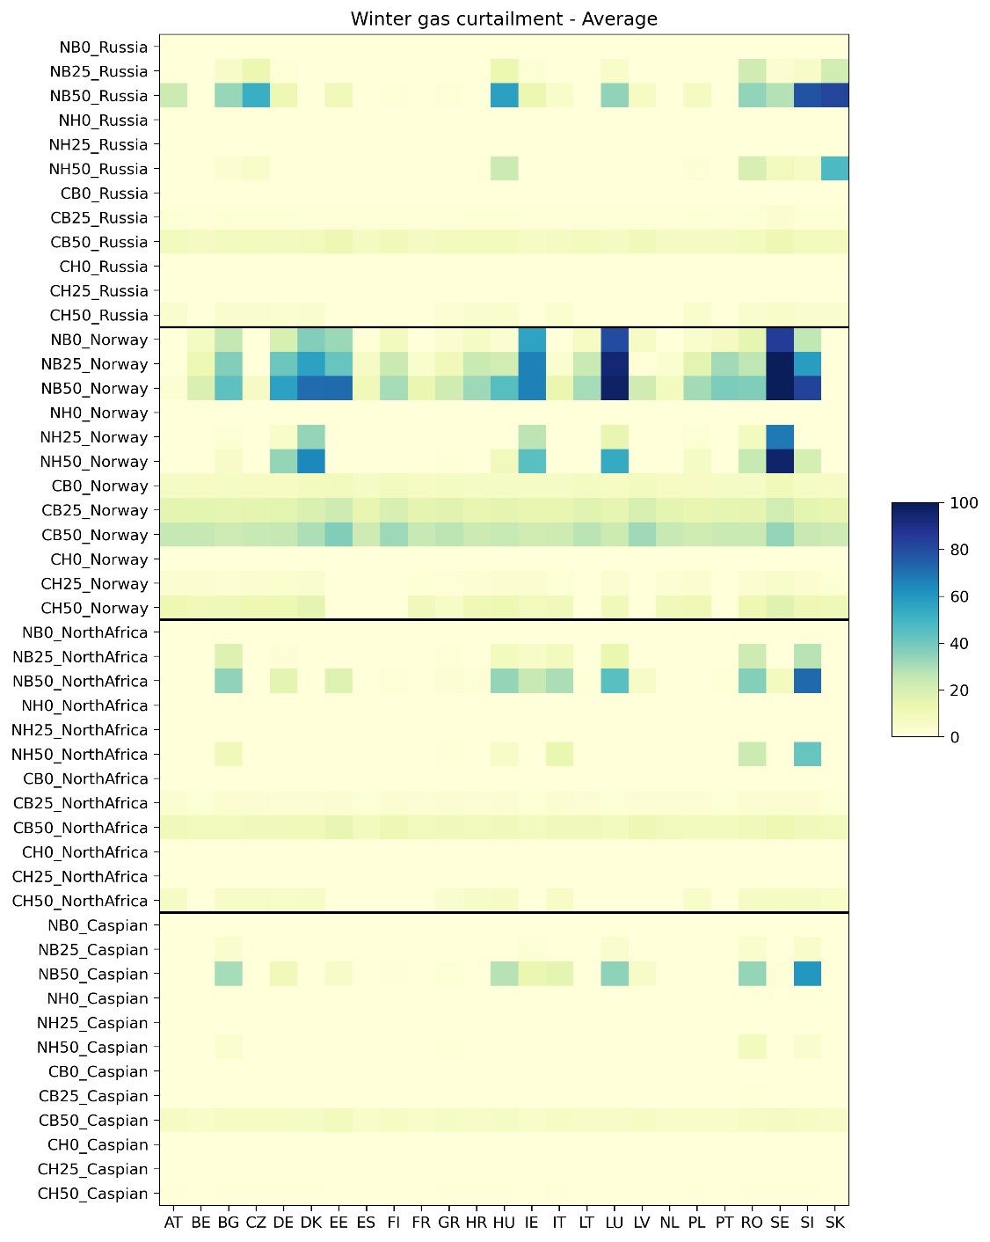

Figure . Average and standard deviation of the gas curtailment for all scenarios and countries.

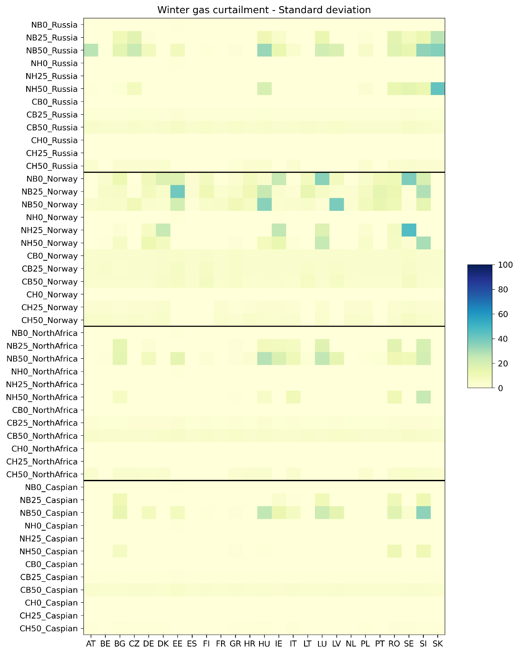

Figure . Standard deviation of the gas curtailment for all scenarios and countries.