River Transport Model Student Guide
Code, numerical methods, and a step by step guide to the Streamlit app
For students of energy and mass transfer | 2 November 2026
This handbook explains the one dimensional river model from input to result. It follows the executed Python port of the Channel VBA macro. Work through the app tutorial first, then use the code chapters to connect each control to an equation and a program step. The app runs without Excel.
Live app: https://ist-river-transport.streamlit.app/
Source code: https://github.com/ricardofmt-lang/Mass_transfer_river_model

What you should be able to do
- Set up a river reach with a meaningful grid, time step, transport scheme, and property distribution.
- Explain advection, longitudinal diffusion, lateral mixing, surface exchange, and reactions in the calculation order used by the code.
- Read the numerical table, spatial profiles, time series, space time map, and animated 3D channel without confusing visualization with a three dimensional calculation.
- Use the Courant and diffusion numbers to reason about resolution and numerical behavior.
- Trace a result from a Streamlit input through configuration, mutable state, solver, and chart modules.

Model boundary and scope
Every river cell represents a whole vertical cross section. Width and depth affect flow, mixing volume, and surface exchange, but each property has only one value per cell. The 3D view gives those 1D values a channel shape; it does not calculate vertical or cross river gradients.
The code deliberately matches the executed macro even where the theory PDF has a typo or a different formula. The final chapter identifies the main differences that matter when reading both together.

Part 1 Using the app

A first complete run
1. Open the live app. It starts with empty numerical fields so the source of every value is clear.
2. Select Load workbook example. This fills a short 20 cell demonstration and is the quickest way to learn the workflow.
3. Read Controls, River, Atmosphere, Discharges, Properties, and Graphs from left to right. Change one value at a time during your first experiments.
4. Select Run simulation. The Results section appears below the input tabs.
5. Choose a property, compare its numerical table with a profile and time series, and then open the 3D river animation.
6. Download saved inputs JSON to reproduce the same case later. Export a result table as CSV or all results as JSON when needed.
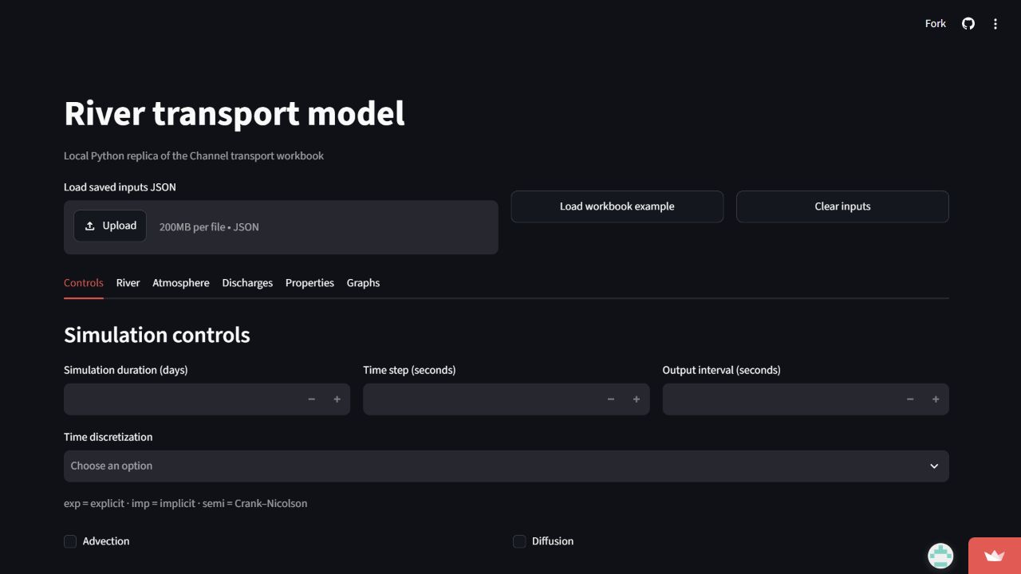
Figure 1 Empty starting state. Focus on the blank duration, time step, and output interval. Loading a preset fills them, but a new study should document its own chosen values.
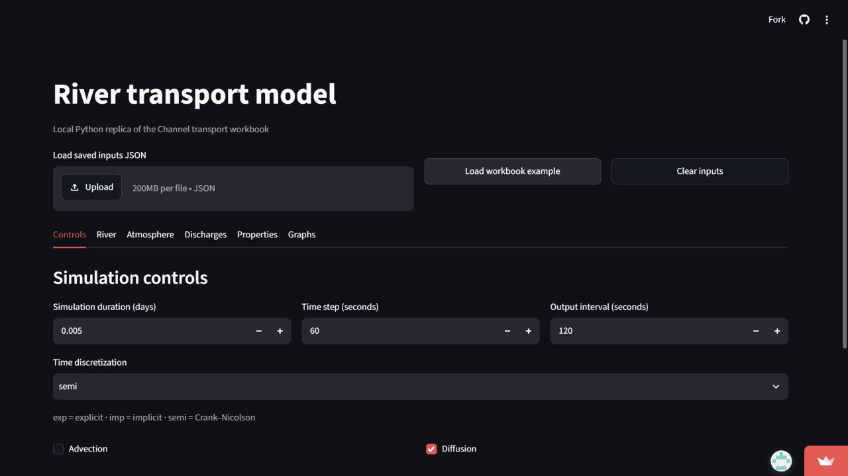
Figure 2 Example controls. The example uses 0.005 day, a 60 second step, a 120 second output interval, semi implicit transport, diffusion on, and advection off.

Controls and numerical resolution
Input | Meaning | How to interpret it
Duration | Requested end time in days. | The loop can finish one step beyond this time; inspect the printed time column.
Time step dt | Seconds advanced by each calculation step. | Smaller steps usually improve time resolution and increase run time.
Output interval | Target spacing between saved rows. | The first step reaching a print threshold is saved; values are not interpolated.
Time method | exp, imp, or semi (Crank Nicolson). | This changes longitudinal transport weighting; source terms retain their macro specific updates.
Advection | Turns transport by mean flow on or off. | Off makes displayed Courant number zero even if velocity is entered.
Diffusion | Turns longitudinal spreading on or off. | Off makes displayed diffusion number zero even if diffusivity is entered.

For equal cells, dx = length / number of cells. Cr = velocity × dt / dx and D = diffusivity × dt / dx² when the respective process is enabled. The app rounds diagnostic numbers to two decimals: a displayed 0.0 can mean a small nonzero value. In the example, dx = 500 m and D = 4 × 60 / 500² = 0.00096, which displays as 0.0.

River geometry and flow
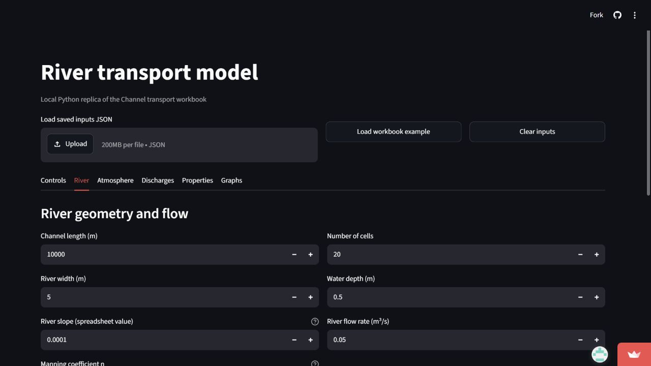
Figure 3 River input tab. Length and cell count determine dx; width and depth determine cross sectional area. The flow selector either computes velocity from Q/(width × depth) or accepts an entered velocity.
Input | Role in calculation | Student check
Length and cells | Fix the one dimensional grid and cell centre positions. | Cell 1 is centred at dx/2, not at x = 0.
Width and depth | Set cell volume and exchange area; depth also enters gas exchange. | A deeper channel dilutes the same lateral load more.
Flow rate or velocity | Set mean longitudinal velocity. | Sign controls which end is upstream; zero removes advective transport.
Diffusivity | Sets longitudinal mixing in m²/s. | The standard option uses 0.1 × abs(velocity) × width.
Slope | Used in the macro gas exchange correlation. | The app preserves the spreadsheet input convention.
Manning coefficient | Retained from the workbook input. | It is not used by this transport solver; no hydraulic model is coupled here.

Atmospheric forcing and solubility
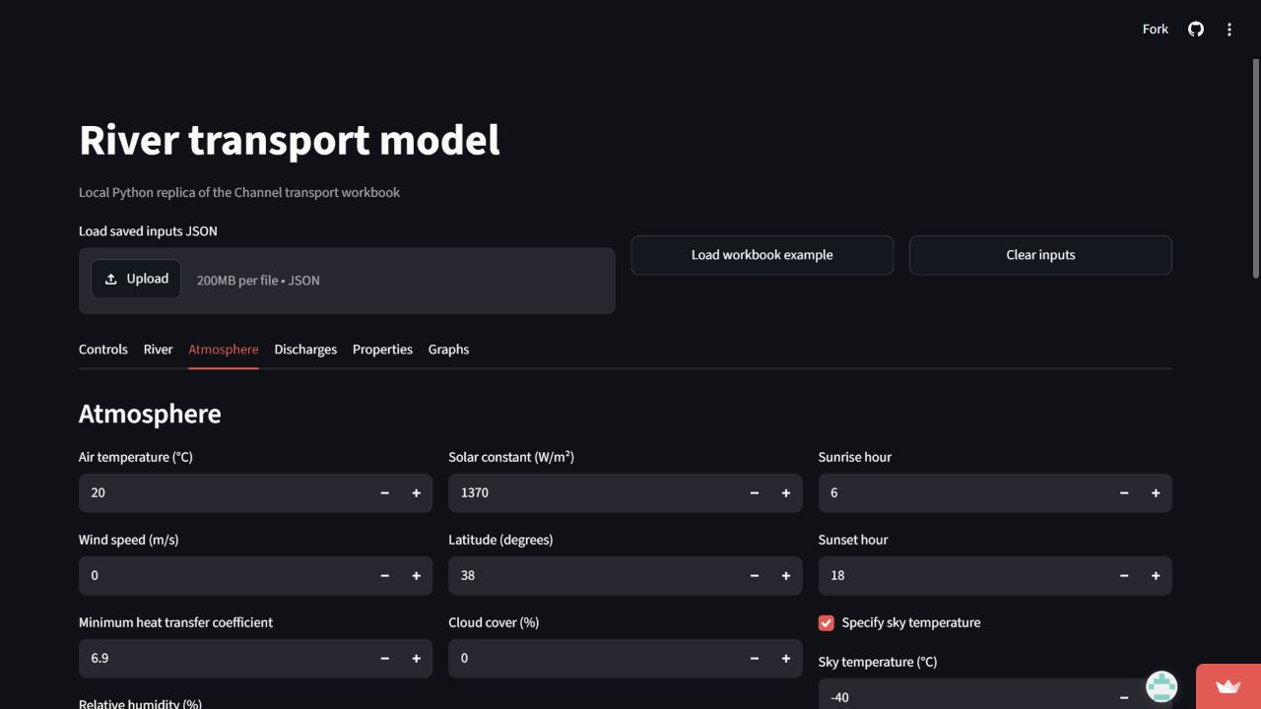
Figure 4 Atmosphere tab. Air temperature, wind, humidity, sun, and sky settings drive heat exchange. Gas pressures and the Henry table appear farther down the same tab.
Solar forcing follows a daylight sine between sunrise and sunset, reduced by latitude, atmospheric absorption, and cloud cover. Sensible heat responds to the air water temperature difference. Latent heat responds to vapour pressure and humidity. Long wave radiation uses an imposed sky temperature or the macro correlation. These processes run only when atmospheric heat exchange is enabled for Temperature.
DO and CO2 surface exchange use Henry constants interpolated at the current water temperature. Enter one temperature per table row, with O2 and CO2 constants in the associated columns. The example CO2 pressure is calculated from the O2 pressure. Gas exchange requires the relevant property and surface exchange switch.

Continuous lateral sources
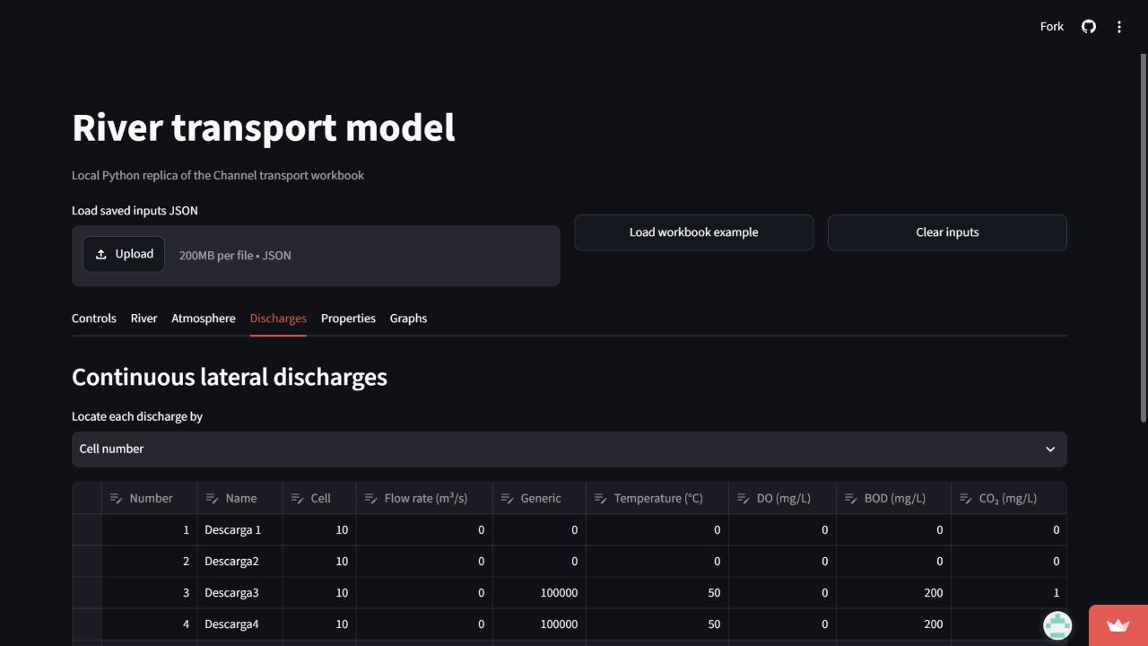
Figure 5 Discharge editor. Choose cell number or distance for each source, then provide its flow rate and each property value in the same table.
A continuous discharge is mixed into its target cell before that step's longitudinal transport. The update is a volume weighted average of old river water and incoming source water. A positive source flow adds water each step in the macro's mixing calculation. Instantaneous releases belong in the initial distribution, not in this table.

Properties, boundaries, and initial values
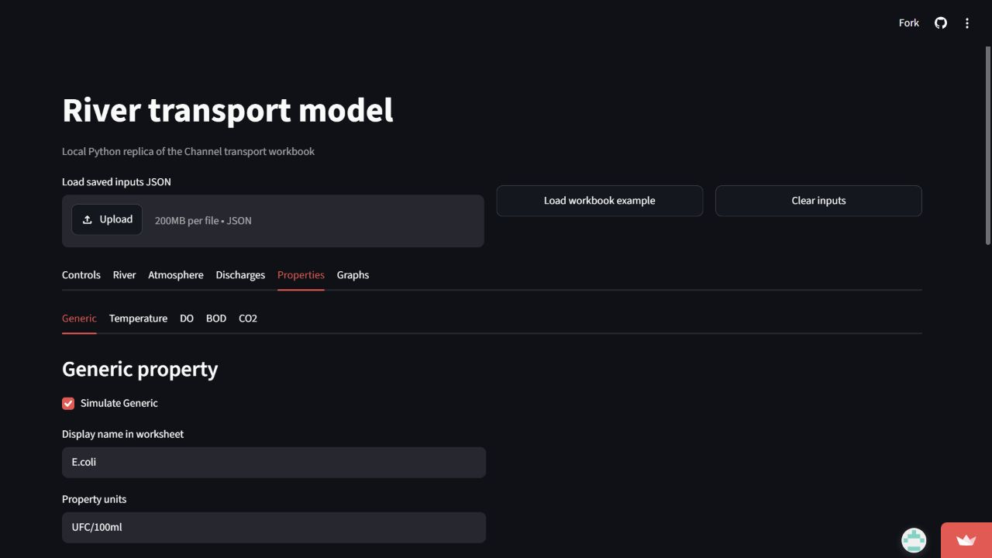
Figure 6 Generic property. The property tabs select Generic, Temperature, DO, BOD, or CO2. The visible fields depend on the active property and initialization choice.
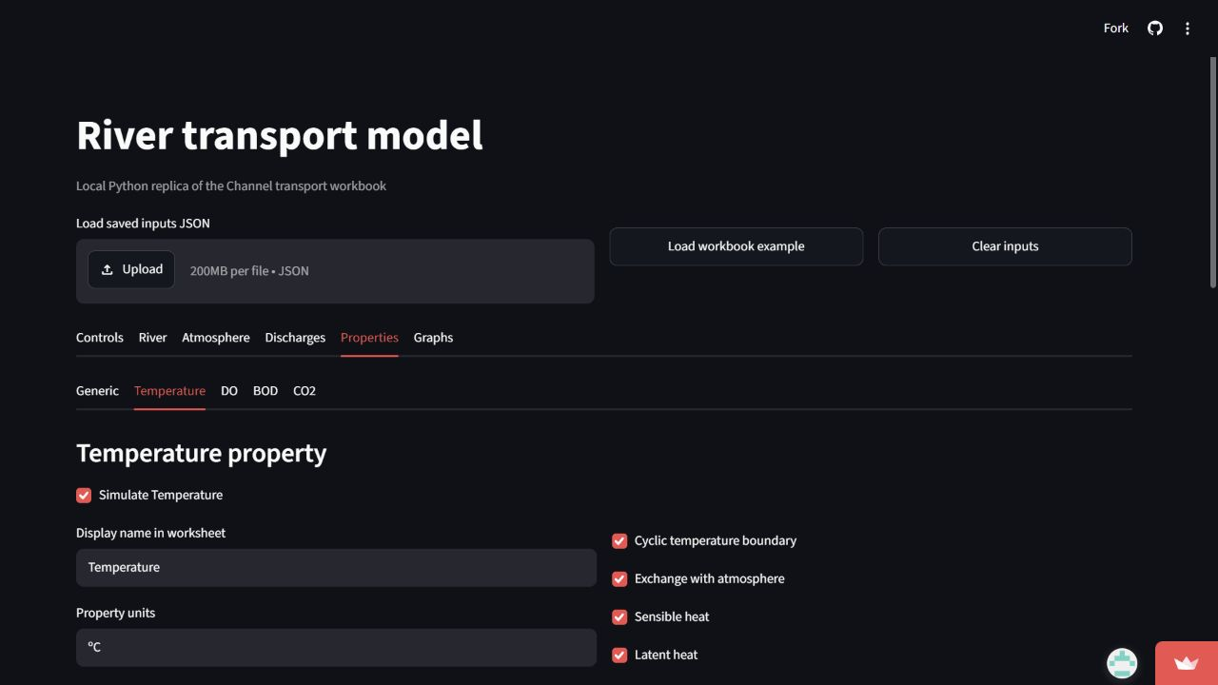
Figure 7 Temperature property. Atmospheric heat switches sit with Temperature. Solar input follows the overall atmosphere exchange switch even when the three optional heat components are off.
Property | What it represents | Coupling or important controls
Generic | A tracer or pollutant in user chosen units. | Optional first order decay or growth; T90 and half life inputs are converted to rates.
Temperature | Water temperature in degrees Celsius. | Surface heat exchange and optional cyclic boundary.
DO | Dissolved oxygen. | Gas exchange and aerobic BOD consumption; needs Temperature.
BOD | Biological oxygen demand. | Growth, aerobic and optional anaerobic decay; needs DO.
CO2 | Dissolved carbon dioxide. | Gas exchange and carbon produced by BOD respiration.

Left and right boundary values describe water entering from either end. Positive velocity enters from the left; negative velocity enters from the right. The cyclic option is implemented for Temperature in the macro and should be interpreted as that specific code behavior, not a generic periodic boundary for every property.
DEFAULT applies a background value everywhere. CELL first fills the background, then overrides named cells. INTERVAL first fills the background, then overrides ranges. Cells not listed remain at the background value. Minimum and maximum fields follow the macro's property rules; do not assume every field is a universal post processing clamp.

Graph selections
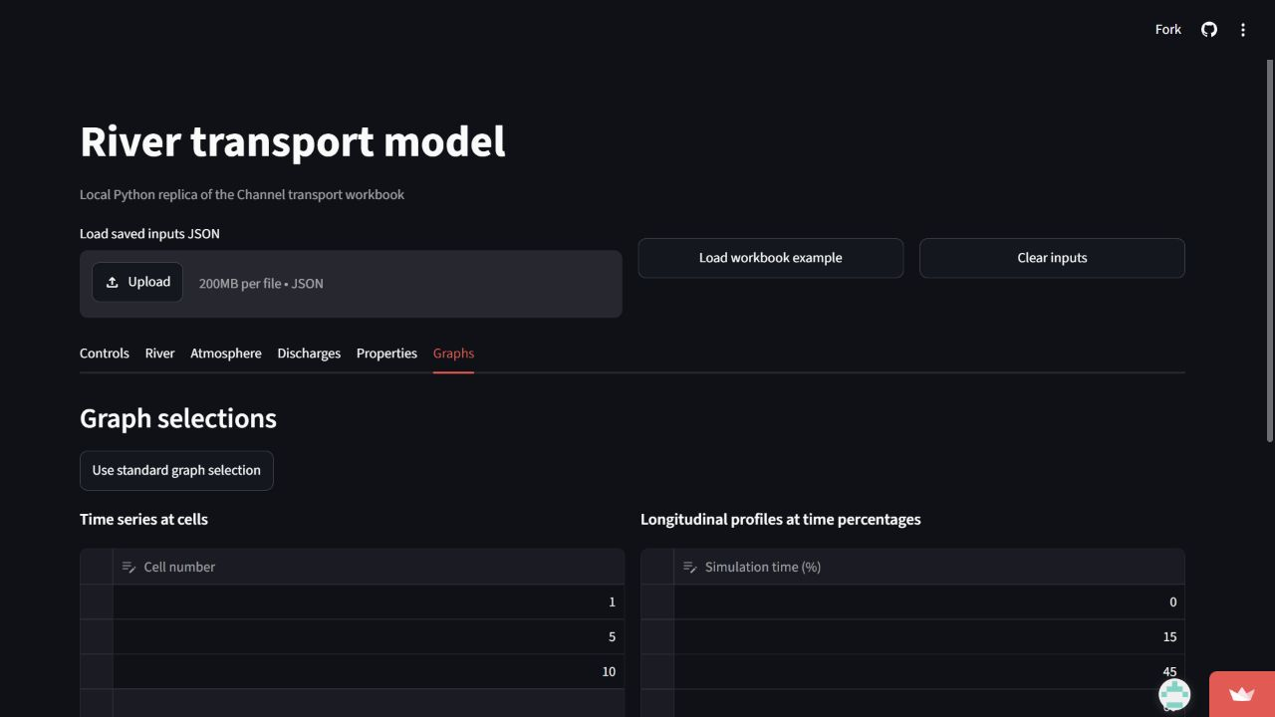
Figure 8 Workbook graph selectors. Time series selectors identify cell numbers. Profile selectors identify percentages of the printed run. Use standard graph selection to populate a teaching example.
These selectors control workbook style chart output. They do not change the numerical solution. If you want to inspect any printed time freely, use the interactive profile slider in Results.

Part 2 Reading and exporting results

Numerical tables
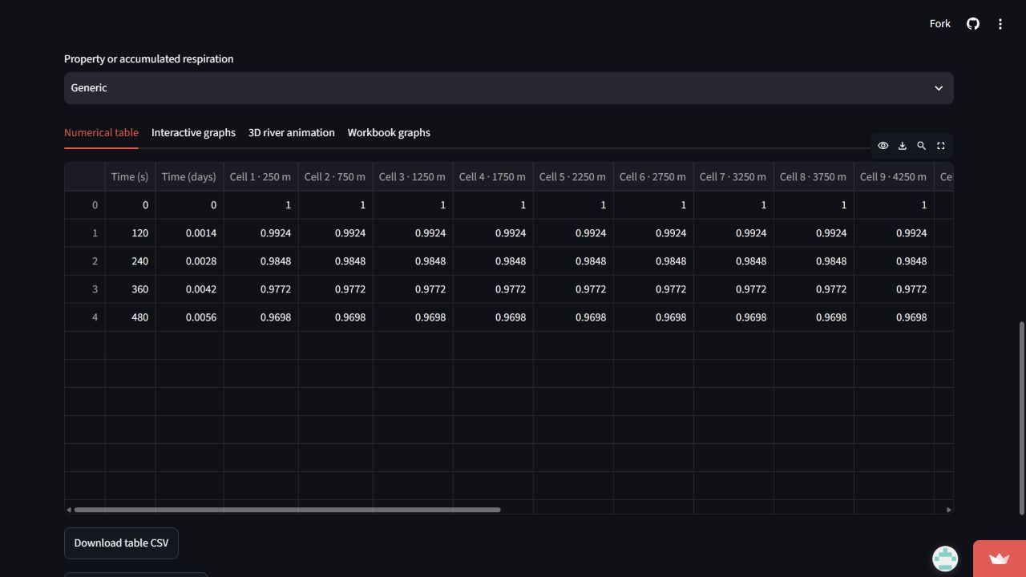
Figure 9 Numerical result table. Each row is a printed time; each cell column is located at the stated centre coordinate. Horizontal scrolling reveals the remaining cells.
The example asks for 0.005 day = 432 seconds but the final printed row is 480 seconds. This follows the macro's step and print threshold logic. Never label the last row as exactly the requested duration without checking Time (s).
Choose the property above the result tabs. Download table CSV gives the selected table; Download all results JSON retains every active property, printed time, coordinate, and diagnostic. Saved inputs JSON is the file to use when you want to reproduce or share the setup.

Profiles and time series
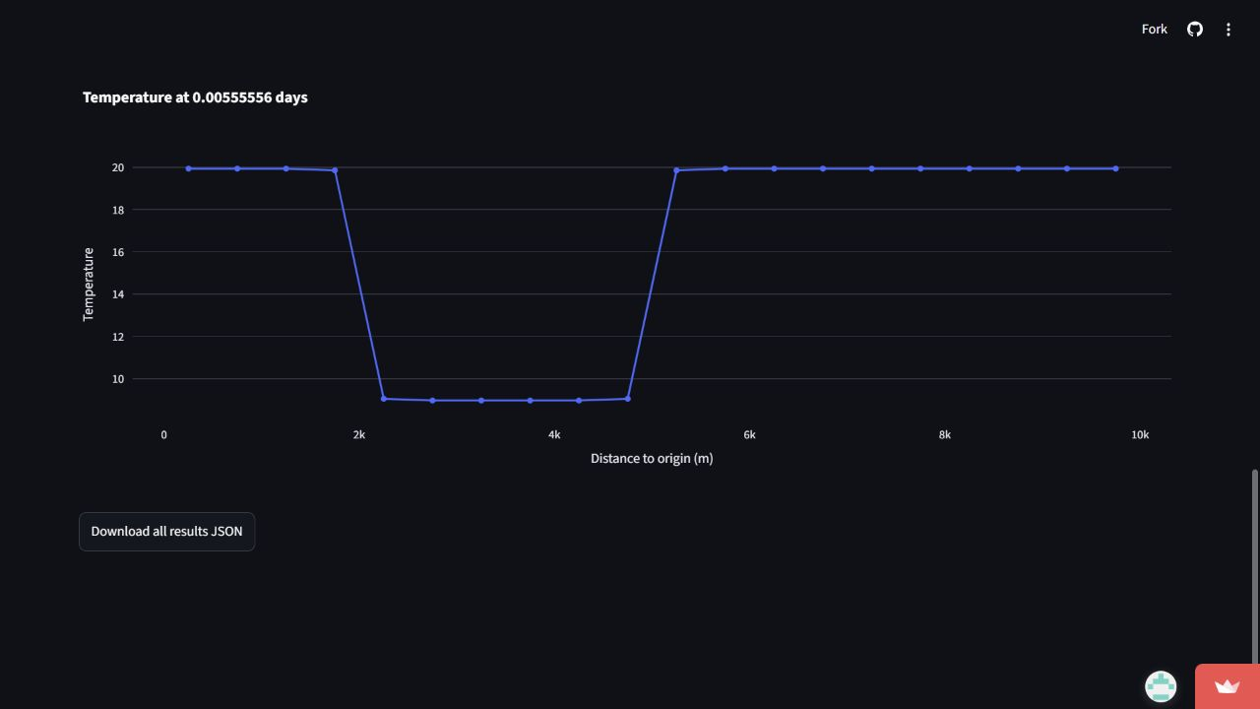
Figure 10 Temperature profile. A longitudinal profile fixes a printed time and shows the value at each cell centre. The cold interval in this example remains visible after diffusion.
A cell time series instead fixes a position and shows the saved values through time. A space time map puts position on one axis, printed time on the other, and uses color for the selected property. Compare all three views before drawing conclusions about movement or spreading.

Animated 3D channel
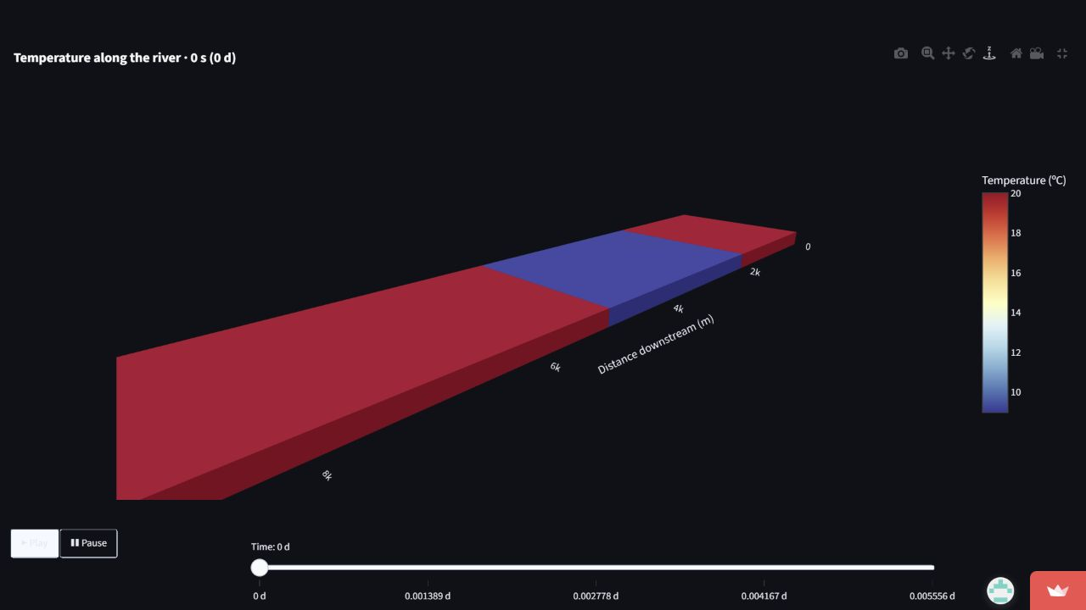
Figure 11 Full screen 3D river. The channel height is the entered 0.5 m depth and its width is 5 m. Use the play button or time slider; the fixed color scale lets you compare frames.
The river is shortened visually relative to its cross section so its faces remain visible. Hover and axis positions retain the actual entered dimensions. A whole cross section shares one color: the model has no variation across width or depth.

Workbook style graphs and diagnostics
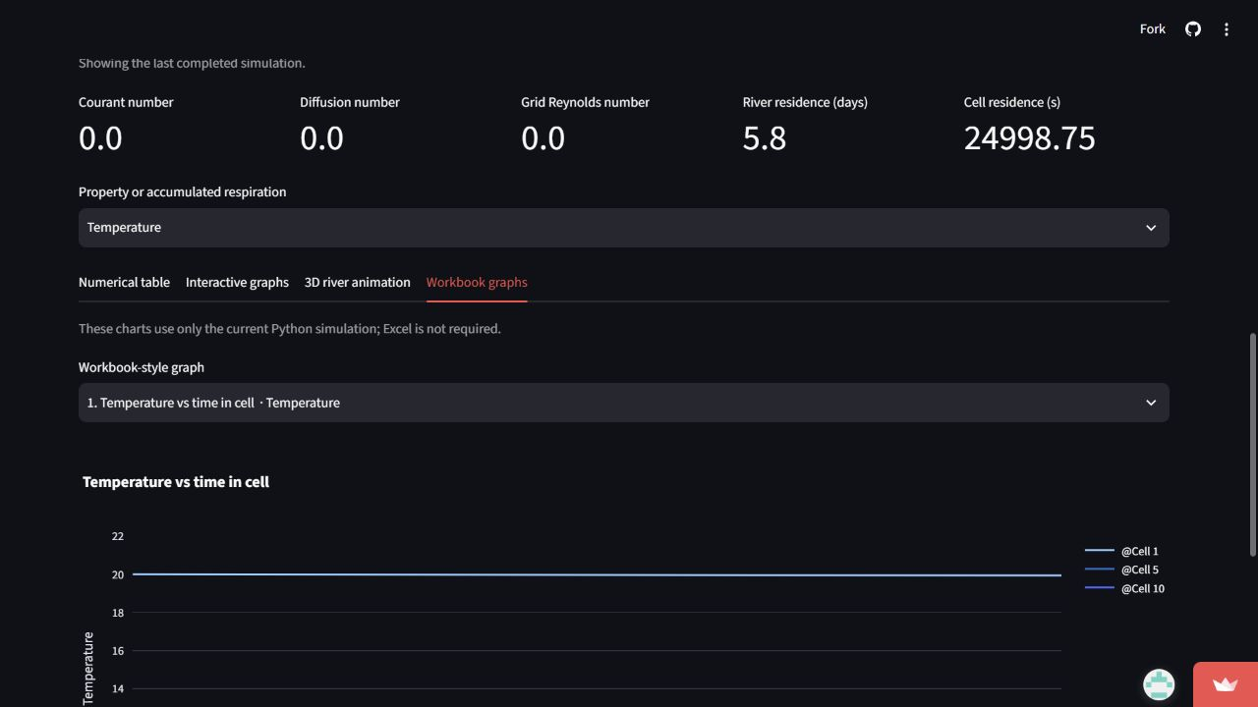
Figure 12 Workbook style chart. These charts use the current Python run rather than old Excel worksheet data. Select a chart above the plot and inspect its series data if needed.
Courant number compares travel in one time step with cell length. Diffusion number compares longitudinal spreading with cell length squared. Grid Reynolds number is Cr/D when D is positive. Residence time estimates travel time from length or cell size and mean velocity; the macro adds a small denominator offset, so treat extreme zero velocity cases cautiously.

When a simulation fails
1. Read the named calculation stage, property, time step, and cell in the error panel.
2. Check the particular input or formula mentioned there: cell index, depth, denominator, Henry table, or a rate that grows too fast.
3. Open Technical details only when you need the original Python exception chain.
4. Correct an input and rerun. Keep the failed setup as saved inputs JSON if you are studying why it failed.

Part 3 How the code works

Module map and data flow
Module | Responsibility | Read it after
app.py | Streamlit editors, results views, downloads, error panel. | The app tutorial
transportmodel/config.py | Turn editor JSON into the macro shaped mutable state. | state.py
transportmodel/state.py | One based arrays and records for grid, flow, properties, atmosphere, coefficients. | The input guide
transportmodel/numerical.py | Execute the time loop and snapshot printed rows. | config.py
transportmodel/transport.py | Build stencils and solve explicit, implicit, or semi implicit transport. | numerical.py
transportmodel/sources.py | Discharges, heat, gas, Generic, and BOD DO CO2 reactions. | numerical.py
transportmodel/charts.py | Create workbook style chart specifications from current results. | The results guide
transportmodel/visualization3d.py | Build the animated channel from one dimensional printed values. | The results guide
transportmodel/workbook.py | Optional Excel input extraction for local reference work. | config.py

The central flow is editor fields -> JSON shaped configuration -> build_state -> mutable model arrays -> run_model -> SimulationResult -> tables and charts. The hosted app needs neither the original workbook nor Excel.

One based state and cell geometry
def zeros(n: int) -> list[float]:
return [0.0] * (n + 1)
g.dx = g.Length / g.NC
for i in range(1, g.NC + 1):
g.xc[i] = g.dx * (i - 0.5)
Index zero is deliberately unused. Cell i has centre x_i = (i - 0.5) dx. The extra slot keeps formulas and loops close to the VBA source and makes Excel parity easier to audit.
The vertical area is width × depth. A cell volume is width × depth × dx. These dimensions explain why equal discharge mass produces a smaller concentration change in deeper or wider water.

Configuration and validation
c.dt = _float(data.get("time_step_seconds"), "Time step")
c.SimulationDuration = _float(
data.get("simulation_duration_days"), "Duration"
) * 24 * 3600
c.DtPrint = _float(data.get("print_interval_seconds"), "Print interval")
The app exposes duration in days while the numerical loop uses seconds. Validation rejects nonfinite values, impossible indices, and cases that would leave the VBA loop running forever.
f.velocity = rate / (gr.RiverWidth * gr.waterdepth)
f.CourantNr = ctrl.dt * f.velocity / gr.dx if ctrl.Advection else 0.0
f.DiffusionNr = ctrl.dt * f.Diffusivity / gr.dx ** 2 if ctrl.Diffusion else 0.0
Flow rate divided by cross sectional area yields mean velocity. The process switches determine whether the corresponding dimensionless transport number participates in the calculation.

The step sequence
while ctrl.T < ctrl.SimulationDuration:
ctrl.T += ctrl.dt
zero_coeffs(coef, gr)
# For each active property: apply lateral discharges.
coef_transport(flow, gr.NC, ctrl, coef)
# For each active property: solve longitudinal transport.
# Then heat, gas, BOD, and Generic sources.
if ctrl.T >= ctrl.printtime:
print_values()
This abridged excerpt shows the order, not a replacement implementation. Source mixing precedes transport. Heat and gas exchange and biochemical reactions follow it. The solver prints time zero before the loop and then at the first step meeting each output threshold.
The property order is Generic, Temperature, DO, BOD, CO2. The shared transport stencil is calculated once per step. Property arrays change in place, so process order matters when a later source reads an earlier updated value.

Longitudinal transport schemes
Diffusion adds equal neighbour contributions D and an interior centre contribution -2D. Upwind advection chooses the upstream side of each face; central differences divide the contribution between neighbours. QUICK estimates face values with a quadratic upstream stencil and therefore reaches two cells away. QUICK_UP can replace that stencil locally with upwind near a sharp gradient.
if ctrl.AdvType == "upwind":
if flow.velocity > 0:
coef.B[i] += flow.CourantNr
coef.e[i] -= flow.CourantNr
else:
coef.e[i] += flow.CourantNr
coef.f[i] -= flow.CourantNr
Positive flow takes information from the left cell; negative flow reverses the direction. The implemented code uses one based coefficient arrays and separately handles boundary cells.
Explicit transport evaluates the entire next field from a frozen Old field. Implicit transport places the new neighbour values in a tridiagonal linear system solved by forward elimination and back substitution. Semi implicit transport splits the stencil between Old and New. QUICK variants require a five diagonal elimination because their stencil spans two extra cells.
A stable looking plot is not proof of physical accuracy. Compare a no diffusion advected patch with the original shape, inspect undershoots and overshoots, and repeat at smaller dx and dt.

Lateral mixing and surface exchange
Prop.NewValue[ncell] = (
Prop.NewValue[ncell] * (gr.AreaVertical * gr.dx)
+ volume_rate * specific_value * dt
) / (gr.AreaVertical * gr.dx + volume_rate * dt)
The numerator adds old property content and incoming property content. The denominator is the combined volume for this step. Multiple discharges into one cell are applied sequentially in list order.
Temperature.NewValue[i] += (
ctrl.dt * solar_flux / (ro * cp * gr.waterdepth)
)
A surface heat flux divided by water density, heat capacity, and depth becomes a temperature change rate for the entire represented water column. The macro then applies sensible, latent, and long wave terms in sequence.
csat = getCsat_Henry(Gas, Temperature.NewValue[i])
Gas.NewValue[i] = (
Gas.NewValue[i] + ctrl.dt * k_gas_exchange * csat
) / (1 + ctrl.dt * k_gas_exchange)
Henry interpolation gives the equilibrium gas concentration. The implicit update relaxes the cell toward equilibrium; the executed coefficient depends on wind, slope, depth, and any supersaturation enhancement.

Coupled BOD, oxygen, and carbon
bod_decay = pr.BOD.NewValue[i] * decay_rate * dt
pr.BOD.NewValue[i] = bod_before_decay - bod_decay
pr.DO.NewValue[i] = pr.DO.NewValue[i] - bod_decay
pr.CO2.NewValue[i] = pr.CO2.NewValue[i] + bod_decay * (44 / 32)
Aerobic respiration removes BOD and the same mass unit of oxygen. The 44/32 molecular weight ratio converts the oxygen equivalent into CO2 mass. The routine limits consumption by available oxygen and BOD before these assignments.
When anaerobic respiration is enabled, further BOD is removed without consuming DO. The simplified macro counts half of that loss toward CO2. Integrated aerobic and anaerobic respiration outputs sum each cell's reacted mass through time. These are deliberately simplified biochemistry, not a full aquatic ecosystem model.

Charts, animation, and errors
charts.py reads the current SimulationResult and builds serializable workbook style chart specifications. This prevents old CO2 worksheet values from appearing in a new run, a known macro chart bug. visualization3d.py repeats each one dimensional cell value across top, side, and end faces, and holds the color scale fixed across animation frames.
A SimulationError attaches stage, property, step, time, and cell to the original exception. The app converts this into a readable explanation, suggested checks, and a Technical details expander. The original cause is preserved for debugging.

Evidence that the port matches the workbook
The test suite checks every printed cell in 89 recorded Excel cases, including coupled and extreme settings, and also compares the saved 1,000 cell workbook run. Chart tests compare series data for cases calculated by both systems. Floating point parity uses a relative tolerance of 1e-14 or absolute tolerance of 1e-12 to allow the last binary rounding bits to differ. The standalone test runs the app without the XLSM.
To repeat the tests locally, install requirements.txt and requirements-dev.txt, then run: python -m pytest -q. The documented code comments were checked against the previous Python AST to confirm that they changed no executable behavior; all 316 tests passed.

Reading the theory PDF critically
- The executed gas exchange uses wind plus 0.1, slope plus 0.00001, division by depth, and an oversaturation enhancement. The PDF's temperature multiplier is not called by the active routine.
- The code uses a solar cloud factor 1 - 0.75 F cubed and 23 percent atmospheric absorption. Compare this with the two solar formulas printed in the PDF.
- The PDF's 20 degree CO2 Henry table entry is a factor of ten below the workbook input 0.039172.
- The macro applies lateral discharges before transport. The PDF's illustrative operator splitting table places them after transport.
- A first CO2 equation in the PDF gives respiration a negative sign; the implemented and later 1D equation use production.

Study exercises
1. Turn off both advection and diffusion. Explain which terms can still change each active property.
2. Increase depth while keeping the same lateral source and other inputs. Predict and verify the concentration response.
3. Enable advection and change its sign. Identify the upstream boundary and compare profile movement.
4. Run the same initial patch with upwind, central, QUICK, and QUICK_UP. Compare spreading and overshoot.
5. Halve dt and dx separately. Calculate the new Cr and D before running, then compare the results.
6. Enable DO, BOD, and CO2 in a saved case. Trace one aerobic decay step through all three arrays.
7. Read one row of the numerical table and locate its time and cell in a profile, time series, map, and 3D frame.

Glossary
Term | Meaning
Cell | One longitudinal river segment representing its whole cross section.
Printed time | A saved result row; not necessarily every computation step.
Courant number | Mean advective travel per step divided by cell length.
Diffusion number | Longitudinal diffusivity times dt divided by dx squared.
Boundary value | Prescribed value used at a reach end in the transport stencil.
Henry constant | Temperature dependent proportionality between gas pressure and equilibrium dissolved concentration.
Operator splitting | Applying transport, exchange, and reaction in successive updates within a step.

End of guide. Use the repository's commented source next to this handbook when studying an individual formula or special case.

