Machine Learning I: Hands-On 2 - Worked Solutions

2.1 CART: worked reference example
The original solution develops the reference dataset step by step. We reproduce that calculation first because it shows exactly how CART evaluates candidate splits.
$A_{1}$​ | $A_{2}$​ | $A_{3}$​ | $Y$​
0 | 0 | 1 | 1
1 | 0 | 1 | 1
1 | 1 | 1 | 1
0 | 0 | 0 | 0
0 | 1 | 0 | 1
For binary classification,
$$G=1−(p_{0}^{2}+p_{1}^{2}),$$
and for a split,
$$G_{\text{split}}=\frac{n_{L}}{n}G_{L}+\frac{n_{R}}{n}G_{R}.$$
CART selects the split with the smallest weighted impurity.

Step 1: Compute impurity at the root
There are five observations. Class $Y=1$ appears four times and class $Y=0$ appears once, so
$$p_{1}=\frac{4}{5}=0.8, p_{0}=\frac{1}{5}=0.2.$$
Hence
$$G_{\text{root}}=1−({0.8}^{2}+{0.2}^{2})=1−(0.64+0.04)=0.32.$$

Step 2: Evaluate the split on $A_{1}$
For $A_{1}=0$, the observations are rows 1, 4, and 5 with targets $1,0,1$. Thus
$$p_{1}=\frac{2}{3}, p_{0}=\frac{1}{3},$$
and
$$G_{L}=1−{\left(\frac{2}{3}\right)}^{2}−{\left(\frac{1}{3}\right)}^{2}=\frac{4}{9}≈0.4444.$$
For $A_{1}=1$, rows 2 and 3 both have $Y=1$, so the right child is pure:
$$G_{R}=0.$$
The weighted impurity is therefore
$$G_{\text{split}}(A_{1})=\frac{3}{5}\left(\frac{4}{9}\right)+\frac{2}{5}(0)=\frac{4}{15}≈0.2667.$$

Step 3: Evaluate the split on $A_{2}$
For $A_{2}=0$, rows 1, 2, and 4 have targets $1,1,0$, so
$$G_{L}=\frac{4}{9}≈0.4444.$$
For $A_{2}=1$, rows 3 and 5 both have $Y=1$, so
$$G_{R}=0.$$
Thus
$$G_{\text{split}}(A_{2})=\frac{3}{5}\left(\frac{4}{9}\right)+\frac{2}{5}(0)≈0.2667.$$

Step 4: Evaluate the split on $A_{3}$
For $A_{3}=0$, rows 4 and 5 have targets $0,1$, giving
$$G_{L}=1−{\left(\frac{1}{2}\right)}^{2}−{\left(\frac{1}{2}\right)}^{2}=0.5.$$
For $A_{3}=1$, rows 1, 2, and 3 all have $Y=1$, so
$$G_{R}=0.$$
Therefore
$$G_{\text{split}}(A_{3})=\frac{2}{5}(0.5)+\frac{3}{5}(0)=0.2.$$

Step 5: Choose the best root split
The candidate weighted impurities are
$$G(A_{1})≈0.2667, G(A_{2})≈0.2667, G(A_{3})=0.2.$$
The smallest value is obtained with $A_{3}$, so CART chooses $A_{3}$ as the root split.
The branch $A_{3}=1$ is already pure and predicts $Y=1$. We only need to continue with the mixed branch $A_{3}=0$.

Step 6: Continue splitting the node $A_{3}=0$
This subset contains rows 4 and 5:
Row | $A_{1}$​ | $A_{2}$​ | $A_{3}$​ | $Y$​
4 | 0 | 0 | 0 | 0
5 | 0 | 1 | 0 | 1
At this node, $A_{1}$ and $A_{3}$ are constant, so neither can separate the two observations. Only $A_{2}$ changes.
Splitting on $A_{2}$ gives
- $A_{2}=0$: one observation with $Y=0$, impurity $0$;
- $A_{2}=1$: one observation with $Y=1$, impurity $0$.
The weighted impurity is therefore
$$\frac{1}{2}(0)+\frac{1}{2}(0)=0.$$
This is a perfect separation.

Final learned tree
The resulting rules are:
- If $A_{3}=1$, predict $Y=1$.
- If $A_{3}=0$ and $A_{2}=0$, predict $Y=0$.
- If $A_{3}=0$ and $A_{2}=1$, predict $Y=1$.
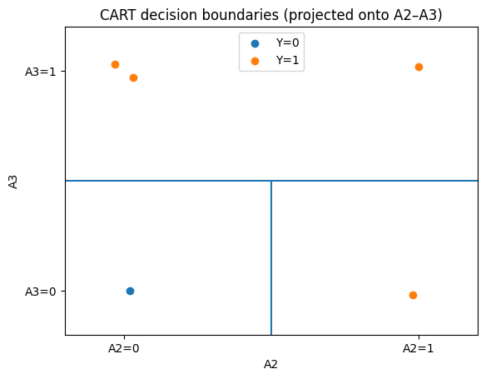
ML insight: greedy impurity reduction
CART chooses the best split at the current node. It does not directly optimize the final tree as one global object. In this example, $A_{3}$ produces the largest immediate reduction in impurity. Once that split is made, only the remaining mixed region needs another partition.

2.2 Applying the same procedure to the exercise dataset
For the exercise dataset, the target values are $0,0,0,1,1$, so
$$G_{\text{root}}=1−{\left(\frac{3}{5}\right)}^{2}−{\left(\frac{2}{5}\right)}^{2}=0.48.$$
The weighted root impurities are
$$G(A_{1})=0.40, G(A_{2})≈0.2667, G(A_{3})≈0.4667.$$
Therefore the best root split is $A_{2}$.
The branch $A_{2}=0$ is pure and predicts class $0$. In the branch $A_{2}=1$, the three remaining observations are
Example | $A_{1}$​ | $A_{3}$​ | $Y$​
3 | 0 | 0 | 0
4 | 1 | 1 | 1
5 | 1 | 0 | 1
Splitting this node on $A_{1}$ makes both children pure, giving weighted impurity $0$. The resulting rules are therefore
- if $A_{2}=0$, predict $Y=0$;
- if $A_{2}=1$ and $A_{1}=0$, predict $Y=0$;
- if $A_{2}=1$ and $A_{1}=1$, predict $Y=1$.
