Machine Learning I: Hands-On 3 - Worked Solutions

3.1 k-nearest neighbors and Naive Bayes: worked solutions

3.1.1 Numerical k-NN
The query is
$$q=(6,5),$$
and the Manhattan distance is
$$d_{i}=|{\text{Age}}_{i}−6|+|{\text{Acidity}}_{i}−5|.$$
Compute the distance for every observation:
Example | Point | Quality | Calculation | Distance
1 | $(4,3)$​ | Good | $|4−6|+|3−5|=2+2$​ | 4
2 | $(1,3)$​ | Bad | $|1−6|+|3−5|=5+2$​ | 7
3 | $(6,2)$​ | Good | $|6−6|+|2−5|=0+3$​ | 3
4 | $(3,7)$​ | Bad | $|3−6|+|7−5|=3+2$​ | 5
5 | $(7,4)$​ | Good | $|7−6|+|4−5|=1+1$​ | 2
6 | $(4,1)$​ | Bad | $|4−6|+|1−5|=2+4$​ | 6
7 | $(6,4)$​ | Good | $|6−6|+|4−5|=0+1$​ | 1
8 | $(4,7)$​ | Bad | $|4−6|+|7−5|=2+2$​ | 4
9 | $(3,6)$​ | Good | $|3−6|+|6−5|=3+1$​ | 4
10 | $(6,1)$​ | Bad | $|6−6|+|1−5|=0+4$​ | 4
Ordering by distance gives
$$7 (1), 5 (2), 3 (3), 1,8,9,10 (4), 4 (5), 6 (6), 2 (7).$$
For $k=3$, the neighbors are Examples 7, 5, and 3. All three are Good, so
$$\boxed{\hat{y}=\text{Good}}.$$
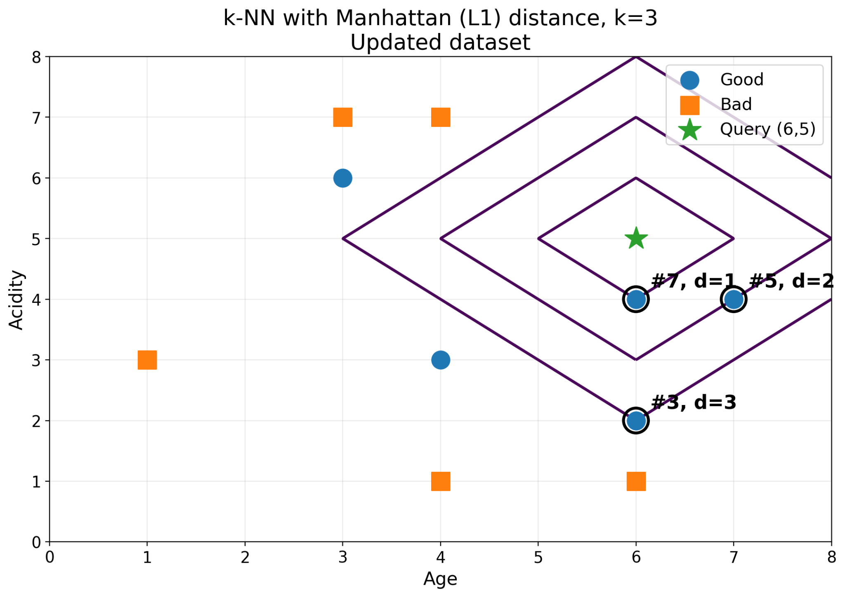
The tie at distance $4$ does not affect the $k=3$ prediction, but it matters if the neighbor cutoff reaches that distance. A practical implementation must use a deterministic policy for equal distances.
As $k$ increases, each prediction averages information over a larger neighborhood. This generally smooths the decision regions: very small $k$ can follow local sample irregularities closely, whereas larger $k$ tends to increase bias and reduce variance.

3.1.2 Categorical k-NN
For the query
$$q=(\text{Red, SUV, Domestic, Automatic, Gasoline}),$$
we count one unit of distance for every mismatching categorical feature.
Example | Stolen? | Mismatches | Distance
1 | Yes | none | 0
2 | Yes | Fuel | 1
3 | Yes | Origin, Transmission | 2
4 | No | Origin, Transmission | 2
5 | No | Type, Origin, Transmission, Fuel | 4
6 | Yes | Color, Type, Origin, Transmission, Fuel | 5
7 | Yes | Color, Type, Origin, Transmission, Fuel | 5
8 | No | Color, Origin, Fuel | 3
9 | Yes | Type, Origin, Fuel | 3
10 | No | Color, Type, Transmission, Fuel | 4
11 | Yes | Color, Type, Transmission, Fuel | 4
The first two nearest neighbors are Examples 1 and 2, both Yes. The third-neighbor position is tied between Examples 3 and 4 at distance 2.
If ties are resolved by original row order, Example 3 is selected and the $k=3$ vote is three Yes votes. If all observations tied at the cutoff are considered, the vote is three Yes versus one No. Either way, this query is predicted as
$$\boxed{\text{Stolen = Yes}}.$$
The 2D Type-versus-Origin projection is useful for intuition but cannot determine the actual prediction on its own because Color, Transmission, and Fuel also contribute to the distance. Two observations that overlap in the displayed projection may still be separated in the full five-dimensional feature space.
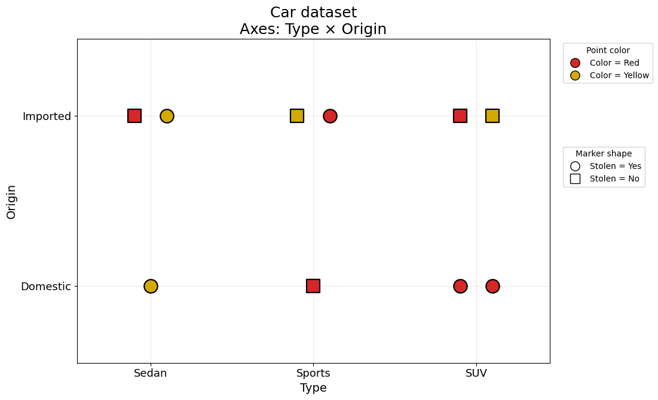

3.1.3 Naive Bayes
There are eight observations:
- 3 with class Yes;
- 5 with class No.
Therefore the class priors are
$$P(\text{Yes})=\frac{3}{8}, P(\text{No})=\frac{5}{8}.$$

Step 1: Probabilities conditioned on Yes
Among the three stolen cars:
- all 3 are Red;
- all 3 are SUVs;
- 2 of the 3 are Domestic.
Hence
$$P(\text{Red}∣\text{Yes})=1,$$
$$P(\text{SUV}∣\text{Yes})=1,$$
$$P(\text{Domestic}∣\text{Yes})=\frac{2}{3}.$$
The unnormalized Naive Bayes score is
$$\begin{aligned}S_{\text{Yes}}&=P(\text{Yes})P(\text{Red}∣\text{Yes})P(\text{SUV}∣\text{Yes})P(\text{Domestic}∣\text{Yes}) \\ &=\frac{3}{8}×1×1×\frac{2}{3} \\ &=\frac{1}{4}=0.25.\end{aligned}$$

Step 2: Probabilities conditioned on No
Among the five non-stolen cars:
- 2 are Red;
- 2 are SUVs;
- 2 are Domestic.
Thus
$$P(\text{Red}∣\text{No})=P(\text{SUV}∣\text{No})=P(\text{Domestic}∣\text{No})=\frac{2}{5}.$$
The score for class No is
$$\begin{aligned}S_{\text{No}}&=\frac{5}{8}×\frac{2}{5}×\frac{2}{5}×\frac{2}{5} \\ &=0.04.\end{aligned}$$

Step 3: Compare the class scores
Since
$$0.25>0.04,$$
Naive Bayes predicts
$$\boxed{\text{Stolen = Yes}}.$$
The numbers $0.25$ and $0.04$ are proportional to the posterior probabilities. For classification, their common normalization constant is unnecessary because only their relative magnitude determines the predicted class.
The same calculation can be repeated for every possible discrete feature combination. This produces a global partition of the discrete feature space: each combination is assigned to whichever class receives the larger posterior score.
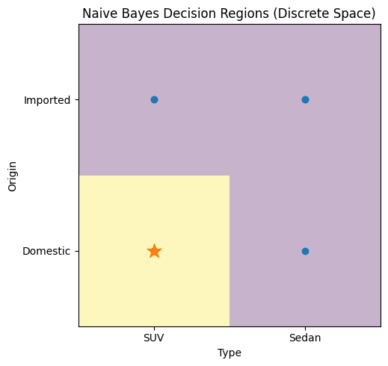
ML insight: why k-NN and Naive Bayes can disagree
k-NN asks which labelled observations are locally closest to the query. Naive Bayes asks which class, according to a global probabilistic model, is more likely to produce the observed feature values. The algorithms therefore encode different inductive biases even when trained on exactly the same data.

