Machine Learning I: Hands-On 8 - Worked Solutions

8.1 Ensembles
The true targets and the four classifier predictions are:
 | ex1 | ex2 | ex3 | ex4 | ex5 | ex6 | ex7 | ex8 | ex9 | ex10
Target | 1 | 0 | 0 | 0 | 0 | 1 | 0 | 1 | 0 | 0
A | 1 | 1 | 0 | 0 | 0 | 1 | 1 | 1 | 0 | 0
B | 1 | 0 | 1 | 0 | 0 | 1 | 0 | 0 | 1 | 0
C | 1 | 0 | 0 | 1 | 1 | 1 | 0 | 1 | 0 | 1
D | 0 | 1 | 1 | 0 | 0 | 0 | 0 | 1 | 0 | 0

1. Individual classifier accuracy
For a binary classifier,
$$\text{Accuracy}=\frac{\text{number of correct predictions}}{\text{number of examples}}.$$
Comparing each row with the true targets gives:
Classifier | Correct predictions | Accuracy
A | 8/10 | 0.80
B | 7/10 | 0.70
C | 7/10 | 0.70
D | 6/10 | 0.60
Classifier A is the best individual classifier by accuracy in this example.

2. Majority-vote ensembles
For each example, the ensemble outputs the class predicted by at least two of its three members.
Ensemble | Majority-vote predictions for ex1–ex10 | Correct | Accuracy
A+B+C | 1, 0, 0, 0, 0, 1, 0, 1, 0, 0 | 10/10 | 1.00
A+B+D | 1, 1, 1, 0, 0, 1, 0, 1, 0, 0 | 8/10 | 0.80
A+C+D | 1, 1, 0, 0, 0, 1, 0, 1, 0, 0 | 9/10 | 0.90
B+C+D | 1, 0, 1, 0, 0, 1, 0, 1, 0, 0 | 9/10 | 0.90
The best ensemble is A+B+C, with 100% accuracy.

3. Why can the ensemble outperform its members?
The best individual classifier, A, reaches 80% accuracy, whereas A+B+C reaches 100%. The improvement is possible because the three classifiers do not make the same mistakes on the same examples. When one member is wrong, the other two can still form a correct majority.
ML insight: diversity matters
A majority-vote ensemble benefits from useful disagreement: its members should be individually competent but should not systematically make the same errors. Majority voting cannot repair an error shared by most members.

8.2 Imbalanced Domain Learning
There are 20 examples: 18 negatives and 2 positives. Class 1 is the positive/minority class.
The confusion-matrix terms are:
Term | Meaning
TP | predicted 1 and the true class is 1
FP | predicted 1 but the true class is 0
FN | predicted 0 but the true class is 1
TN | predicted 0 and the true class is 0
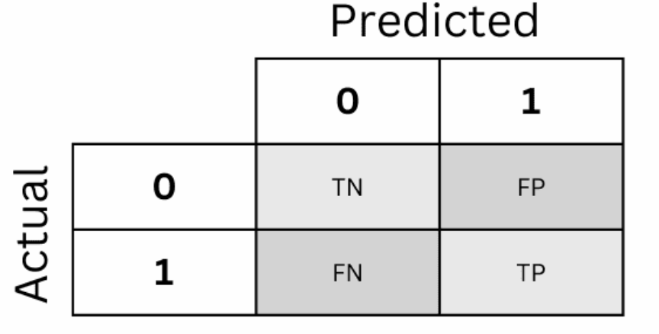

1. Confusion matrices
Read each prediction row against the true targets.

Classifier A
A predicts class 0 for every example. Therefore:
- $TP=0$: no positive example is detected;
- $FP=0$: it never predicts a false positive;
- $FN=2$: both positive examples are missed;
- $TN=18$: all negative examples are correctly classified.

Classifier B
B predicts both positives correctly, but also predicts four negatives as positive:
- $TP=2$;
- $FP=4$;
- $FN=0$;
- $TN=14$.

Classifier C
C detects one of the two positives and creates no false positives:
- $TP=1$;
- $FP=0$;
- $FN=1$;
- $TN=18$.

Classifier D
D detects one positive and incorrectly flags two negatives:
- $TP=1$;
- $FP=2$;
- $FN=1$;
- $TN=16$.
The four confusion matrices can therefore be summarized as:
Classifier | TN | FP | FN | TP
A | 18 | 0 | 2 | 0
B | 14 | 4 | 0 | 2
C | 18 | 0 | 1 | 1
D | 16 | 2 | 1 | 1

2. Accuracy, precision, recall, and F1-score
Use
$$\text{Accuracy}=\frac{TP+TN}{TP+TN+FP+FN},$$
$$\text{Precision}=\frac{TP}{TP+FP}, \text{Recall}=\frac{TP}{TP+FN},$$
$$F_{1}=2\frac{\text{Precision}⋅\text{Recall}}{\text{Precision}+\text{Recall}}.$$

Classifier A
$$\text{Accuracy}=\frac{18}{20}=0.90,$$
but it never predicts the positive class, so
$$\text{Precision}=0, \text{Recall}=0, F_{1}=0.$$

Classifier B
$$\text{Accuracy}=\frac{14+2}{20}=0.80,$$
$$\text{Precision}=\frac{2}{2+4}=\frac{1}{3}≈0.33,$$
$$\text{Recall}=\frac{2}{2+0}=1.00,$$
$$F_{1}=2\frac{(1/3)(1)}{1/3+1}=0.50.$$

Classifier C
$$\text{Accuracy}=\frac{18+1}{20}=0.95,$$
$$\text{Precision}=\frac{1}{1+0}=1.00, \text{Recall}=\frac{1}{1+1}=0.50,$$
$$F_{1}=2\frac{(1)(0.5)}{1+0.5}≈0.67.$$

Classifier D
$$\text{Accuracy}=\frac{16+1}{20}=0.85,$$
$$\text{Precision}=\frac{1}{1+2}=\frac{1}{3}≈0.33, \text{Recall}=\frac{1}{1+1}=0.50,$$
$$F_{1}=2\frac{(1/3)(0.5)}{1/3+0.5}=0.40.$$
The final comparison is:
Classifier | Accuracy | Precision | Recall | $F_{1}$​
A | 0.90 | 0.00 | 0.00 | 0.00
B | 0.80 | 0.33 | 1.00 | 0.50
C | 0.95 | 1.00 | 0.50 | 0.67
D | 0.85 | 0.33 | 0.50 | 0.40

3. Which classifier should be selected?
There is no context-free answer.
If false negatives are extremely costly, Classifier B is the natural choice among these four because its recall is 1.00: it finds both positive examples. The cost is four false positives and lower overall accuracy.
If false positives are very costly, but detecting at least some positive examples is required, Classifier C is attractive. It produces no false positives and detects one of the two positives. The trade-off is recall 0.50: one positive example is missed.
Classifier A is the key counterexample to selecting by accuracy alone. It achieves 90% accuracy despite detecting none of the minority examples. The high accuracy is produced simply by exploiting the majority-class frequency.
ML insight: metrics encode different error preferences
Accuracy measures overall correctness. Recall focuses on missed positives, precision focuses on false alarms, and $F_{1}$ balances precision and recall symmetrically. None of these metrics defines a universally optimal classifier without first specifying which mistakes matter.

