Settings

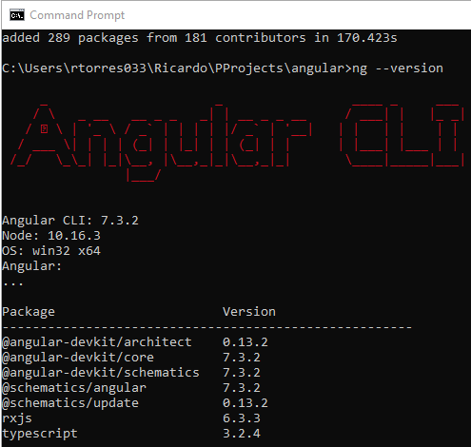

https://docs.microsoft.com/en-us/aspnet/core/tutorials/first-mvc-app/start-mvc?view=aspnetcore-3.0&tabs=visual-studio-code

https://learning.oreilly.com/learning-paths/learning-path-a/9781838645236/

https://learning.oreilly.com/learning-paths/learning-path-mean/9781838557478/

ng --version

npm uninstall -g @angular/cli

npm cache clean --force

npm install -g @angular/cli@7.2.12

ng --version

npm install -g @angular/cli@7.3.2

>ng new angular-news --routing --style=scss --skip-install --inline-style --inline-template --dry-run

> ng new angular-news --routing --style=scss --skip-install

>cd angular-news

npm install

ng s –o

ng add @angular/material

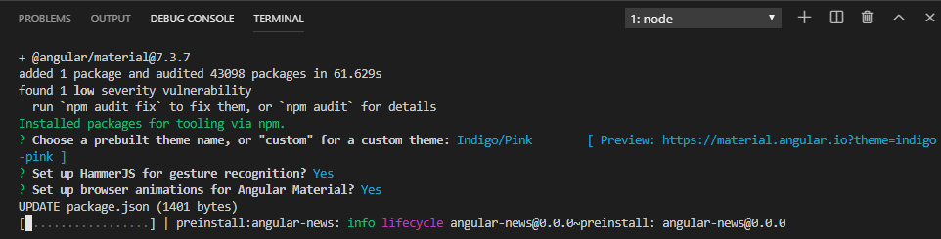

ng generate module material

//delete material folder and write this

ng generate module material –flat, to create the module in the root path with app module.

//adding material button

//open app.component.html

<button mat-button>Click me!</button>

<router-outlet></router-outlet>

//open app.module.ts

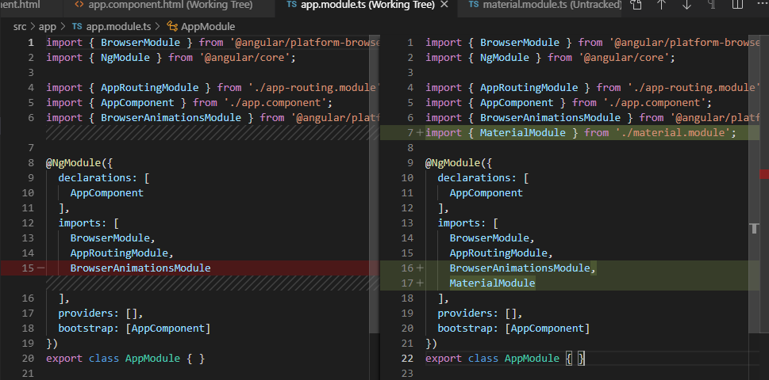

import { BrowserModule } from '@angular/platform-browser';

import { NgModule } from '@angular/core';

import { AppRoutingModule } from './app-routing.module';

import { AppComponent } from './app.component';

import { BrowserAnimationsModule } from '@angular/platform-browser/animations';

import { MaterialModule } from './material.module';

@NgModule({

  declarations: [

    AppComponent

  ],

  imports: [

    BrowserModule,

    AppRoutingModule,

    BrowserAnimationsModule,

    MaterialModule

  ],

  providers: [],

  bootstrap: [AppComponent]

})

export class AppModule { }

//open material.module.ts

import { NgModule } from '@angular/core';

import { CommonModule } from '@angular/common';

import {MatButtonModule} from '@angular/material/button';

@NgModule({

  declarations: [],

  imports: [

    CommonModule,

    MatButtonModule

  ],

  exports : [ MatButtonModule]

})

export class MaterialModule { }

npm install bootstrap

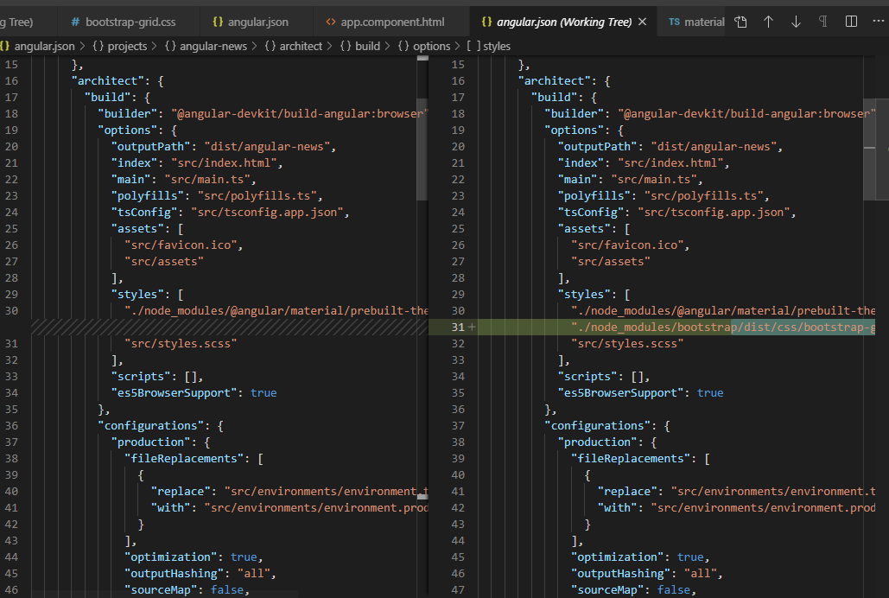

"./node_modules/bootstrap/dist/css/bootstrap-grid.css",

ng g c home --module=app --dry-run

ng g c home --module=app --spec-false

ng g c headlines --module=app --spec-false

ng g c sources --module=app --spec-false