1. Please download git from  [https://git-scm.com/download/win](https://www.google.com/url?q=https://git-scm.com/download/win&sa=D&source=hangouts&ust=1570656668052000&usg=AFQjCNFuX_8vro-SsCd29vNPgwH_ruAUgw)
2. Please Download drawio from <https://about.draw.io/integrations/#integrations_offline>
3. Open a windows command line and type

Git clone <https://github.com/ricardojavister/diagram.git>

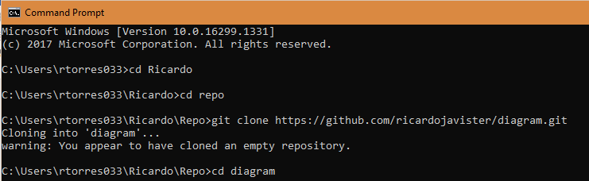

1. Go to the diagram folder created inside your folder by typing cd diagram



1. You will see a file called *Full Stack Development.drawio*

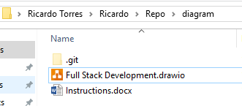

1. Open this file, you will and you will see the mind map.

