# Broken Links Report

• Broken link on <https://www.utep.edu/cs/main-menu/sfs_application.html> on **Main Content (Top small navigation)** section, the broken link is displayed as: **main-menu** and the link is pointing to : <https://www.utep.edu/cs/main-menu/>

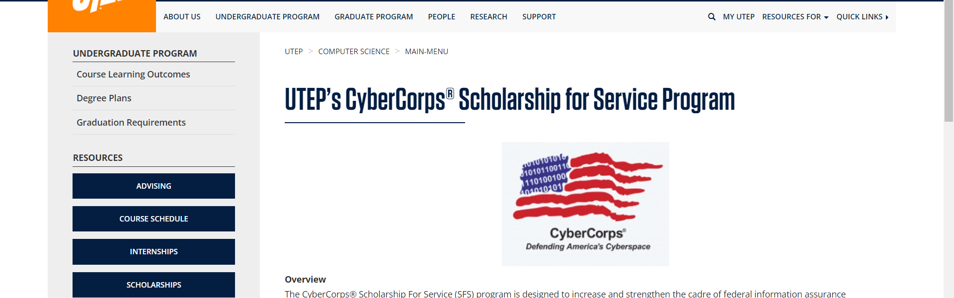

• Broken link on <https://www.utep.edu/cs/main-menu/sfs_application.html> on **Main Content** section, the broken link is displayed as: **MSSwE)** and the link is pointing to : <https://www.utep.edu/graduate/_Files/docs/admission-and-enrollment/fast-track.pdf>

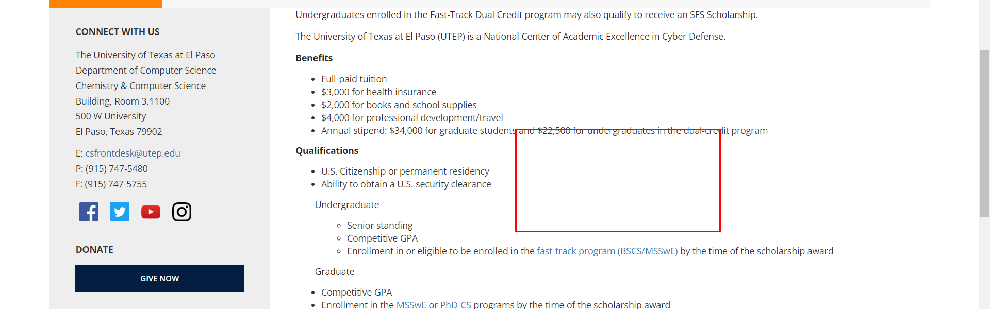

• Broken link on <https://www.utep.edu/cs/main-menu/sfs_application.html> on **Somewhere unknown** section, the broken link is displayed as: **People** and the link is pointing to : <https://www.utep.edu/cs/people/faculty_and_staff.html>

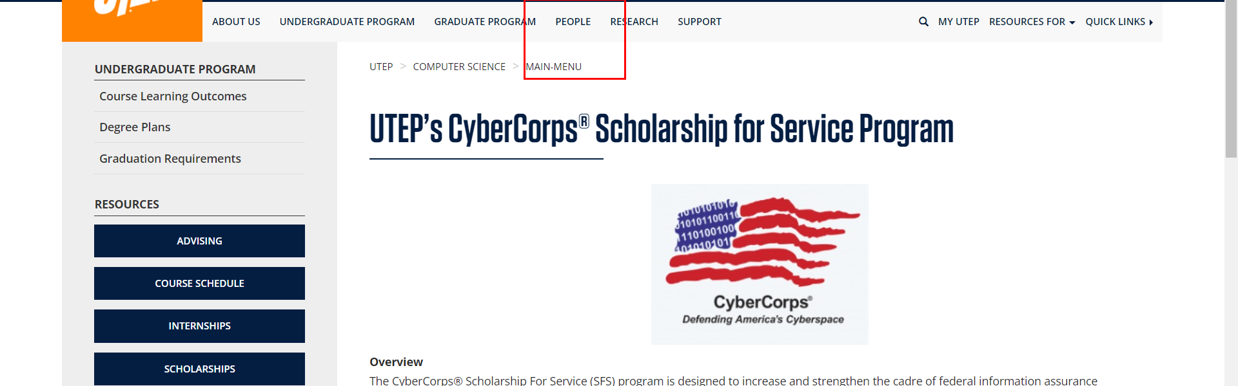

• Broken link on <https://www.utep.edu/cs/main-menu/sfs_application.html> on **Somewhere unknown** section, the broken link is displayed as: **Research** and the link is pointing to : <https://www.utep.edu/cs/research/research_centers.html>

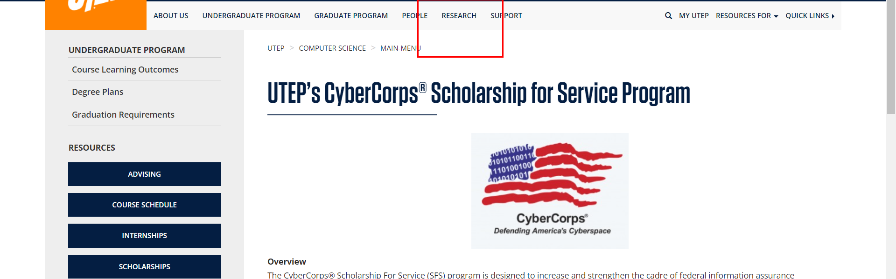

• Broken link on <https://www.utep.edu/cs/main-menu/sfs_application.html> on **Left Navigation** section, the broken link is displayed as: **Give Now** and the link is pointing to : <https://www.utep.edu/entity/open.act?type=symlink&id=1a2ffcaf816c09bf244acb94b5b6fadd>

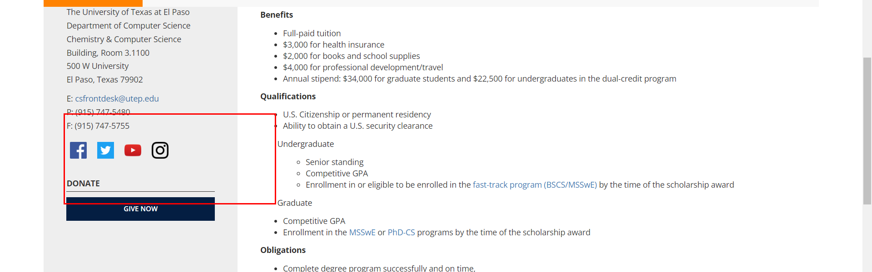

• Broken link on <https://www.utep.edu/cs/main-menu/sfs_application.html> on **Left Navigation** section, the broken link is displayed as: **Advising** and the link is pointing to : <https://www.utep.edu/cs/main-menu/advising.html>

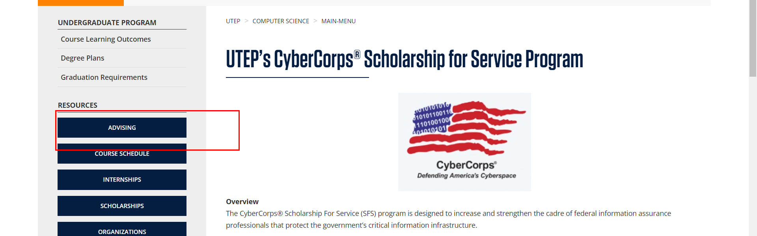

• Broken link on <https://www.utep.edu/cs/main-menu/sfs_application.html> on **Main Content** section, the broken link is displayed as: **FOLLOWING LINK** and the link is pointing to : <http://www.cs.utep.edu/utep-sfs-program/sfs-application-process/>

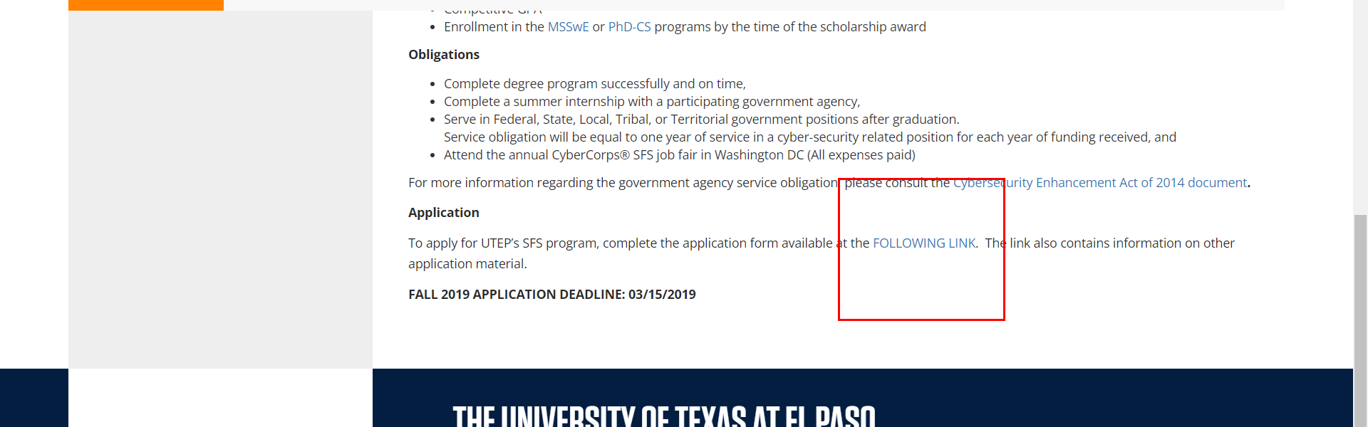

• Broken link on <https://www.utep.edu/cs/main-menu/sfs_application.html> on **Main Content** section, the broken link is displayed as: **Cybersecurity Enhancement Act of 2014 document** and the link is pointing to : <http://www.cs.utep.edu/wp-content/uploads/2016/02/PLAW-113publ274.pdf>

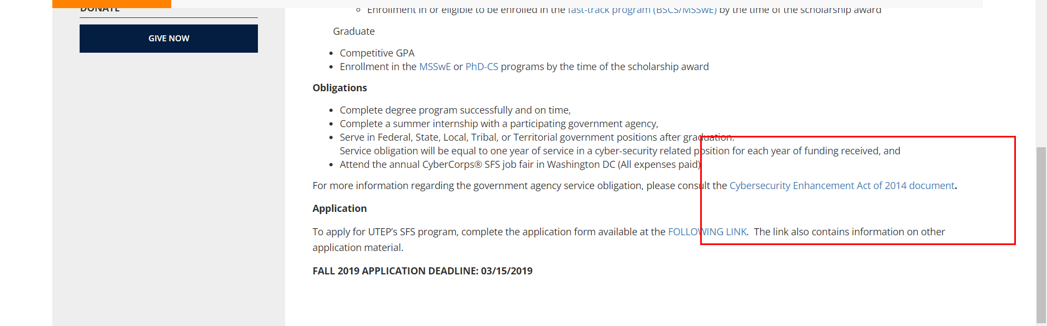

• Broken link on <https://www.utep.edu/cs/main-menu/sfs_application.html> on **Left Navigation** section, the broken link is displayed as: **Internships** and the link is pointing to : <https://www.utep.edu/cs/main-menu/internships.html>

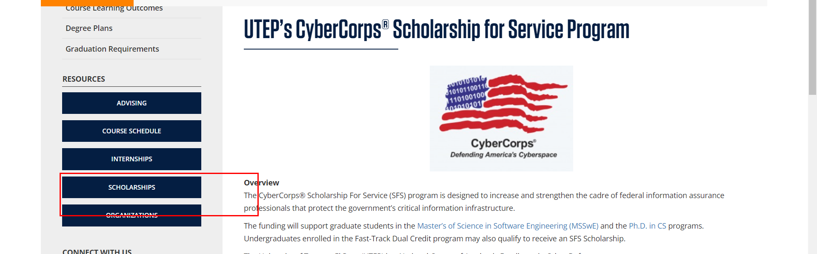

• Broken link on <https://www.utep.edu/cs/main-menu/sfs_application.html> on **Left Navigation** section, the broken link is displayed as: **Organizations** and the link is pointing to : <https://www.utep.edu/cs/main-menu/organizations.html>

