# Broken Links Report

• Broken link on <https://www.utep.edu/about/bhutan.html> on **Main Navigation, tab name: ACADEMICS** section, the broken link is displayed as: **Faculty Photograph Library** and the link is pointing to : <https://www.utep.edu/marketing-and-communications/faculty-photograph-library/index.html>

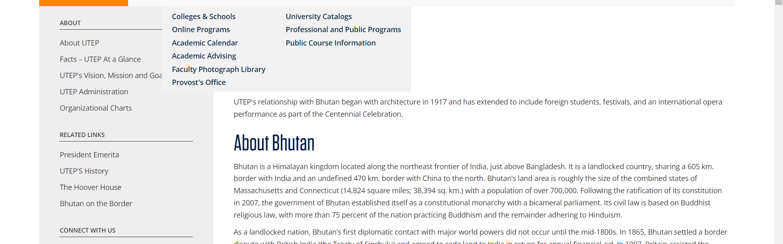

• Broken link on <https://www.utep.edu/about/history.html> on **Main Content: Section ID: theBanner** section, the broken link is displayed as: **Learn More** and the link is pointing to : <https://www.utep.edu/engineering/tcm/tcm.html>

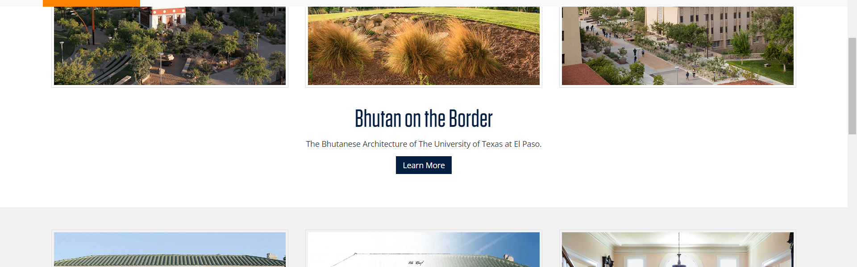

• Broken link on <https://www.utep.edu/about/divisions/information-res-pln.html> on **Main Navigation, tab name: ABOUT** section, the broken link is displayed as: **About UTEP** and the link is pointing to : <https://www.utep.edu/about/about-utep.html>

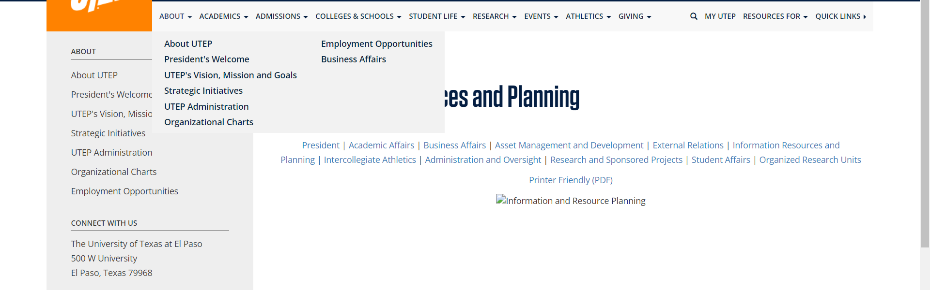

• Broken link on <https://www.utep.edu/about/divisions/information-res-pln.html> on **Main Navigation, tab name: ACADEMICS** section, the broken link is displayed as: **Faculty Photograph Library** and the link is pointing to : <https://www.utep.edu/university-communications/faculty-photograph-library/index.html>

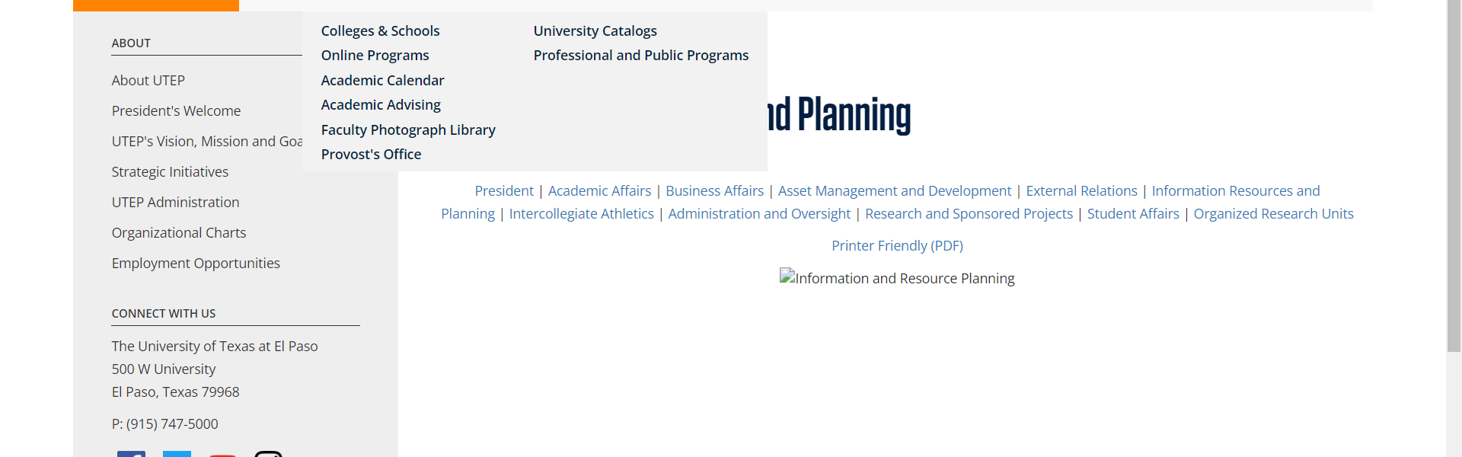

• Broken link on <https://www.utep.edu/about/divisions/information-res-pln.html> on **Main Navigation, tab name: ADMISSIONS** section, the broken link is displayed as: **New Students** and the link is pointing to : <https://www.utep.edu/student-affairs/admissions/how-to-apply/freshman.html>

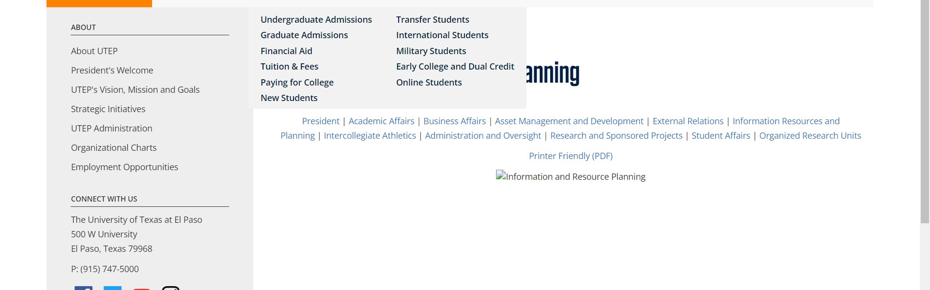

• Broken link on <https://www.utep.edu/about/divisions/information-res-pln.html> on **Main Navigation, tab name: ADMISSIONS** section, the broken link is displayed as: **International Students** and the link is pointing to : <https://www.utep.edu/student-affairs/admissions/how-to-apply/international.html>

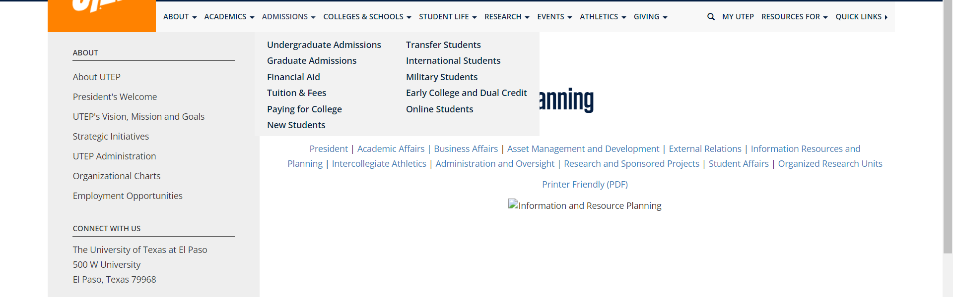

• Broken link on <https://www.utep.edu/about/divisions/information-res-pln.html> on **Main Navigation, tab name: ADMISSIONS** section, the broken link is displayed as: **Transfer Students** and the link is pointing to : <https://www.utep.edu/student-affairs/admissions/how-to-apply/transfer.html>



• Broken link on <https://www.utep.edu/about/divisions/information-res-pln.html> on **Main Content** section, the broken link is displayed as: **Printer Friendly (PDF)** and the link is pointing to : <https://www.utep.edu/about/divisions/March-2018/Information%20Resources%20and%20Planning-rev3-9-18.pdf>

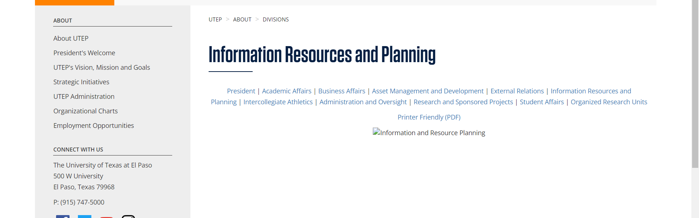

• Broken link on <https://www.utep.edu/about/divisions/information-res-pln.html> on **Main Content** section, the broken link is displayed as: **Administration and Oversight** and the link is pointing to : <https://www.utep.edu/about/divisions/administration-and-oversight.html>



• Broken link on <https://www.utep.edu/about/divisions/information-res-pln.html> on **Main Content** section, the broken link is displayed as: **External Relations** and the link is pointing to : <https://www.utep.edu/about/divisions/external-relations.html>



• Broken link on <https://www.utep.edu/about/divisions/information-res-pln.html> on **Main Content** section, the broken link is displayed as: **Asset Management and Development** and the link is pointing to : <https://www.utep.edu/about/divisions/asset-management-and-development.html>



• Broken link on <https://www.utep.edu/about/divisions/information-res-pln.html> on **Main Content** section, the broken link is displayed as: **Organized Research Units** and the link is pointing to : <https://www.utep.edu/about/divisions/organized-res-units.html>



• Broken link on <https://www.utep.edu/about/presidents-speeches-in/2016-fall-convocation.html> on **Main Navigation, tab name: ACADEMICS** section, the broken link is displayed as: **Faculty Photograph Library** and the link is pointing to : <https://www.utep.edu/university-communications/faculty-photograph-library/index.html>

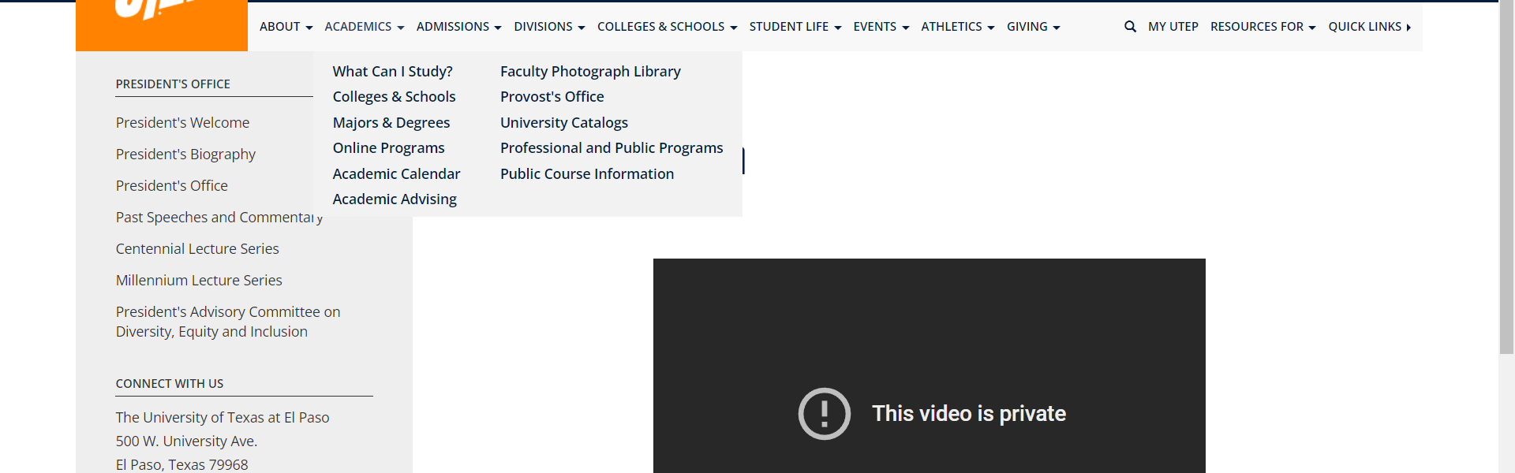

• Broken link on <https://www.utep.edu/about/presidents-speeches-in/2016-fall-convocation.html> on **Main Navigation, tab name: ABOUT** section, the broken link is displayed as: **What Can I Study?** and the link is pointing to : <https://www.utep.edu/majors-and-degrees/>



• Broken link on <https://www.utep.edu/about/presidents-speeches-in/2016-fall-convocation.html> on **Main Content (Top small navigation)** section, the broken link is displayed as: **presidents-speeches-in** and the link is pointing to : <https://www.utep.edu/about/presidents-speeches-in/>

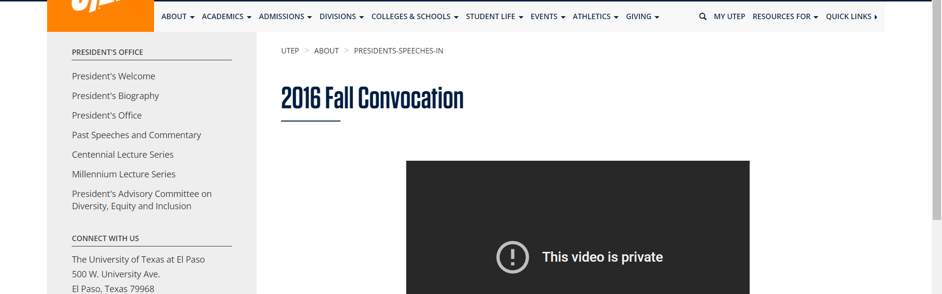

• Broken link on <https://www.utep.edu/about/presidents-speeches-in/2016-fall-convocation.html> on **Left Navigation** section, the broken link is displayed as: **Millennium Lecture Series** and the link is pointing to : <https://www.utep.edu/about/millennium-lecture-series.html>

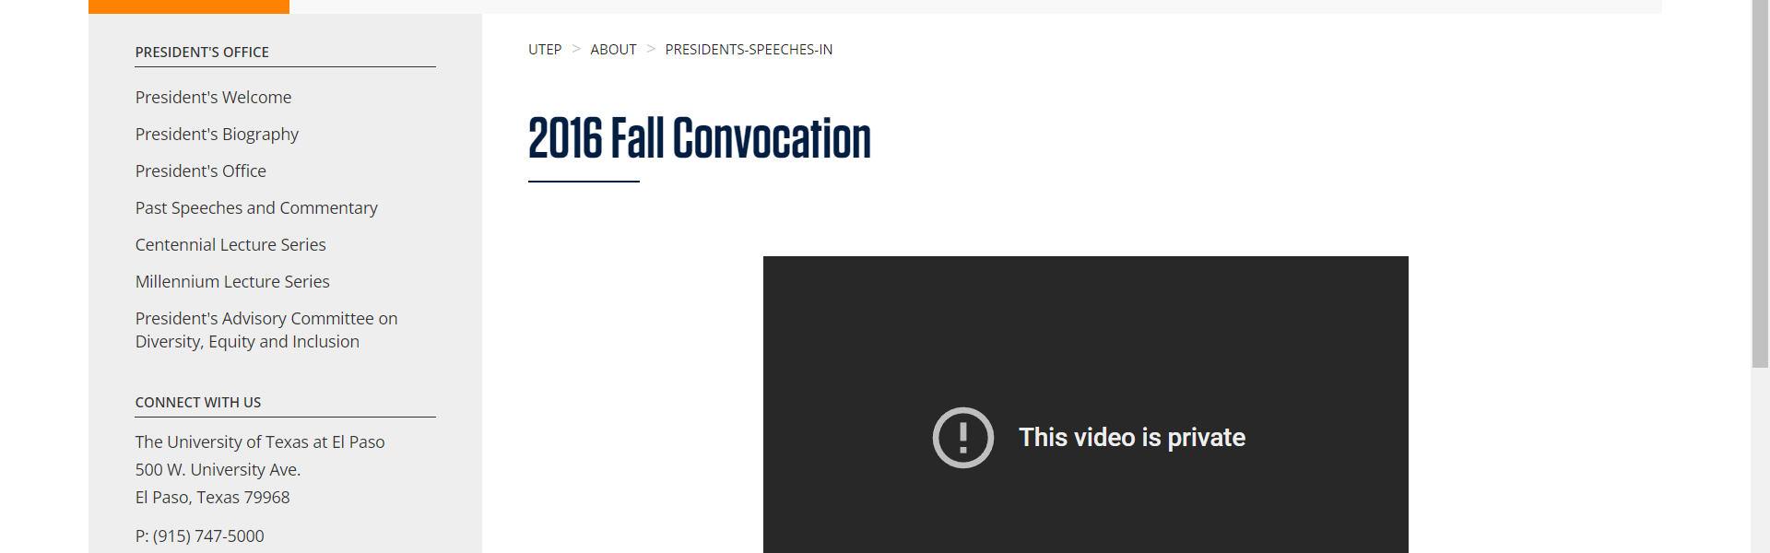

• Broken link on <https://www.utep.edu/about/presidents-speeches-in/focus-on-campus-oct-2010.html> on **Main Navigation, tab name: ABOUT** section, the broken link is displayed as: **What Can I Study?** and the link is pointing to : <https://www.utep.edu/majors-and-degrees/>



• Broken link on <https://www.utep.edu/about/presidents-speeches-in/2016-fall-convocation.html> on **Left Navigation** section, the broken link is displayed as: **President's Advisory Committee on Diversity, Equity and Inclusion** and the link is pointing to : <https://www.utep.edu/about/committee-on-diversity.html>



• Broken link on <https://www.utep.edu/about/presidents-speeches-in/focus-on-campus-oct-2010.html> on **Main Navigation, tab name: ACADEMICS** section, the broken link is displayed as: **Faculty Photograph Library** and the link is pointing to : <https://www.utep.edu/university-communications/faculty-photograph-library/index.html>

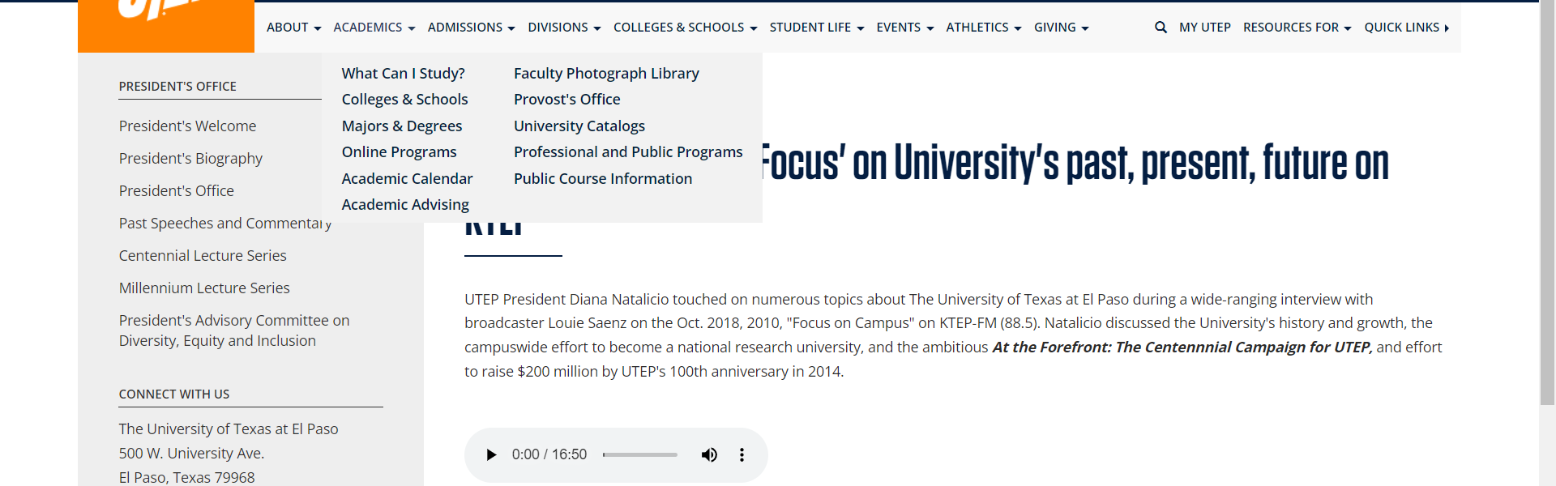

• Broken link on <https://www.utep.edu/about/presidents-speeches-in/2016-fall-convocation.html> on **Left Navigation** section, the broken link is displayed as: **Centennial Lecture Series** and the link is pointing to : <https://www.utep.edu/about/CentennialLectureSeries.html>



• Broken link on <https://www.utep.edu/about/presidents-speeches-in/2016-fall-convocation.html> on **Left Navigation** section, the broken link is displayed as: **Past Speeches and Commentary** and the link is pointing to : <https://www.utep.edu/about/presidents-speeches.html>



• Broken link on <https://www.utep.edu/about/presidents-speeches-in/focus-on-campus-oct-2010.html> on **Main Content (Top small navigation)** section, the broken link is displayed as: **presidents-speeches-in** and the link is pointing to : <https://www.utep.edu/about/presidents-speeches-in/>

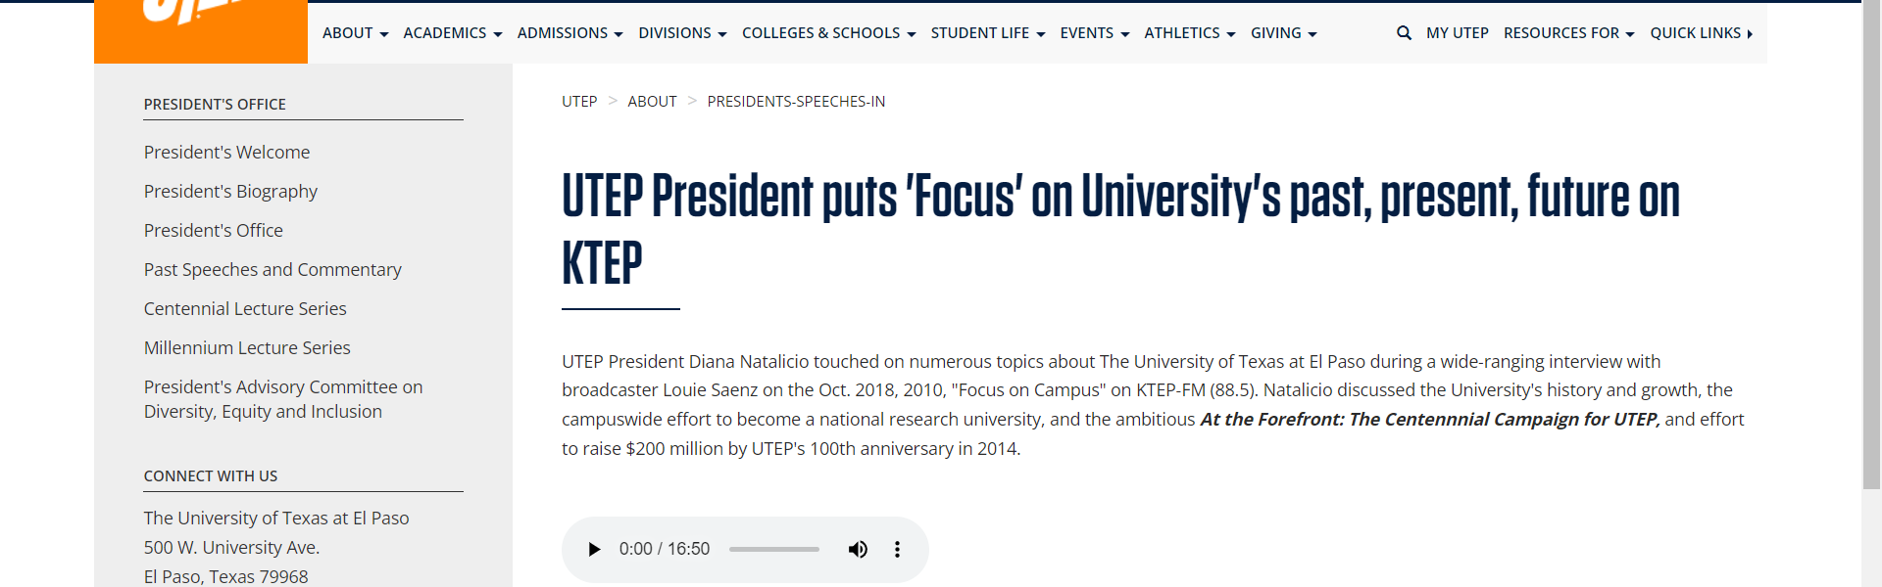

• Broken link on <https://www.utep.edu/about/presidents-speeches-in/focus-on-campus-oct-2010.html> on **Left Navigation** section, the broken link is displayed as: **Past Speeches and Commentary** and the link is pointing to : <https://www.utep.edu/about/presidents-speeches.html>

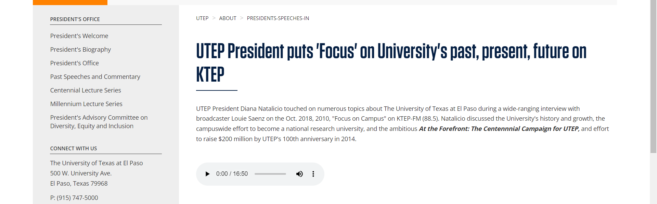

• Broken link on <https://www.utep.edu/about/presidents-speeches-in/focus-on-campus-oct-2010.html> on **Left Navigation** section, the broken link is displayed as: **Centennial Lecture Series** and the link is pointing to : <https://www.utep.edu/about/CentennialLectureSeries.html>



• Broken link on <https://www.utep.edu/about/presidents-speeches-in/focus-on-campus-oct-2010.html> on **Left Navigation** section, the broken link is displayed as: **Millennium Lecture Series** and the link is pointing to : <https://www.utep.edu/about/millennium-lecture-series.html>

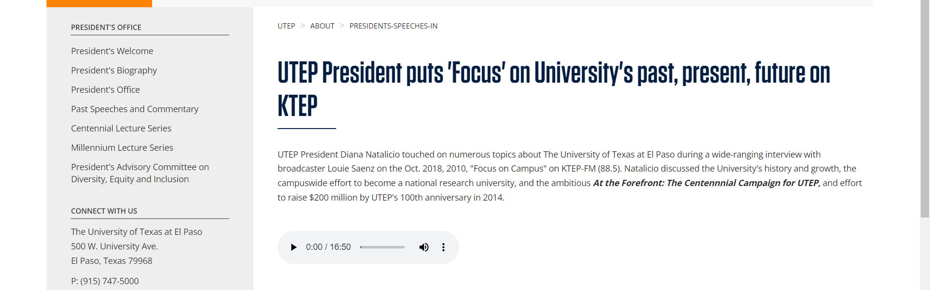

• Broken link on <https://www.utep.edu/about/presidents-speeches-in/focus-on-campus-oct-2010.html> on **Left Navigation** section, the broken link is displayed as: **President's Advisory Committee on Diversity, Equity and Inclusion** and the link is pointing to : <https://www.utep.edu/about/committee-on-diversity.html>

