# Broken Links Report

• On <https://www.utep.edu/cms/dev-ricardo/404/phototabs.html> there is a broken link on section **Main Content**, the broken link is called **efwe** and the link is : <https://www.utep.edu/cms/dev-ricardo/indefqwex>

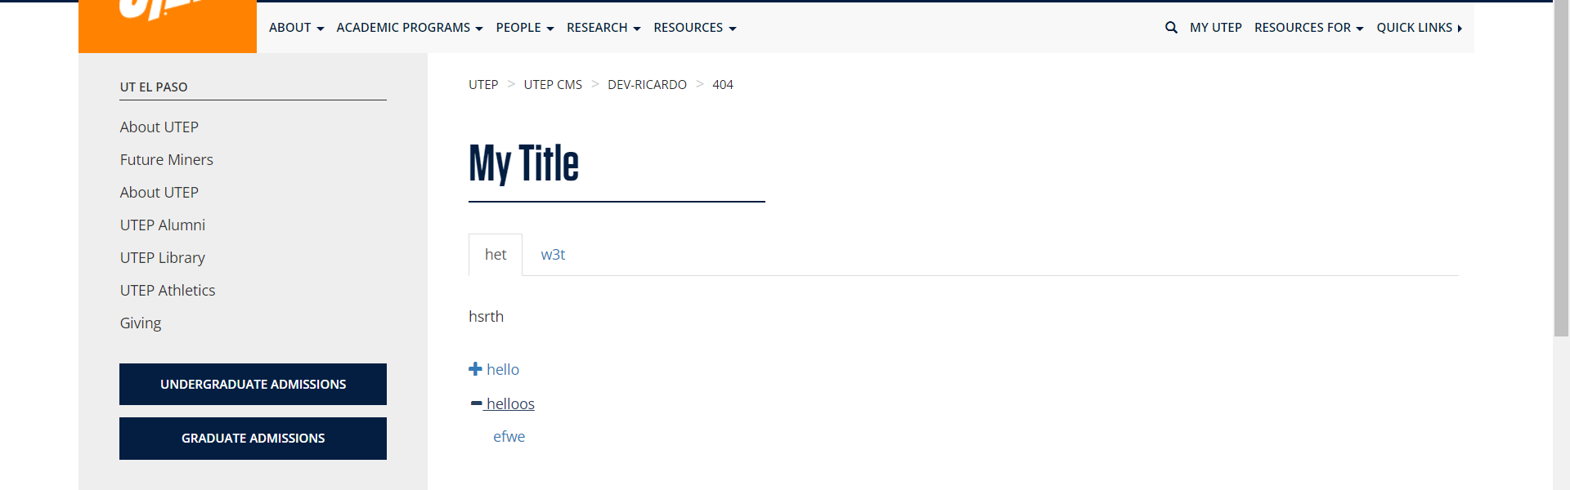

• On <https://www.utep.edu/cms/dev-ricardo/404/phototabs.html> there is a broken link on section **Main Content**, the broken link is called **efwe** and the link is : <https://www.utep.edu/cms/dev-ricardo/indexewqf>

