# Broken Links Report

• Broken link on <https://www.utep.edu/cms/dev-ricardo/404/phototabs.html> on **Main Content** section, the broken link is displayed as: **efwe** and the link is pointing to : <https://www.utep.edu/cms/dev-ricardo/indexewqf>

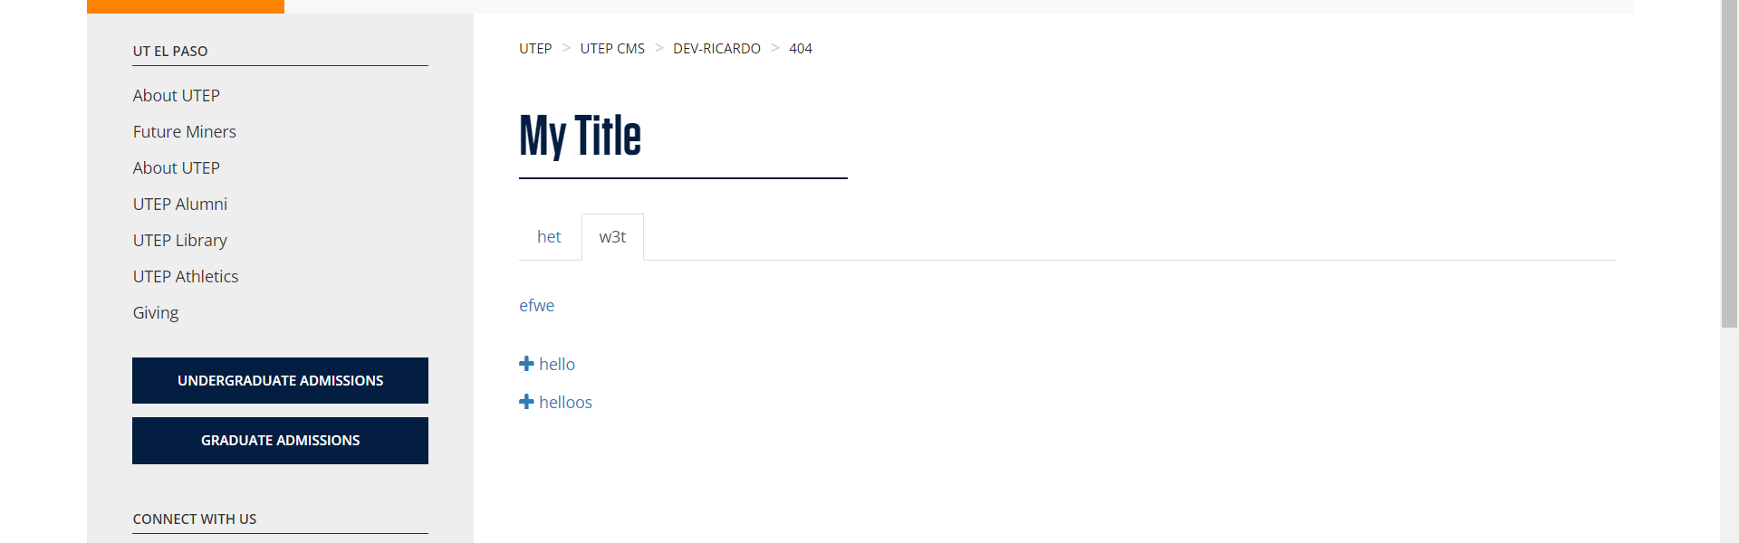

• Broken link on <https://www.utep.edu/cms/dev-ricardo/404/phototabs.html> on **Main Content** section, the broken link is displayed as: **efwe** and the link is pointing to : <https://www.utep.edu/cms/dev-ricardo/indefqwex>

