# Broken Links Report

**• On https://www.utep.edu/cms/dev-ricardo/404/phototabs.html there is a broken link on section 'Main Content', the broken link is called 'accordion3/efwe' and the link is 'https://www.utep.edu/cms/dev-ricardo/indefqwex'.**

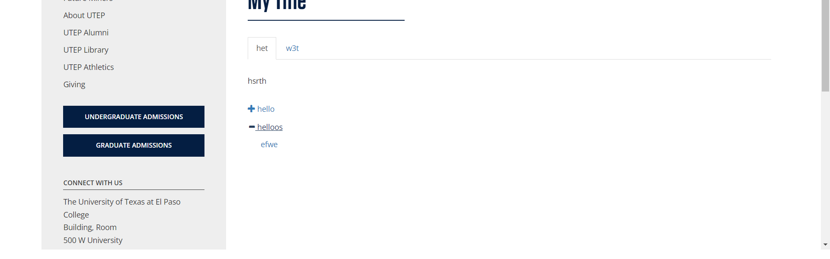

**• On https://www.utep.edu/cms/dev-ricardo/404/phototabs.html there is a broken link on section 'Main Content', the broken link is called 'tab1/efwe' and the link is 'https://www.utep.edu/cms/dev-ricardo/indexewqf'.**

