# Broken Links Report

• Broken link on <https://www.utep.edu/cs/Events/events-page-test.html> on **Main Content** section, the broken link is displayed as: **Read More** and the link is pointing to : <https://www.utep.edu/cs/news/news-2013/congratulations-dr-kreinovich112>

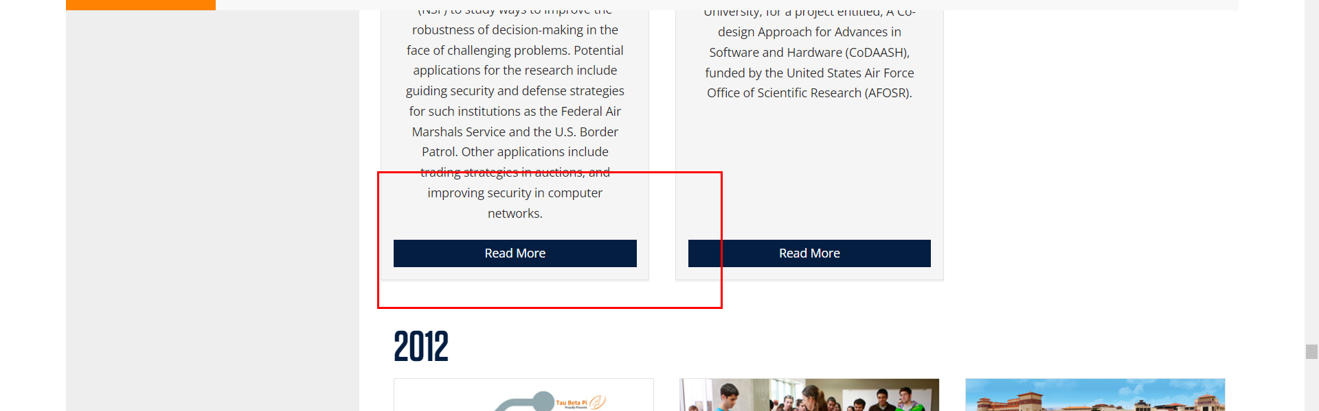

• Broken link on <https://www.utep.edu/cs/Events/events-page-test.html> on **Main Content** section, the broken link is displayed as: **Read More** and the link is pointing to : <https://www.utep.edu/cs/news/news-2013/congratulations-dr-kreinovich1124>

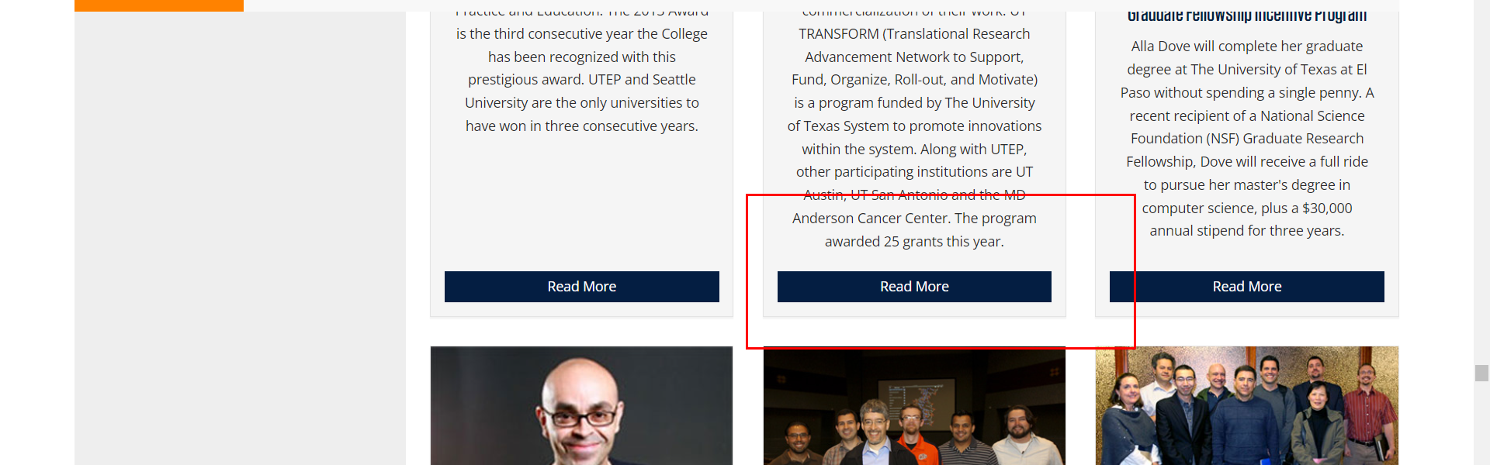

• Broken link on <https://www.utep.edu/cs/Events/events-page-test.html> on **Main Content** section, the broken link is displayed as: **Read More** and the link is pointing to : <https://www.utep.edu/cs/news/news-2011/congratulations-dr-kreinovich1>



• Broken link on <https://www.utep.edu/cs/Events/seminars.html> on **Main Content** section, the broken link is displayed as: **https://academics.uccs.edu/~ooluwada/** and the link is pointing to : <https://academics.uccs.edu/~ooluwada/>

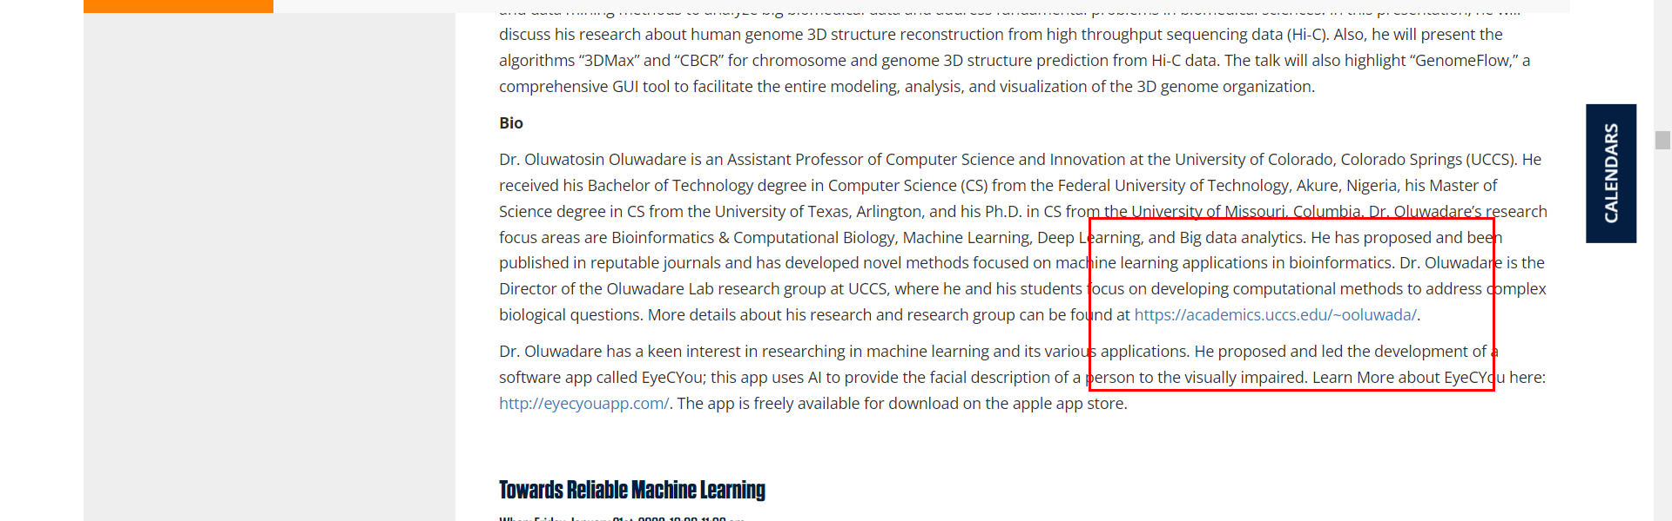

• Broken link on <https://www.utep.edu/cs/Events/seminars.html> on **Main Content** section, the broken link is displayed as: **https://web.mst.edu/~tauritzd/CSSI/** and the link is pointing to : <https://web.mst.edu/~tauritzd/CSSI/>

