# Broken Links Report

• Broken link on <https://www.utep.edu/cs/calendar/events.html> on **Main Content** section, the broken link is displayed as: **Read More** and the link is pointing to : <https://www.utep.edu/cs/news/news-2013/congratulations-dr-kreinovich1124>

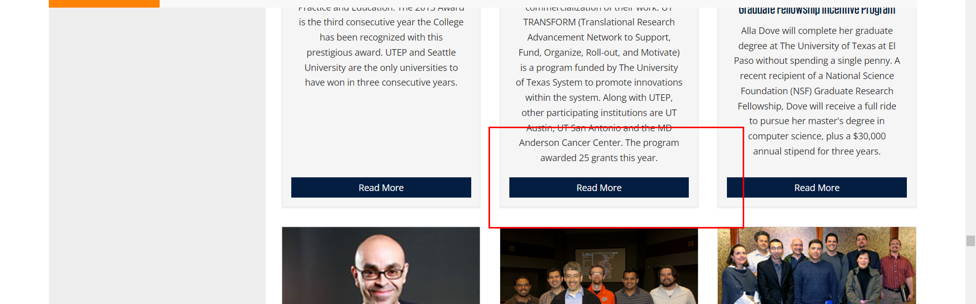

• Broken link on <https://www.utep.edu/cs/calendar/events.html> on **Main Content** section, the broken link is displayed as: **Read More** and the link is pointing to : <https://www.utep.edu/cs/news/news-2011/congratulations-dr-kreinovich1>



• Broken link on <https://www.utep.edu/cs/calendar/events.html> on **Main Content** section, the broken link is displayed as: **Read More** and the link is pointing to : <https://www.utep.edu/cs/news/news-2013/congratulations-dr-kreinovich112>

