# Broken Links Report

• Broken link on <https://www.utep.edu/cs/course-schedules/fall-2020-course-schedule.html> on **Main Content (Top small navigation)** section, the broken link is displayed as: **Schedule** and the link is pointing to : <https://www.utep.edu/cs/course-schedules/>

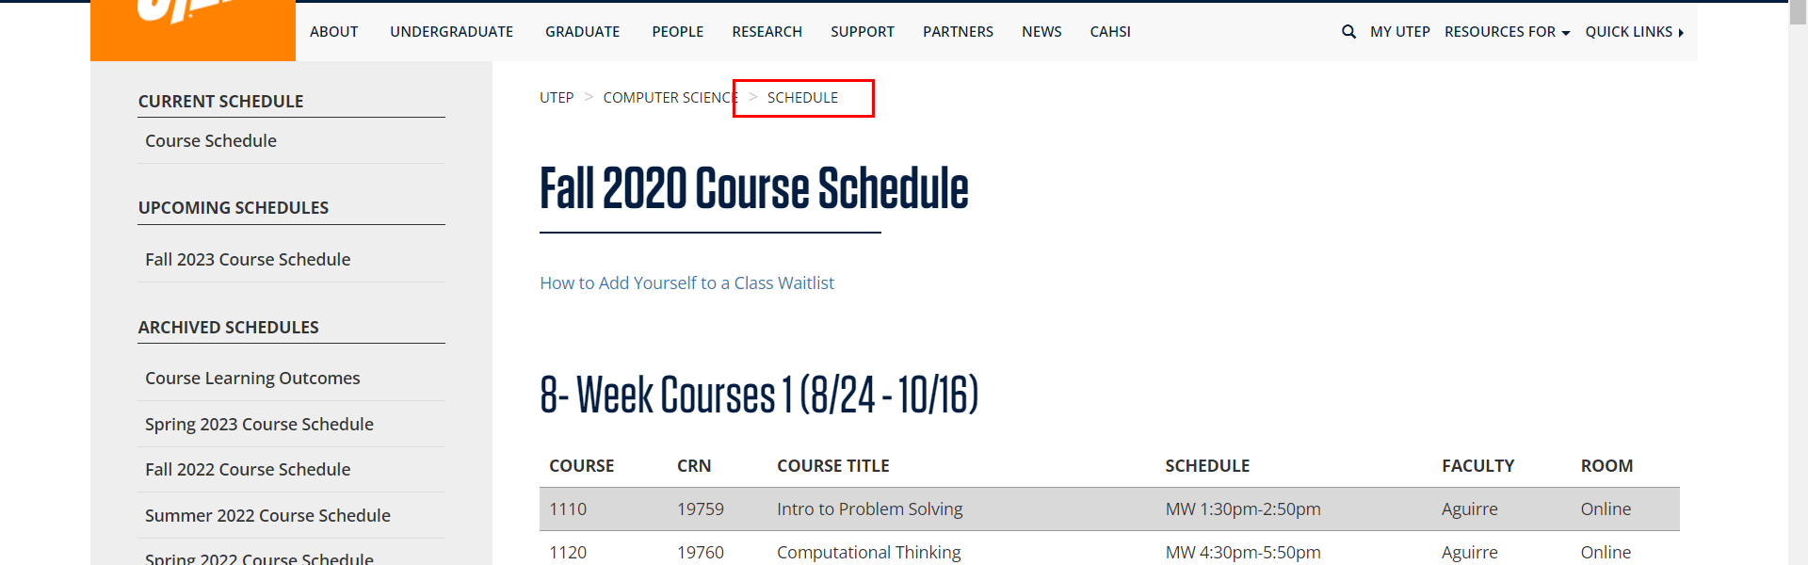

• Broken link on <https://www.utep.edu/cs/course-schedules/fall-2021-course-schedule.html> on **Main Content (Top small navigation)** section, the broken link is displayed as: **Schedule** and the link is pointing to : <https://www.utep.edu/cs/course-schedules/>

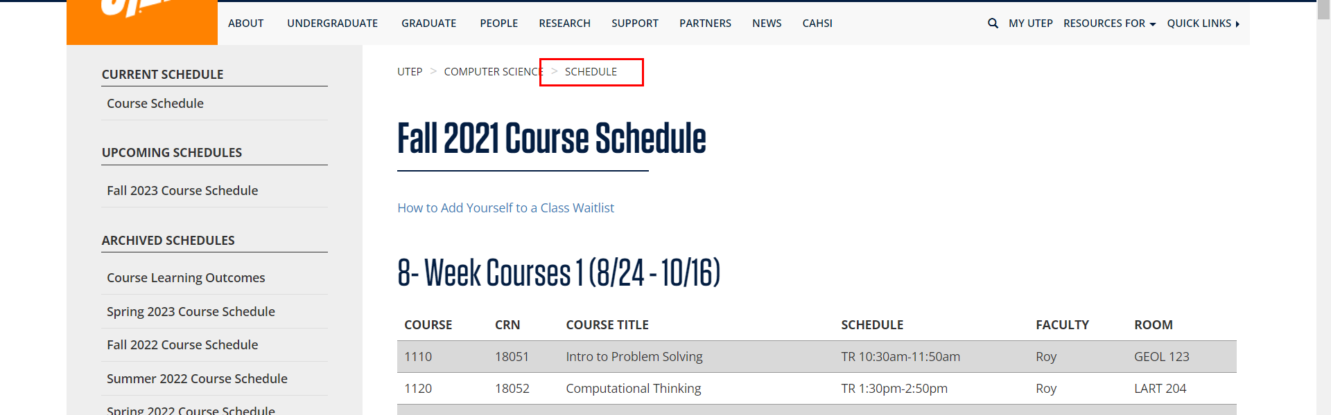

• Broken link on <https://www.utep.edu/cs/course-schedules/fall-2022-course-schedule.html> on **Main Content (Top small navigation)** section, the broken link is displayed as: **Schedule** and the link is pointing to : <https://www.utep.edu/cs/course-schedules/>

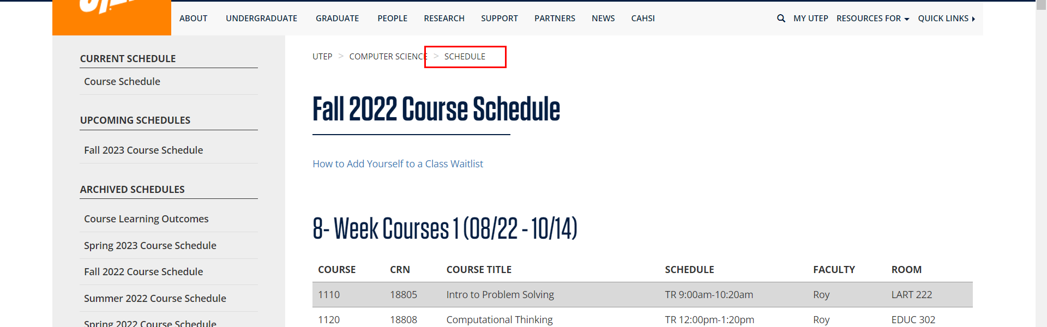

• Broken link on <https://www.utep.edu/cs/course-schedules/fall-2023-course-schedule.html> on **Main Content (Top small navigation)** section, the broken link is displayed as: **Schedule** and the link is pointing to : <https://www.utep.edu/cs/course-schedules/>

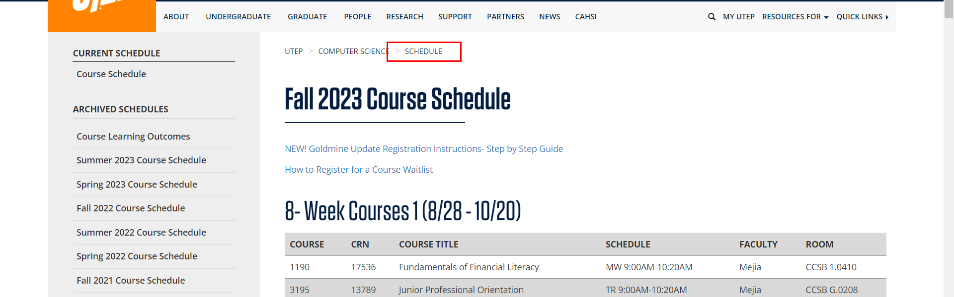

• Broken link on <https://www.utep.edu/cs/course-schedules/fall2016-course-schedule.html> on **Main Content (Top small navigation)** section, the broken link is displayed as: **Schedule** and the link is pointing to : <https://www.utep.edu/cs/course-schedules/>

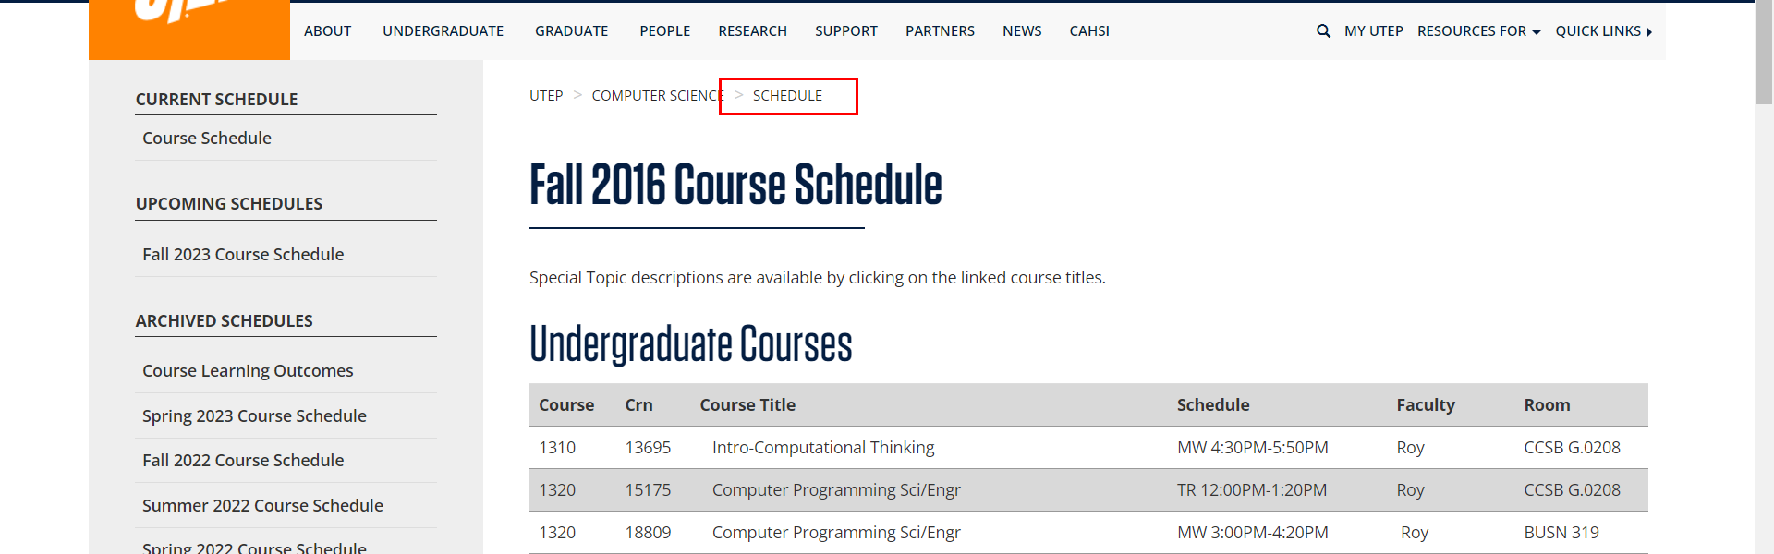

• Broken link on <https://www.utep.edu/cs/course-schedules/fall2017-course-schedule.html> on **Main Content (Top small navigation)** section, the broken link is displayed as: **Schedule** and the link is pointing to : <https://www.utep.edu/cs/course-schedules/>

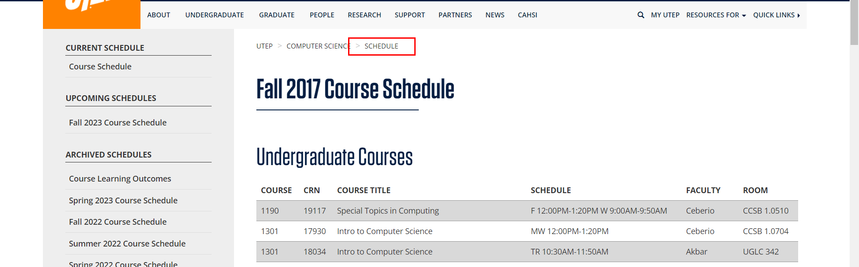

• Broken link on <https://www.utep.edu/cs/course-schedules/fall2018-course-schedule.html> on **Main Content (Top small navigation)** section, the broken link is displayed as: **Schedule** and the link is pointing to : <https://www.utep.edu/cs/course-schedules/>

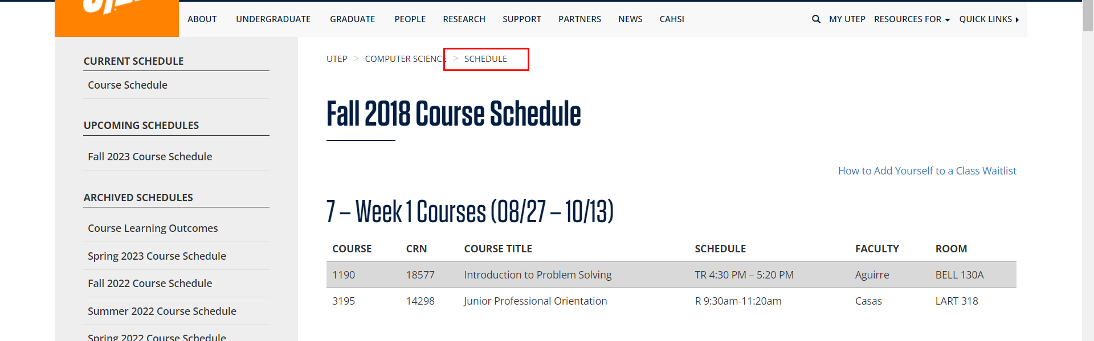

• Broken link on <https://www.utep.edu/cs/course-schedules/fall2018-course-schedule.html> on **Main Content** section, the broken link is displayed as: **Information Retrieval and Information Visualization** and the link is pointing to : <http://www.cs.utep.edu/wp-content/uploads/2018/04/4390IR_outline.pdf>

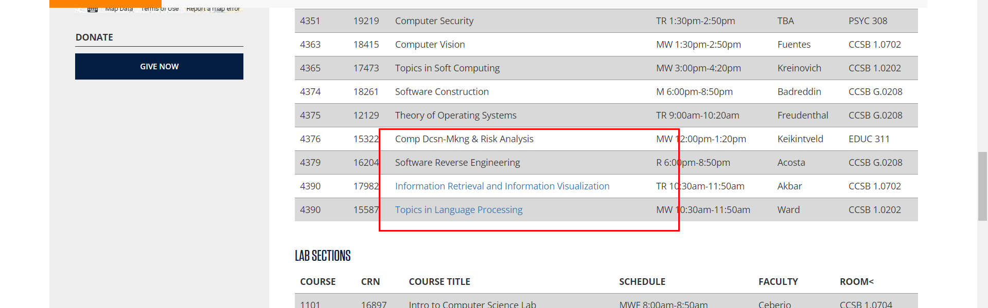

• Broken link on <https://www.utep.edu/cs/course-schedules/fall2018-course-schedule.html> on **Main Content** section, the broken link is displayed as: **Topics in Language Processing** and the link is pointing to : <http://www.cs.utep.edu/nigel/slp-outline.pdf>

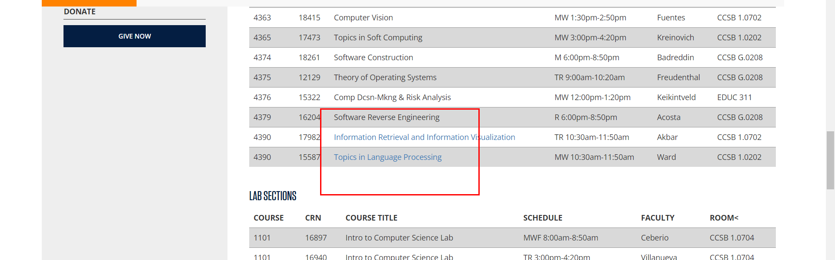

• Broken link on <https://www.utep.edu/cs/course-schedules/spring-2017-course-schedule.html> on **Main Content (Top small navigation)** section, the broken link is displayed as: **Schedule** and the link is pointing to : <https://www.utep.edu/cs/course-schedules/>

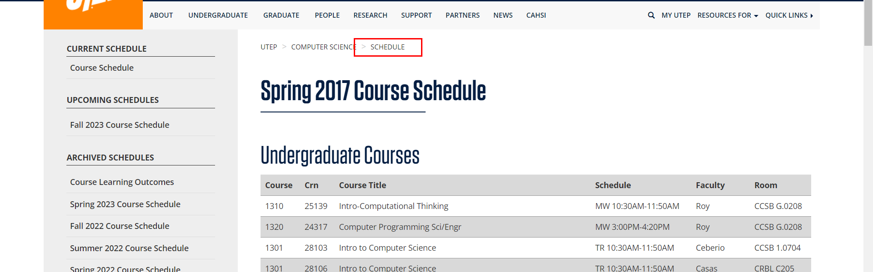

• Broken link on <https://www.utep.edu/cs/course-schedules/spring-2017-course-schedule.html> on **Main Content** section, the broken link is displayed as: **Special Topic: Wireless Networks** and the link is pointing to : <http://www.cs.utep.edu/wp-content/uploads/2015/10/WirelessNetworks2016.pdf>

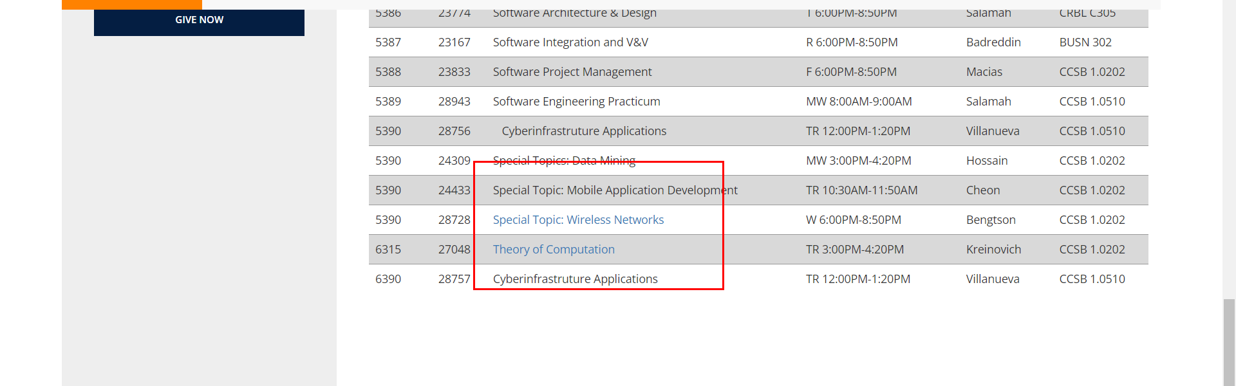

• Broken link on <https://www.utep.edu/cs/course-schedules/spring-2019-course-schedule.html> on **Main Content (Top small navigation)** section, the broken link is displayed as: **Schedule** and the link is pointing to : <https://www.utep.edu/cs/course-schedules/>

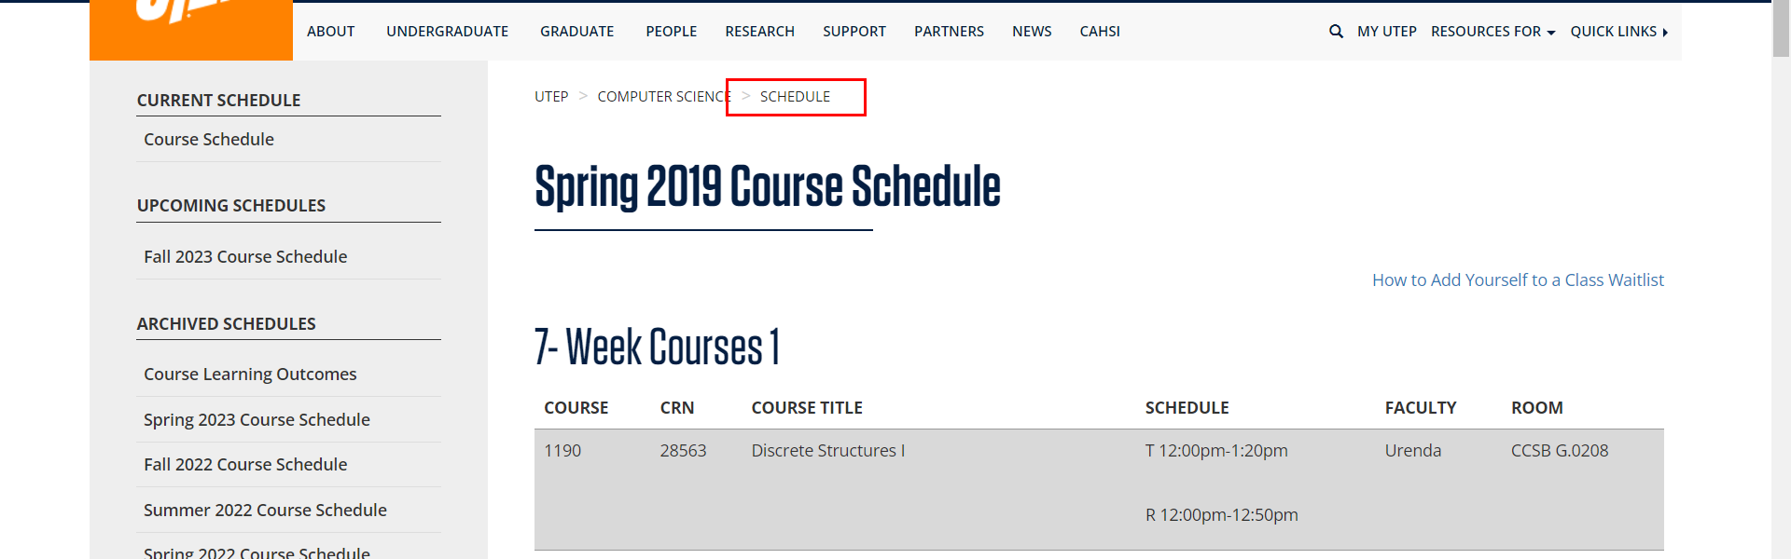

• Broken link on <https://www.utep.edu/cs/course-schedules/spring-2021-course-schedule.html> on **Main Content (Top small navigation)** section, the broken link is displayed as: **Schedule** and the link is pointing to : <https://www.utep.edu/cs/course-schedules/>

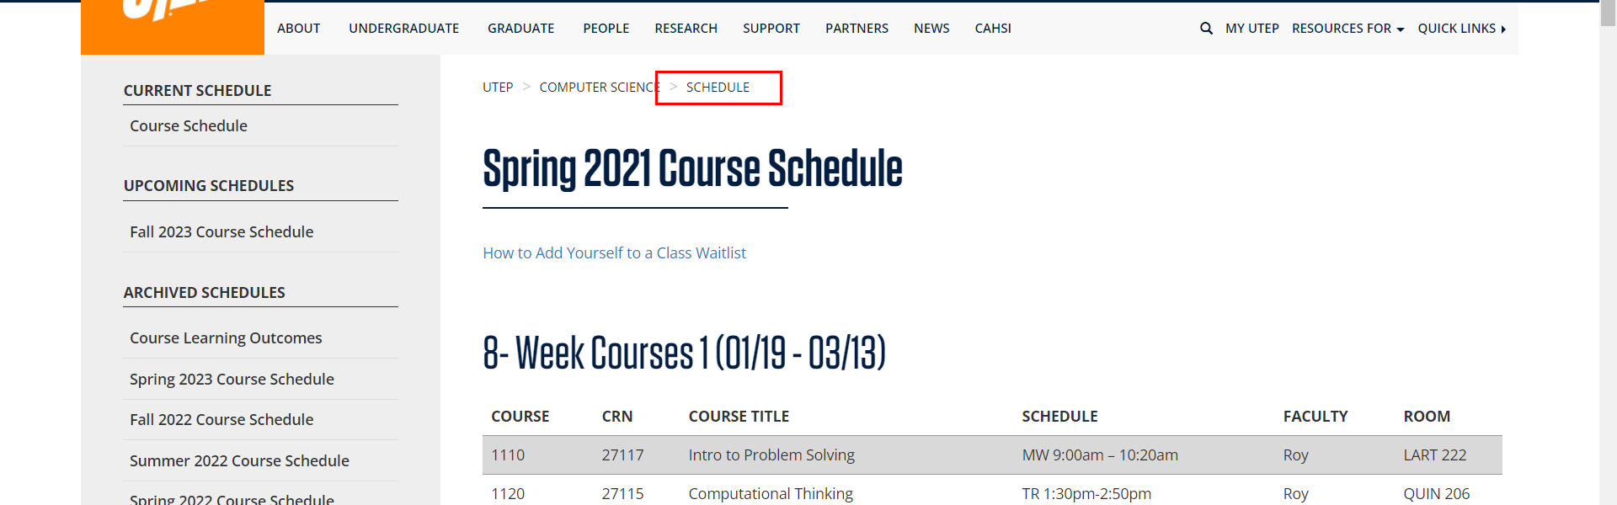

• Broken link on <https://www.utep.edu/cs/course-schedules/spring-2021-course-schedule.html> on **Main Content** section, the broken link is displayed as: **Topics in Data Science: Algorithms in Computational Biology** and the link is pointing to : <https://specialtopics.deblasiolab.org/s22/>

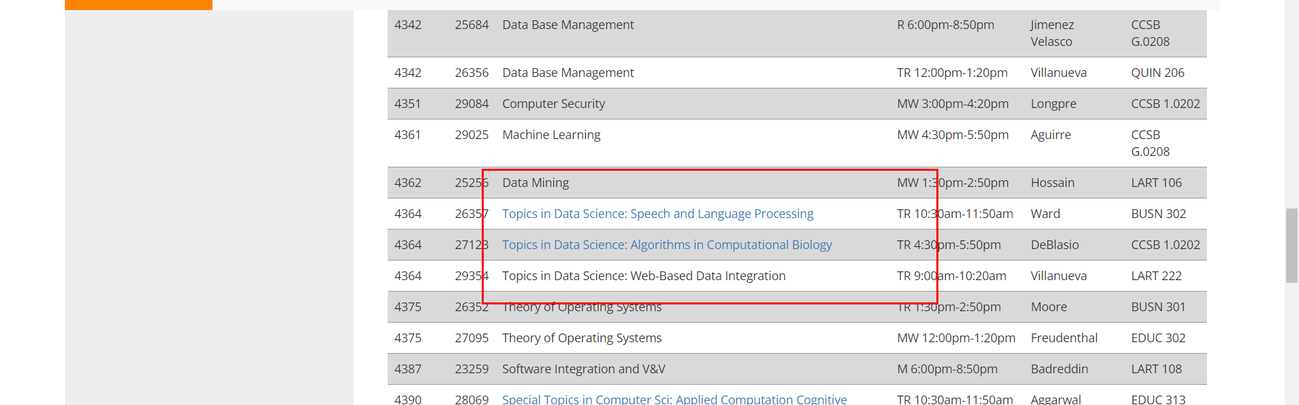

• Broken link on <https://www.utep.edu/cs/course-schedules/spring-2022-course-schedule.html> on **Main Content (Top small navigation)** section, the broken link is displayed as: **Schedule** and the link is pointing to : <https://www.utep.edu/cs/course-schedules/>

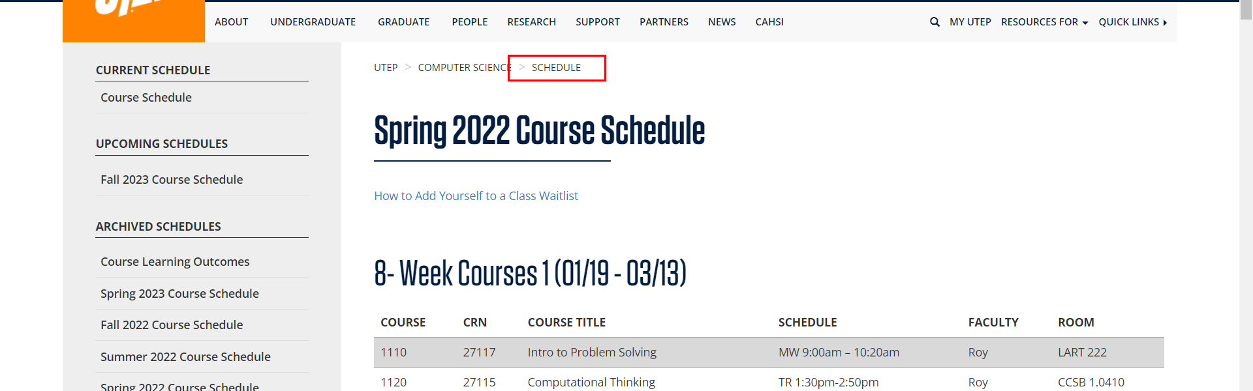

• Broken link on <https://www.utep.edu/cs/course-schedules/spring-2022-course-schedule.html> on **Main Content** section, the broken link is displayed as: **Topics in Data Science: Algorithms in Computational Biology** and the link is pointing to : <https://specialtopics.deblasiolab.org/s22/>

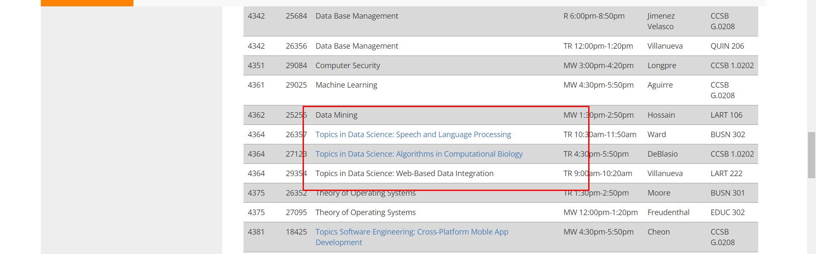

• Broken link on <https://www.utep.edu/cs/course-schedules/spring2018-course-schedule.html> on **Main Content (Top small navigation)** section, the broken link is displayed as: **Schedule** and the link is pointing to : <https://www.utep.edu/cs/course-schedules/>

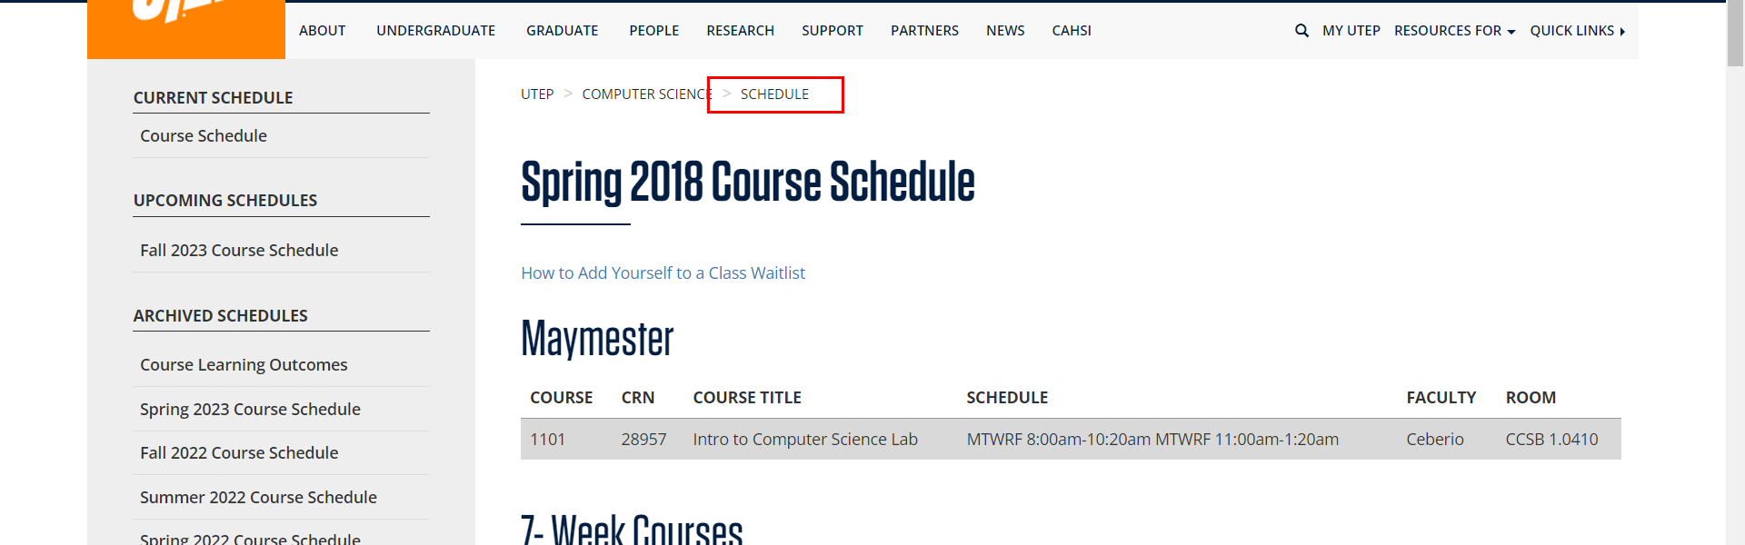

• Broken link on <https://www.utep.edu/cs/course-schedules/spring2023-course-schedule.html> on **Main Content (Top small navigation)** section, the broken link is displayed as: **Schedule** and the link is pointing to : <https://www.utep.edu/cs/course-schedules/>

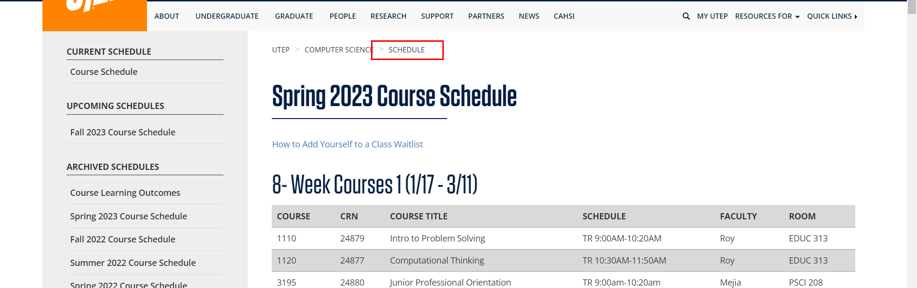

• Broken link on <https://www.utep.edu/cs/course-schedules/summer-2017-course-schedule.html> on **Main Content (Top small navigation)** section, the broken link is displayed as: **Schedule** and the link is pointing to : <https://www.utep.edu/cs/course-schedules/>

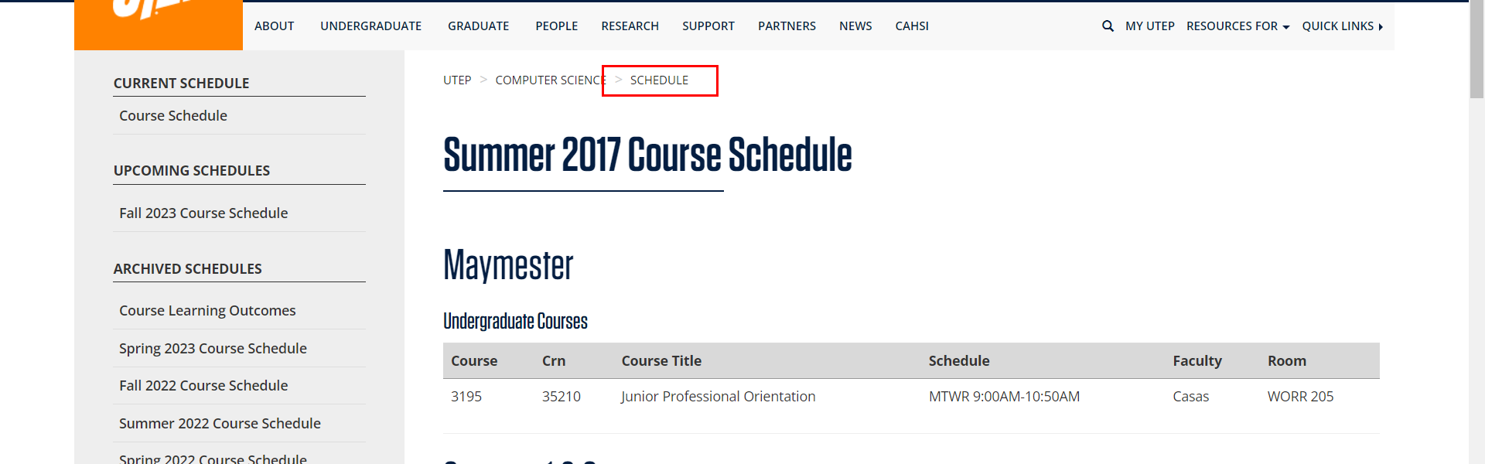

• Broken link on <https://www.utep.edu/cs/course-schedules/summer-2020-course-schedule.html> on **Main Content (Top small navigation)** section, the broken link is displayed as: **Schedule** and the link is pointing to : <https://www.utep.edu/cs/course-schedules/>

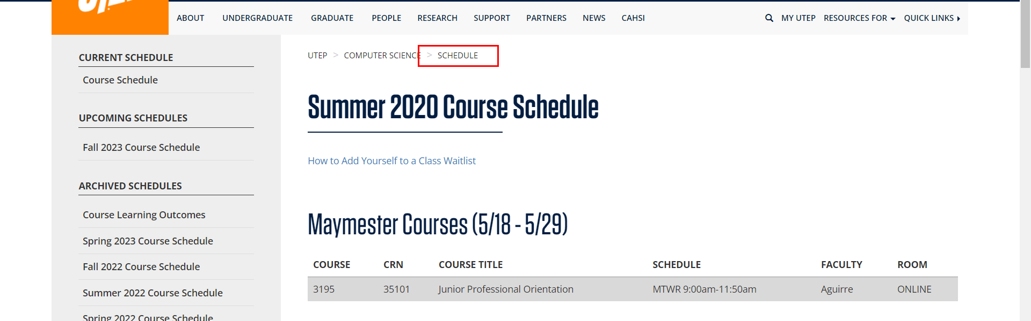

• Broken link on <https://www.utep.edu/cs/course-schedules/summer-2021-course-schedule.html> on **Main Content (Top small navigation)** section, the broken link is displayed as: **Schedule** and the link is pointing to : <https://www.utep.edu/cs/course-schedules/>

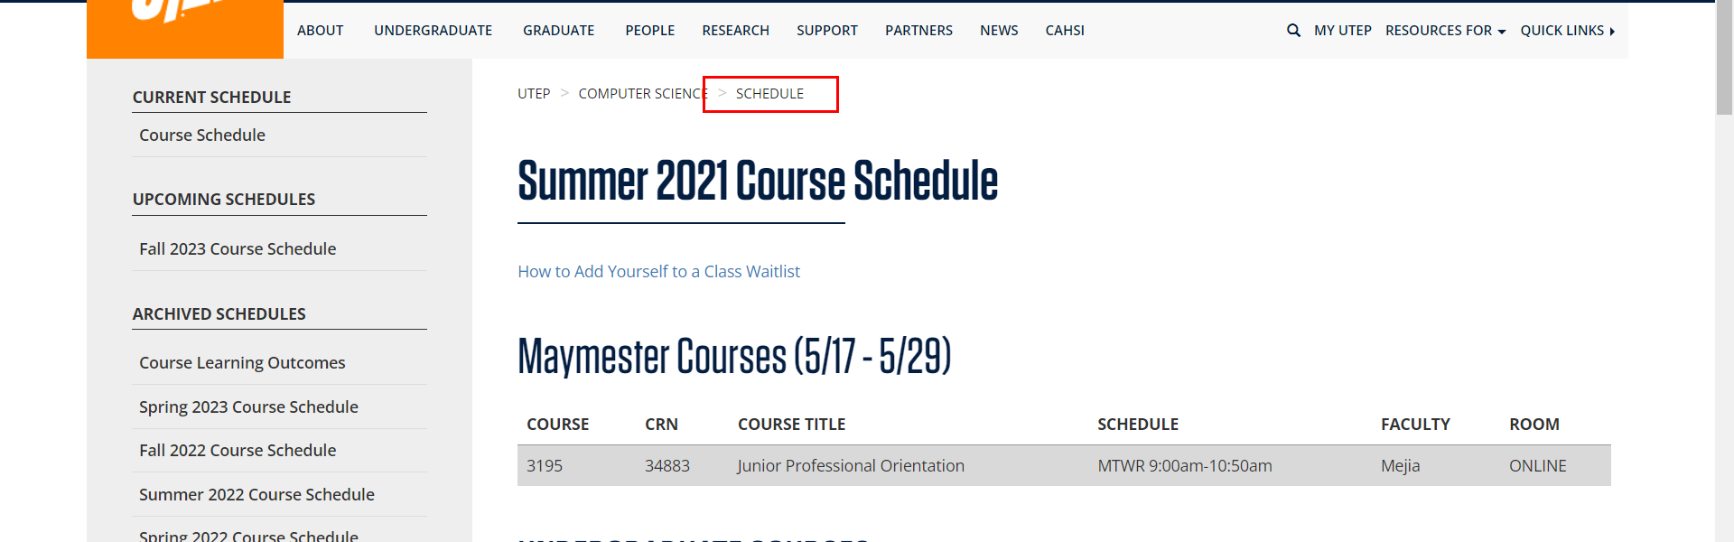

• Broken link on <https://www.utep.edu/cs/course-schedules/summer-2022-course-schedule.html> on **Main Content (Top small navigation)** section, the broken link is displayed as: **Schedule** and the link is pointing to : <https://www.utep.edu/cs/course-schedules/>

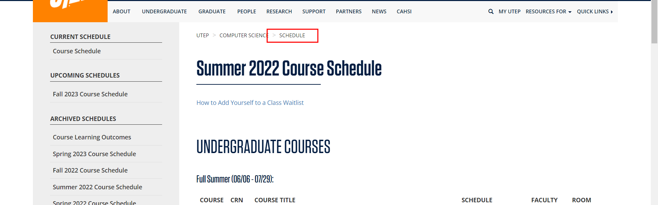

• Broken link on <https://www.utep.edu/cs/course-schedules/summer-2023-course-schedule.html> on **Main Content (Top small navigation)** section, the broken link is displayed as: **Schedule** and the link is pointing to : <https://www.utep.edu/cs/course-schedules/>

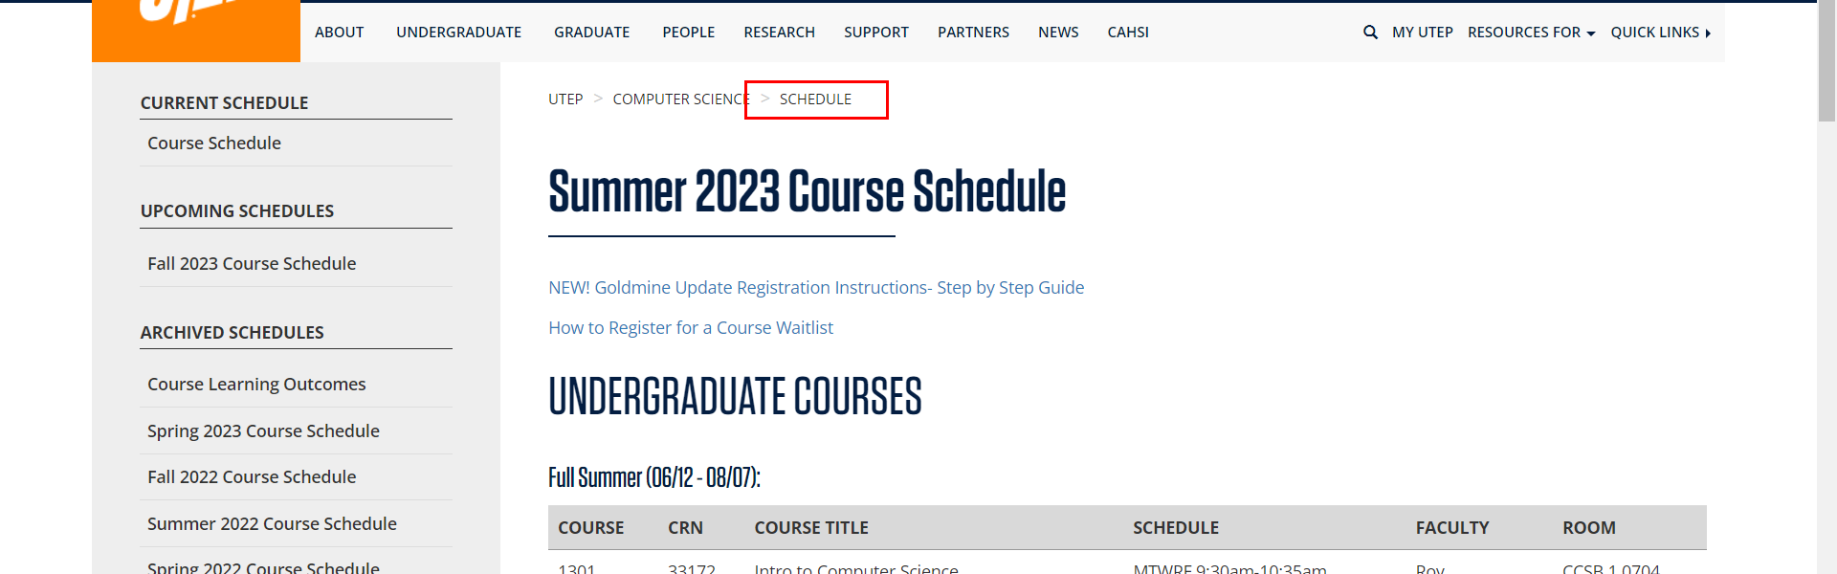

• Broken link on <https://www.utep.edu/cs/course-schedules/summer2018-course-schedule.html> on **Main Content (Top small navigation)** section, the broken link is displayed as: **Schedule** and the link is pointing to : <https://www.utep.edu/cs/course-schedules/>

