# Broken Links Report

• Broken link on <https://www.utep.edu/cs/junk/test-page-cs.html> on **Main Content (Top small navigation)** section, the broken link is displayed as: **junk** and the link is pointing to : <https://www.utep.edu/cs/junk/>

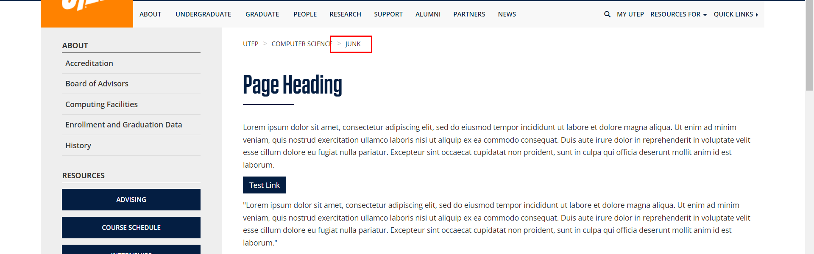

• Broken link on <https://www.utep.edu/cs/junk/test-page-cs.html> on **Left Navigation** section, the broken link is displayed as: **Computing Facilities** and the link is pointing to : <https://www.utep.edu/cs/support/computing_facilities.html>

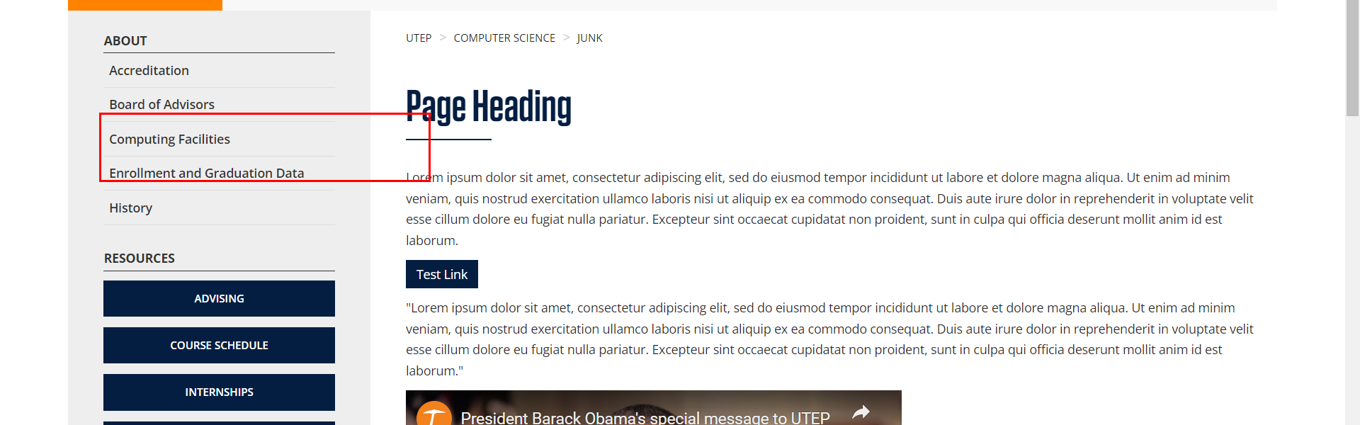

• Broken link on <https://www.utep.edu/cs/junk/test-page-cs.html> on **Left Navigation** section, the broken link is displayed as: **Advising** and the link is pointing to : <https://www.utep.edu/cs/advising/index.html>

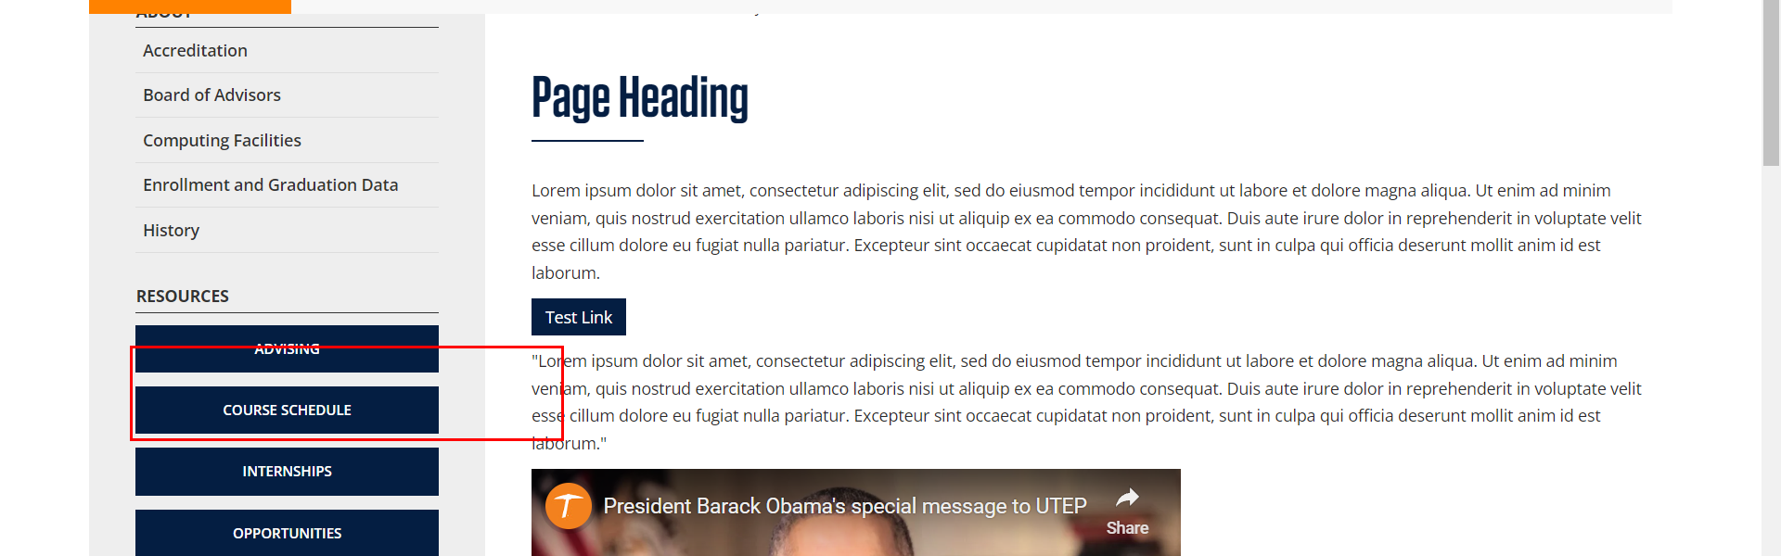

• Broken link on <https://www.utep.edu/cs/junk/test-page-cs.html> on **Main Content** section, the broken link is displayed as: **Test Link** and the link is pointing to : <https://www.utep.edu/cs/index-temp>

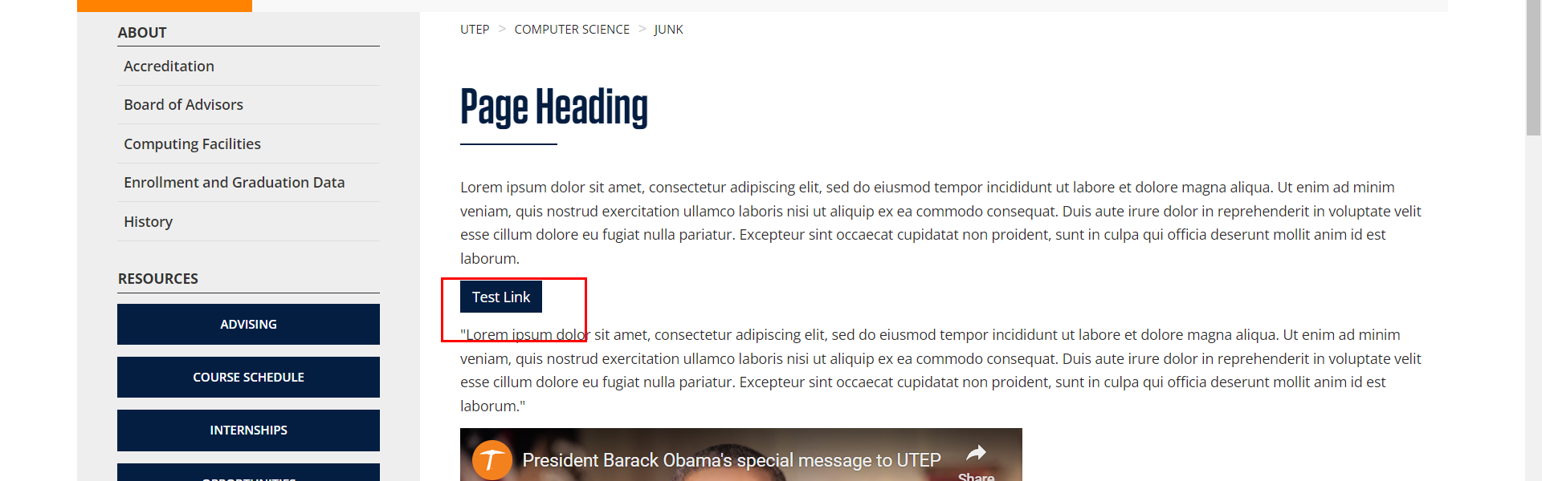

• Broken link on <https://www.utep.edu/cs/junk/test-page-cs.html> on **Left Navigation** section, the broken link is displayed as: **Opportunities** and the link is pointing to : <https://www.utep.edu/cs/opportunities/index.html>

