# Broken Links Report

• Broken link on <https://www.utep.edu/cs/opportunities/dod_cyber_scholarship_program.html> on **Main Content (Top small navigation)** section, the broken link is displayed as: **opportunities** and the link is pointing to : <https://www.utep.edu/cs/opportunities/>

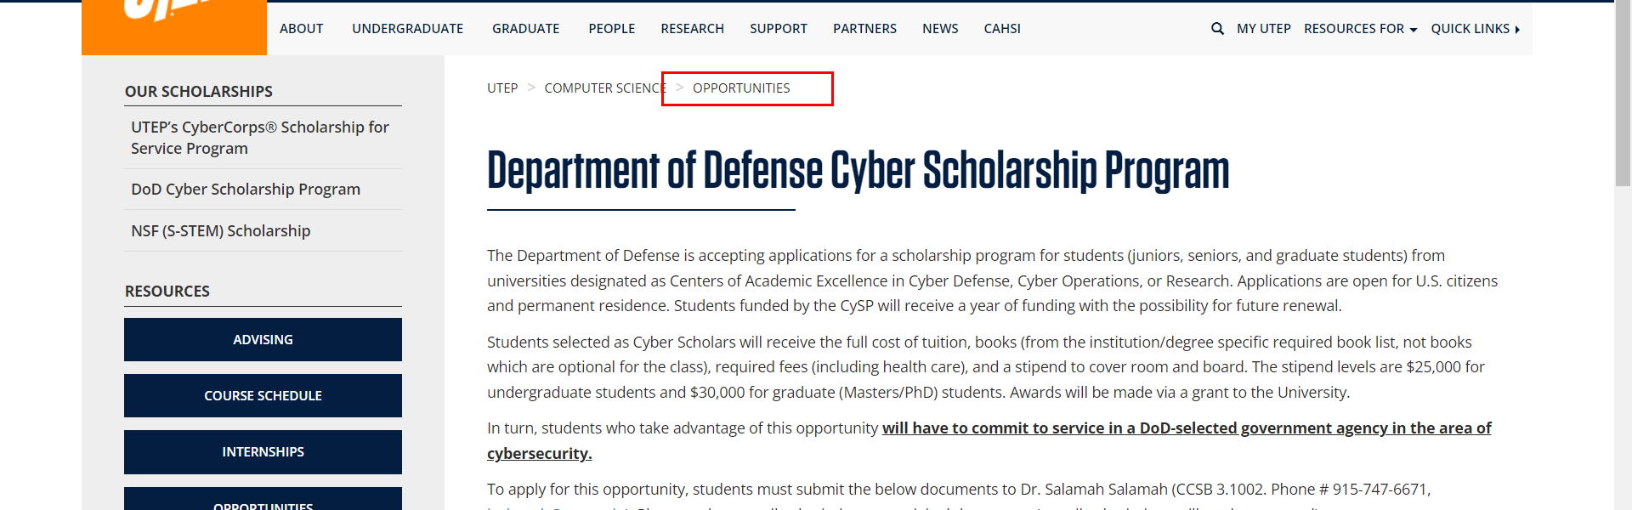

• Broken link on <https://www.utep.edu/cs/opportunities/fast_track_program.html> on **Main Content (Top small navigation)** section, the broken link is displayed as: **opportunities** and the link is pointing to : <https://www.utep.edu/cs/opportunities/>

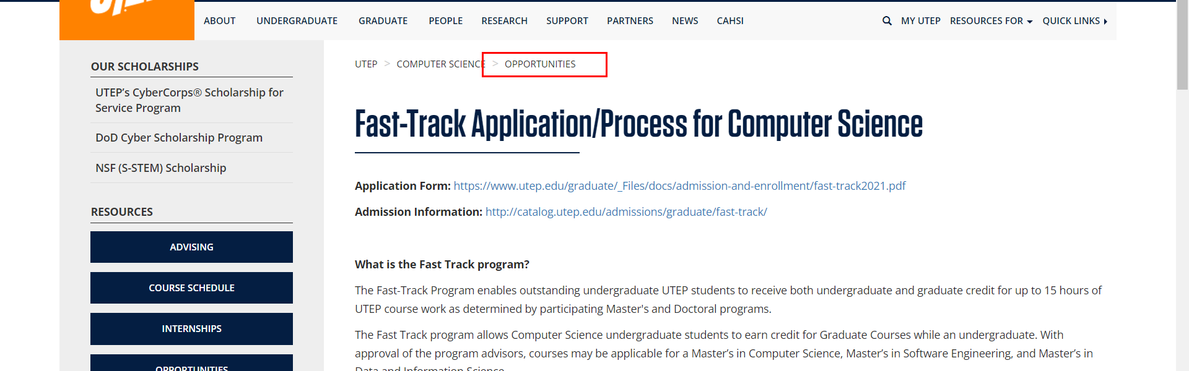

• Broken link on <https://www.utep.edu/cs/opportunities/internships.html> on **Main Content (Top small navigation)** section, the broken link is displayed as: **opportunities** and the link is pointing to : <https://www.utep.edu/cs/opportunities/>

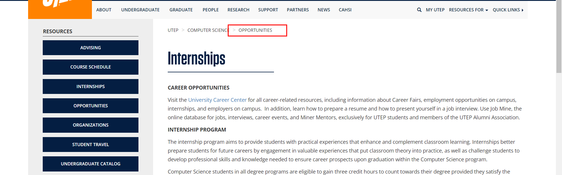

• Broken link on <https://www.utep.edu/cs/opportunities/opportunities.html> on **Main Content (Top small navigation)** section, the broken link is displayed as: **opportunities** and the link is pointing to : <https://www.utep.edu/cs/opportunities/>

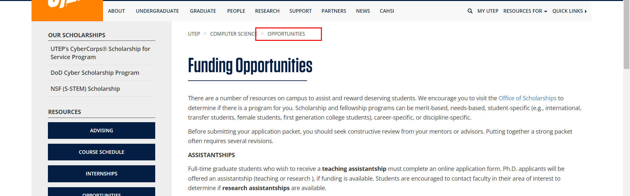

• Broken link on <https://www.utep.edu/cs/opportunities/opportunities.html> on **Main Content** section, the broken link is displayed as: and the link is pointing to : [https://www.csc.tntech.edu/wicys/](http://www.wicys.net/)



• Broken link on <https://www.utep.edu/cs/opportunities/s-stem_scholarship_program.html> on **Main Content (Top small navigation)** section, the broken link is displayed as: **opportunities** and the link is pointing to : <https://www.utep.edu/cs/opportunities/>

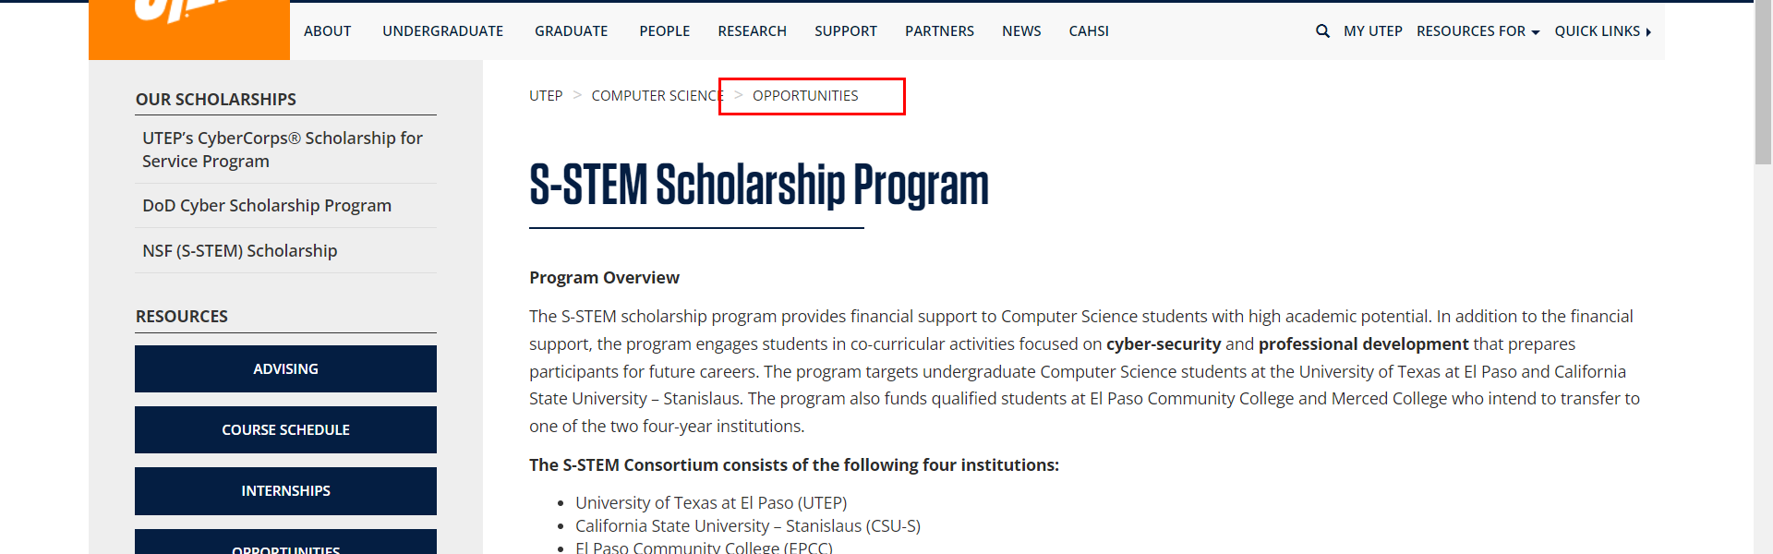

• Broken link on <https://www.utep.edu/cs/opportunities/s-stem_scholarship_program.html> on **Main Content** section, the broken link is displayed as: and the link is pointing to : <http://www.cs.utep.edu/wp-content/uploads/2016/12/image003.jpg>



• Broken link on <https://www.utep.edu/cs/opportunities/sfs_application.html> on **Main Content (Top small navigation)** section, the broken link is displayed as: **opportunities** and the link is pointing to : <https://www.utep.edu/cs/opportunities/>

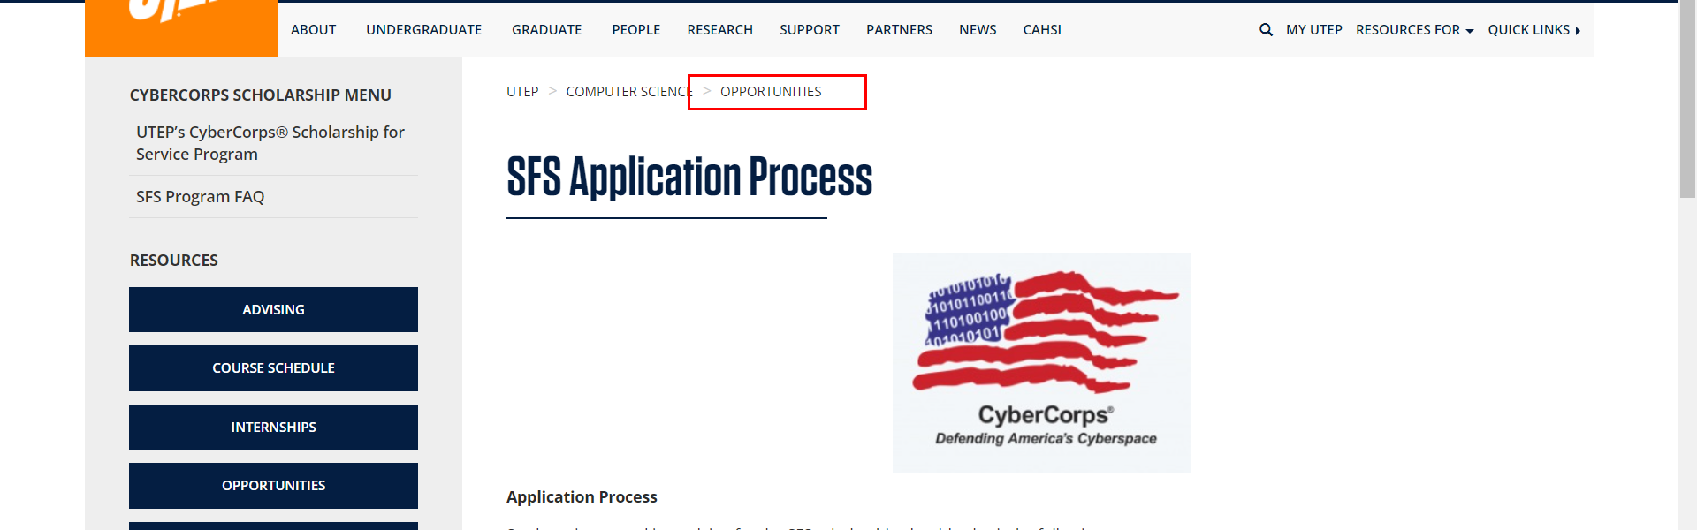

• Broken link on <https://www.utep.edu/cs/opportunities/sfs_program.html> on **Main Content (Top small navigation)** section, the broken link is displayed as: **opportunities** and the link is pointing to : <https://www.utep.edu/cs/opportunities/>

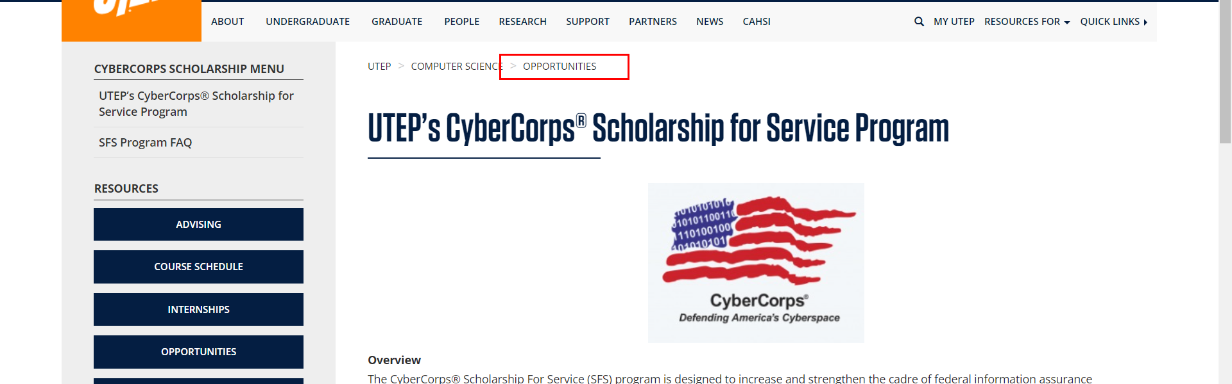

• Broken link on <https://www.utep.edu/cs/opportunities/sfs_program_faq.html> on **Main Content (Top small navigation)** section, the broken link is displayed as: **opportunities** and the link is pointing to : <https://www.utep.edu/cs/opportunities/>

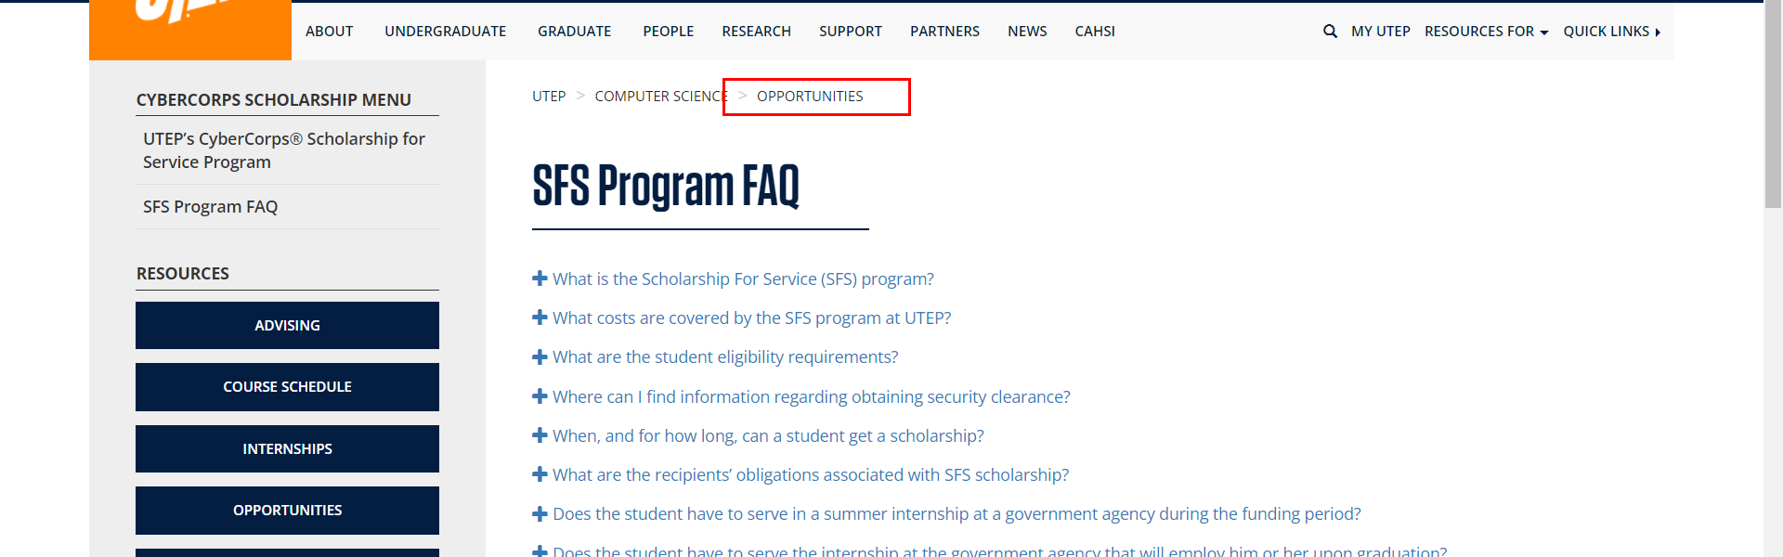

• Broken link on <https://www.utep.edu/cs/opportunities/sstem.html> on **Main Content (Top small navigation)** section, the broken link is displayed as: **opportunities** and the link is pointing to : <https://www.utep.edu/cs/opportunities/>

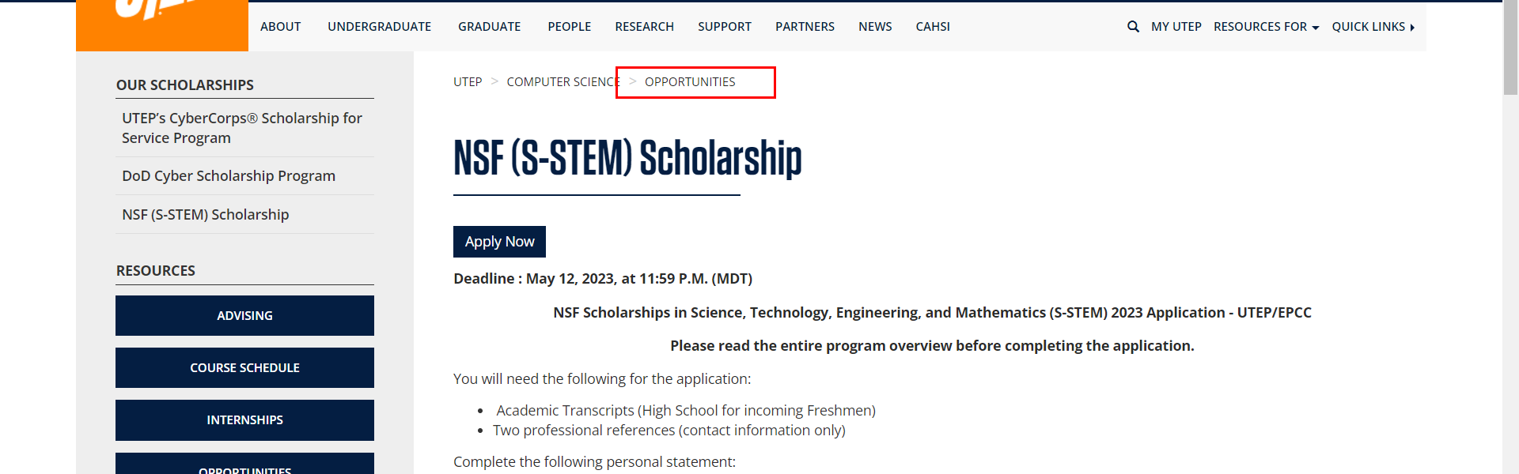

• Broken link on <https://www.utep.edu/cs/opportunities/sstem.html> on **Main Content** section, the broken link is displayed as: and the link is pointing to : <http://www.cs.utep.edu/wp-content/uploads/2016/12/image003.jpg>



• Broken link on <https://www.utep.edu/cs/opportunities/student-travel.html> on **Main Content (Top small navigation)** section, the broken link is displayed as: **opportunities** and the link is pointing to : <https://www.utep.edu/cs/opportunities/>

