# Broken Links Report

• Broken link on <https://www.utep.edu/cs/people/Freudenthal.html> on **Main Content** section, the broken link is displayed as: **calendar** and the link is pointing to : <https://sites.google.com/site/freudenthalnet/eric-freudenthal-s-availability>

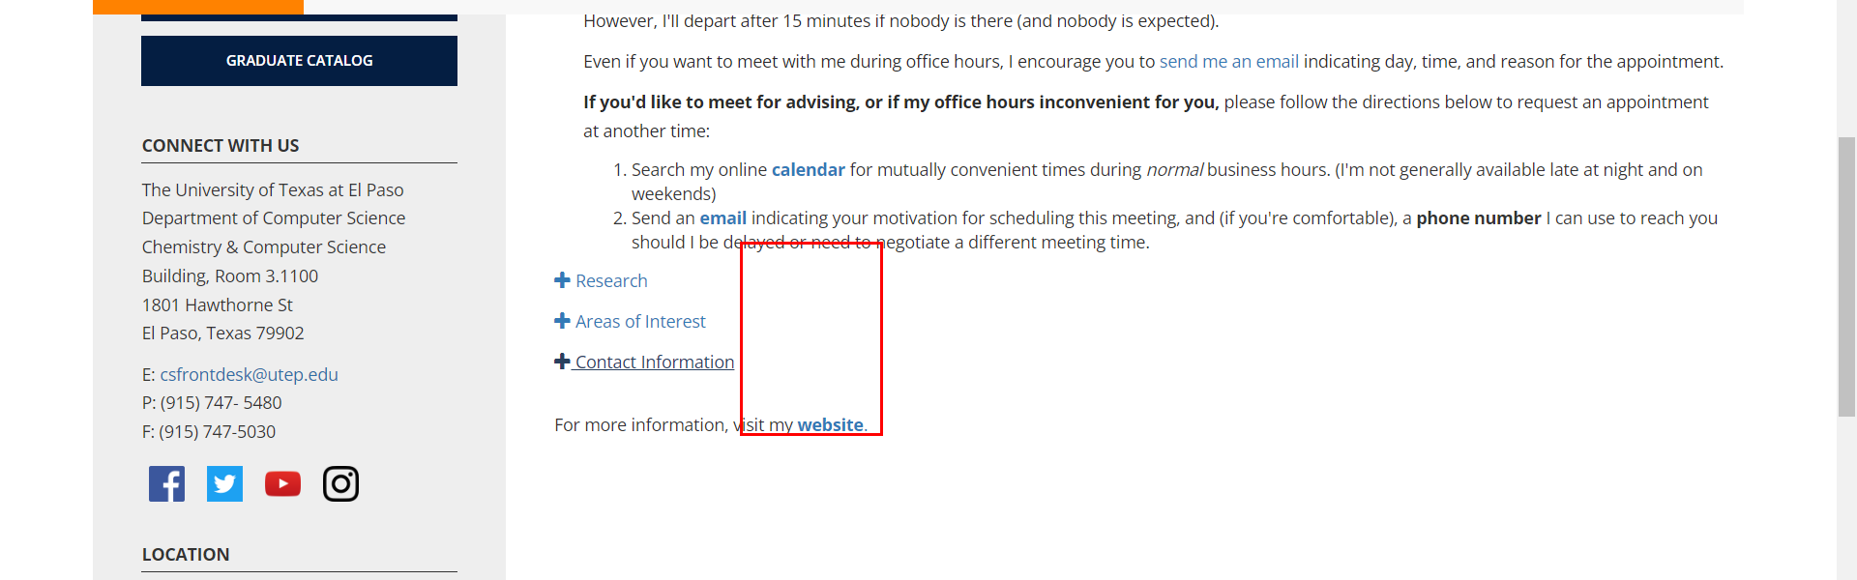

• Broken link on <https://www.utep.edu/cs/people/Freudenthal.html> on **Main Content** section, the broken link is displayed as: **Coral-CDN** and the link is pointing to : <https://www.utep.edu/cs/people/coralcdn.org>

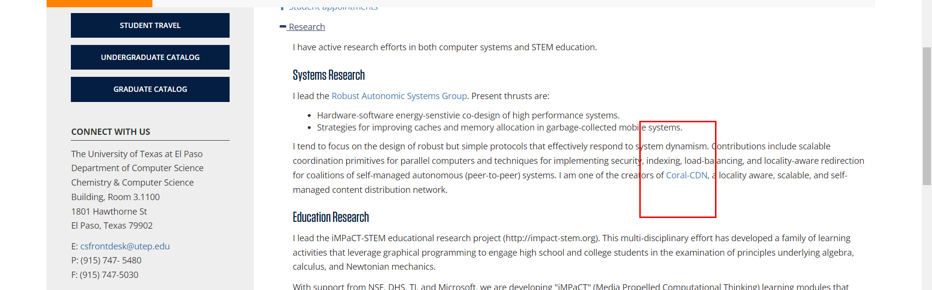

• Broken link on <https://www.utep.edu/cs/people/Fuentes_Publications.html> on **Main Content** section, the broken link is displayed as: **Harnessing the power of big data: infusing the scientific method with machine learning to transform ecology** and the link is pointing to : [http://www.esajournals.org/doi/pdf/10.1890/ES13-00359.1](https://esajournals.onlinelibrary.wiley.com/)

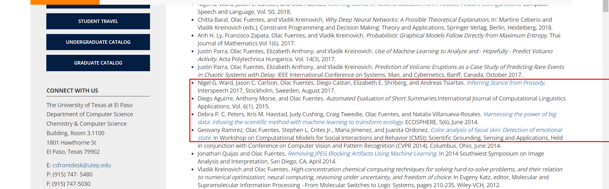

• Broken link on <https://www.utep.edu/cs/people/Fuentes_Publications.html> on **Main Content** section, the broken link is displayed as: **Face Detection in Low-resolution Color Images** and the link is pointing to : <http://www.cs.utep.edu/ofuentes/iciar10.pdf>

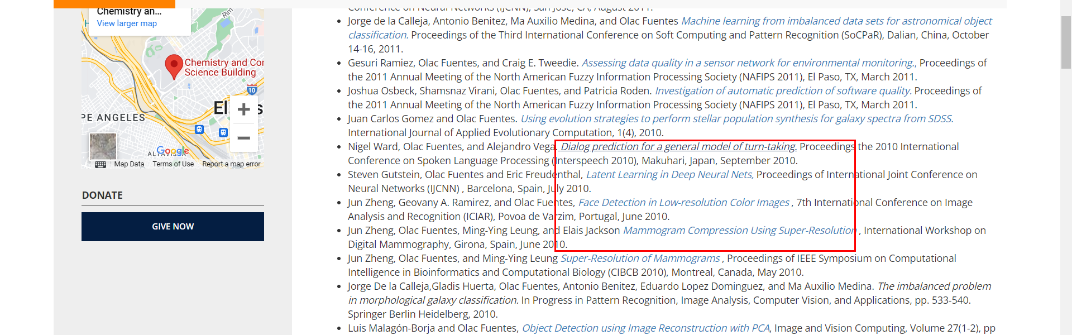

• Broken link on <https://www.utep.edu/cs/people/longpre.html> on **Main Content** section, the broken link is displayed as: **here** and the link is pointing to : [https://outlook.office365.com/owa/calendar/ComputerScienceAdvising1@minersutep.onmicrosoft.com/bookings/s/R171XriyvkSfOYZt7opfCw2](https://outlook.office365.com/book/ComputerScienceAdvising1@minersutep.onmicrosoft.com/s/R171XriyvkSfOYZt7opfCw2?isAnonymous=true)

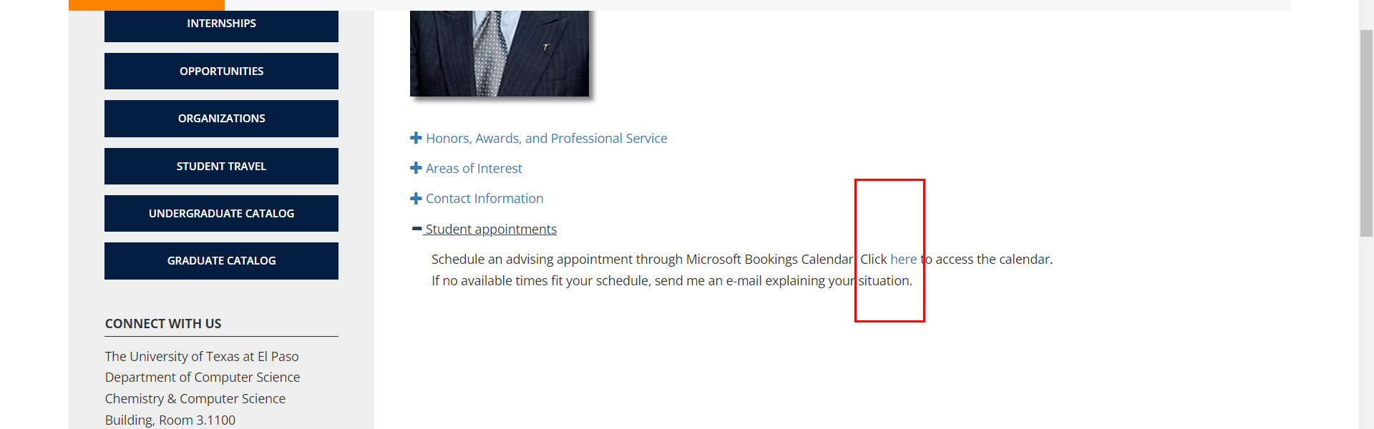

• Broken link on <https://www.utep.edu/cs/people/nvillanuevarosales.html> on **Main Content** section, the broken link is displayed as: **[Website]** and the link is pointing to : <https://esajournals.onlinelibrary.wiley.com/doi/full/10.1890/ES13-00359.1>

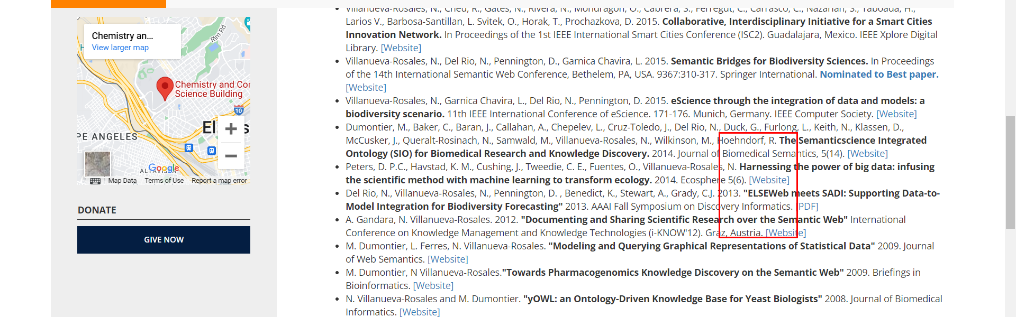

• Broken link on <https://www.utep.edu/cs/people/nvillanuevarosales.html> on **Main Content** section, the broken link is displayed as: **[PDF]** and the link is pointing to : [https://www.aaai.org/ocs/index.php/FSS/FSS13/paper/viewFile/7631/7488](https://aaai.org/ocs/index.php/FSS/FSS13/paper/viewFile/7631/7488)

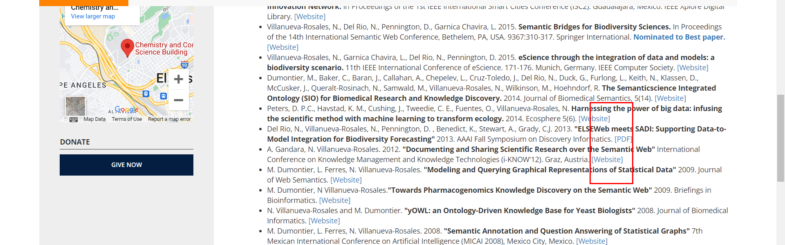

• Broken link on <https://www.utep.edu/cs/people/nvillanuevarosales.html> on **Main Content** section, the broken link is displayed as: **Google Scholar page.** and the link is pointing to : <https://scholar.google.com/citations?user=DCfeFYQAAAAJ&hl=en&oi=ao>

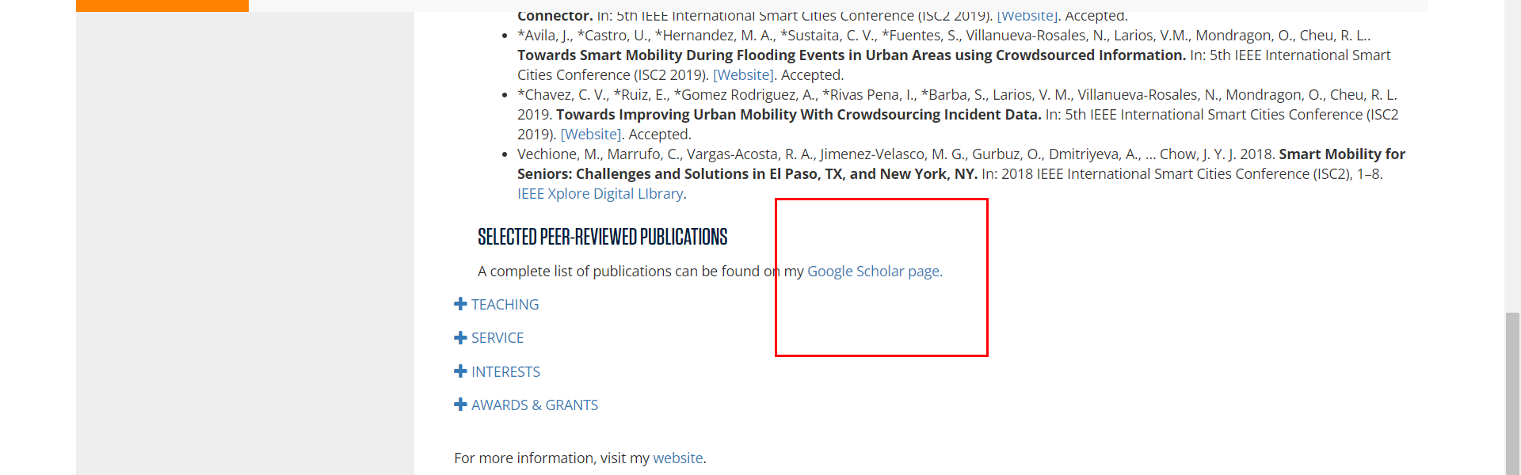

• Broken link on <https://www.utep.edu/cs/people/nvillanuevarosales.html> on **Main Content** section, the broken link is displayed as: **2019 Undergraduate Research Mentoring Award** and the link is pointing to : <https://www.ncwit.org/2019-undergraduate-research-mentoring-award-recipients>

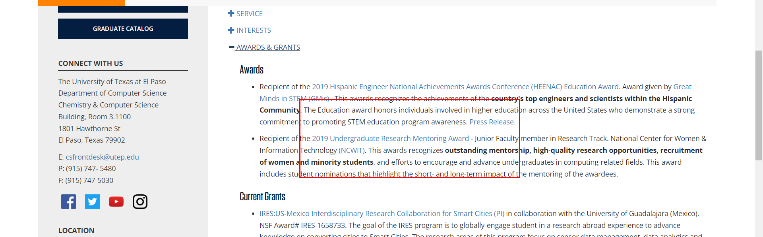

• Broken link on <https://www.utep.edu/cs/people/nvillanuevarosales.html> on **Main Content** section, the broken link is displayed as: **2019 Hispanic Engineer National Achievements Awards Conference (HEENAC) Education Award** and the link is pointing to : [http://www.greatmindsinstem.org/professionals/award-winners-2019](https://greatmindsinstem.org/professionals/award-winners-2019)

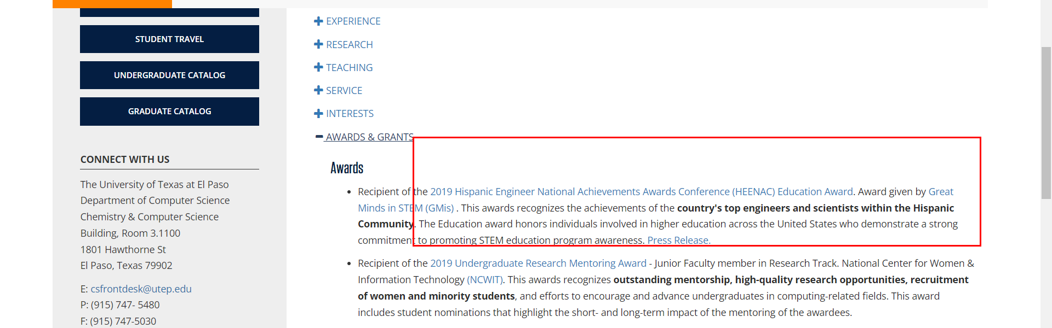

• Broken link on <https://www.utep.edu/cs/people/nvillanuevarosales.html> on **Main Content** section, the broken link is displayed as: **Great Minds in STEM (GMis)** and the link is pointing to : [http://www.greatmindsinstem.org/index.htm](https://greatmindsinstem.org/index.htm)

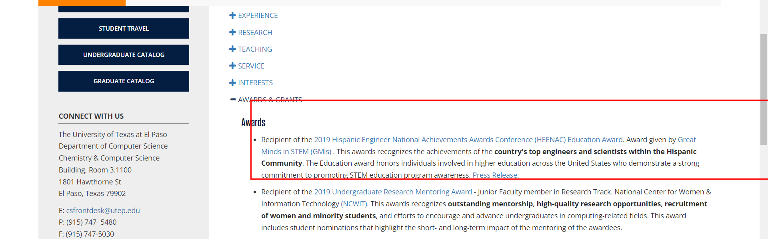

• Broken link on <https://www.utep.edu/cs/people/Eric/index.html> on **Main Content** section, the broken link is displayed as: **accordion4/http://faculty.utep.edu/longpre** and the link is pointing to : [http://faculty.utep.edu/longpre](https://www.utep.edu/longpre)

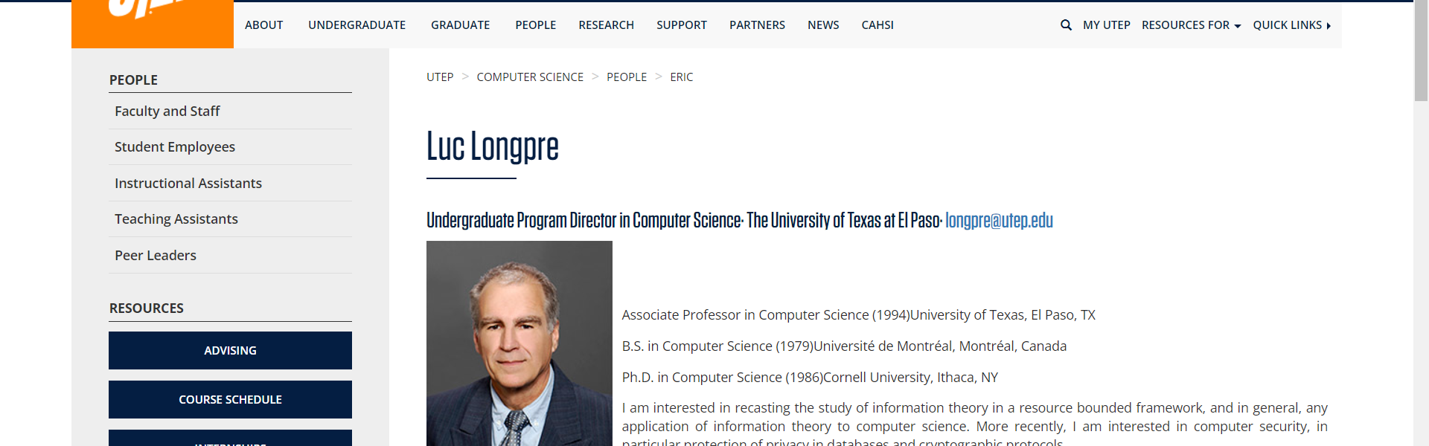

• Broken link on <https://www.utep.edu/cs/people/faculty-websites/jacosta.html> on **Main Content (Top small navigation)** section, the broken link is displayed as: **Faculty Websites** and the link is pointing to : <https://www.utep.edu/cs/people/faculty-websites/>

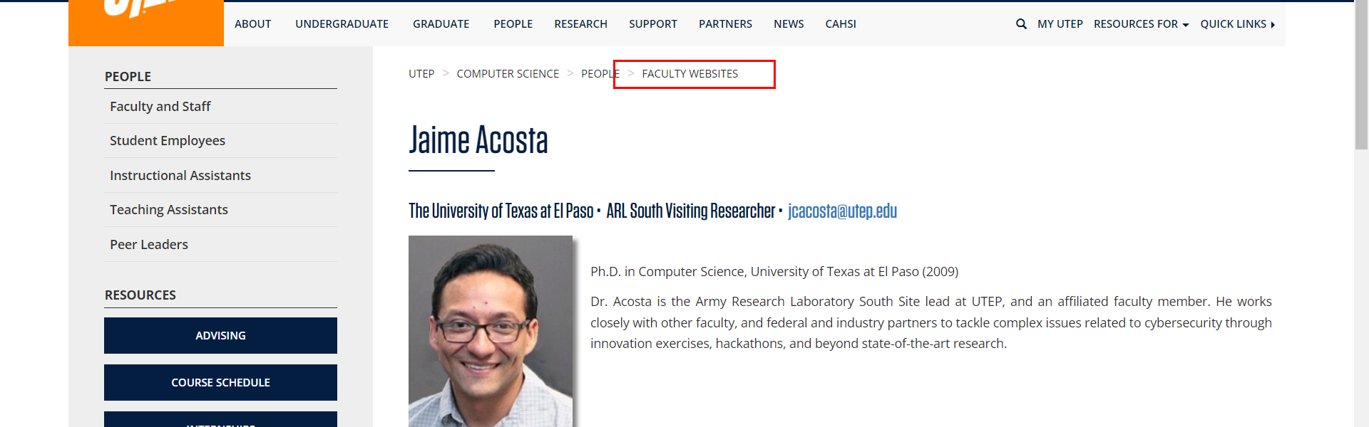

• Broken link on <https://www.utep.edu/cs/people/faculty-websites/omondragon.html> on **Main Content (Top small navigation)** section, the broken link is displayed as: **Faculty Websites** and the link is pointing to : <https://www.utep.edu/cs/people/faculty-websites/>

