# Broken Links Report

• Broken link on <https://www.utep.edu/cs/pickx/aboutUs/aboutpickx.html> on **Main Content (Top small navigation)** section, the broken link is displayed as: **aboutUs** and the link is pointing to : <https://www.utep.edu/cs/pickx/aboutUs/>

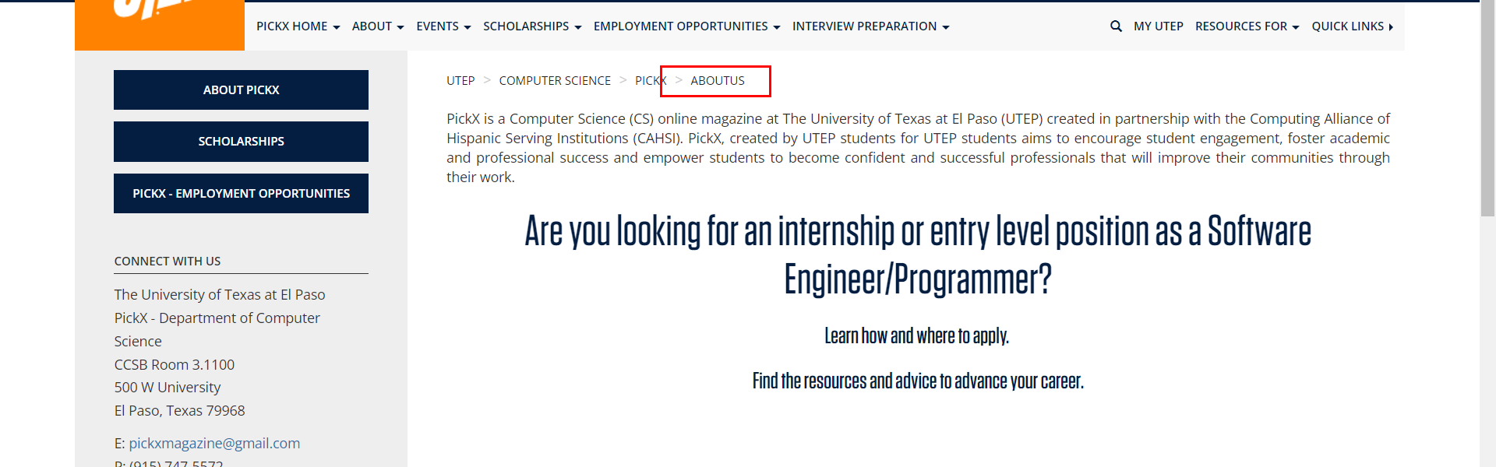

• Broken link on <https://www.utep.edu/cs/pickx/archive/2018/july/resume_tips.html> on **Main Content** section, the broken link is displayed as: **Nova Southeastern University** and the link is pointing to : <http://www.nova.edu/career/resources/forms/resume_computer_science.pdf>

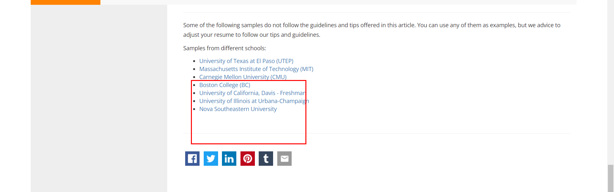

• Broken link on <https://www.utep.edu/cs/pickx/archive/2018/july/resume_tips.html> on **Main Content** section, the broken link is displayed as: **University of Texas at El Paso (UTEP)** and the link is pointing to : <https://www.utep.edu/student-affairs/careers/_Files/pdfs/Final-Online-Undergraduate-Resume-Sample-RD-8.3.2015.pdf>

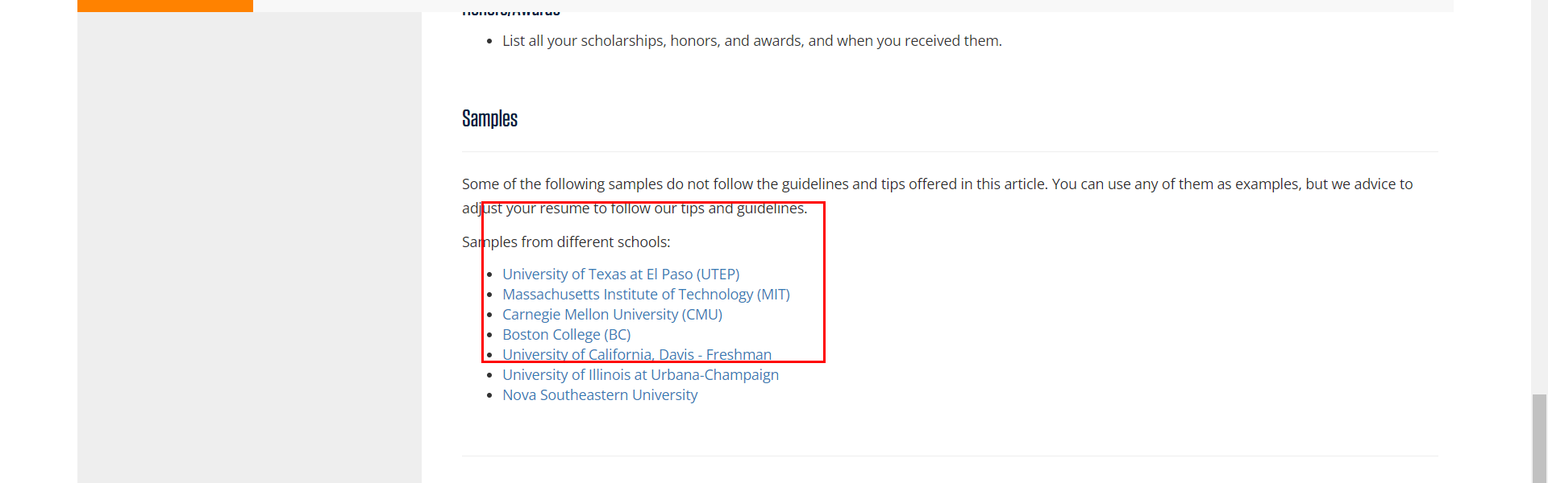

• Broken link on <https://www.utep.edu/cs/pickx/archive/2018/july/resume_tips.html> on **General content** section, the broken link is displayed as: **None** and the link is pointing to : [https://www.careercenter.illinois.edu/sites/default/files/downloads/Career Center Resume Flyer.pdf](https://www.careercenter.illinois.edu/sites/default/files/downloads/Career%20Center%20Resume%20Flyer.pdf)

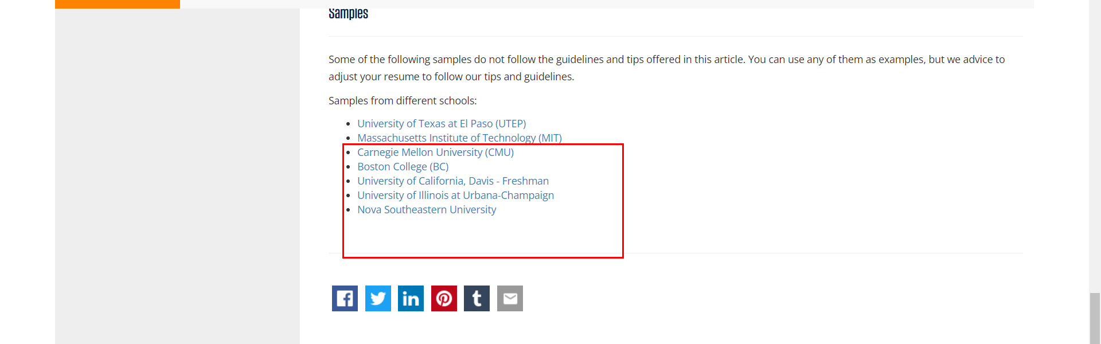

• Broken link on <https://www.utep.edu/cs/pickx/archive/2018/july/resume_tips.html> on **Main Content** section, the broken link is displayed as: **List of Action Verbs for Resumes & Professional Profiles** and the link is pointing to : [http://career.opcd.wfu.edu/files/2011/05/Action-Verbs-for-Resumes.pdf](https://prod.wp.cdn.aws.wfu.edu/sites/41/2011/05/Action-Verbs-for-Resumes.pdf)

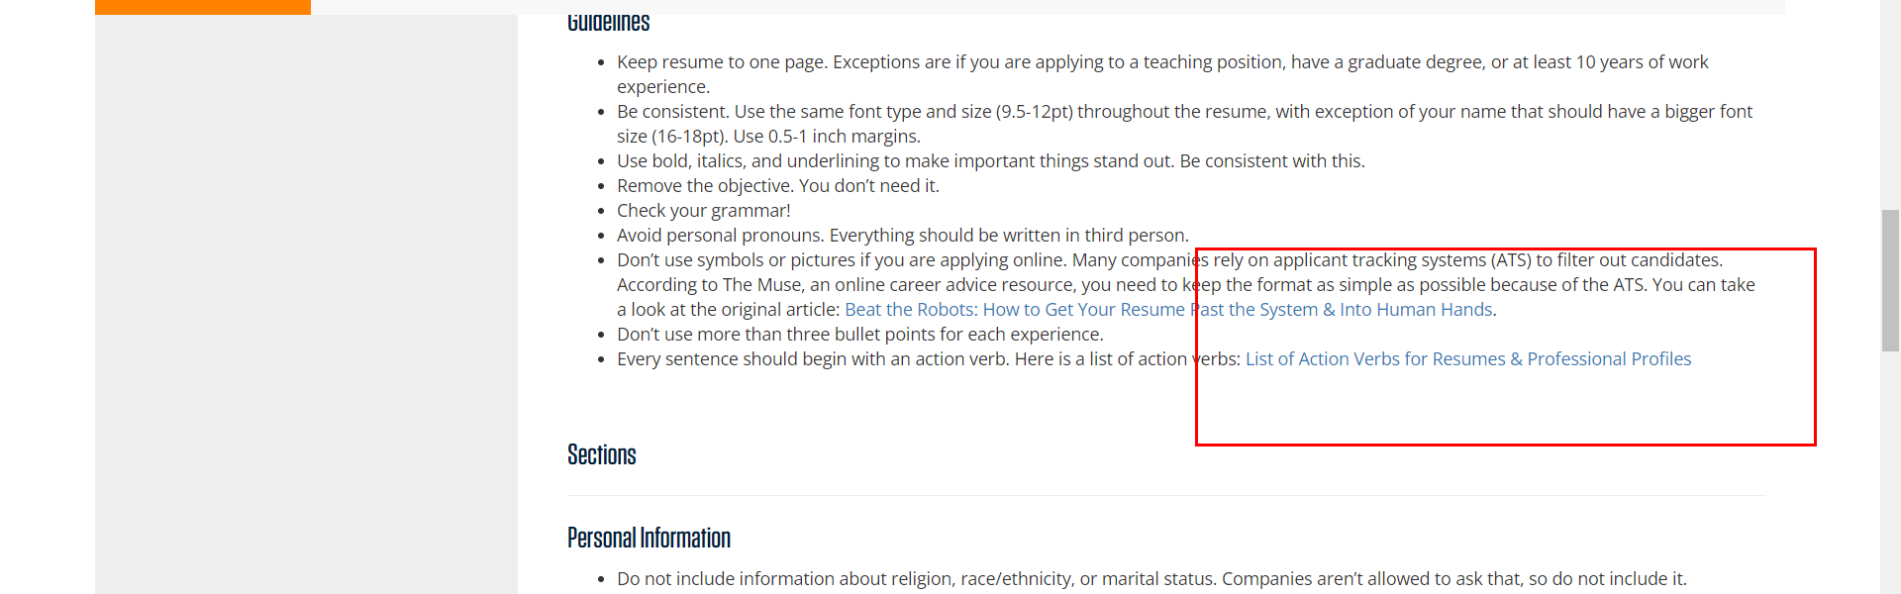

• Broken link on <https://www.utep.edu/cs/pickx/archive/2018/july/why_extracurricular_activities_matter.html> on **Main Content** section, the broken link is displayed as: **Research at UTEP - Computer Science** and the link is pointing to : <http://www.cs.utep.edu/research/>

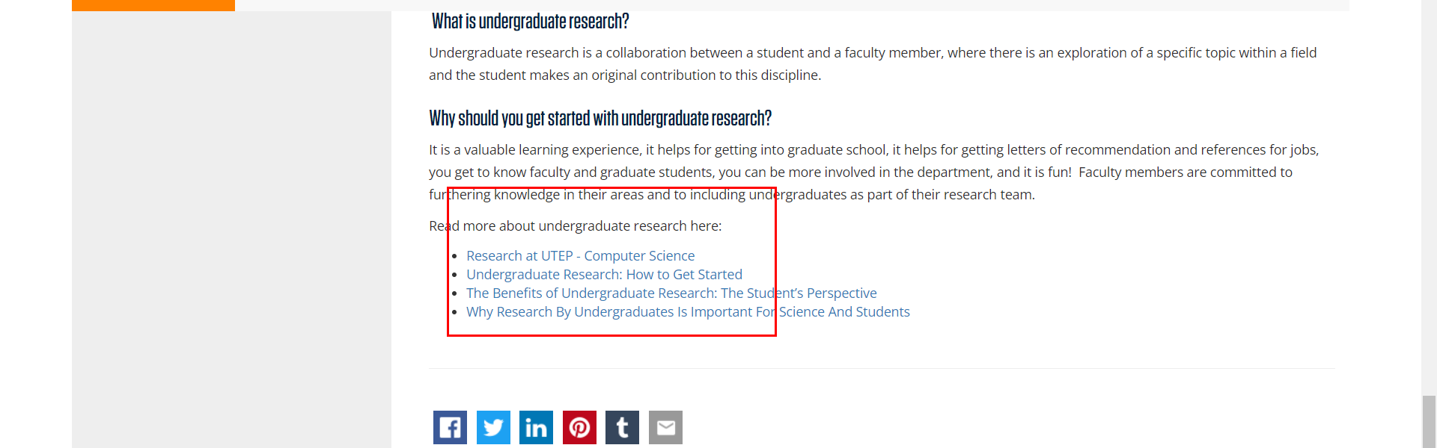

• Broken link on <https://www.utep.edu/cs/pickx/archive/2018/july/why_extracurricular_activities_matter.html> on **Main Content** section, the broken link is displayed as: **The Benefits of Undergraduate Research: The Student’s Perspective** and the link is pointing to : <https://dus.psu.edu/mentor/2013/05/undergraduate-research-students-perspective/>

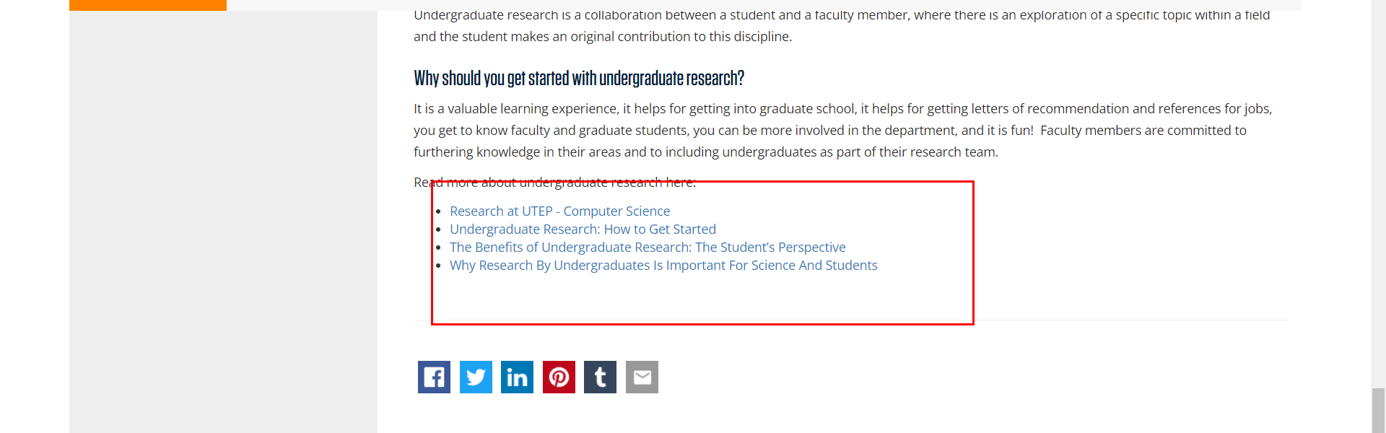

• Broken link on <https://www.utep.edu/cs/pickx/interview_preparation/index.html> on **Main Content** section, the broken link is displayed as: and the link is pointing to : <https://www.utep.edu/computer-science/pickx/archive/July%202018/Resumes>

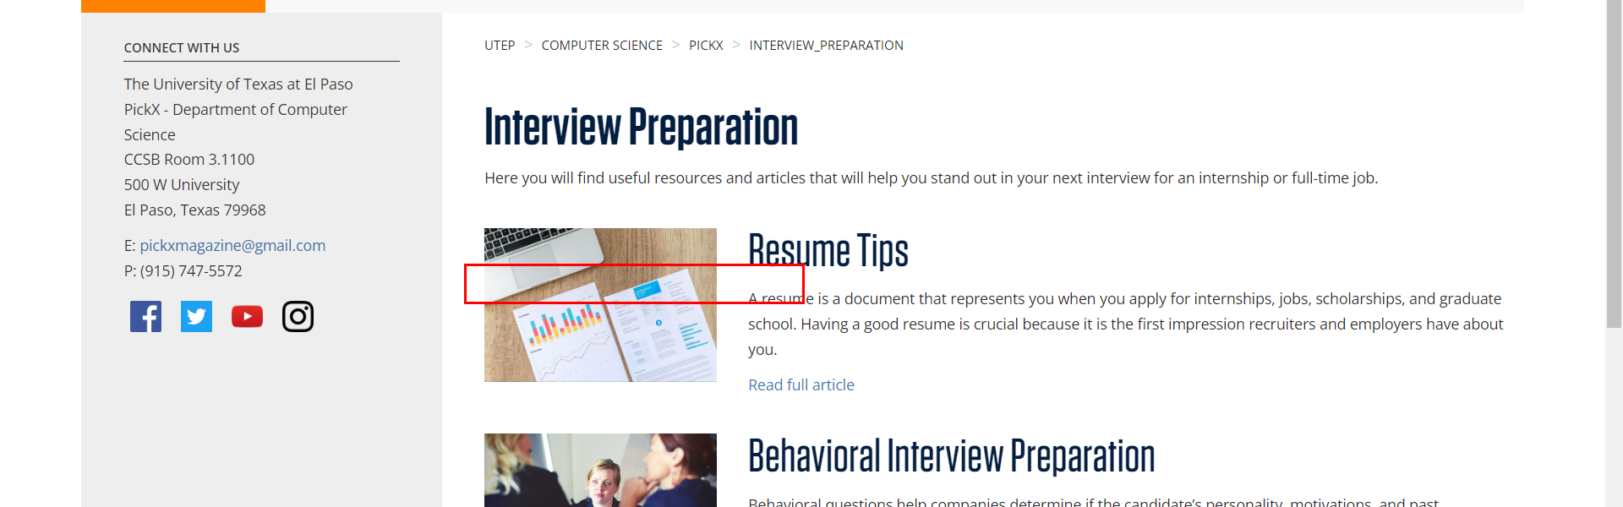

• Broken link on <https://www.utep.edu/cs/pickx/scholarships/index.html> on **Main Content** section, the broken link is displayed as: **S-STEM Scholarship Program** and the link is pointing to : <http://www.cs.utep.edu/s-stem-program/>

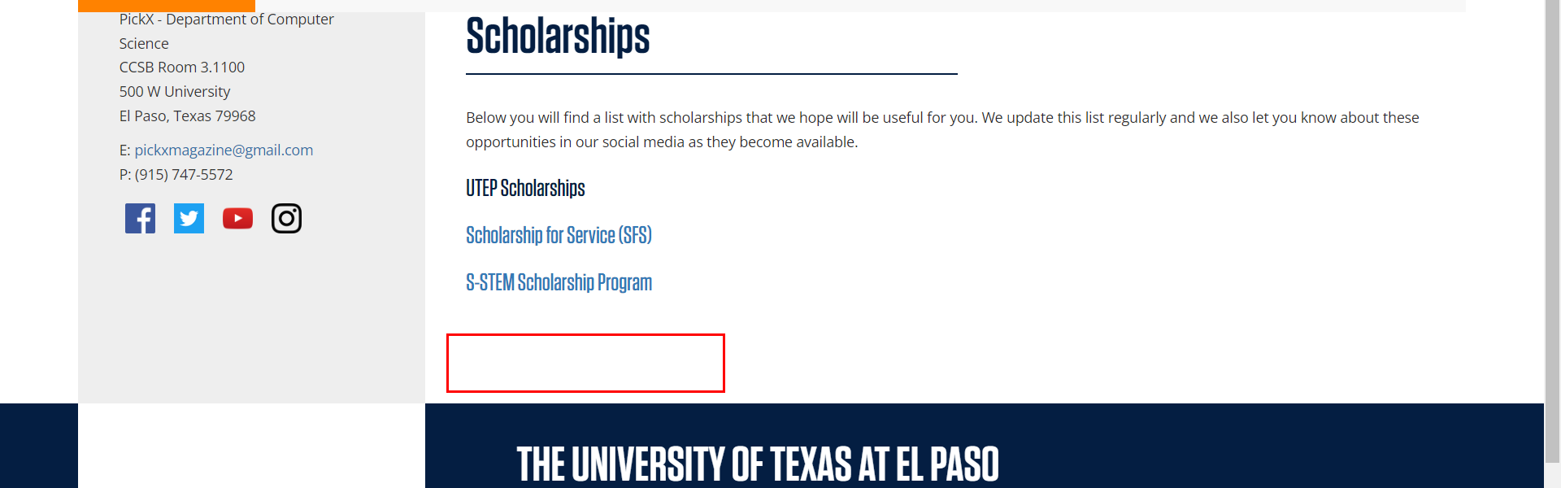

• Broken link on <https://www.utep.edu/cs/pickx/scholarships/index.html> on **Main Content** section, the broken link is displayed as: **Scholarship for Service (SFS)** and the link is pointing to : <http://www.cs.utep.edu/utep-sfs-program/>

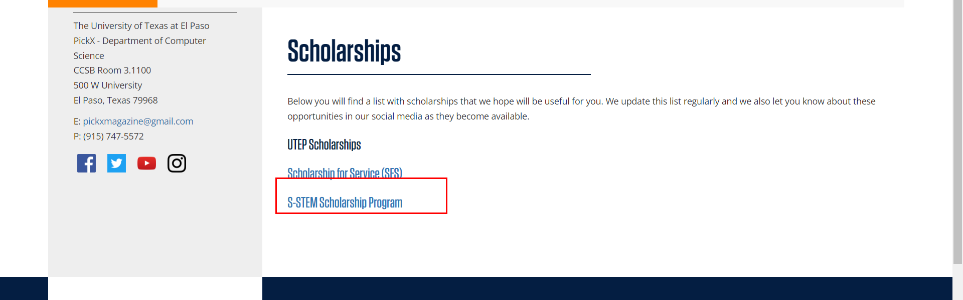

• Broken link on <https://www.utep.edu/cs/pickx/_Files/article_template.html> on **Main Content (Top small navigation)** section, the broken link is displayed as: **_Files** and the link is pointing to : <https://www.utep.edu/cs/pickx/_Files/>

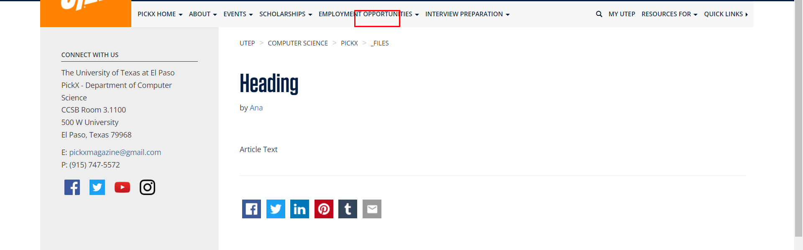

• Broken link on <https://www.utep.edu/cs/pickx/_Files/july_2018_archive.html> on **Main Content (Top small navigation)** section, the broken link is displayed as: **_Files** and the link is pointing to : <https://www.utep.edu/cs/pickx/_Files/>

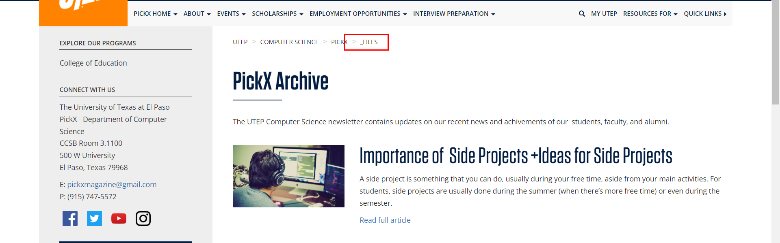

• Broken link on <https://www.utep.edu/cs/pickx/_Files/july_2018_archive.html> on **Main Content** section, the broken link is displayed as: and the link is pointing to : <https://www.utep.edu/computer-science/pickx/July%202018/Resume_Tips>



• Broken link on <https://www.utep.edu/cs/pickx/_Files/july_2018_archive.html> on **Main Content** section, the broken link is displayed as: and the link is pointing to : <https://www.utep.edu/computer-science/pickx/July%202018/importance_of_side_projects>

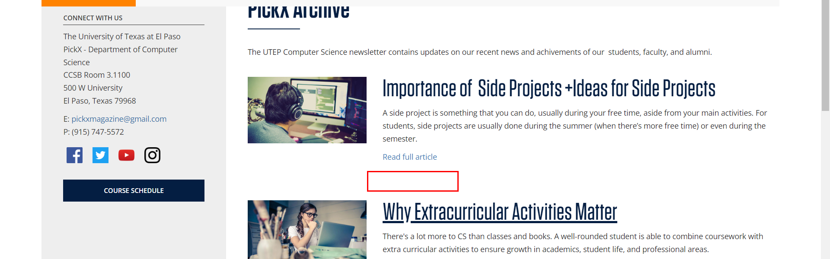

• Broken link on <https://www.utep.edu/cs/pickx/_Files/july_2018_archive.html> on **Main Content** section, the broken link is displayed as: and the link is pointing to : <https://www.utep.edu/computer-science/pickx/July%202018/why_extracurricular_activities_matter>

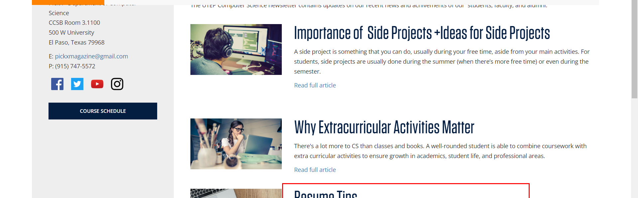

• Broken link on <https://www.utep.edu/cs/pickx/_Files/july_2018_archive.html> on **Main Content** section, the broken link is displayed as: **View all Newsletters** and the link is pointing to : <https://www.utep.edu/entity/open.act?type=page&id=fa19c9f1816c09bf20aa067e4bbcce33&confId=fa19c9f2816c09bf20aa067e9d07619d>

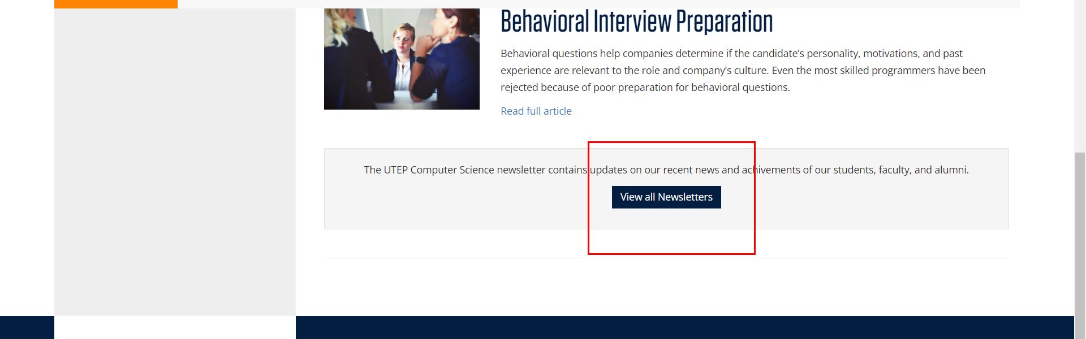

• Broken link on <https://www.utep.edu/cs/pickx/_Files/july_2018_archive.html> on **Main Content** section, the broken link is displayed as: and the link is pointing to : <https://www.utep.edu/computer-science/pickx/July%202018/behavioral_interview_preparation>

