# Broken Links Report

• Broken link on <https://www.utep.edu/cs/support/CS-Software-Center.html> on **Main Content** section, the broken link is displayed as: **Download** and the link is pointing to : <https://www.anaconda.com/distribution/>

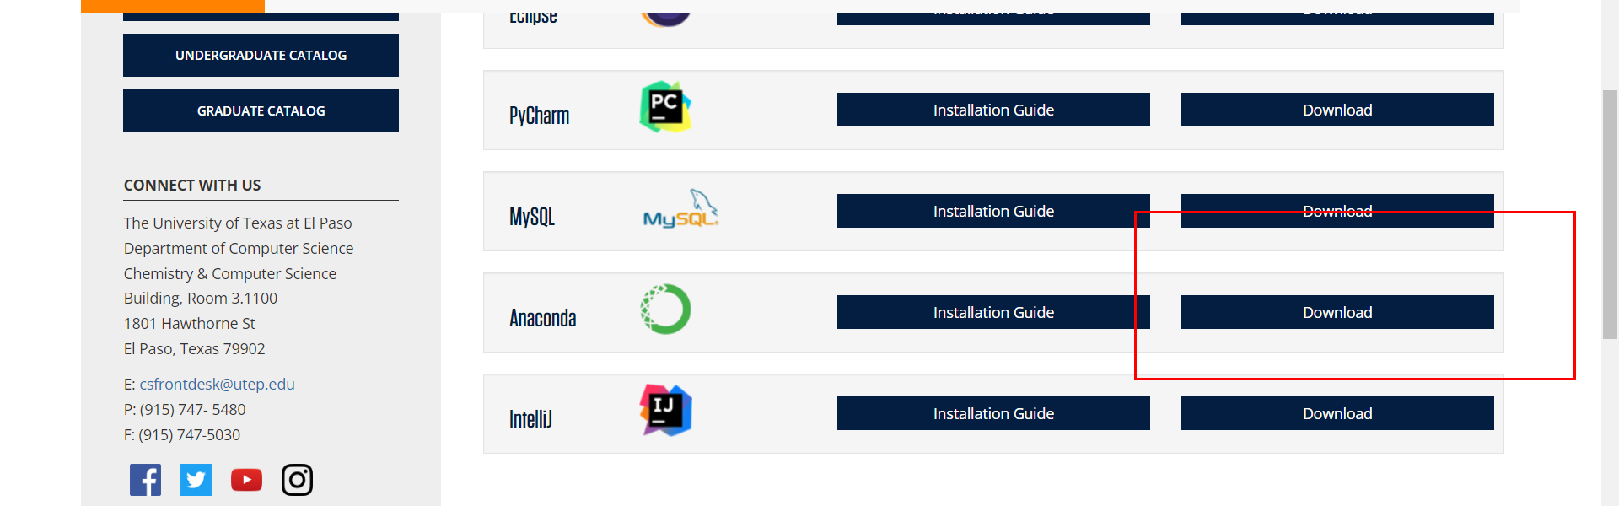

• Broken link on <https://www.utep.edu/cs/support/CS-Software-Center.html> on **Main Content** section, the broken link is displayed as: **Download** and the link is pointing to : <https://www.microsoft.com/en-us/p/ubuntu/9nblggh4msv6?activetab=pivot:overviewtab>

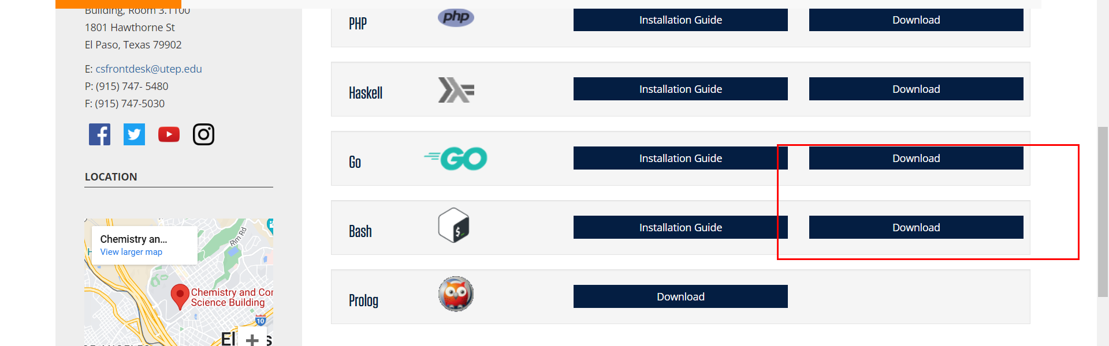

• Broken link on <https://www.utep.edu/cs/support/research.html> on **Main Content** section, the broken link is displayed as: **http://cssrvlab01.utep.edu/classes/cs3360/username/** and the link is pointing to : <http://cssrvlab01.utep.edu/classes/cs3360/username/>

