# Broken Links Report

• Broken link on <https://www.utep.edu/liberalarts/academic-programs/online/index.html> on **Main Content** section, the broken link is displayed as: **Chicano Studies** and the link is pointing to : <http://online.utep.edu/chicano-studies/>

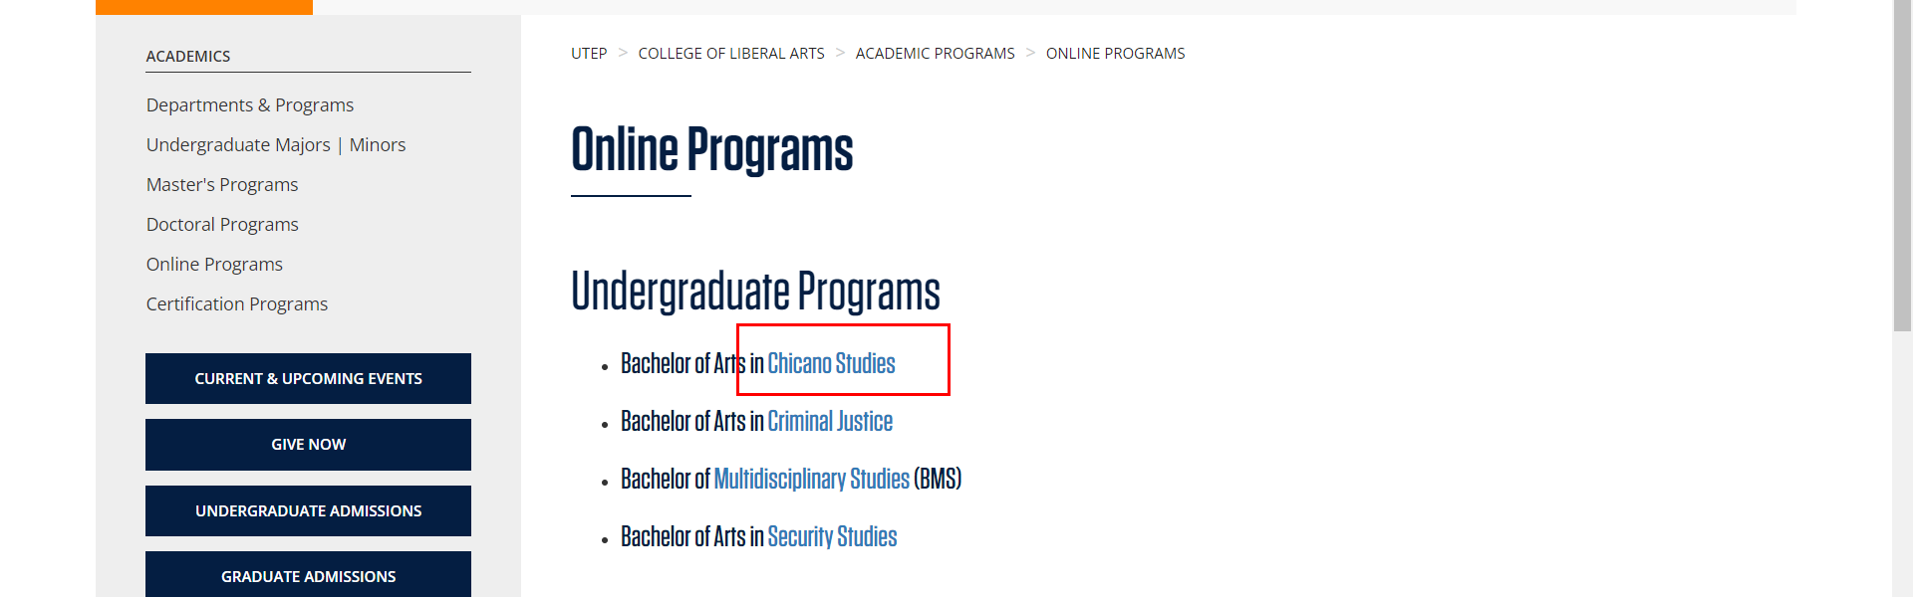

• Broken link on <https://www.utep.edu/liberalarts/academic-programs/online/index.html> on **Main Content** section, the broken link is displayed as: **Security Studies** and the link is pointing to : <http://online.utep.edu/undergraduate-programs/security-studies/>



• Broken link on <https://www.utep.edu/liberalarts/academic-programs/online/index.html> on **Main Content** section, the broken link is displayed as: **Defense and Strategic Studies** and the link is pointing to : <http://online.utep.edu/graduate-programs/defense-strategic-studies/>



• Broken link on <https://www.utep.edu/liberalarts/academic-programs/online/index.html> on **Main Content** section, the broken link is displayed as: **Criminal Justice** and the link is pointing to : <http://online.utep.edu/undergraduate-programs/criminal-justice/>

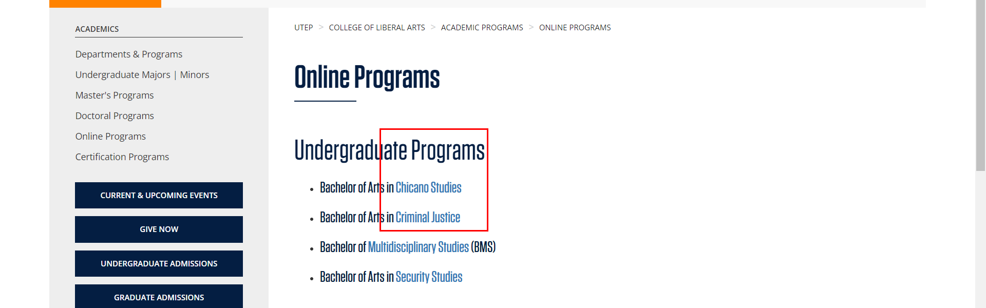

• Broken link on <https://www.utep.edu/liberalarts/academic-programs/online/index.html> on **Main Content** section, the broken link is displayed as: **Technical & Professional Writing** and the link is pointing to : <http://online.utep.edu/graduate-programs/certificate-in-technical-professional-writing/>

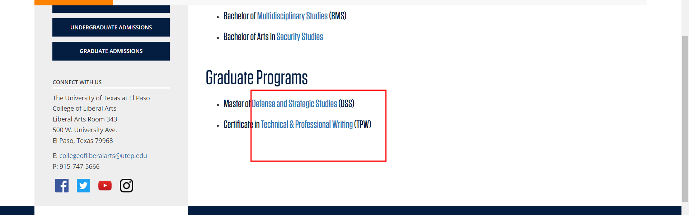

• Broken link on <https://www.utep.edu/liberalarts/academic-programs/online/index.html> on **Main Content** section, the broken link is displayed as: **Multidisciplinary Studies** and the link is pointing to : <http://online.utep.edu/undergraduate-programs/multidisciplinary-studies/>

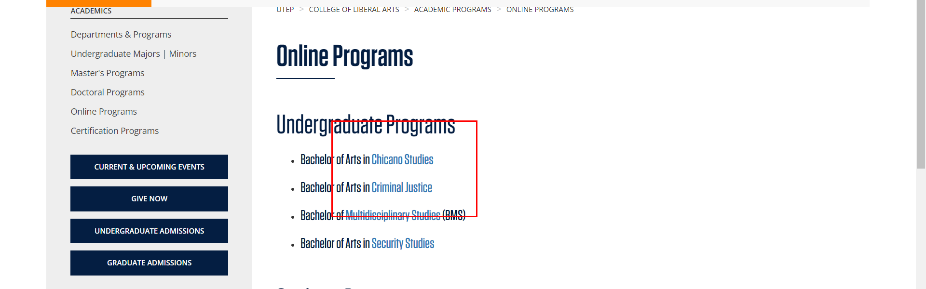

• Broken link on <https://www.utep.edu/liberalarts/academic-programs/undergraduate/index.html> on **Main Content** section, the broken link is displayed as: **Online** and the link is pointing to : <https://www.utep.edu/extendeduniversity/utepconnect/online-programs/bachelor-programs/bachelors-of-arts-in-media-advertising.html>



• Broken link on <https://www.utep.edu/liberalarts/academic-programs/undergraduate/index.html> on **Main Content** section, the broken link is displayed as: **Online** and the link is pointing to : <https://www.utep.edu/extendeduniversity/utepconnect/online-programs/bachelor-programs/online-bachelor-of-arts-in-chicano-studies.html>

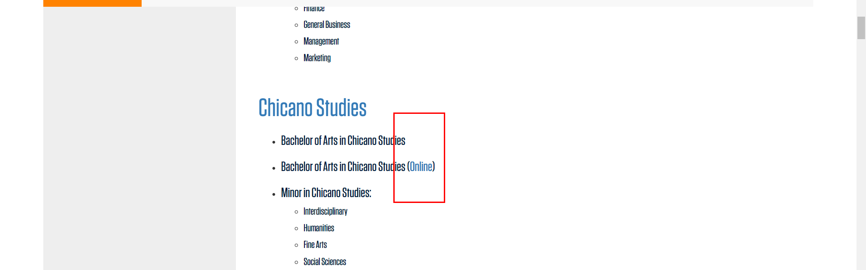

• Broken link on <https://www.utep.edu/liberalarts/academic-programs/undergraduate/index.html> on **Main Content** section, the broken link is displayed as: **Online** and the link is pointing to : <https://www.utep.edu/extendeduniversity/utepconnect/online-programs/bachelor-programs/bachelors-of-arts-in-criminal-justice.html>

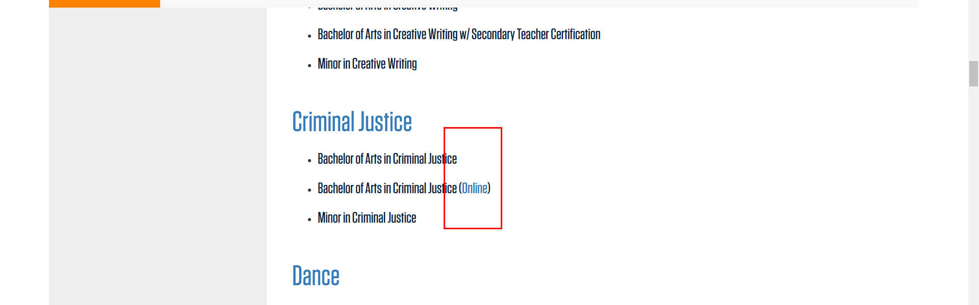

• Broken link on <https://www.utep.edu/liberalarts/academic-programs/undergraduate/index.html> on **Main Content** section, the broken link is displayed as: **Bachelor of Arts in Organizational and Corporate Communication** and the link is pointing to : <https://www.utep.edu/extendeduniversity/utepconnect/online-programs/bachelor-programs/bachelors-of-arts-in-organizational-and-corporate-communication.html>

