# Broken Links Report

• Broken link on <https://www.utep.edu/liberalarts/african-american-studies/news/archived/an-evening-with-prof-yearby.html> on **Main Content (Top small navigation)** section, the broken link is displayed as: **archived** and the link is pointing to : <https://www.utep.edu/liberalarts/african-american-studies/news/archived/>

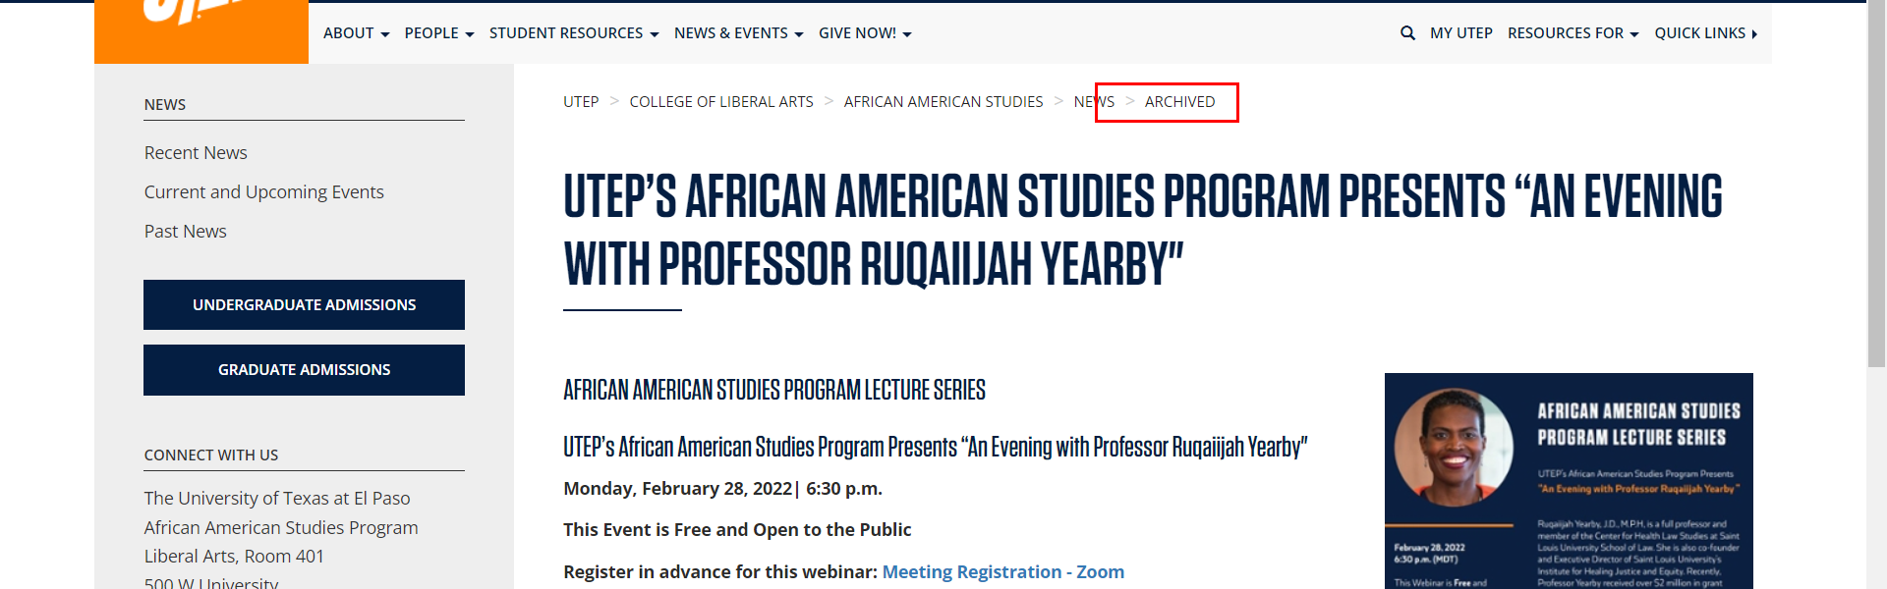

• Broken link on <https://www.utep.edu/liberalarts/african-american-studies/news/archived/an-evening-with-prof-yearby.html> on **Main Content** section, the broken link is displayed as: **Meeting Registration - Zoom** and the link is pointing to : <https://utep-edu.zoom.us/meeting/register/tZUuduyhrTorE9ZOpK54Mhlimrh31-05EvEw>

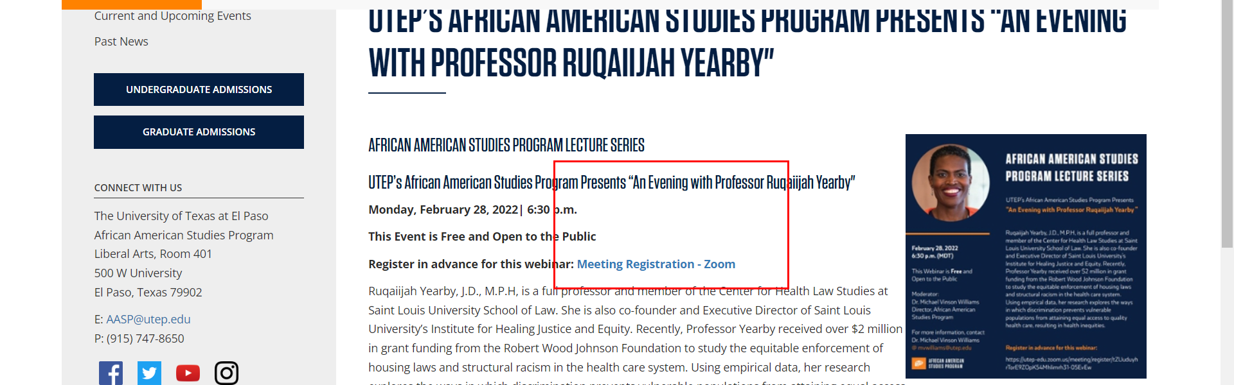

• Broken link on <https://www.utep.edu/liberalarts/african-american-studies/people/faculty-and-staff.html> on **Main Content (Top small navigation)** section, the broken link is displayed as: **People** and the link is pointing to : <https://www.utep.edu/liberalarts/african-american-studies/people/>

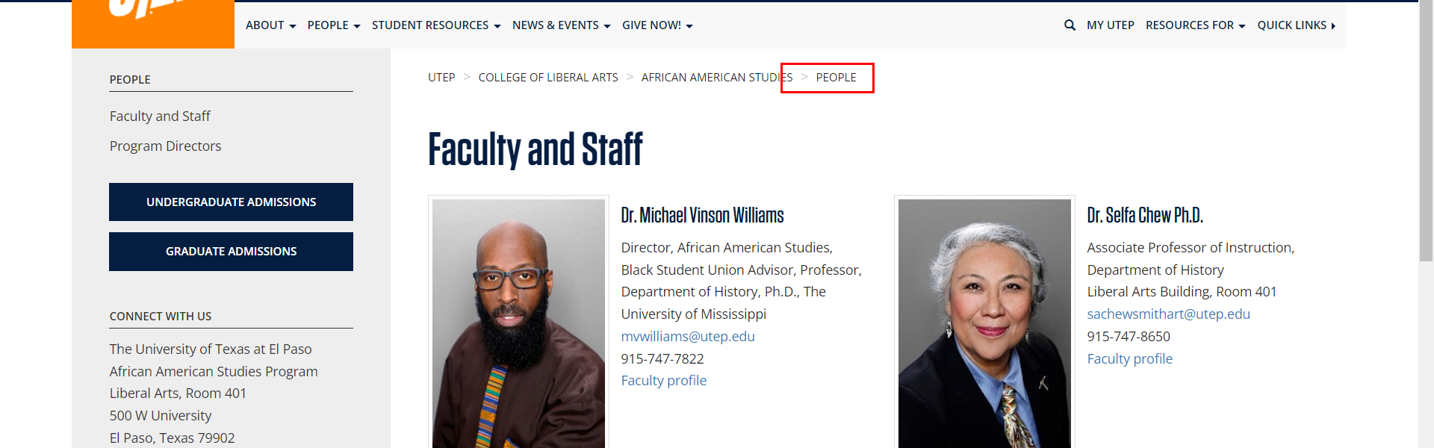

• Broken link on <https://www.utep.edu/liberalarts/african-american-studies/people/program-directors.html> on **Main Content (Top small navigation)** section, the broken link is displayed as: **People** and the link is pointing to : <https://www.utep.edu/liberalarts/african-american-studies/people/>

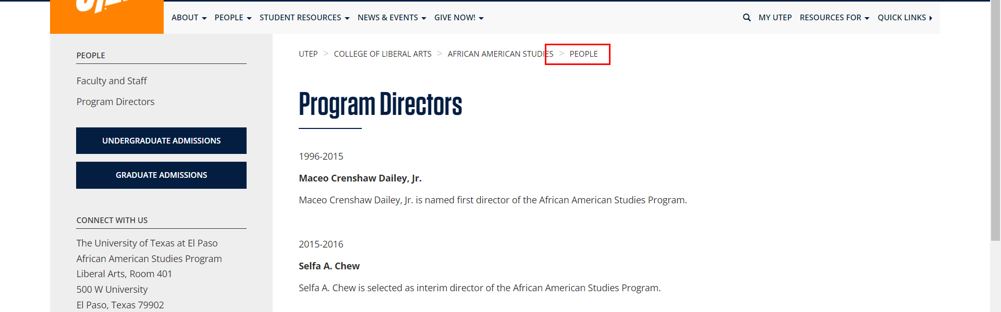

• Broken link on <https://www.utep.edu/liberalarts/african-american-studies/student-resources/index.html> on **Main Content** section, the broken link is displayed as: **Actuarial Diversity Scholarship** and the link is pointing to : <http://www.actuarialfoundation.org/programs/actuarial/act-diversity.shtml>

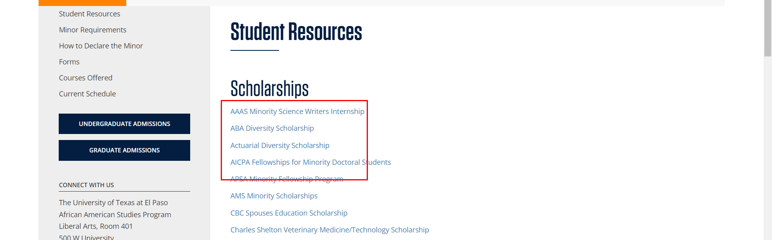

• Broken link on <https://www.utep.edu/liberalarts/african-american-studies/student-resources/index.html> on **Main Content** section, the broken link is displayed as: **George A. Strait Minority Scholarships** and the link is pointing to : <https://www.aallnet.org/mm/Member-Resources/scholarships/George-A-Strait-Minority-Scholarship>

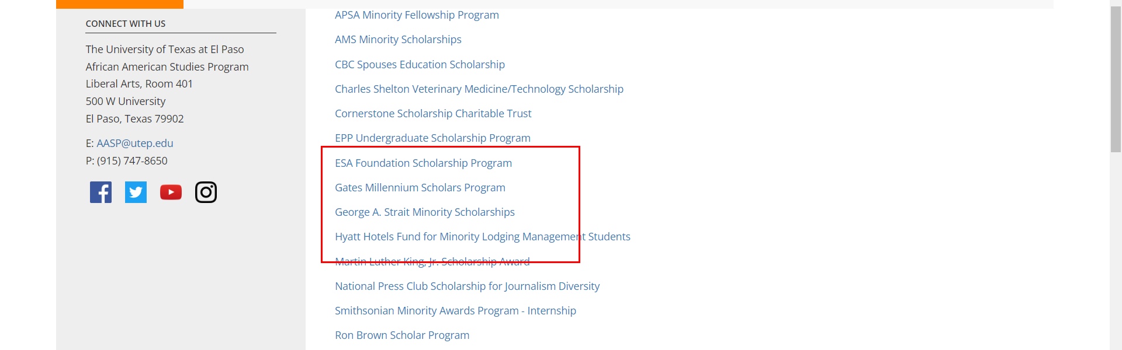

• Broken link on <https://www.utep.edu/liberalarts/african-american-studies/student-resources/index.html> on **Main Content** section, the broken link is displayed as: **Hyatt Hotels Fund for Minority Lodging Management Students** and the link is pointing to : [https://www.ahlef.org/Scholarships/Academic/AH_LEF_Self-Nominated_Scholarships/#scholarHyatt](https://www.ahlafoundation.org/Scholarships/Academic/AH_LEF_Self-Nominated_Scholarships/#scholarHyatt)

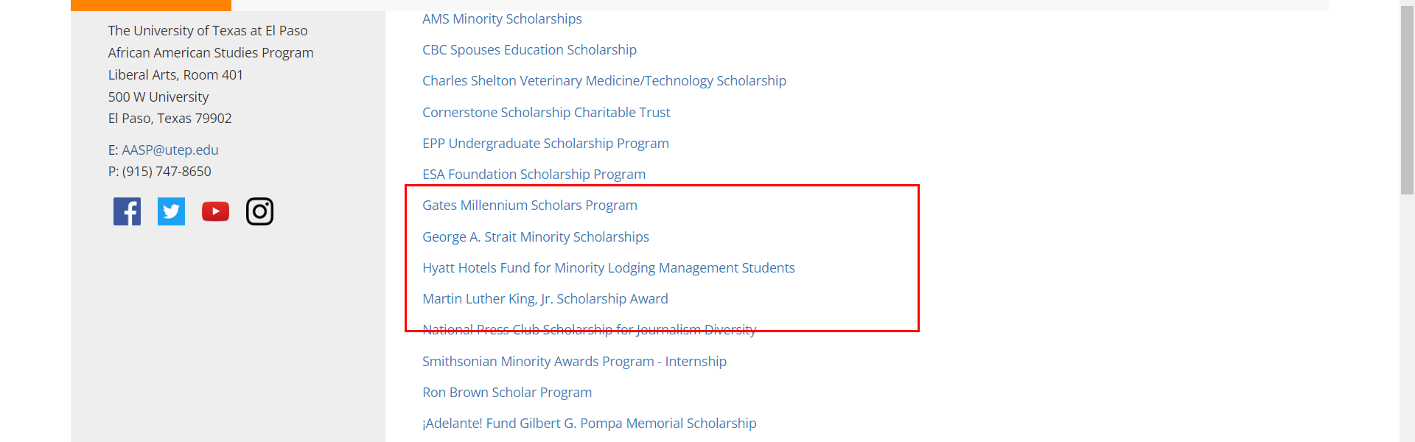

• Broken link on <https://www.utep.edu/liberalarts/african-american-studies/student-resources/index.html> on **Main Content** section, the broken link is displayed as: and the link is pointing to : <https://www.surveymonkey.com/r/C1TX>

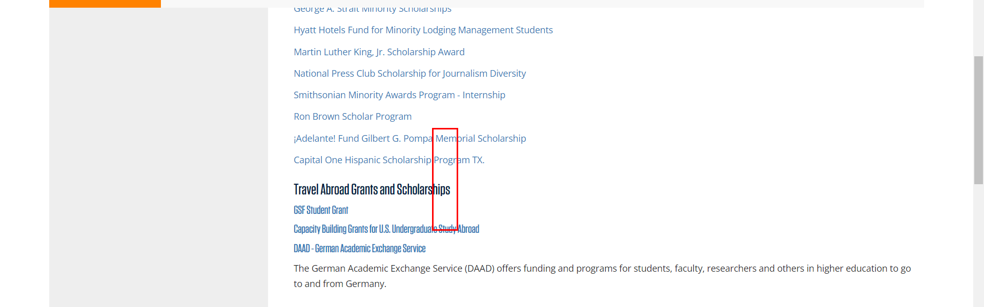

• Broken link on <https://www.utep.edu/liberalarts/african-american-studies/student-resources/index.html> on **Main Content** section, the broken link is displayed as: and the link is pointing to : <https://www.utep.edu/http://oascentral.educationdynamics.com/RealMedia/ads/click_lx.ads/studyabroad/marketplace/financial-aid/L37/626571809/x82/EDynamic/SA-Boren-1001544-TXT-FinancialAidListing-121216/SA-Boren-1001544-TXT-FinancialAidListing-121215.html/6d4c63502f3162734d786b414354727a?http://www.borenawards.org/>

