# Broken Links Report

• Broken link on <https://www.utep.edu/liberalarts/asian-studies/index.html> on **Main Navigation, tab name: Resources** section, the broken link is displayed as: **Lecture Series** and the link is pointing to : [http://ieas.berkeley.edu/publications/aparvlectures.html](https://ieas.berkeley.edu/publications/aparvlectures.html)

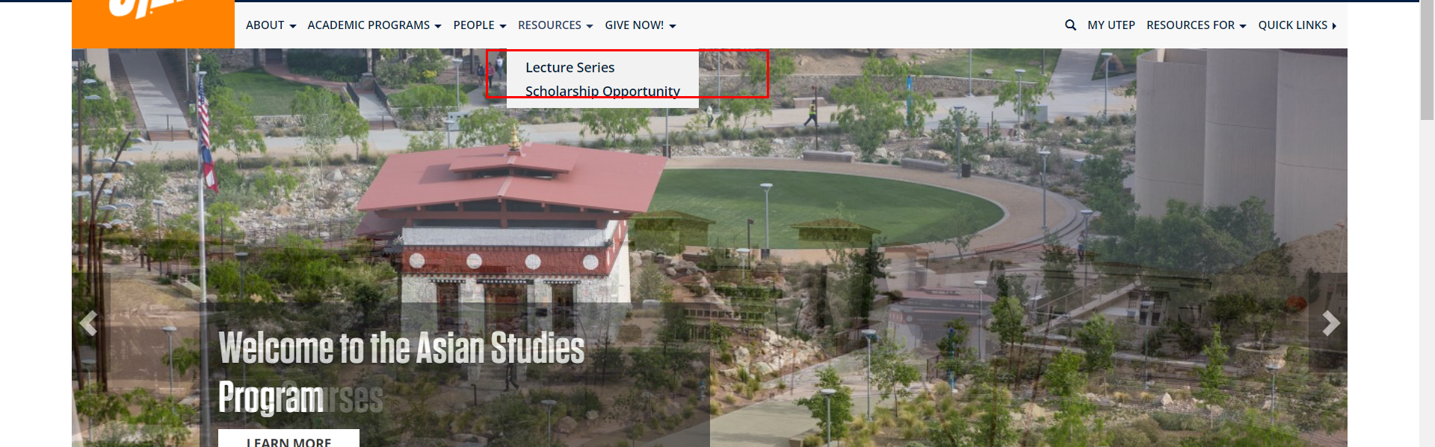

• Broken link on <https://www.utep.edu/liberalarts/asian-studies/about/contact-us.html> on **Main Navigation, tab name: Resources** section, the broken link is displayed as: **Lecture Series** and the link is pointing to : [http://ieas.berkeley.edu/publications/aparvlectures.html](https://ieas.berkeley.edu/publications/aparvlectures.html)

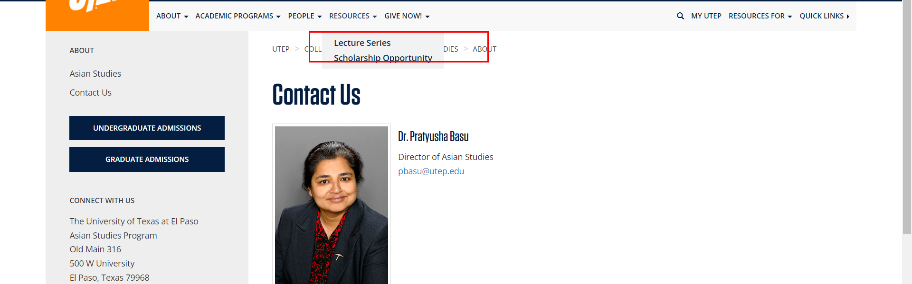

• Broken link on <https://www.utep.edu/liberalarts/asian-studies/about/index.html> on **Main Navigation, tab name: Resources** section, the broken link is displayed as: **Lecture Series** and the link is pointing to : [http://ieas.berkeley.edu/publications/aparvlectures.html](https://ieas.berkeley.edu/publications/aparvlectures.html)

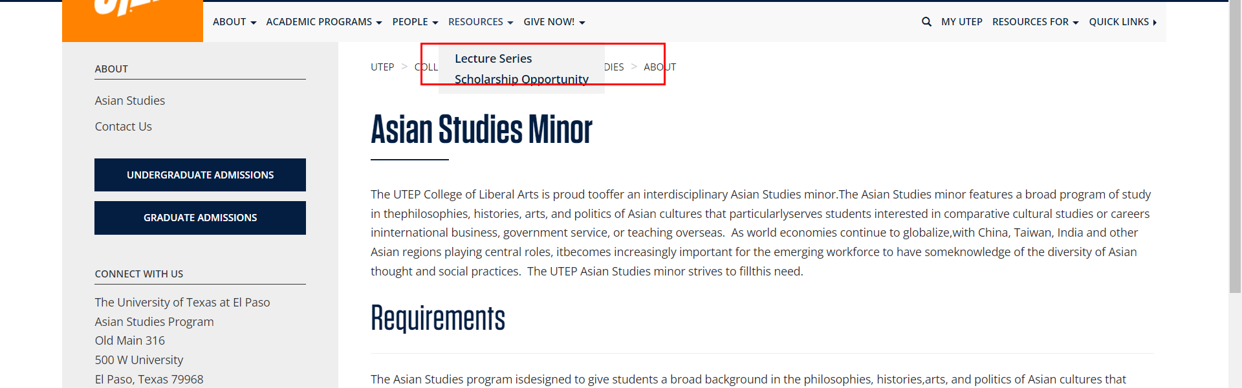

• Broken link on <https://www.utep.edu/liberalarts/asian-studies/academic-programs/courses.html> on **Main Navigation, tab name: Resources** section, the broken link is displayed as: **Lecture Series** and the link is pointing to : [http://ieas.berkeley.edu/publications/aparvlectures.html](https://ieas.berkeley.edu/publications/aparvlectures.html)

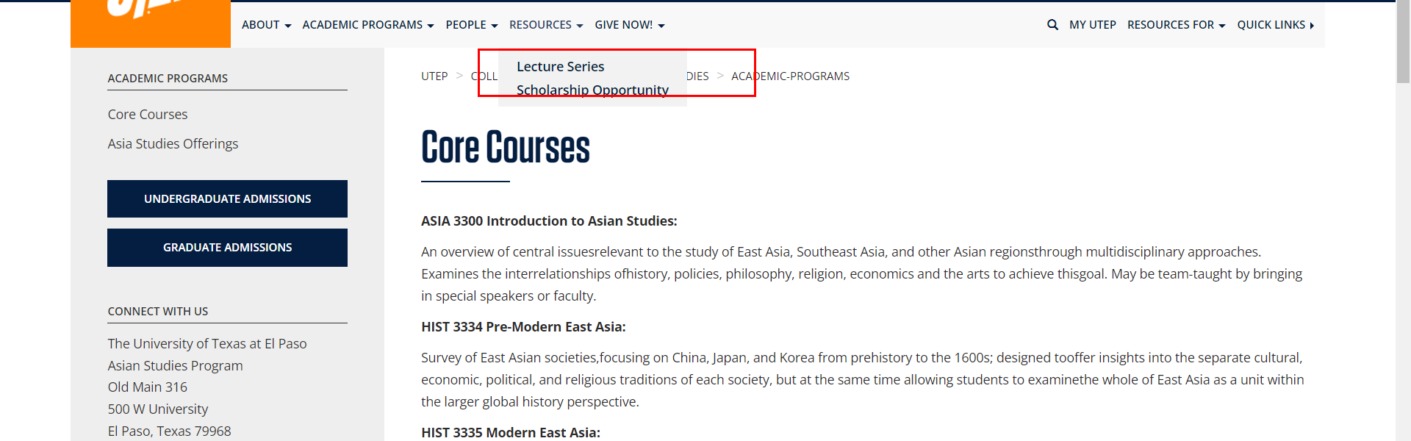

• Broken link on <https://www.utep.edu/liberalarts/asian-studies/academic-programs/index.html> on **Main Navigation, tab name: Resources** section, the broken link is displayed as: **Lecture Series** and the link is pointing to : [http://ieas.berkeley.edu/publications/aparvlectures.html](https://ieas.berkeley.edu/publications/aparvlectures.html)

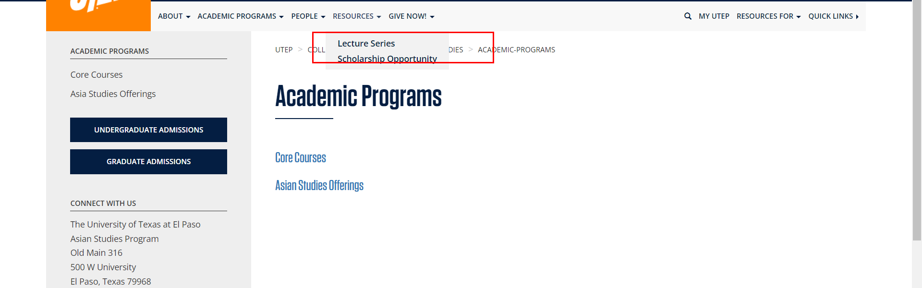

• Broken link on <https://www.utep.edu/liberalarts/asian-studies/academic-programs/offerings.html> on **Main Navigation, tab name: Resources** section, the broken link is displayed as: **Lecture Series** and the link is pointing to : [http://ieas.berkeley.edu/publications/aparvlectures.html](https://ieas.berkeley.edu/publications/aparvlectures.html)

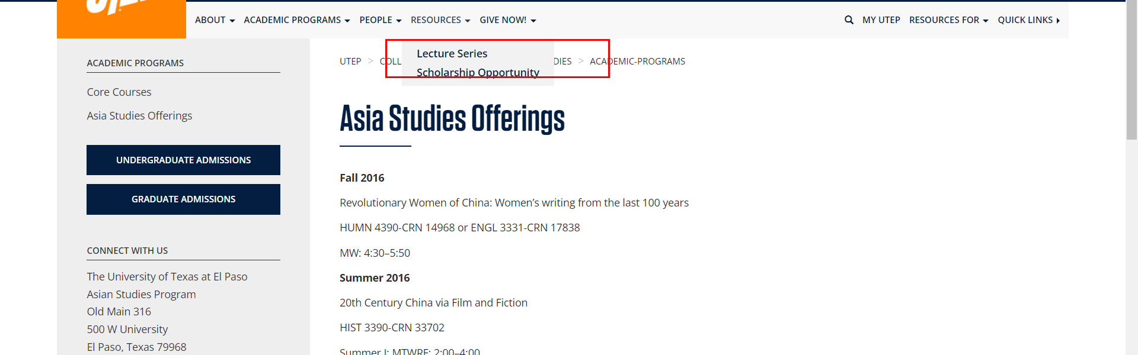

• Broken link on <https://www.utep.edu/liberalarts/asian-studies/people/affiliated-faculty.html> on **Main Navigation, tab name: Resources** section, the broken link is displayed as: **Lecture Series** and the link is pointing to : [http://ieas.berkeley.edu/publications/aparvlectures.html](https://ieas.berkeley.edu/publications/aparvlectures.html)

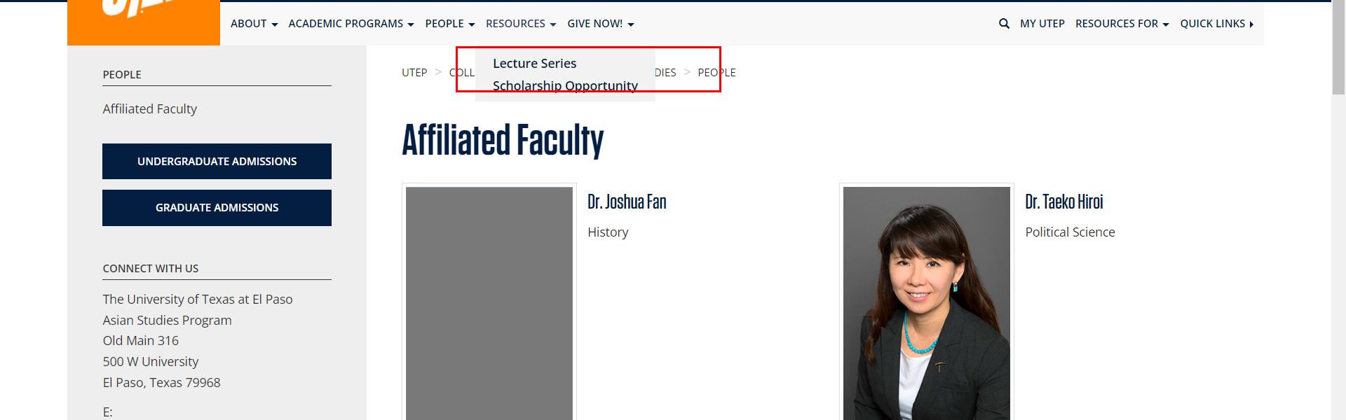

• Broken link on <https://www.utep.edu/liberalarts/asian-studies/people/index.html> on **Main Navigation, tab name: Resources** section, the broken link is displayed as: **Lecture Series** and the link is pointing to : [http://ieas.berkeley.edu/publications/aparvlectures.html](https://ieas.berkeley.edu/publications/aparvlectures.html)

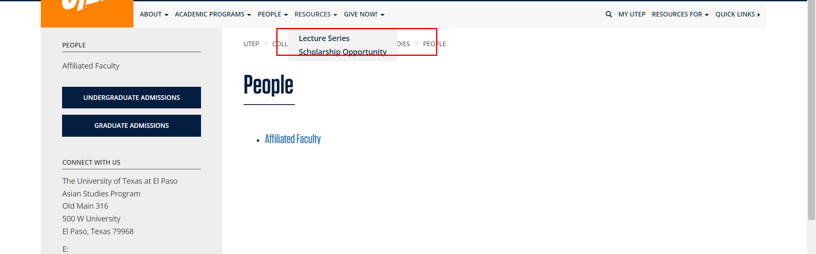

• Broken link on <https://www.utep.edu/liberalarts/asian-studies/student-resources/scholarship-opportunity.html> on **Main Navigation, tab name: Resources** section, the broken link is displayed as: **Lecture Series** and the link is pointing to : [http://ieas.berkeley.edu/publications/aparvlectures.html](https://ieas.berkeley.edu/publications/aparvlectures.html)

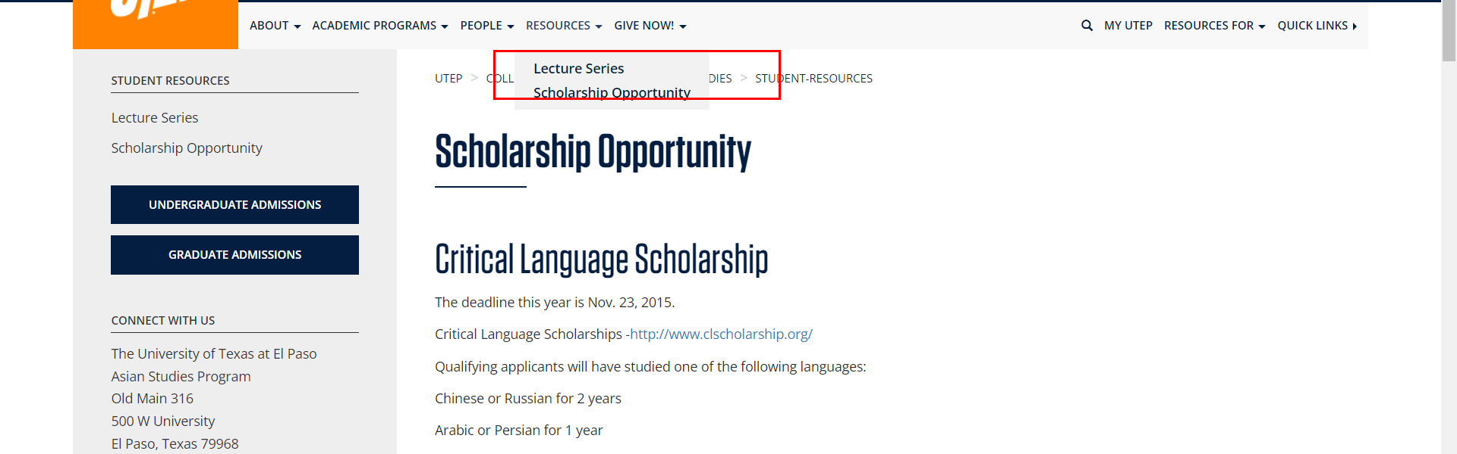

• Broken link on <https://www.utep.edu/liberalarts/asian-studies/student-resources/scholarship-opportunity.html> on **Main Content (Top small navigation)** section, the broken link is displayed as: **student-resources** and the link is pointing to : <https://www.utep.edu/liberalarts/asian-studies/student-resources/>

