# Broken Links Report

• Broken link on <https://www.utep.edu/liberalarts/bms/about/vision-mission.html> on **Main Content (Top small navigation)** section, the broken link is displayed as: **About** and the link is pointing to : <https://www.utep.edu/liberalarts/bms/about/>

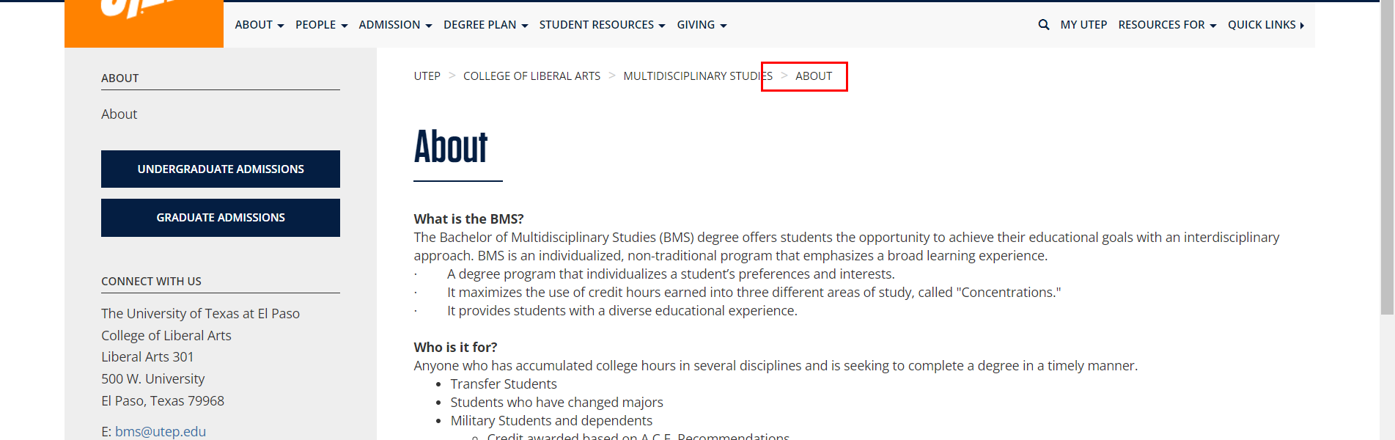

• Broken link on <https://www.utep.edu/liberalarts/bms/admission/index.html> on **Main Content** section, the broken link is displayed as: **apply for admission** and the link is pointing to : <https://www.utep.edu/extendeduniversity/utepconnect/future-miners/index.html>

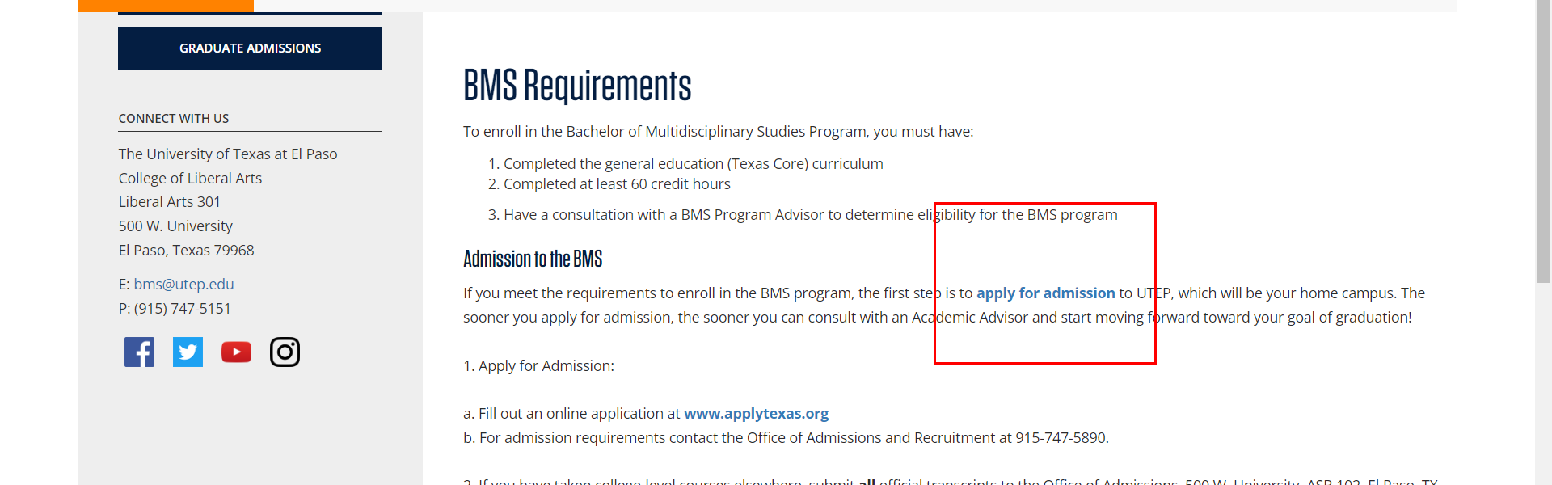

• Broken link on <https://www.utep.edu/liberalarts/bms/student-resources/links.html> on **Main Content** section, the broken link is displayed as: **Tuition and Fee Information** and the link is pointing to : <https://www.utep.edu/extendeduniversity/utepconnect/financials/tuition-and-fees/index.html>

