# Broken Links Report

• Broken link on <https://www.utep.edu/liberalarts/borderland-chopin-festival/index.html> on **Main Navigation, tab name: Piano Competition** section, the broken link is displayed as: **About** and the link is pointing to : <https://www.utep.edu/liberalarts/borderland-chopin-festival/about/about.html>

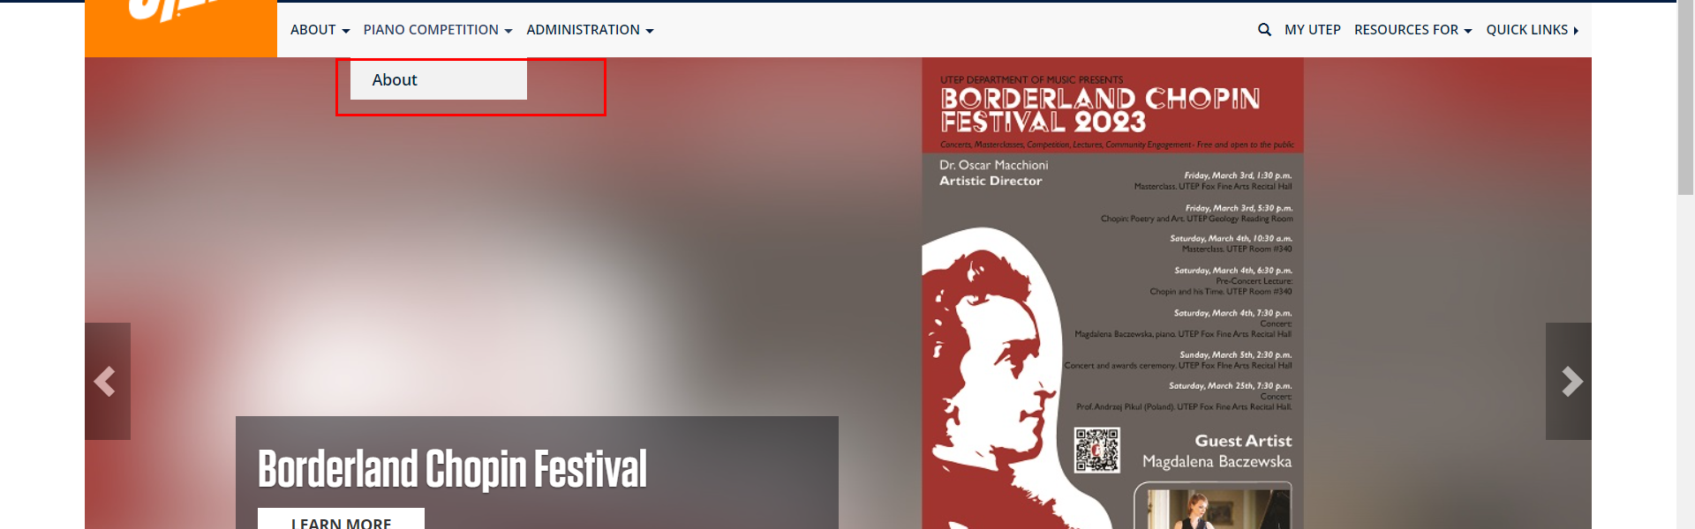

• Broken link on <https://www.utep.edu/liberalarts/borderland-chopin-festival/people/people-template.html> on **Main Navigation, tab name: Piano Competition** section, the broken link is displayed as: **About** and the link is pointing to : <https://www.utep.edu/liberalarts/borderland-chopin-festival/about/about.html>

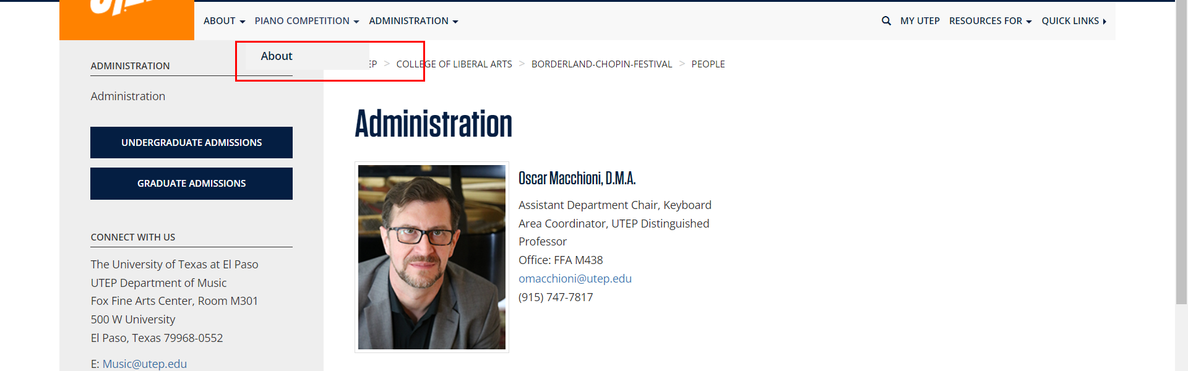

• Broken link on <https://www.utep.edu/liberalarts/borderland-chopin-festival/people/people-template.html> on **Main Content (Top small navigation)** section, the broken link is displayed as: **People** and the link is pointing to : <https://www.utep.edu/liberalarts/borderland-chopin-festival/people/>

