# Broken Links Report

• Broken link on <https://www.utep.edu/liberalarts/cae/news/items/2020-01-08-utep-interns-to-take-note-at-chamber-music-festival.html> on **Main Content (Top small navigation)** section, the broken link is displayed as: **items** and the link is pointing to : <https://www.utep.edu/liberalarts/cae/news/items/>

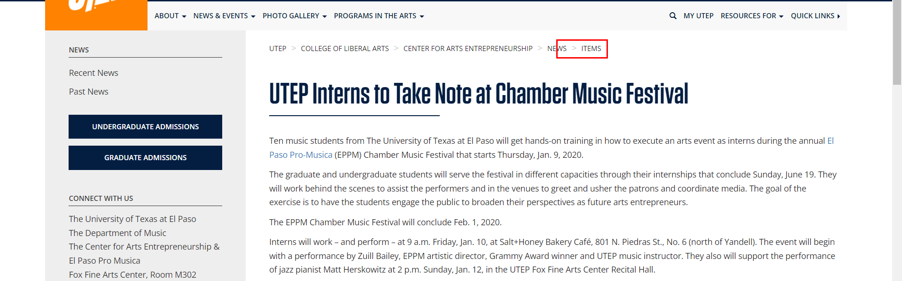

• Broken link on <https://www.utep.edu/liberalarts/cae/people/leadership.html> on **Main Content (Top small navigation)** section, the broken link is displayed as: **People** and the link is pointing to : <https://www.utep.edu/liberalarts/cae/people/>

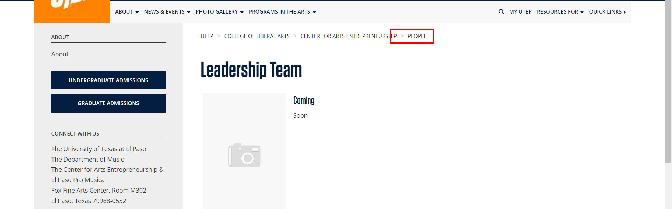

• Broken link on <https://www.utep.edu/liberalarts/cae/photo-gallery/photo-gallery.html> on **Main Content (Top small navigation)** section, the broken link is displayed as: **photo-gallery** and the link is pointing to : <https://www.utep.edu/liberalarts/cae/photo-gallery/>

