# Broken Links Report

• Broken link on <https://www.utep.edu/liberalarts/cel-program/about/about-cel.html> on **Main Content (Top small navigation)** section, the broken link is displayed as: **About** and the link is pointing to : <https://www.utep.edu/liberalarts/cel-program/about/>

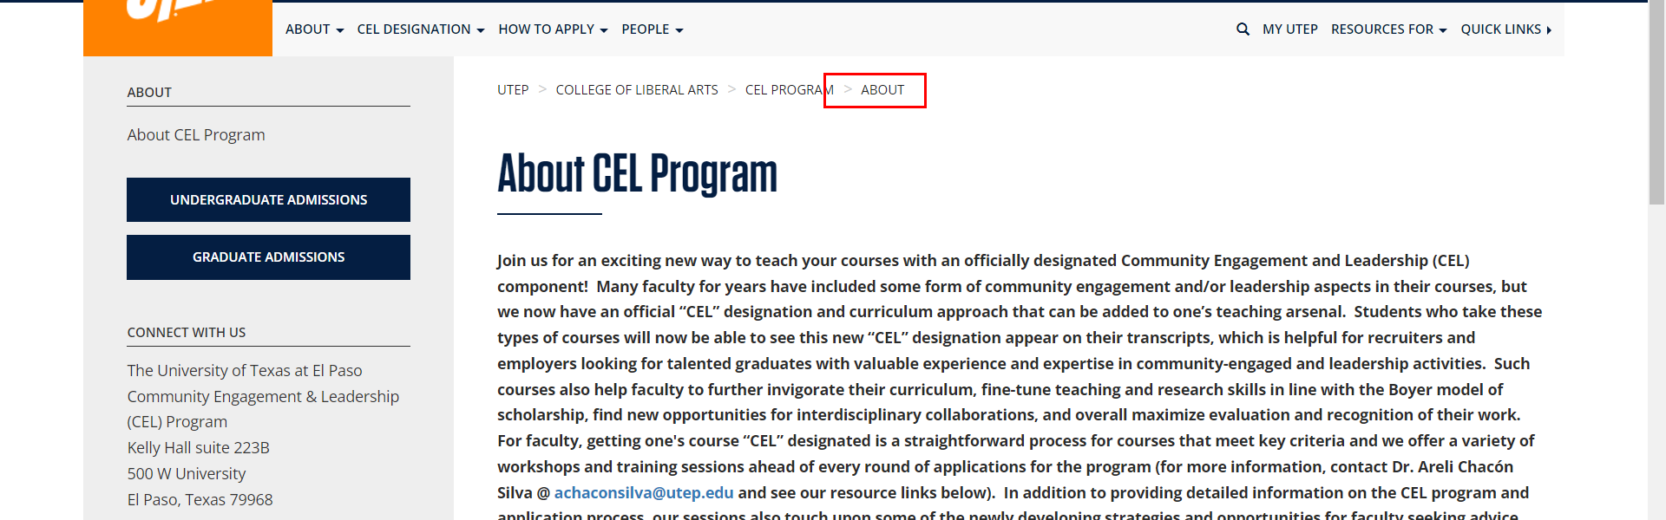

• Broken link on <https://www.utep.edu/liberalarts/cel-program/about/flexible-content-template.html> on **Main Content (Top small navigation)** section, the broken link is displayed as: **About** and the link is pointing to : <https://www.utep.edu/liberalarts/cel-program/about/>

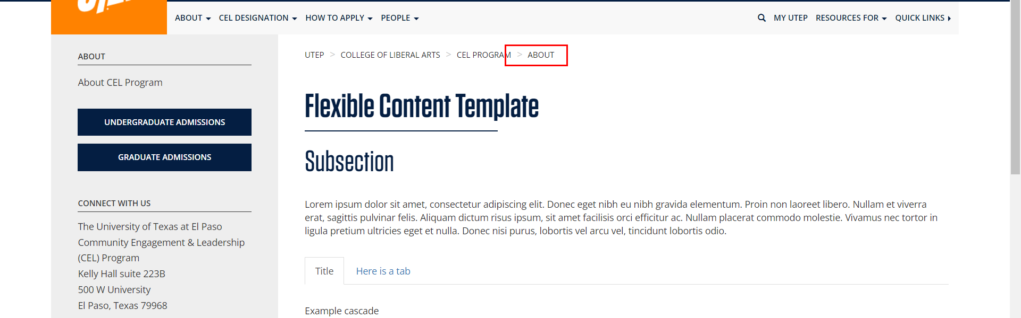

• Broken link on <https://www.utep.edu/liberalarts/cel-program/about/Full-Width.html> on **Main Content (Top small navigation)** section, the broken link is displayed as: **About** and the link is pointing to : <https://www.utep.edu/liberalarts/cel-program/about/>

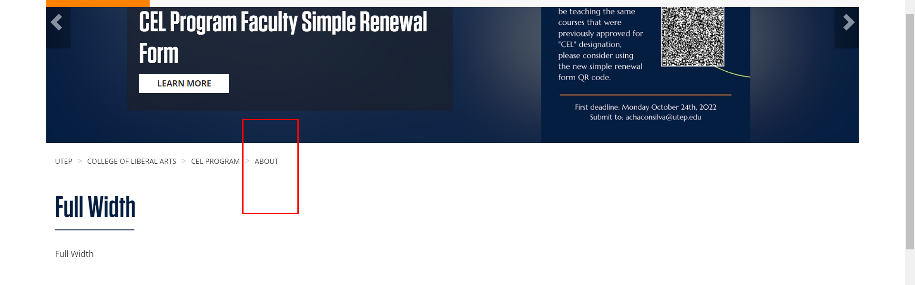

• Broken link on <https://www.utep.edu/liberalarts/cel-program/how-to-apply/modules-and-tools-for-support-in-developing-cel-curriculum.html> on **Main Content** section, the broken link is displayed as: **Video Link** and the link is pointing to : <https://drive.google.com/file/d/15fRm-7wzuqbmKwUlkz92A23IkVLEFB_p/view?ts=60648d2b>

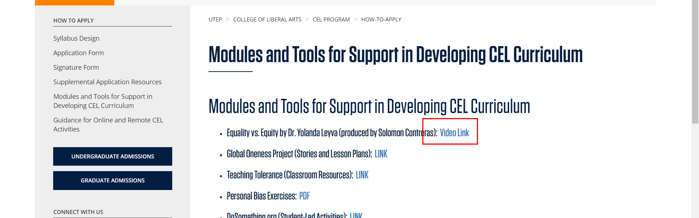

• Broken link on <https://www.utep.edu/liberalarts/cel-program/how-to-apply/supplemental-application-resources.html> on **General content** section, the broken link is displayed as: **None** and the link is pointing to : [https://www.utep.edu/liberalarts/political-science/people/professors/Virtual Coffee Feb 24 Flyer.pdf](https://www.utep.edu/liberalarts/political-science/people/professors/Virtual%20Coffee%20Feb%2024%20Flyer.pdf)

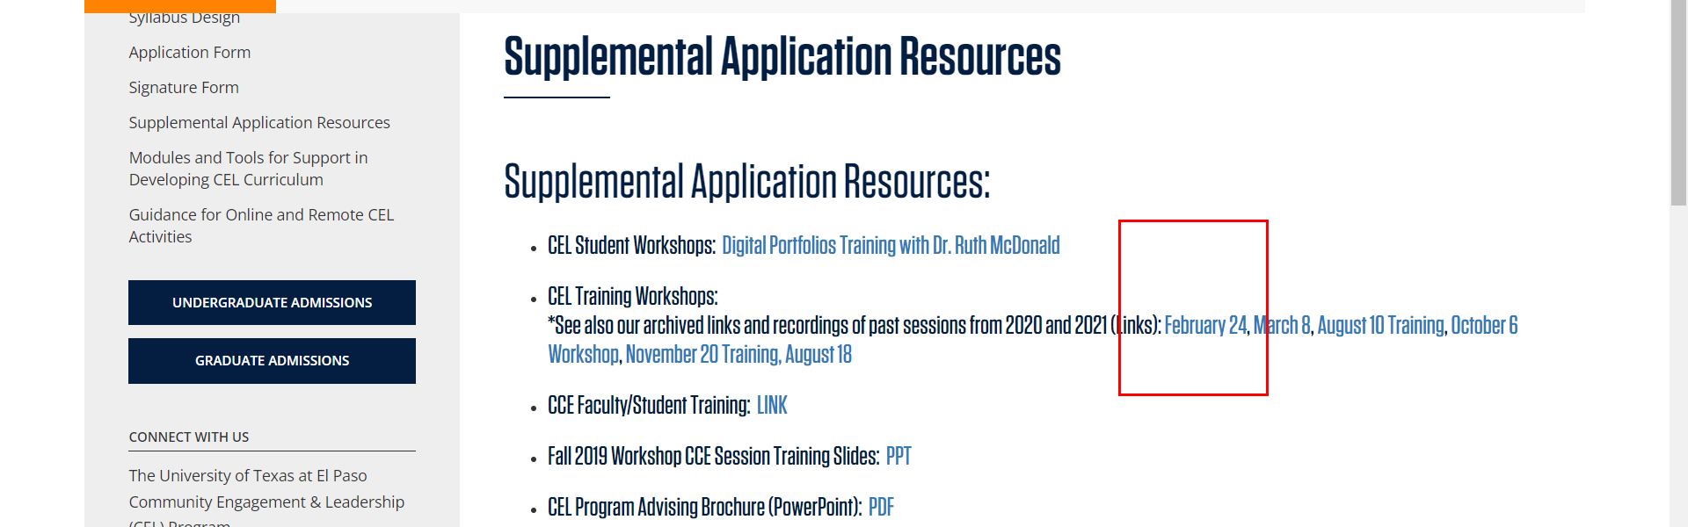

• Broken link on <https://www.utep.edu/liberalarts/cel-program/people/cel-task-force-review-committee.html> on **Main Content (Top small navigation)** section, the broken link is displayed as: **People** and the link is pointing to : <https://www.utep.edu/liberalarts/cel-program/people/>

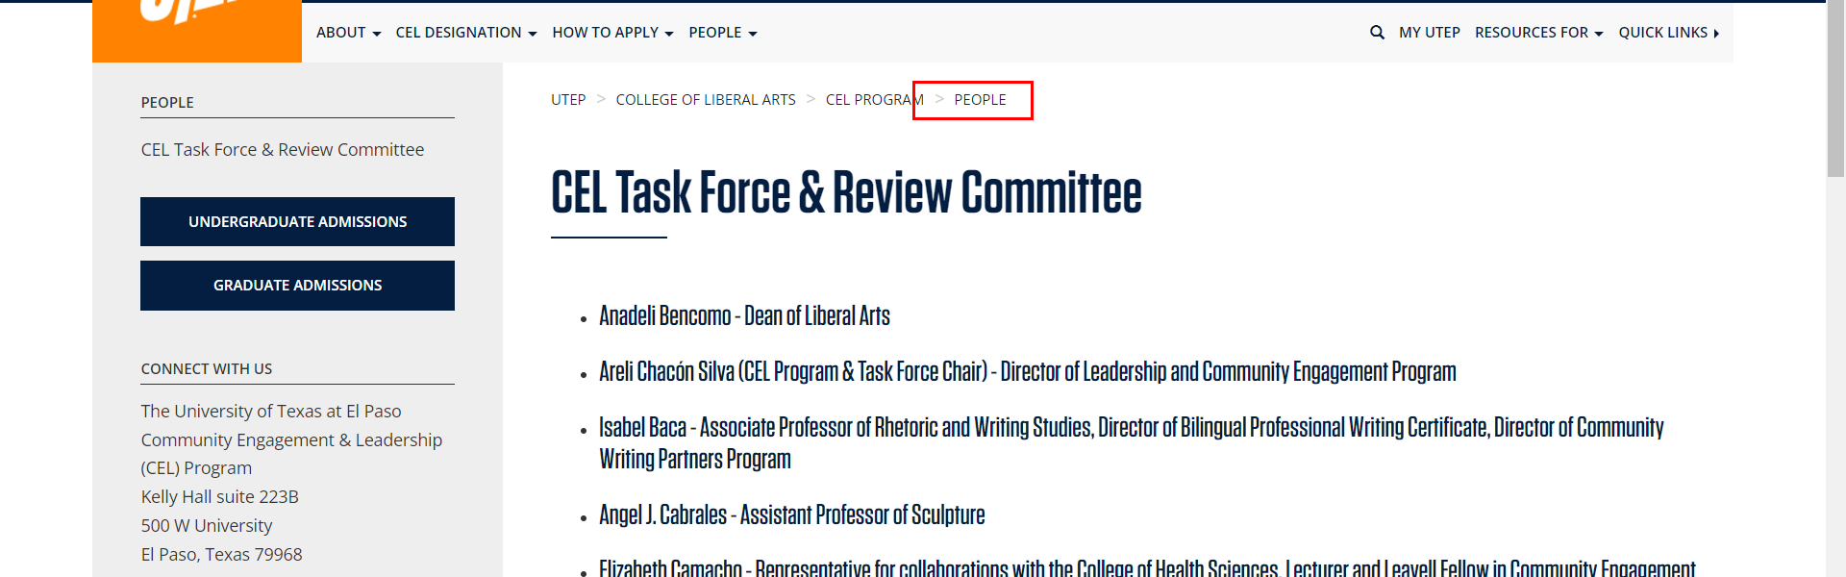

• Broken link on <https://www.utep.edu/liberalarts/cel-program/people/people-template.html> on **Main Content (Top small navigation)** section, the broken link is displayed as: **People** and the link is pointing to : <https://www.utep.edu/liberalarts/cel-program/people/>

