# Broken Links Report

• On <https://www.utep.edu/engineering/student-resources/student-resources.html> **there is a broken link on section 'Main Navigation: Dropdown name: Research', the broken link is called 'Research Centers and Facilities' and the link is 'https://www.utep.edu/engineering/research/research-centers.html'.**

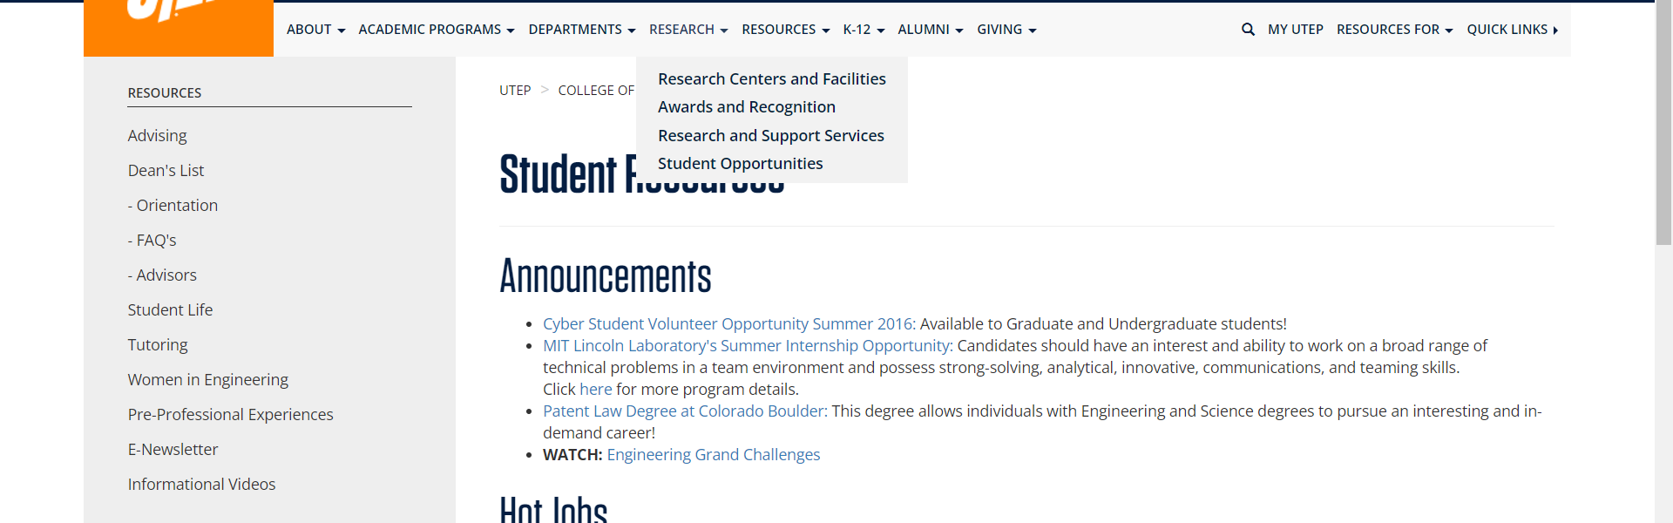

• On <https://www.utep.edu/engineering/student-resources/student-resources.html> **there is a broken link on section 'Main Navigation: Dropdown name: Resources', the broken link is called 'Advising' and the link is 'https://www.utep.edu/engineering/student-resources/student-resources-advising.html'.**

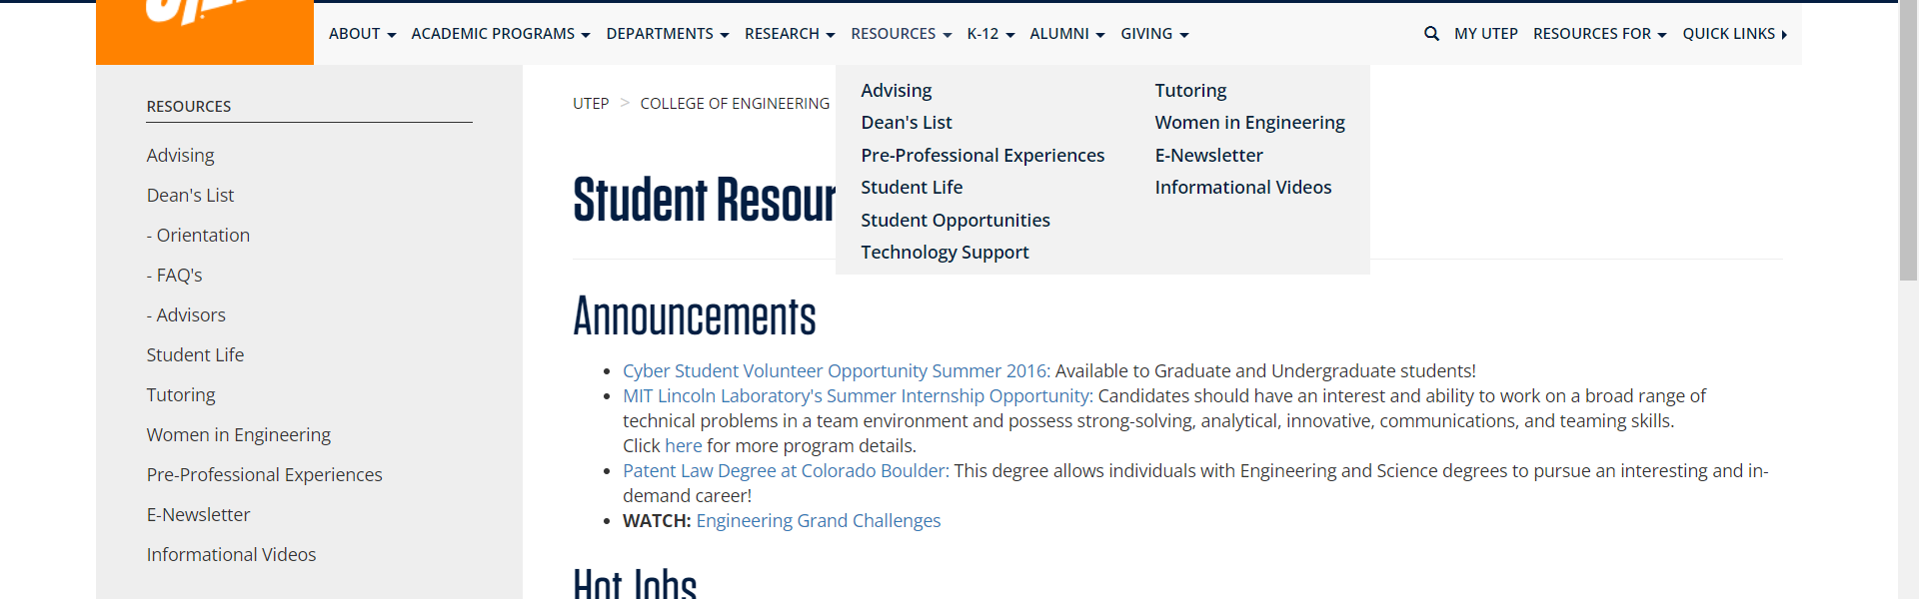

• On <https://www.utep.edu/engineering/student-resources/student-resources.html> **there is a broken link on section 'Main Navigation: Dropdown name: K-12', the broken link is called 'K12 Outreach' and the link is 'https://www.utep.edu/engineering/academic-programs/k12-outreach/k12-outreach.html'.**

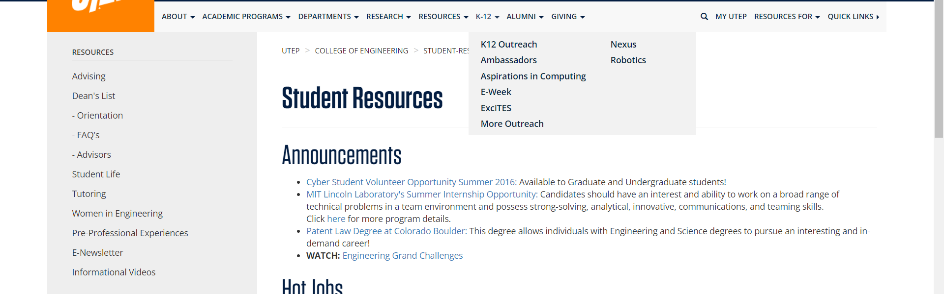

• On <https://www.utep.edu/engineering/student-resources/student-resources.html> **there is a broken link on section 'Main Navigation: Dropdown name: K-12', the broken link is called 'E-Week' and the link is 'https://www.utep.edu/engineering/academic-programs/k12-outreach/e-week.html'.**

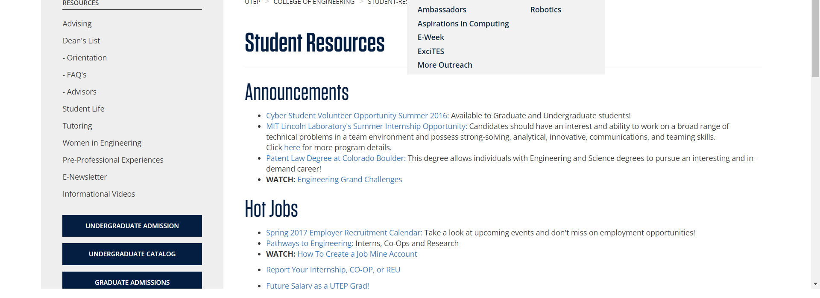

• On <https://www.utep.edu/engineering/student-resources/student-resources.html> **there is a broken link on section 'Main Navigation: Dropdown name: K-12', the broken link is called 'Nexus' and the link is 'https://www.utep.edu/engineering/academic-programs/k12-outreach/nexus.html'.**



• On <https://www.utep.edu/engineering/student-resources/student-resources.html> **there is a broken link on section 'Main Navigation: Dropdown name: Alumni', the broken link is called 'Membership Levels' and the link is 'https://www.utep.edu/engineering/alumni/membership-levels.html'.**

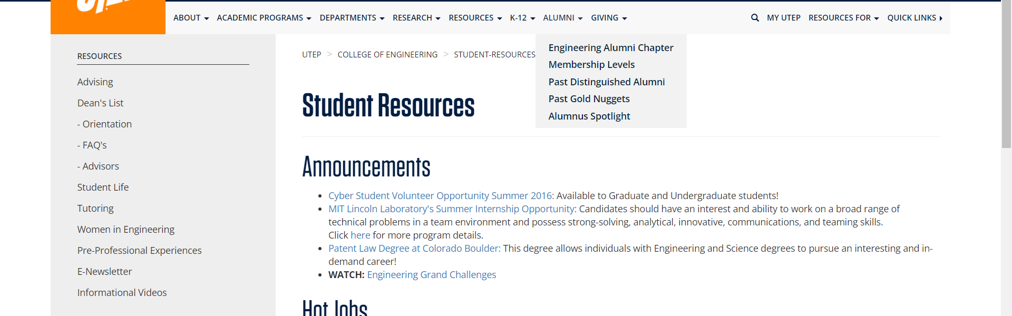

• On <https://www.utep.edu/engineering/student-resources/student-resources.html> **there is a broken link on section 'Main Navigation: Dropdown name: K-12', the broken link is called 'Ambassadors' and the link is 'https://www.utep.edu/engineering/academic-programs/k12-outreach/ambassadors.html'.**



• On <https://www.utep.edu/engineering/student-resources/student-resources.html> **there is a broken link on section 'Main Navigation: Dropdown name: K-12', the broken link is called 'ExciTES' and the link is 'https://www.utep.edu/engineering/academic-programs/k12-outreach/excites.html'.**



• On <https://www.utep.edu/engineering/student-resources/student-resources.html> **there is a broken link on section 'Main Navigation: Dropdown name: K-12', the broken link is called 'Aspirations in Computing' and the link is 'https://www.utep.edu/engineering/academic-programs/k12-outreach/aspiration-in-computing.html'.**



• On <https://www.utep.edu/engineering/student-resources/student-resources.html> **there is a broken link on section 'Main Navigation: Dropdown name: K-12', the broken link is called 'More Outreach' and the link is 'https://www.utep.edu/engineering/academic-programs/k12-outreach/more-outreach.html'.**



• On <https://www.utep.edu/engineering/student-resources/student-resources.html> **there is a broken link on section 'Main Navigation: Dropdown name: K-12', the broken link is called 'Robotics' and the link is 'https://www.utep.edu/engineering/academic-programs/k12-outreach/robotics.html'.**



• On <https://www.utep.edu/engineering/student-resources/student-resources.html> **there is a broken link on section 'Main Content', the broken link is called 'here' and the link is 'http://www.ll.mit.edu/college/summerprogram.html.'.**

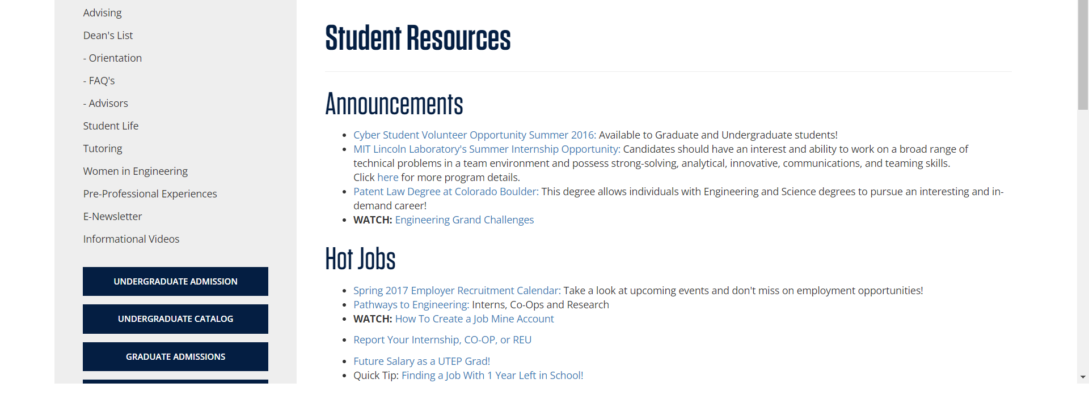

• On <https://www.utep.edu/engineering/student-resources/student-resources.html> **there is a broken link on section 'Main Content', the broken link is called 'Spring 2017 Employer Recruitment Calendar:' and the link is 'http://sa.utep.edu/careers/employers-on-campus'.**

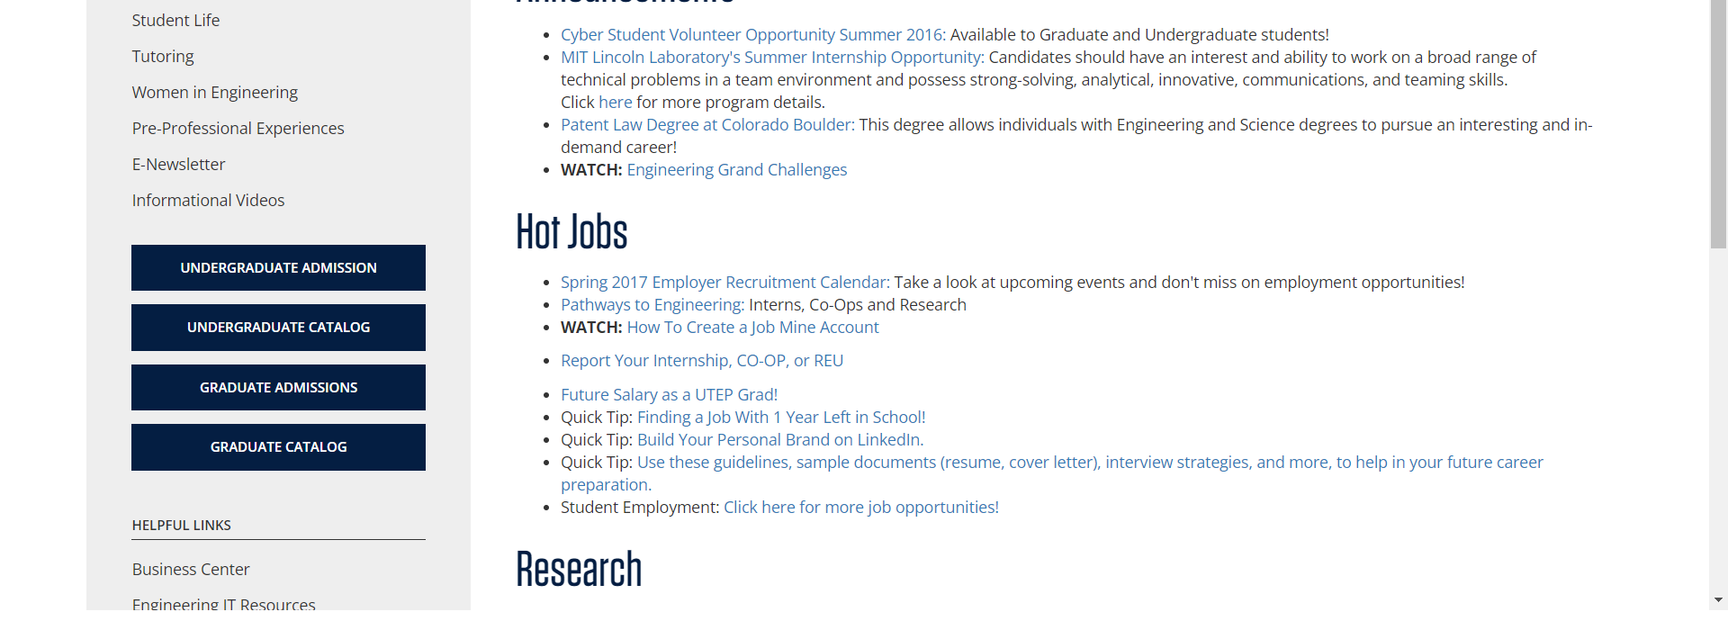

• On <https://www.utep.edu/engineering/student-resources/student-resources.html> **there is a broken link on section 'Main Content', the broken link is called 'GET the Software You Need at ETC' and the link is 'http://etc.utep.edu/index.htm'.**

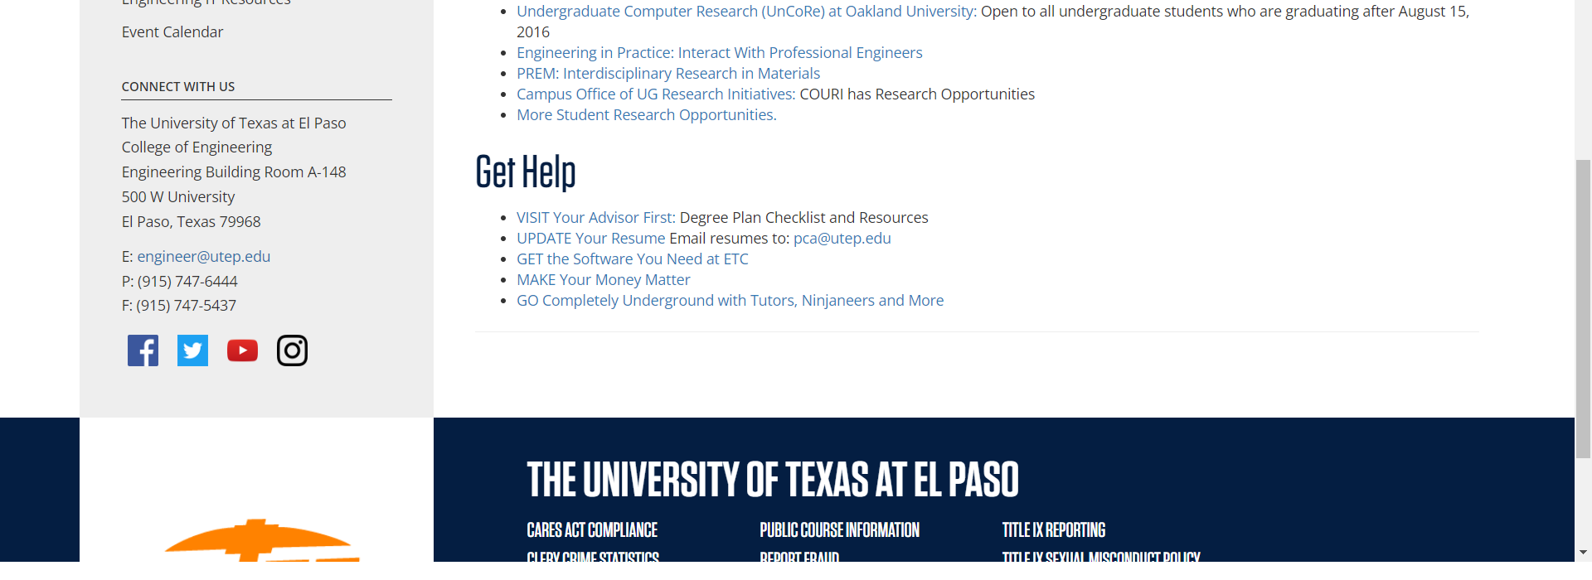

• On <https://www.utep.edu/engineering/student-resources/student-resources.html> **there is a broken link on section 'Main Navigation: Dropdown name: Resources', the broken link is called 'Tutoring' and the link is 'https://www.utep.edu/engineering/student-resources/'.**



• On <https://www.utep.edu/engineering/student-resources/student-resources.html> **there is a broken link on section 'Main Content', the broken link is called 'Use these guidelines, sample documents (resume, cover letter), interview strategies, and more, to help in your future career preparation.' and the link is 'http://sa.utep.edu/careers/students/sample-documents'.**

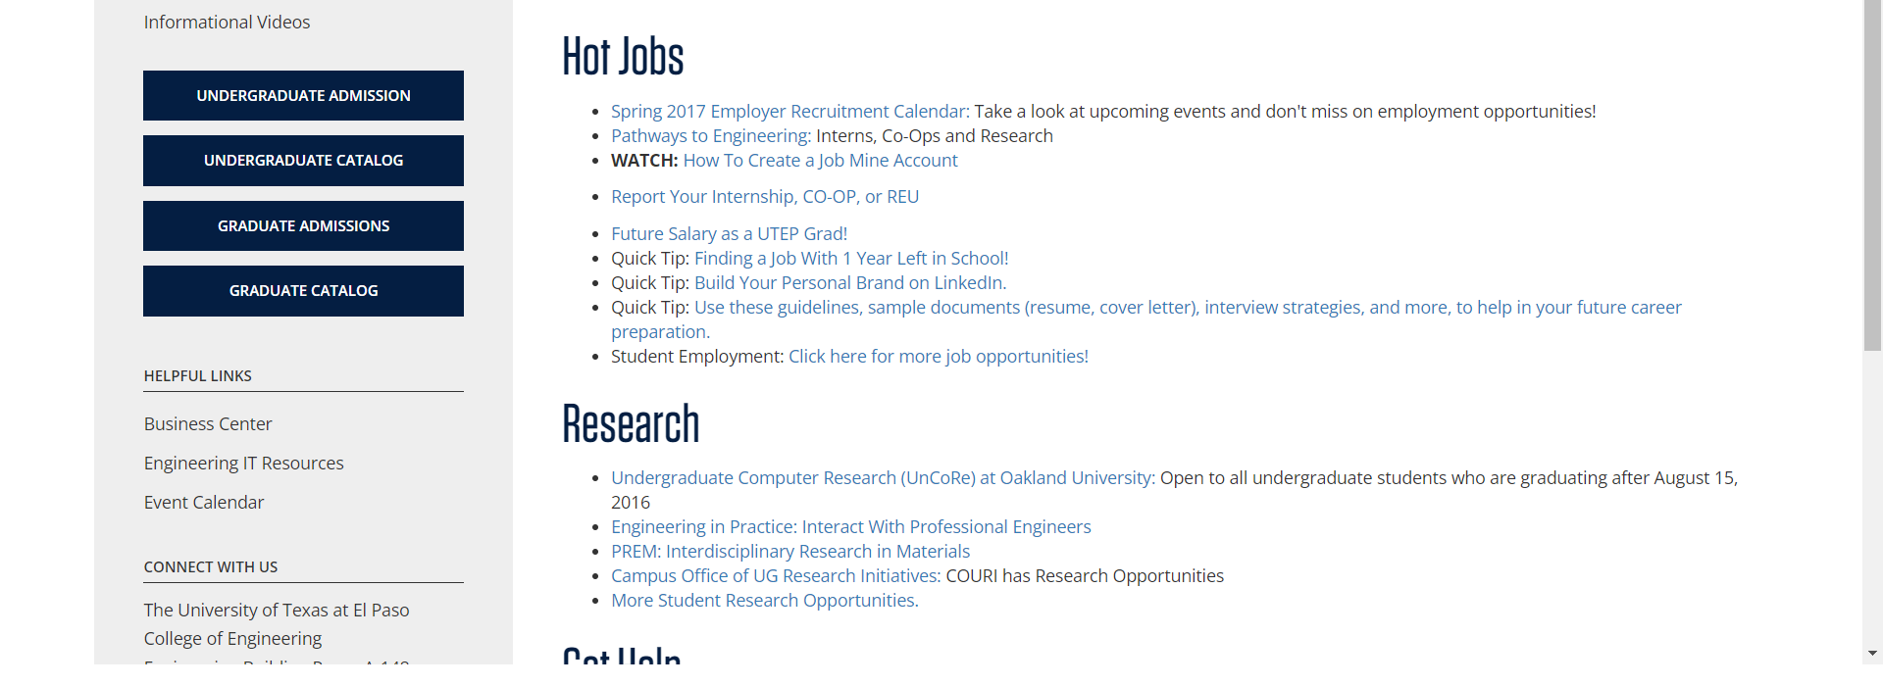

• On <https://www.utep.edu/engineering/student-resources/student-resources.html> **there is a broken link on section 'Main Content', the broken link is called 'Click here for more job opportunities!' and the link is 'https://www.utep.edu/engineering/student-resources/student-employment'.**

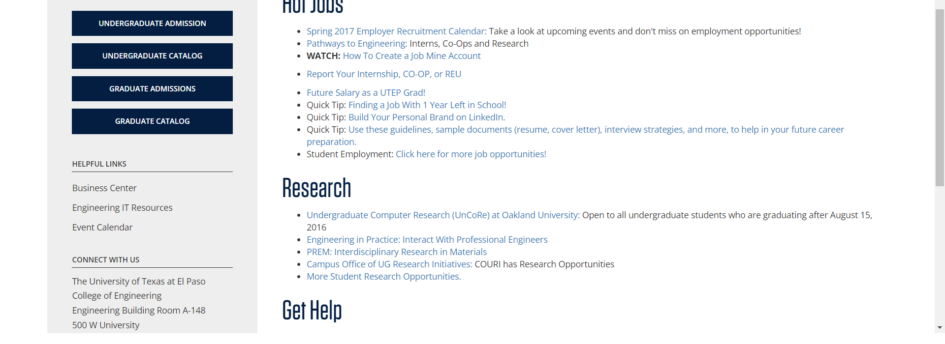

• On <https://www.utep.edu/engineering/student-resources/student-resources.html> **there is a broken link on section 'Main Content', the broken link is called 'Future Salary as a UTEP Grad!' and the link is 'https://www.utsystem.edu/seekut/Terms.htm'.**

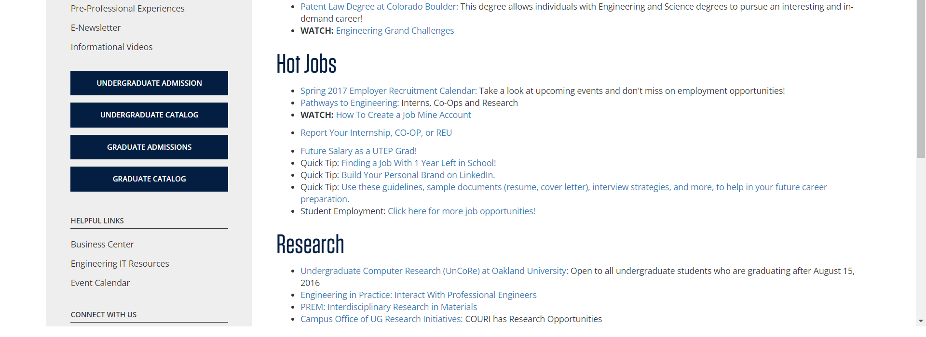

• On <https://www.utep.edu/engineering/student-resources/student-resources.html> **there is a broken link on section 'Left Navigation', the broken link is called '- Orientation' and the link is 'https://www.utep.edu/engineering/student-resources/student-resources-advising-orientation.html'.**

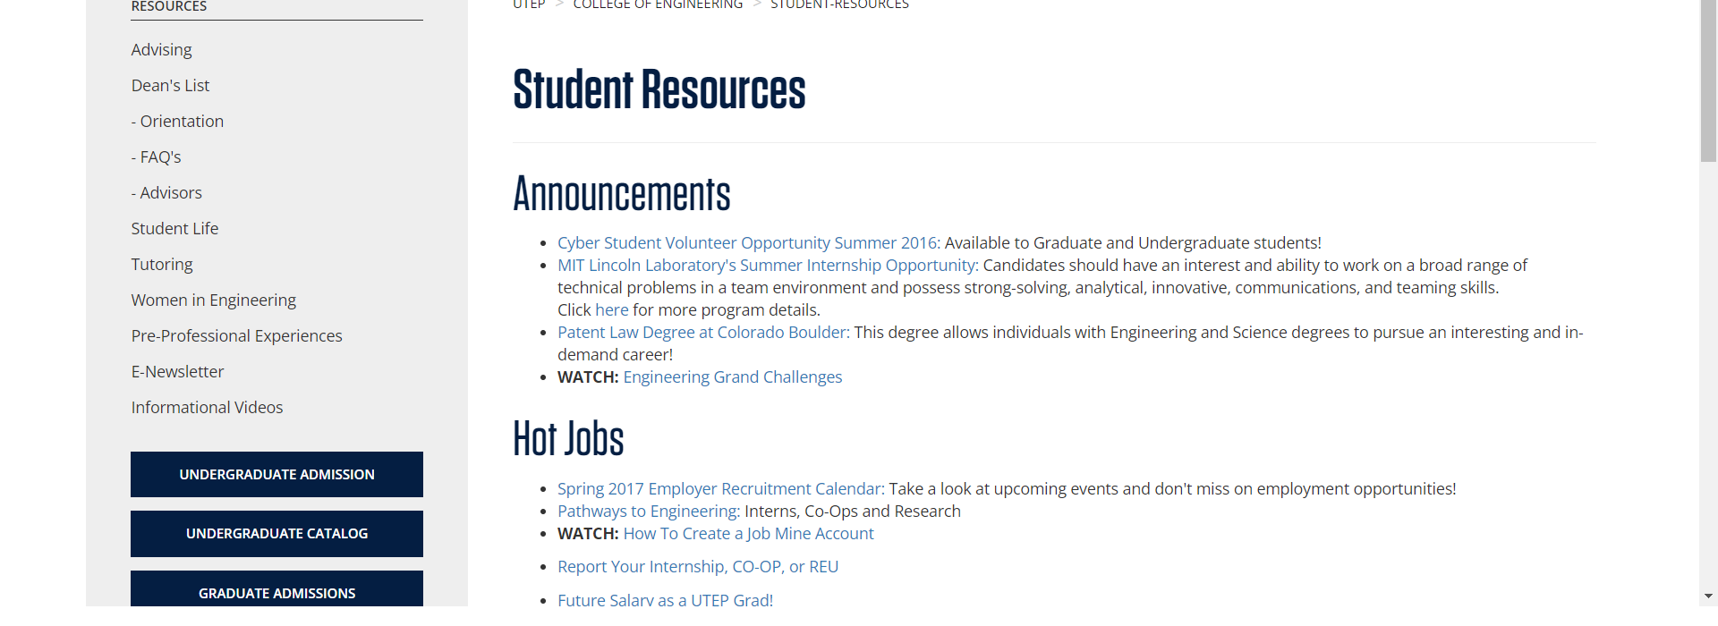

• On <https://www.utep.edu/engineering/student-resources/student-resources.html> **there is a broken link on section 'Left Navigation', the broken link is called 'Tutoring' and the link is 'https://www.utep.edu/engineering/student-resources/student-resources-tutoring.html'.**

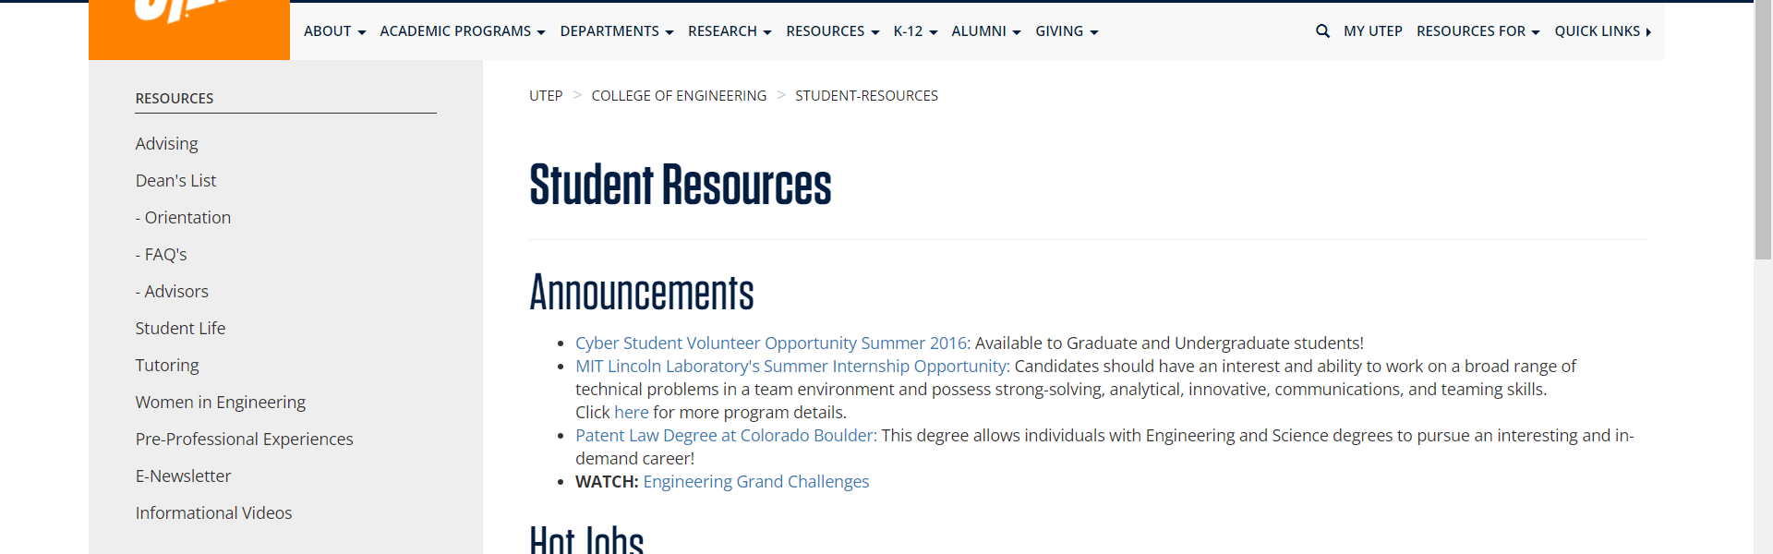

• On <https://www.utep.edu/engineering/student-resources/student-resources.html> **there is a broken link on section 'Left Navigation', the broken link is called '- FAQ's' and the link is 'https://www.utep.edu/engineering/student-resources/student-resources-ug-admissions-faqs.html'.**

