# Broken Links Report

• Broken link on <https://www.utep.edu/engineering/student-resources/student-resources.html> on **Main Navigation: Dropdown name: Resources** section, the broken link is displayed as: **Advising** and the link is pointing to : <https://www.utep.edu/engineering/student-resources/student-resources-advising.html>

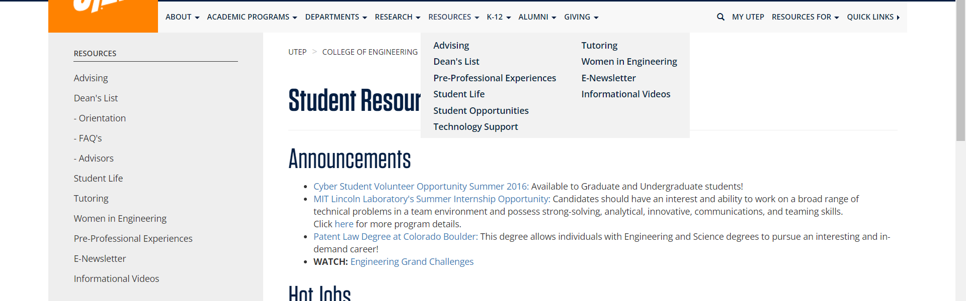

• Broken link on <https://www.utep.edu/engineering/student-resources/student-resources.html> on **Main Navigation: Dropdown name: Research** section, the broken link is displayed as: **Research Centers and Facilities** and the link is pointing to : <https://www.utep.edu/engineering/research/research-centers.html>

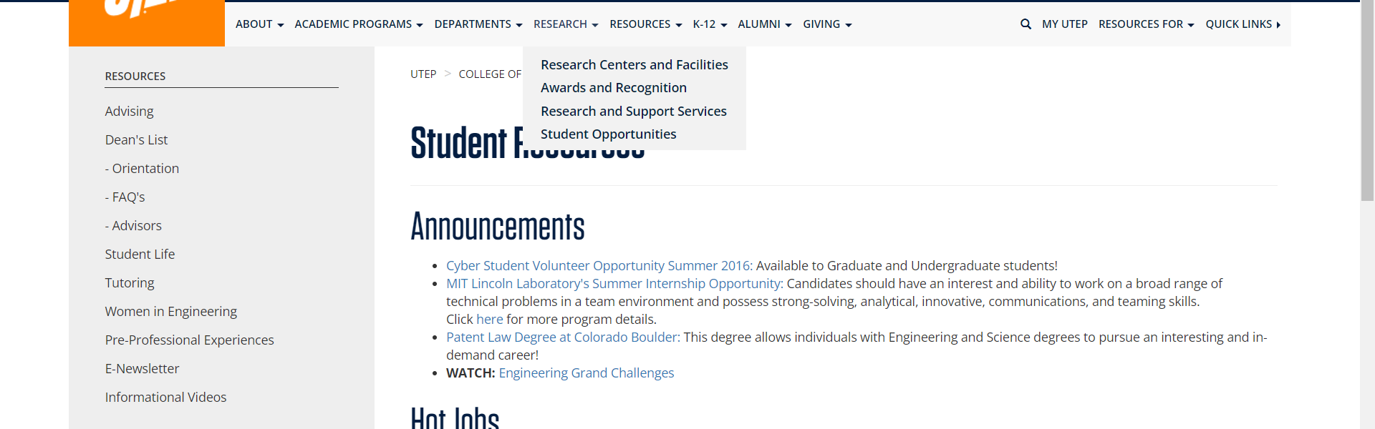

• Broken link on <https://www.utep.edu/engineering/student-resources/student-resources.html> on **Main Navigation: Dropdown name: K-12** section, the broken link is displayed as: **More Outreach** and the link is pointing to : <https://www.utep.edu/engineering/academic-programs/k12-outreach/more-outreach.html>

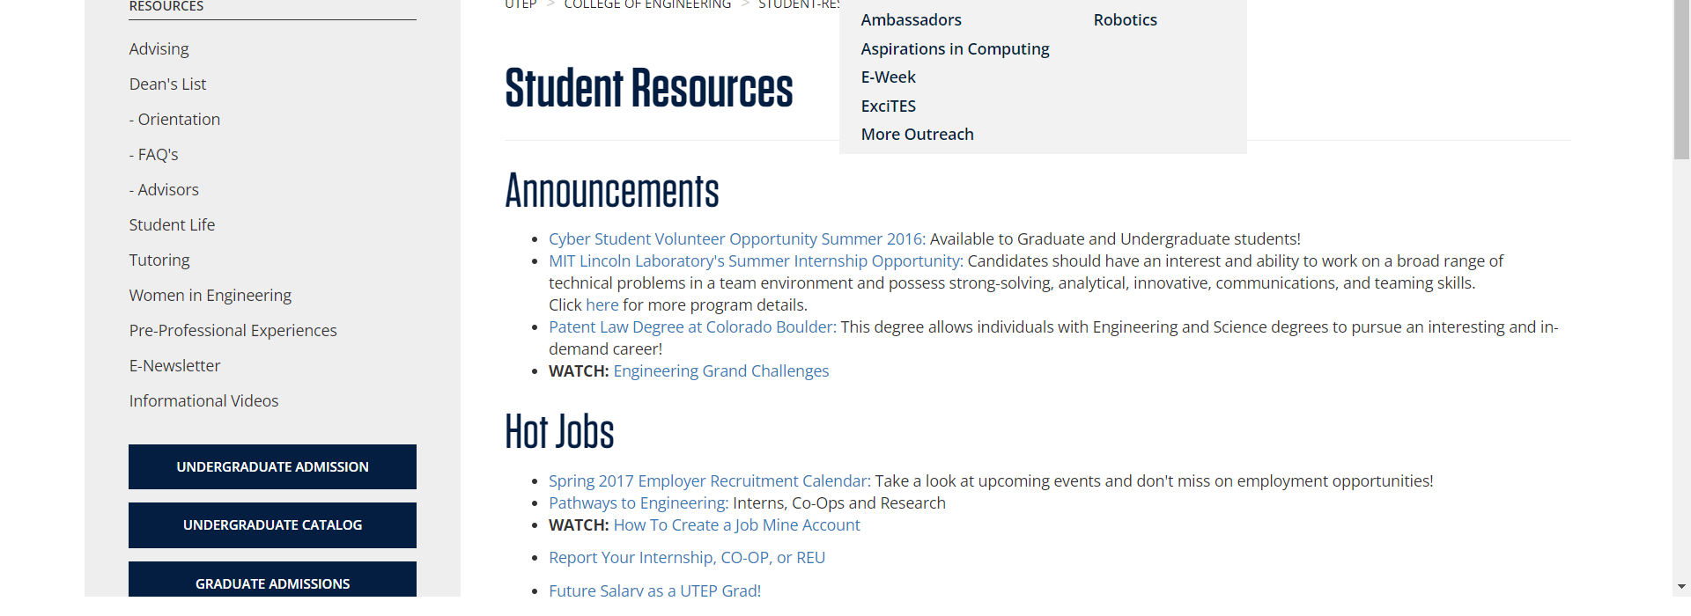

• Broken link on <https://www.utep.edu/engineering/student-resources/student-resources.html> on **Main Navigation: Dropdown name: K-12** section, the broken link is displayed as: **Aspirations in Computing** and the link is pointing to : <https://www.utep.edu/engineering/academic-programs/k12-outreach/aspiration-in-computing.html>

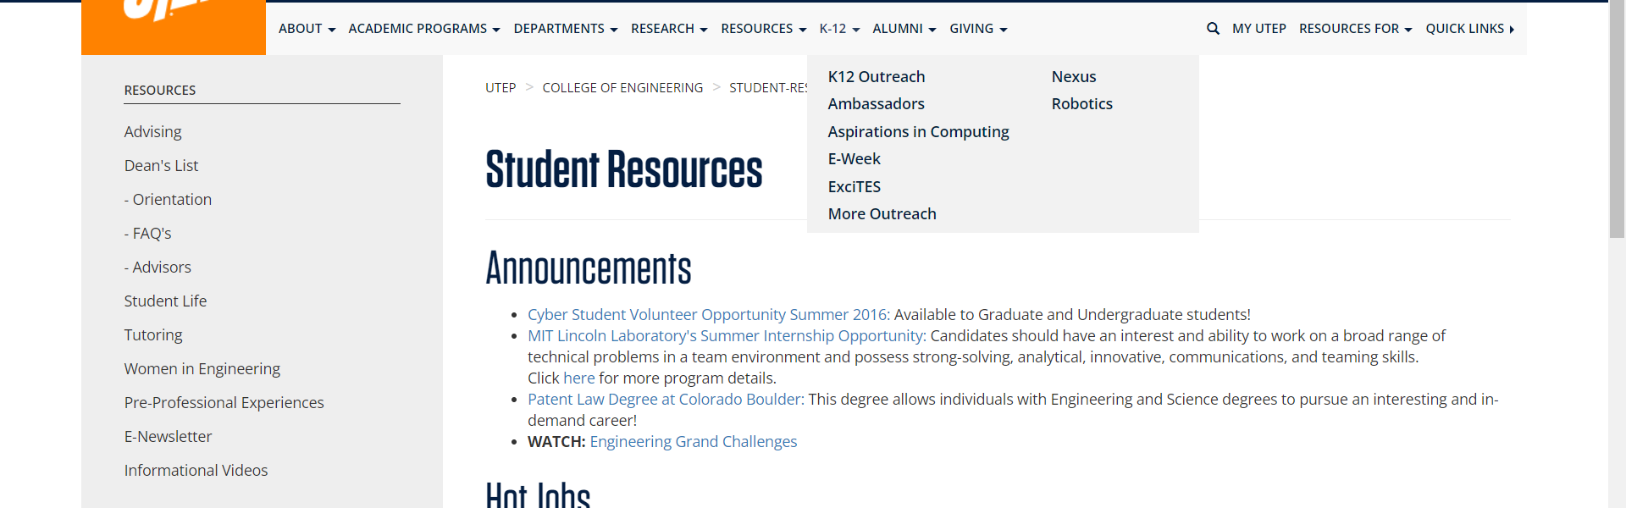

• Broken link on <https://www.utep.edu/engineering/student-resources/student-resources.html> on **Main Navigation: Dropdown name: K-12** section, the broken link is displayed as: **K12 Outreach** and the link is pointing to : <https://www.utep.edu/engineering/academic-programs/k12-outreach/k12-outreach.html>



• Broken link on <https://www.utep.edu/engineering/student-resources/student-resources.html> on **Main Navigation: Dropdown name: Alumni** section, the broken link is displayed as: **Membership Levels** and the link is pointing to : <https://www.utep.edu/engineering/alumni/membership-levels.html>

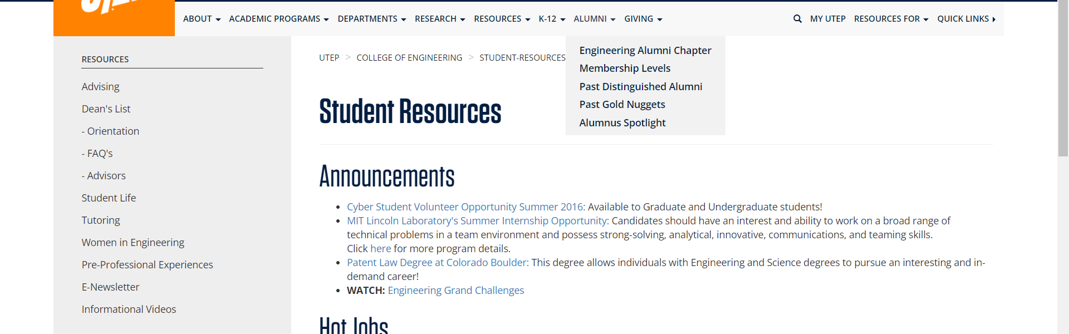

• Broken link on <https://www.utep.edu/engineering/student-resources/student-resources.html> on **Main Navigation: Dropdown name: K-12** section, the broken link is displayed as: **Ambassadors** and the link is pointing to : <https://www.utep.edu/engineering/academic-programs/k12-outreach/ambassadors.html>



• Broken link on <https://www.utep.edu/engineering/student-resources/student-resources.html> on **Main Navigation: Dropdown name: K-12** section, the broken link is displayed as: **Nexus** and the link is pointing to : <https://www.utep.edu/engineering/academic-programs/k12-outreach/nexus.html>



• Broken link on <https://www.utep.edu/engineering/student-resources/student-resources.html> on **Main Navigation: Dropdown name: K-12** section, the broken link is displayed as: **E-Week** and the link is pointing to : <https://www.utep.edu/engineering/academic-programs/k12-outreach/e-week.html>



• Broken link on <https://www.utep.edu/engineering/student-resources/student-resources.html> on **Main Navigation: Dropdown name: K-12** section, the broken link is displayed as: **Robotics** and the link is pointing to : <https://www.utep.edu/engineering/academic-programs/k12-outreach/robotics.html>



• Broken link on <https://www.utep.edu/engineering/student-resources/student-resources.html> on **Main Navigation: Dropdown name: K-12** section, the broken link is displayed as: **ExciTES** and the link is pointing to : <https://www.utep.edu/engineering/academic-programs/k12-outreach/excites.html>



• Broken link on <https://www.utep.edu/engineering/student-resources/student-resources.html> on **Main Content** section, the broken link is displayed as: **here** and the link is pointing to : <http://www.ll.mit.edu/college/summerprogram.html.>

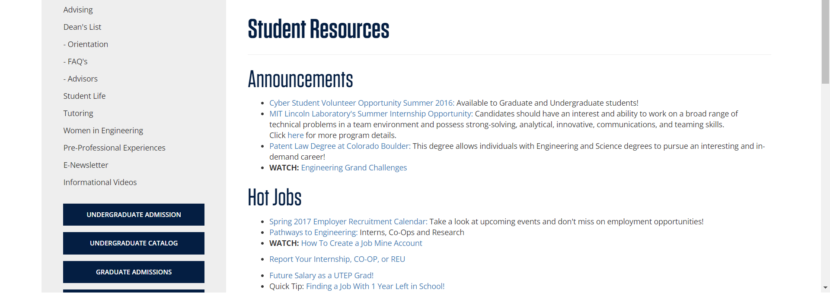

• Broken link on <https://www.utep.edu/engineering/student-resources/student-resources.html> on **Main Content** section, the broken link is displayed as: **Use these guidelines, sample documents (resume, cover letter), interview strategies, and more, to help in your future career preparation.** and the link is pointing to : <http://sa.utep.edu/careers/students/sample-documents>

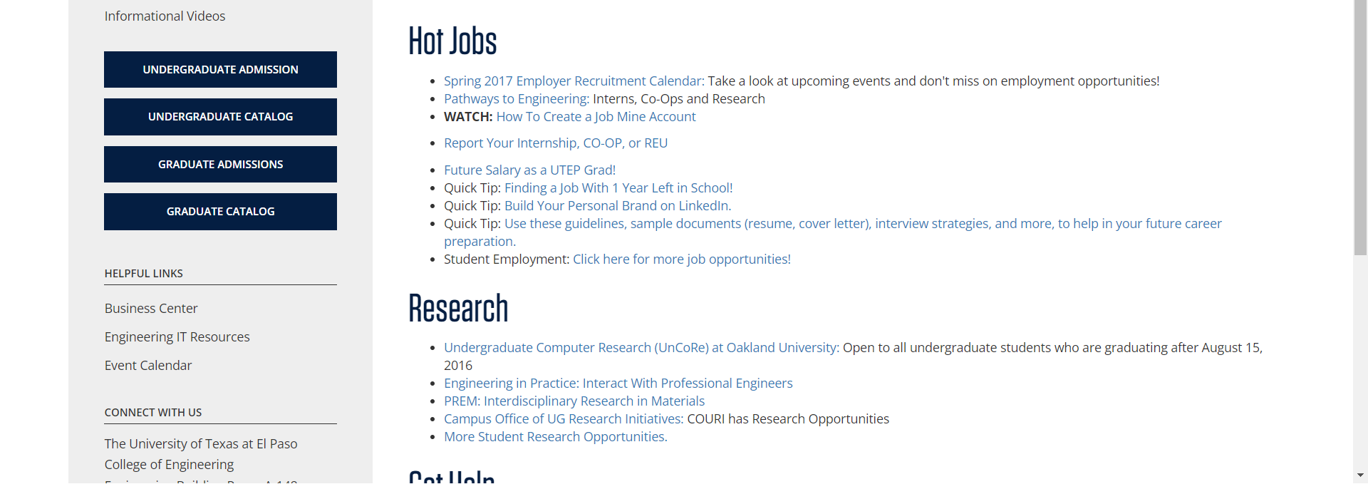

• Broken link on <https://www.utep.edu/engineering/student-resources/student-resources.html> on **Main Content** section, the broken link is displayed as: **GET the Software You Need at ETC** and the link is pointing to : <http://etc.utep.edu/index.htm>

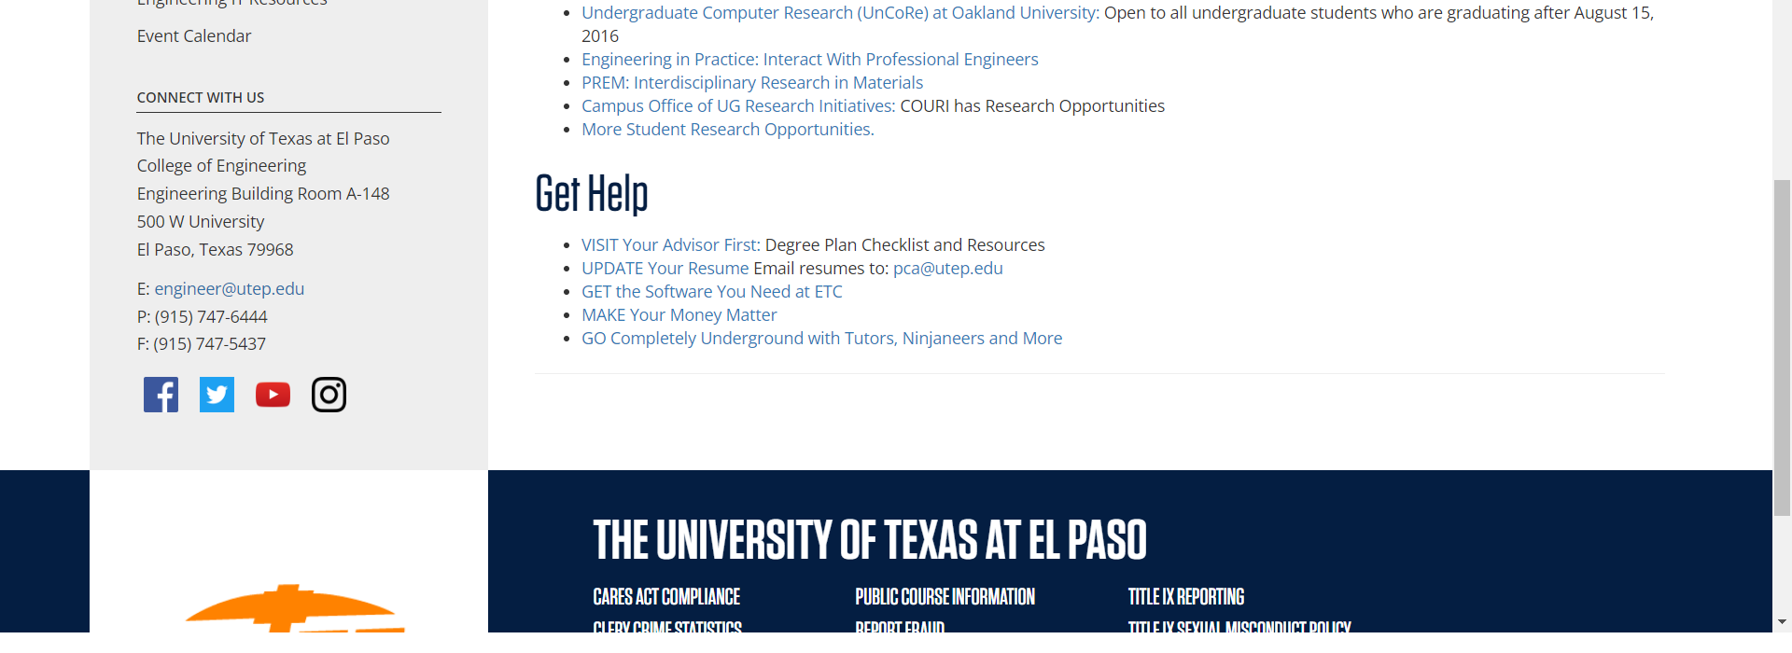

• Broken link on <https://www.utep.edu/engineering/student-resources/student-resources.html> on **Main Content** section, the broken link is displayed as: **Spring 2017 Employer Recruitment Calendar:** and the link is pointing to : <http://sa.utep.edu/careers/employers-on-campus>

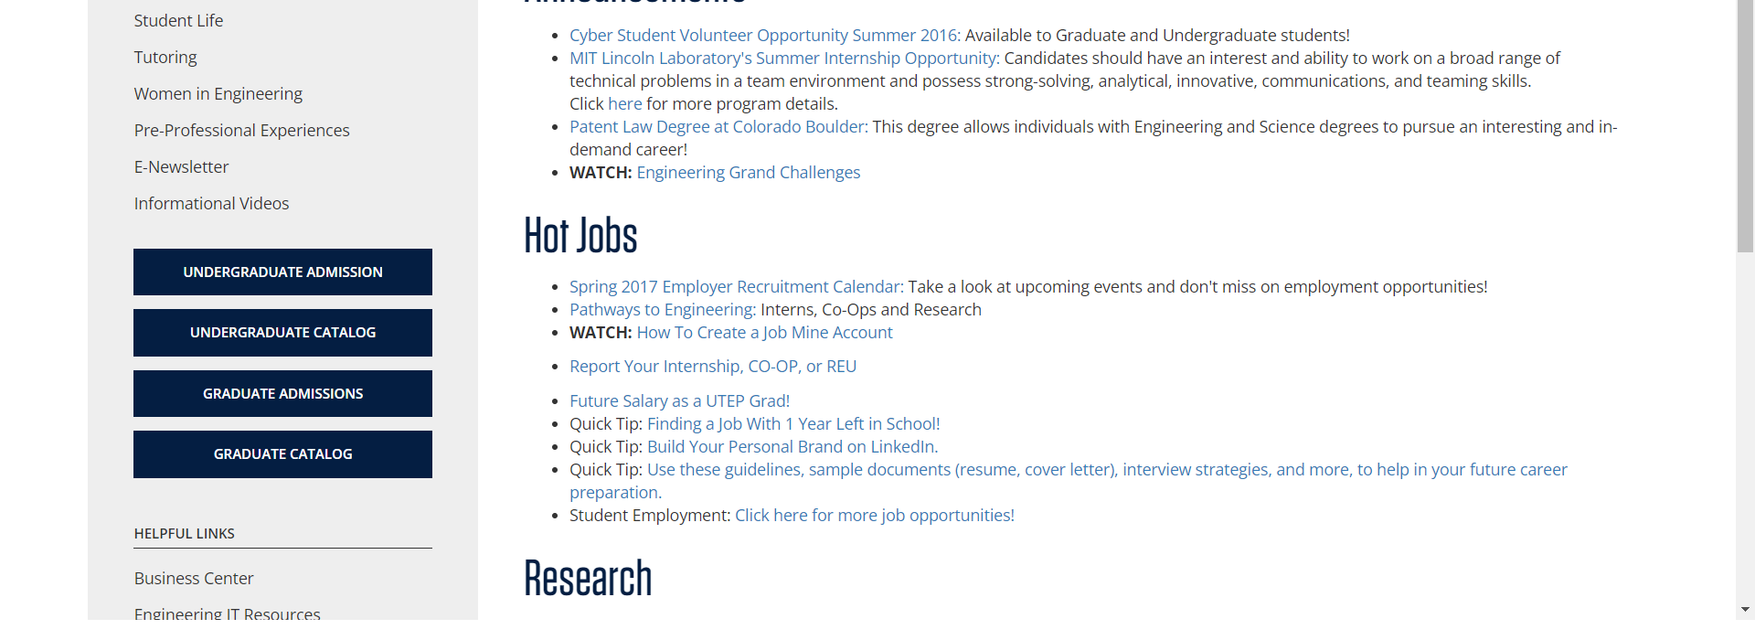

• Broken link on <https://www.utep.edu/engineering/student-resources/student-resources.html> on **Main Content** section, the broken link is displayed as: **Click here for more job opportunities!** and the link is pointing to : <https://www.utep.edu/engineering/student-resources/student-employment>

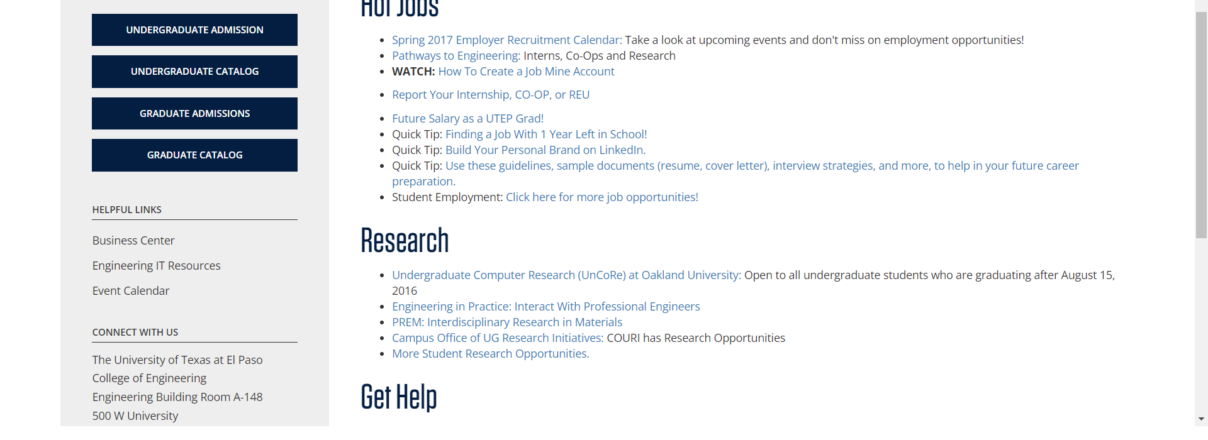

• Broken link on <https://www.utep.edu/engineering/student-resources/student-resources.html> on **Main Navigation: Dropdown name: Resources** section, the broken link is displayed as: **Tutoring** and the link is pointing to : <https://www.utep.edu/engineering/student-resources/>



• Broken link on <https://www.utep.edu/engineering/student-resources/student-resources.html> on **Main Content** section, the broken link is displayed as: **Future Salary as a UTEP Grad!** and the link is pointing to : <https://www.utsystem.edu/seekut/Terms.htm>

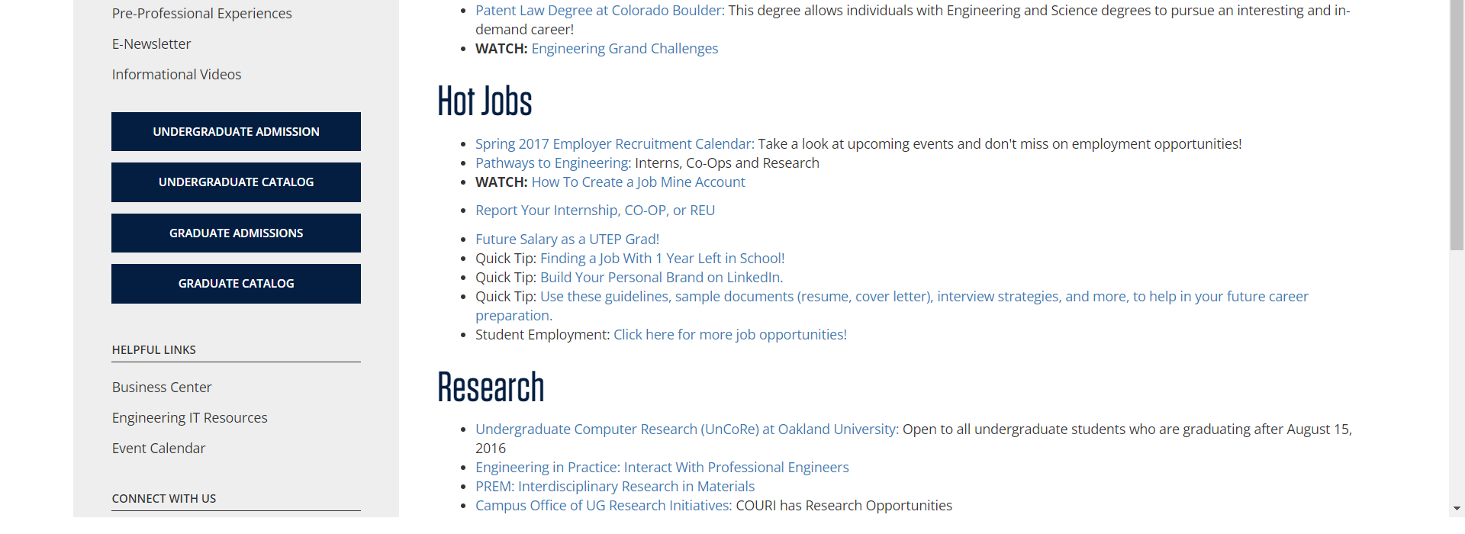

• Broken link on <https://www.utep.edu/engineering/student-resources/student-resources.html> on **Left Navigation** section, the broken link is displayed as: **Tutoring** and the link is pointing to : <https://www.utep.edu/engineering/student-resources/student-resources-tutoring.html>

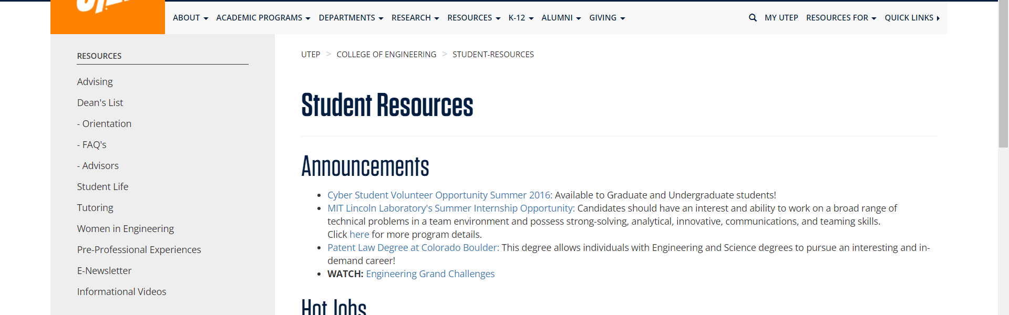

• Broken link on <https://www.utep.edu/engineering/student-resources/student-resources.html> on **Left Navigation** section, the broken link is displayed as: **- Orientation** and the link is pointing to : <https://www.utep.edu/engineering/student-resources/student-resources-advising-orientation.html>

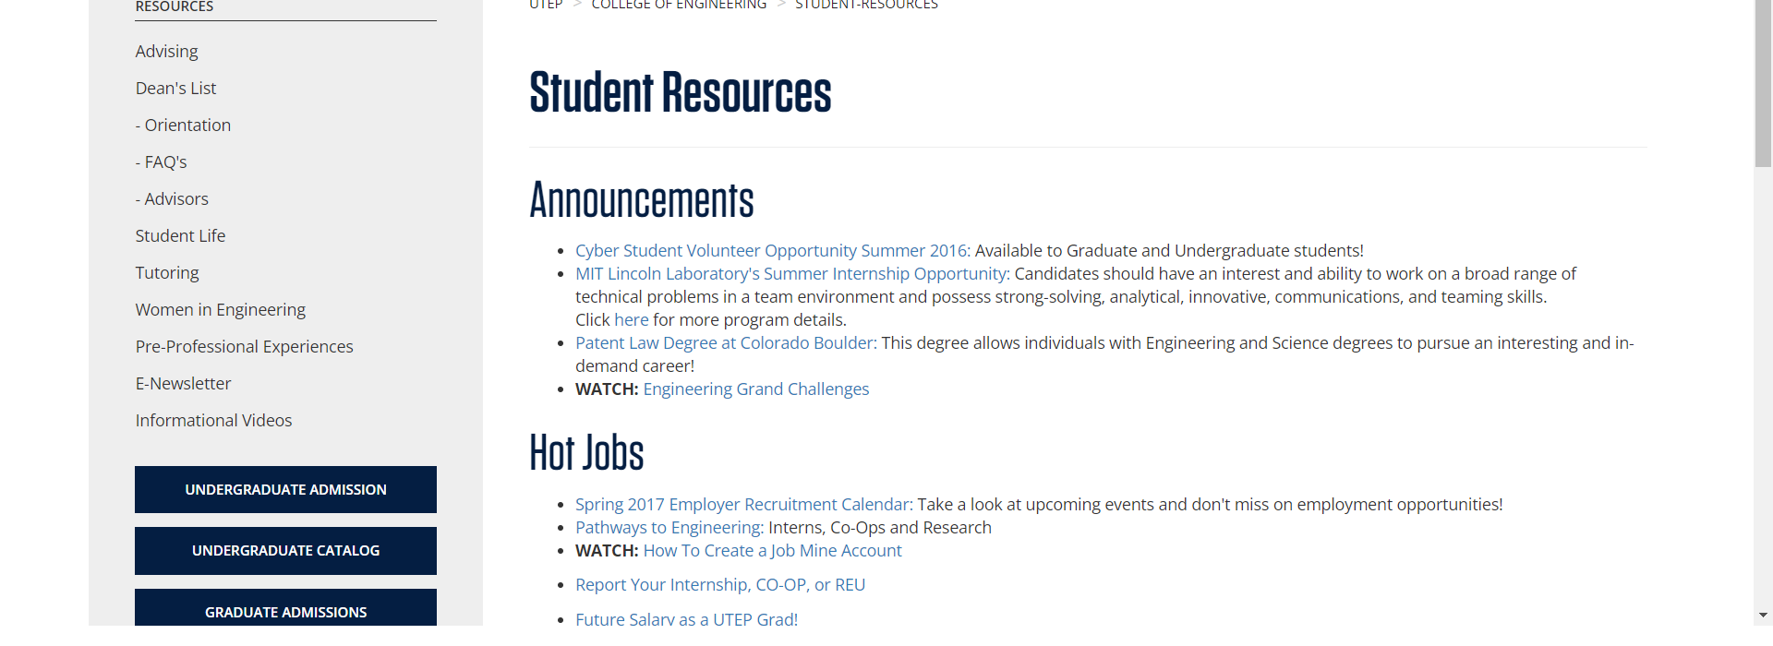

• Broken link on <https://www.utep.edu/engineering/student-resources/student-resources.html> on **Left Navigation** section, the broken link is displayed as: **- FAQ's** and the link is pointing to : <https://www.utep.edu/engineering/student-resources/student-resources-ug-admissions-faqs.html>

