potential_output

Ricardo Mayer

April 17, 2017

LAC-18, average trend growth for 2003-2008 and 2010-2016. Source: real gdp from, WEO April 2017, and then HP filtered by author

Average growth of potential output

|  |  |  |  |
| --- | --- | --- | --- |
| país | 2003-2008 | 2010-2016 | cambio |
| Argentina | 5.4 | 1.5 | -3.9 |
| Bolivia | 4.1 | 5.1 | 0.9 |
| Brazil | 4.0 | 1.3 | -2.8 |
| Chile | 4.8 | 3.4 | -1.4 |
| China | 11.2 | 8.0 | -3.2 |
| Colombia | 4.8 | 3.9 | -0.8 |
| Costa Rica | 4.8 | 3.8 | -1.0 |
| Dominican Republic | 5.4 | 5.3 | -0.1 |
| Ecuador | 4.5 | 3.1 | -1.4 |
| El Salvador | 2.3 | 1.7 | -0.7 |
| Guatemala | 3.7 | 3.4 | -0.3 |
| Honduras | 4.9 | 3.2 | -1.7 |
| Mexico | 2.4 | 2.4 | 0.0 |
| Nicaragua | 3.4 | 4.4 | 1.0 |
| Panama | 7.1 | 6.9 | -0.1 |
| Paraguay | 3.5 | 5.0 | 1.5 |
| Peru | 6.2 | 4.8 | -1.4 |
| United States | 2.0 | 1.8 | -0.2 |
| Uruguay | 4.2 | 3.7 | -0.5 |
| Venezuela | 5.8 | -2.1 | -7.9 |

AEs, G7 and Euro zone, average trend growth for 2003-2008 and 2010-2016. Source: real gdp growth and out gap from WEO April 2017, and potential gdp growth by author

Average growth of potential output

|  |  |  |  |
| --- | --- | --- | --- |
| país | 2003-2008 | 2010-2016 | cambio |
| Advanced economies | 2.1 | 1.4 | -0.7 |
| Euro area | 1.5 | 0.9 | -0.7 |
| G7 | 1.8 | 1.2 | -0.6 |

Combined table:

Average growth of potential output

|  |  |  |  |
| --- | --- | --- | --- |
| país | 2003-2008 | 2010-2016 | cambio |
| Argentina | 5.4 | 1.5 | -3.9 |
| Bolivia | 4.1 | 5.1 | 0.9 |
| Brazil | 4.0 | 1.3 | -2.8 |
| Chile | 4.8 | 3.4 | -1.4 |
| China | 11.2 | 8.0 | -3.2 |
| Colombia | 4.8 | 3.9 | -0.8 |
| Costa Rica | 4.8 | 3.8 | -1.0 |
| Dominican Republic | 5.4 | 5.3 | -0.1 |
| Ecuador | 4.5 | 3.1 | -1.4 |
| El Salvador | 2.3 | 1.7 | -0.7 |
| Guatemala | 3.7 | 3.4 | -0.3 |
| Honduras | 4.9 | 3.2 | -1.7 |
| Mexico | 2.4 | 2.4 | 0.0 |
| Nicaragua | 3.4 | 4.4 | 1.0 |
| Panama | 7.1 | 6.9 | -0.1 |
| Paraguay | 3.5 | 5.0 | 1.5 |
| Peru | 6.2 | 4.8 | -1.4 |
| United States | 2.0 | 1.8 | -0.2 |
| Uruguay | 4.2 | 3.7 | -0.5 |
| Venezuela | 5.8 | -2.1 | -7.9 |
| Advanced economies | 2.1 | 1.4 | -0.7 |
| Euro area | 1.5 | 0.9 | -0.7 |
| G7 | 1.8 | 1.2 | -0.6 |

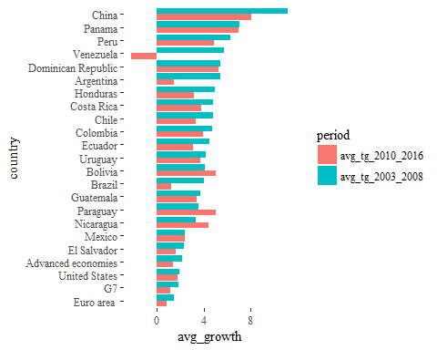

LAC only:

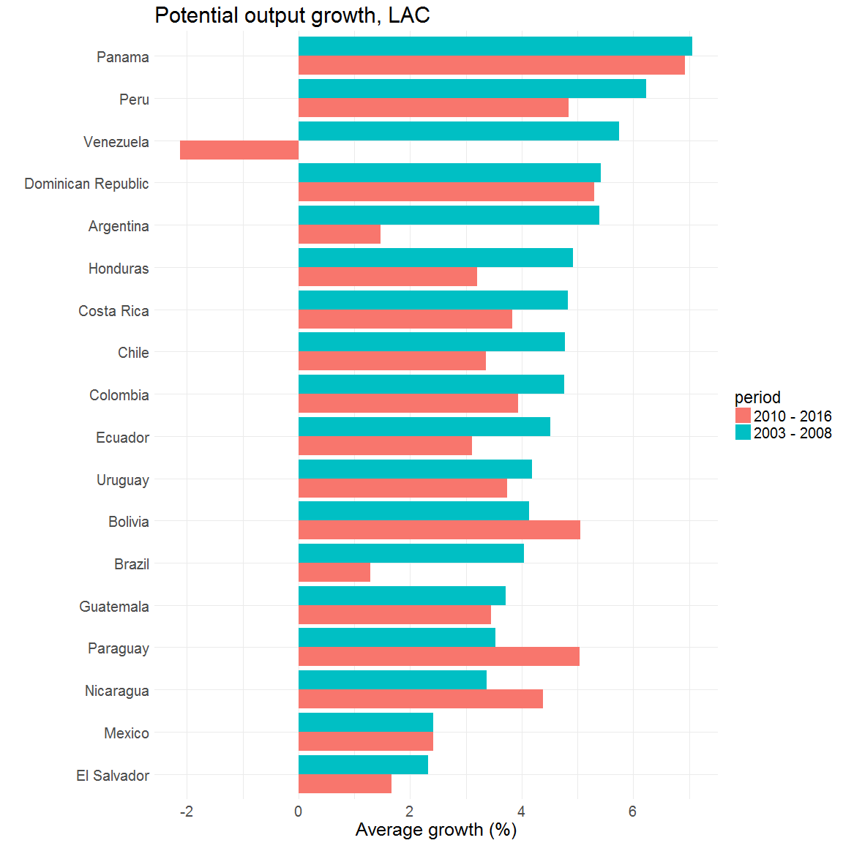

Selected economies:

