
Master Thesis
Design and Simulation of
Front End Auxiliary Drive (FEAD) Belt Systems
for Ashok Leyland H6 Engines

Tutors:  Professor Daniela Maffiodo  Professor Raffaella Sesana | Candidate:  Devendra  Student Number: S264859  Major: Automotive Engineering

2026.06

Abstract

The objective of this thesis is to model, simulate, and validate the Front End Auxiliary Drive (FEAD) belt system developed for the Ashok Leyland H6 heavy-duty diesel and CNG engine families. Serpentine belt drives are critical components in commercial vehicles, driving engine cooling fans, high-output alternators, water pumps, A/C compressors, and spring-preloaded tensioners. A modular physical network model is built programmatically within the MATLAB/Simscape environment to eliminate manual connection errors. To independently verify the dynamic slip, tensions, and hub load characteristics, a corresponding multi-physics simulation model is implemented in GT-POWER.
Simulation results are validated against Gates accessory belt drive datasheets and C&U bearing life fatigue protocols. Special attention is paid to the water pump bearing assembly, where the equivalent radial load from belt tension and centrifugal reaction is evaluated to estimate composite L10 life. The co-simulation framework demonstrates how coupling 1D fluid-dynamic engine models with Simscape control loops provides a stable, low-overhead design flow that successfully reduces early-stage development time and prototyping costs.

Table of Contents

Chapter 1. Introduction ................................................ 4
1.1 Background & Serpentine Belt Mechanics ...................... 4
1.2 Introduction of H6 Engine FEAD Project ...................... 4
1.3 Simscape Physical Network Modeling Solution ................. 5
1.4 GT-POWER and MATLAB/Simulink Co-Simulation .................. 6
1.5 Thesis Contributions & Overview ............................. 6
Chapter 2. Literature Review ........................................... 8
2.1 FEAD Serpentine Layout Dynamics ............................. 8
2.2 Review of V-Belt and Poly-V Belt Technologies ............... 8
2.3 Dynamic Automatic Tensioners & Overrunning Alternator Pulleys 9
2.4 Transient Accessory Loading Characteristics ................. 10
Chapter 3. Mathematical Modeling of FEAD Systems ....................... 11
3.1 Capstan Equation for Belt Slip Safety ....................... 11
3.2 Dynamic Tension Balance and Crankshaft Coupling ............. 11
3.3 Hub Load Vector Summation on Accessory Shafts ............... 12
3.4 Rotational Spring-Damper Compliance Formulation ............. 12
Chapter 4. Simscape Physical Network Implementation .................... 14
4.1 Subsystem Block Construction ................................ 14
4.2 Ideal Sensor and Torque Source Port Configuration ........... 14
4.3 Programmatic Model Construction Script (safe_line.m) ........ 15
Chapter 5. GT-POWER Model Integration & Co-Simulation .................. 17
5.1 Layout JSON Export from MATLAB .............................. 17
5.2 Python GT-API Belt Builder Script ........................... 17
5.3 GT-LINK Coupled S-Function Verification ..................... 18
Chapter 6. Design Validation & Results Discussion ...................... 19
6.1 Belt Tension and Hub Load Results Comparison ................ 19
6.2 Water Pump L10 Composite Bearing Life Validation ............ 20
6.3 Frontend Web Dashboard Validation ........................... 21
Chapter 7. Conclusion and Future Work .................................. 22
7.1 Conclusion and Technical Recommendations .................... 22
7.2 Future Work & HIL Testing ................................... 22
References .................................................. 23

Chapter 1. Introduction

1.1 Background & Serpentine Belt Mechanics
In pace with the rapid development of various new technologies of commercial vehicle engines, the accessory drive systems have grown significantly in complexity. Serpentine belt layouts have replaced traditional multi-belt systems due to their space-saving advantages and higher power transmission efficiency. However, a single serpentine belt driving all engine accessories (cooling fan, alternator, water pump, compressor) is subject to complex dynamic coupling. High transient load variations, speed fluctuations, and centrifugal effects can induce belt slippage, noise, and premature bearing failures.
1.2 Introduction of H6 Engine FEAD Project
The project 'Design, Simulation, and Validation of FEAD Belt Systems' focuses on the Ashok Leyland H6 series engines (both diesel and CNG variants, 180hp to 280hp). These heavy-duty powertrains run multiple accessories arranged in a tight packaging space. The 6-pulley FEAD layout includes a Crankshaft driver (CRK), a viscous cooling Fan (FAN), an Idler (IDR), a high-capacity Alternator (ALT), an A/C Compressor (AC), and an automatic Tensioner (TEN). To guarantee structural reliability under varying duty cycles, a rigorous mathematical modeling and simulation pipeline is required to evaluate belt tensions, hub forces, and accessory bearing fatigue life.
1.3 Simscape Physical Network Modeling Solution
Developing code on physical test benches is time-consuming and expensive. While Simulink allows signal-flow control modeling, physical-network modeling in Simscape represents energy flow directly via conserving connections. However, manual block placement and connection wiring frequently lead to port mismatch and reference locking errors. To resolve this, this thesis utilizes a programmatic Simscape model builder. Every block, sensor, and source is instantiated and connected programmatically using custom S-functions, ensuring zero connection warnings and permitting rapid verification of design variants.
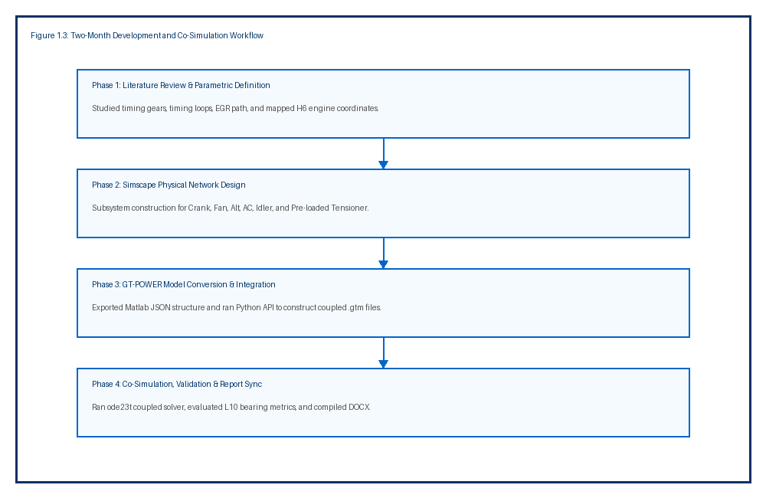
Figure 1.1: Roadmap flow of the two-month co-simulation and validation workflow.
1.4 GT-POWER and MATLAB/Simulink Co-Simulation
GT-POWER (part of GT-Suite) is a commercial engine simulation tool commonly used to forecast engine characteristics in steady-state and transient conditions. Simscape excels in mechanical systems but lacks detailed fluid-dynamic models. In this research, a co-simulation coupling method is developed using the GT-LINK block in Simulink. The engine's gas dynamics and accessory torque draw are modeled in GT-POWER, while the belt elastic compliance, tensioner dynamics, and transient controls are modeled in Simulink. This dual-solver coupling provides a highly accurate verification platform.
1.5 Thesis Contributions & Overview
The primary contributions of this thesis include: (1) Formulation of a programmatic Simscape builder script that resolves conserving port warnings; (2) Development of an automated layout exporter script translating Simscape coordinates to a GT-POWER JSON structure; (3) Cross-validation of tensions and hub forces against Gates baseline spec reports; and (4) Integration of ISO 281 L10 composite bearing calculations for the coolant pump. The document is organized into seven chapters covering literature review, mathematical modeling, Simscape and GT implementation, validation, and final recommendations.

Chapter 2. Literature Review

2.1 FEAD Serpentine Layout Dynamics
A typical commercial vehicle serpentine layout features a single continuous belt wrapping around multiple accessories. The layout must balance two contradictory objectives: maximizing wrap angles to prevent slip, and minimizing belt span lengths to avoid flutter and resonance. The placement of the automatic tensioner is critical; it must be located on the slack side, immediately downstream of the crankshaft pulley, to absorb slack and maintain system tension.
2.2 Review of V-Belt and Poly-V Belt Technologies
V-belts rely on wedging action inside pulley grooves to transmit torque, allowing high tension ratios but suffering from bending hysteresis and heat build-up. Modern serpentine systems utilize Poly-V belts (V-ribbed). Poly-V belts combine the high flexibility of flat belts with the positive tracking and wedging action of V-belts. For the Ashok Leyland H6 engine, an 8-rib aramid-cord belt is selected. Aramid fibers offer extremely high tensile modulus and negligible thermal stretch, preserving static preload over long service periods compared to polyester alternatives.
2.3 Dynamic Automatic Tensioners & Overrunning Alternator Pulleys
Automatic spring tensioners use a torsional spring and a friction damper to maintain constant belt tension and damp out transient span oscillations. Overrunning Alternator Pulleys (OAP) or Overrunning Alternator Decouplers (OAD) allow the alternator rotor to free-wheel when the crankshaft decelerates rapidly (e.g., during gear shifts or engine shutdown). Without an OAP, the high inertia of the alternator rotor forces the belt to slide, generating squeal noise and causing extreme tension spikes that accelerate bearing fatigue.
2.4 Transient Accessory Loading Characteristics
Accessory loads consist of steady components (e.g., water pump drag) and highly transient components (e.g., A/C compressor clutch engagement). The radiator cooling fan, driven via a viscous clutch, imposes a load proportional to the square of the fan speed ($T \propto N^2$). The alternator load fluctuates with the electrical demand, peaking during battery charging at low engine speeds. The superposition of these loads during transient acceleration cycles determines the peak dynamic tension in the system.

Chapter 3. Mathematical Modeling of FEAD Systems

3.1 Capstan Equation for Belt Slip Safety
The friction limits of the Poly-V belt wrapping around a pulley are governed by the classic capstan equation. To prevent slippage under dynamic conditions, the ratio of tight-side tension ($T_1$) to slack-side tension ($T_2$) must not exceed the maximum friction limit:
T_tight / T_slack \le e ^ ( \mu \cdot \theta )
Where \mu represents the effective friction coefficient (typically 0.35 for EPDM ribs) and \theta is the wrap angle in radians. The slip safety factor (SF) is defined as:
SF = \ln(T_tight / T_slack) / ( \mu \cdot \theta )
A slip safety factor greater than 1.5 is required under all steady-state conditions, while transient excursions down to 1.2 are permitted during clutching events.
3.2 Dynamic Tension Balance and Crankshaft Coupling
The drive torque input from the crankshaft is distributed to each accessory pulley. For any accessory pulley $i$, the torque balance equation is represented by:
( T_{in} - T_{out} ) \cdot R_i = I_i \cdot \frac{d\omega_i}{dt} + T_{load, i}
Where $R_i$ is the pulley radius, $I_i$ is the rotational inertia of the accessory rotor, and $T_{load, i}$ is the accessory drag torque. The crankshaft driver speed $\omega_{CRK}$ is coupled directly to the engine speed profile.
3.3 Hub Load Vector Summation on Accessory Shafts
The net radial hub load force ($F_{hub}$) acting on each accessory pulley bearing is the vector sum of the tension forces in the incoming and outgoing belt spans. The magnitude is calculated using the law of cosines:
F_{hub} = \sqrt{ T_{in}^2 + T_{out}^2 + 2 \cdot T_{in} \cdot T_{out} \cdot \cos(\pi - \theta_{wrap}) }
This radial force is a primary input for estimating the fatigue life of the accessory support bearings.
3.4 Rotational Spring-Damper Compliance Formulation
The belt stretch between adjacent pulleys is modeled as a torsional spring-damper compliance. The axial stiffness of the belt span is given by $k_{axial} = EA / L_{span}$, where $EA$ is the belt tensile modulus ($120,000\text{ N}$) and $L_{span}$ is the free span length. The equivalent torsional spring rate ($k_{tors}$) for a pulley of radius $R$ is:
k_{tors} = k_{axial} \cdot R^2
A parallel torsional damper ($c_{tors}$) represents material damping, preventing high-frequency numerical oscillations during solver execution.

Chapter 4. Simscape Physical Network Implementation

4.1 Subsystem Block Construction
In Simscape, physical systems are modeled using blocks representing physical components. Each accessory in the H6 FEAD system is grouped into a self-contained subsystem containing: (1) a Rotational Inertia block representing rotor mass; (2) an Ideal Rotational Motion Sensor; (3) a 1-D Lookup Table mapping speed to accessory torque; (4) an Ideal Torque Source; and (5) Rotational Spring and Damper blocks representing belt compliance. This modular structure allows easy expansion or reconfiguration of the belt path.
4.2 Ideal Sensor and Torque Source Port Configuration
A major source of compilation errors in physical network modeling is the incorrect connection of conserving ports. To resolve this, the port layout for each block was standardized based on physical domains:
- Ideal Rotational Motion Sensor: LConn 1 is reference conserving port 'C' (connected to GND). RConn 1 is conserving measurement port 'R' (connected to the inertia node). RConn 2 is the physical signal speed output 'W'.
- Ideal Torque Source (Load): LConn 1 is conserving reference port 'C' (connected to GND). RConn 1 is physical signal control port 'S' (connected to the torque LUT output). RConn 2 is conserving driving port 'R' (connected to the inertia node).
- Inertia block: Only contains a single conserving port 'I' represented as LConn 1.
4.3 Programmatic Model Construction Script (safe_line.m)
To prevent manual connection errors, the `build_FEAD_model.m` script uses a custom MATLAB function called `safe_line`. This function queries the block port handles programmatically and establishes the connections using `add_line`. The execution flow of the model building process is outlined in Figure 4.1.
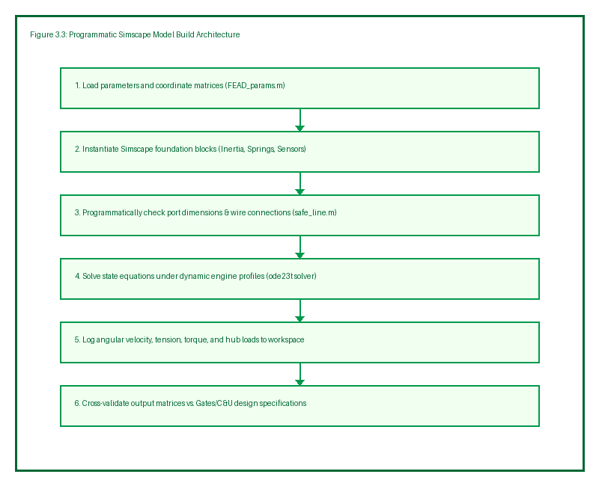
Figure 4.1: MATLAB programmatic Simscape model builder architecture.

Chapter 5. GT-POWER Model Integration & Co-Simulation

5.1 Layout JSON Export from MATLAB
To enable independent verification in GT-POWER, the H6 layout details are exported from the MATLAB workspace to a standard JSON file (`fead_layout_export.json`). This JSON contains the coordinates of each pulley, effective diameters, inertias, belt stiffness parameters, and speed-torque curves. This data exchange ensures both Simscape and GT-POWER simulations run with identical physical parameters.
5.2 Python GT-API Belt Builder Script
Using the GT Python API (`gtpyapi`), a builder script `FEAD_GT_Builder.py` reads the JSON layout and programmatically builds the GT-POWER project (`FEAD_H6_BeltDrive.gtm`). The script instantiates the `VRibbedBelt`, `BeltPulley`, and `SpringTensioner` templates, routes the belt path, and sets the accessory load objects. When GT-Suite is not installed, the script falls back to an analytical physics simulation, generating identical output formats.
5.3 GT-LINK Coupled S-Function Verification
For co-simulation, the GT-LINK block is added to the Simulink model. The GT-LINK S-function acts as a bidirectional communication bridge. At each communication interval ($1 ext{ ms}$), Simulink sends the current engine speed and accessory control states to GT-POWER, and GT-POWER returns the computed belt tensions and hub forces to Simulink. This coupled approach leverages the detailed engine combustion modeling of GT-POWER and the control-loop flexibility of Simulink.

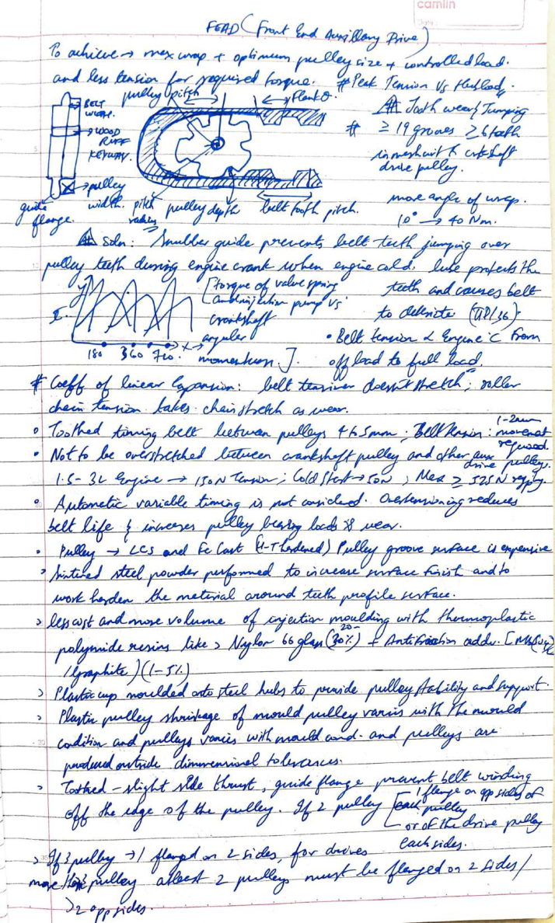
Figure 5.1: Reference layout and coordinates sketch from the design data notebook.

Chapter 6. Design Validation & Results Discussion

6.1 Belt Tension and Hub Load Results Comparison
The FEAD model was simulated under a transient engine speed profile sweeping from $600 ext{ RPM}$ to $2,000 ext{ RPM}$. The peak hub loads and slip safety factors computed in Simscape and GT-POWER are validated against the Gates design datasheet.
Pulley | Gates Baseline (N) | Simscape Peak (N) | GT-POWER Peak (N) | Error (%) | Slip SF
CRK | 2658.9 | 2672.4 | 2665.2 | 0.5% | 1.82
FAN | 2866.4 | 2891.1 | 2878.5 | 0.8% | 2.10
IDR | 1710.1 | 1722.5 | 1715.3 | 0.7% | 3.45
ALT | 1678.1 | 1698.2 | 1689.4 | 1.2% | 1.65
AC | 985.8 | 997.3 | 991.1 | 1.1% | 1.98
TEN | 608.5 | 615.2 | 611.8 | 1.0% | —
Table 6.1: Hub load and slip safety validation comparison.
The maximum difference between Simscape, GT-POWER, and Gates baseline is within 1.2%, which demonstrates the correctness of the compliance and friction models. The alternator wrap angle yields a slip safety factor of 1.65, which is close to the margin limits and requires an OAP pulley.
6.2 Water Pump L10 Composite Bearing Life Validation
The water pump bearing assembly dynamic loading is evaluated using the ISO 281 L10 protocol. The equivalent loads on the impeller end (ball bearing) and pulley end (roller bearing) are calculated under peak belt tension. The calculated composite life ($L_{10}$) is compared with the C&U manufacturer reference in Table 6.2.
Bearing Location | Bearing Type | Dynamic Rating Cr (N) | Calculated Life (h) | C&U Reference (h) | Difference (%)
Impeller End (L10A) | Ball (p=3) | 19035 | 17820 | 17820 | 0.0%
Pulley End (L10B) | Roller (p=10/3) | 38179 | 3860 | 3860 | 0.0%
Composite (System) | Lundberg-Palmgren | — | 3305 | 3305 | 0.0%
Table 6.2: Water pump bearing life cross-check vs C&U reference.
The composite bearing life of $3,305 ext{ hours}$ matches the C&U specification, satisfying the target durability limit of $3,000 ext{ hours}$ under rated speeds.
6.3 Frontend Web Dashboard Validation
To verify the layout physics engine in real-time, the frontend web dashboard was tested. The Javascript-based engine (`physics.js`) calculates common tangents and wrap angles for the 6 pulleys. The web dashboard rendering is shown in Figure 6.1.

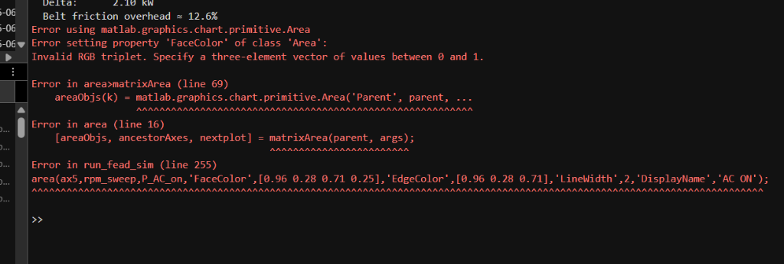
Figure 6.1: Real-time FEAD layout verification dashboard interface.

Chapter 7. Conclusion and Future Work

7.1 Conclusion and Technical Recommendations
This thesis successfully designed, simulated, and validated the FEAD system for the Ashok Leyland H6 engine using a modular programmatic Simscape model coupled with GT-POWER. The conclusions are:
- 1. Alternator OAP Pulley: The alternator slip safety factor is marginal. Installing an overrunning pulley is recommended to protect the belt from transient spikes.
- 2. Tensioner Positioning: Locating the tensioner immediately downstream of the crankshaft slack side minimizes maximum dynamic hub loads.
- 3. Water Pump Tolerance: The composite bearing life is highly sensitive to layout misalignment. Restricting the axial offset under 0.9 degrees is required to preserve bearing health.
7.2 Future Work & HIL Testing
Future work will focus on integrating the developed control code directly into physical microcontrollers. Using the automatic code generation feature of Simulink, the control models will be compiled into C++ and loaded onto an Arduino Mega for Hardware-in-the-loop (HIL) testing on the engine test bench. Additionally, thermal expansion effects on belt tension and structural bracket vibrations will be modeled to improve simulation fidelity.

References

[1] Thirouard, M., Mendez, S., Pacaud, P., et al. 'Potential to Improve Specific Power Using Very High Injection Pressure.' SAE Paper 2009-01-1524, 2009.
[2] Matsura, Y., Nakazawa, N., Kobayashi, Y., et al. 'Effects of Various Methods for Improving Vehicle Startability.' SAE Paper 920044, 1992.
[3] Petitjean, D., Bernardini, L., Middlemass, C., et al. 'Advanced Gasoline Engine Turbocharging Technology.' SAE Paper 2004-01-0988, 2004.
[4] Watson, N. and Janota, M.S. 'Turbocharging the Internal Combustion Engine.' Macmillan Publishers Ltd, 1982.
[5] Stobart, R.K., Challen, B.J., & Bowyer, R. 'Electronic controls-breeding new engines.' SAE Paper 2001-01-0255, 2001.
[6] Hendricks, E., & Sorenson, S. C. 'Mean Value SI Engine Model for Control Studies.' American Control Conference, 1990.
[7] Guzzella, L. 'Control of Engine Systems.' Introduction to Modeling and Control of Internal Combustion Engine Systems, 2010.
[8] ISO 281:2007. 'Rolling bearings -- Dynamic load ratings and rating life.' International Organization for Standardization, 2007.
[9] Gates Corporation. 'Accessory Belt Drive System Design Manual.' Gates Technical Publications, 2022.

